
Assignment Cover Sheet

Student Name: | Reema Ahmed
Student Number: | 1794
Course: | Diploma in Forensic Accounting
Assignment NO: | Assessment #4

- Short Questions
  - Fraud risk factors are three conditions that are primarily used to determine the presence of fraud – they are: management characteristics, industry characteristics and operating characteristics, which includes financial stability. These factors do not necessarily mean that existence of fraud is guaranteed, but are usually present in situations where fraud has been perpetrated. Management characteristics pertain to the management’s motivation to carry out financial reporting fraud. For example, this can be increased involvement in setting accounting principles or simply, a history of violations. In essence, these characteristics reflect the abilities of management in question, their respective style and attitude, the internal controls of the company and the equivalent reporting process. Industry characteristics, however, are the economic and regulatory aspects of the environment where the business operates. For example, these characteristics can be increased competition or saturation of the market; fundamentally, it includes such things needed to keep up with the industry. In contrast, operating characteristics and financial stability includes the nature and complexity of the business and its respective transactions. Principally, we can correlate fraud risk factors in the context of the fraud triangle, as presented to us in an earlier lesson. An auditor may detect incidents or situations that reflect incentives and/or pressures to conduct fraud, the existence of opportunities to carry out the fraud, in addition to, attitudes and/or rationalizations to justify such fraudulent activities. Illustrated by the image below are the fraud triangle and an example of a respective risk factor for each element.
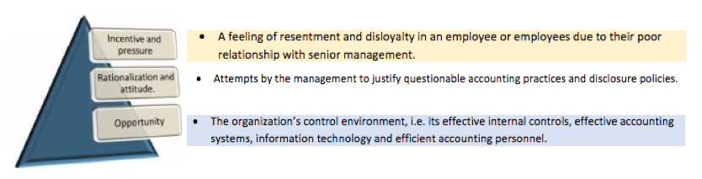

  - Detecting corruption is very difficult as it is generally concealed by legal transactions and therefore, the internal controls that are implemented are targeted towards deterrence rather then detection. In addition, anyone with authority to award contracts or purchase products is a target for fraudulent schemes. Therefore, control mechanisms are designed to minimize the risk of corruption or fraud; such mechanisms include:
    - Transparency and integrity in the bidding process (usually involved in asset procurement)
    - Frequent rotation of employees through different vendor assignments
    - Using private fax machines and having the bids submitted to named individuals other than those who are soliciting the bids. This prevents fraudsters from informing the parties involved about lower bidding competitors.
    - Establishing a hotline to enable vendors to complain in case they find themselves in a scenario where they are approached by someone seeking to bribe them
    - Enforcing a strict full disclosure of conflicts of interest, receipt of gifts, non-cash items, etc.

Even with these control mechanisms in place, it is also essential to be well acquainted with some of the red flags that may help detect corruption schemes. These can range from such things as having the same vendor for most orders, cost of materials not being consistent with business activities, extravagant lifestyle of the buyers, very short time for bid response, terms and conditions that restrict competition and when managers outside the purchasing department are making decisions that favour suppliers.
  - There are three main benefits of analytical testing procedures:
    - Assessing the company’s ability to remain a going concern: the company’s ability to remain a going concern can further be assessed by analyzing a company’s general financial performance, its performance relative to competitors, any future financial problems it may face and whether it will be able to sustain itself throughout.
    - Indicating errors in financial statements: analytical procedures can help identify discrepancies between actual and expected performances, which highlight the possibility of accounting errors, and irregularities in the financial statements.
    - Implications for detailed audit testing and procedures: If the procedures do not reveal any discrepancies between expected and actual performance then that may mean there exists no material irregularities or errors. In that scenario, further audit testing may be deferred as the evidence gathered suggests that the company’s financial performance is fairly reflected in its statements. However, if material irregularities exist, then detailed audit testing becomes essential.

  - Rationalizations for a fraudster are originated by three factors: the culture of the organization, the psychology of the people working for the organization and the relationship between both employees and company in question. Though frauds usually start out small, they increase in size depending on the repercussions of the previous perpetration. However, it is also important to note that some perpetrators are first time offenders and rationalizing helps them hide from their dishonest acts. Some common rationalizations that are used to justify financial crime and fraud are the following:
    - The company will make more money the next financial quarter, therefore, the missing money will go unnoticed.
    - This month’s fictitious accounting entry can be reversed by a counter-entry the following month resulting in no loss for the organization.
    - Management does not take supervision of internal control and discipline seriously.
    - The perception that the company overlooked an employee’s hard work and promoted someone less deserving, thereby deserving the short-term rewards of the fraud.
    - The perception that the company does not compensate its employees enough and may undergo employee cuts therefore the fraud would make up those benefits that the company may be eliminating in the future.

  - Like any other subject matter, an understanding of risk factors leads to the proper evaluation of fraud risk factors. Risk factors can only be properly identified and evaluated through a combination of three elements: the environment in which the business operates, the structure and culture of the entity and the respective internal controls. It is also essential to understand the differentiating factors between small and large corporations. For example, in small business and corporations, management committees, audit committees and the segregation of duties both accounting and operational are not as well defined and developed in comparison to such practices in a larger corporation. Consequently, this entails more involvement of the manager or owner in the day-to-day activities of running the business. Subsequently, unusual and suspicious transactions alongside ambiguous financial rations and questionable explanations by management should not be overlooked when evaluating fraud risk factors. Normal business functions and the respective industry in which it operates in, in addition to the relationship between the entity and its suppliers, customers and partners should be clearly identified and understood. Identification of fraud risk factors is increased once an auditor has thorough understanding that every stage of the audit involved the auditors being vigilant and alert to misstatements as they may come across new information at any stage from the following:
    - Planning and risk assessment
    - Discussions with employees or with management
    - Audit tests such as control testing, substantive or analytical testing
    - Review of audit

  - Analytical procedures are important in the audit process as they evaluate financial information made by relationships amongst both financial and nonfinancial data. The three purposes of why analytic procedures are used are as follows:
    - Primary: preliminary analytic procedures help provide an insight into the company and point out the high-risk areas. This helps to determine the nature, timing and extent of the audit procedures. The objective of this should entail identifying the existence of unusual transactions and events, amounts, ratios and trends that may indicate matters that have material financial misstatements.
    - Functional: substantive analytic procedures are used to evaluate account balances and obtain efficient audit evidence Keeping in mind the size of the corporation, the procedures may vary from not as extensive to an extensive analysis of financial statements.
    - Concluding: final analytic procedures carry out a final assessment of financial statements and assess whether the respective conclusions are correct or not. Such results will further determine if additional evidence may be needed or not.

- Keeping in mind that fraud detection mechanisms are not foolproof and cannot always catch fraudsters, there are a few circumstances that exist which create opportunities for management and other staff to commit fraud. Management and other employees may often find themselves in situations where they are offered incentives or are under pressure to commit fraud. Popular examples include circumstances that threaten the profitability of the business entity, pressure on management to meet or exceed expectations, internal pressures imposed by senior management, personal financial problems, adverse relationships, fear of losing one’s position and desire to be promoted. However, the three main opportunities that exist for management or others to act on their needs include:
    - Weak or ineffective controls
    - Poor segregation of duties or lack thereof
    - Lack of supervision
In context of risk factors, opportunities to commit fraud include:
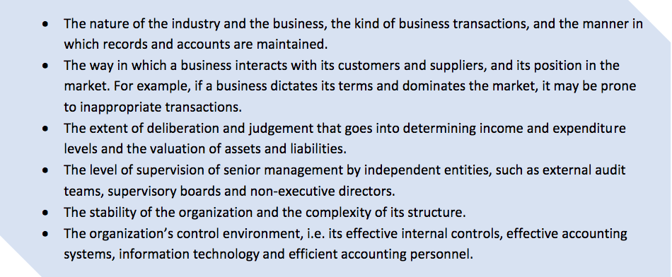

- Carrying out inquiries with management amongst other precautions leads to the identification of fraud risk factors. By making such inquiries, the views about the risks of fraud and how they are actually addressed come into perspective. The auditor should frame their questions around whether management has knowledge of any fraud or speculation thereof which may affect the overall entity, whether they have implemented fraud detection and prevention programs and controls to overall mitigate fraud risks and how effective the internal controls really are. Some important questions an auditor may consider asking are shown below:

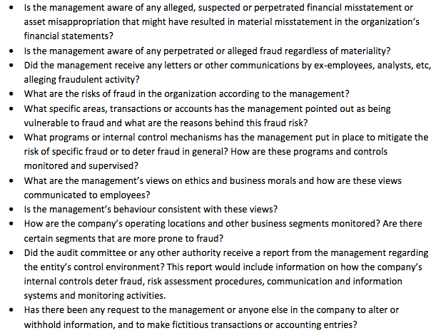

Case Study
- Essentially, the expert was under the impression that the man on remand was earning revenue and held assets through the means of fraud. Therefore, knowing where to start to support such suspicion is the first step in detecting fraud. The expert needs to consider the nature of the business and how it generates and accounts for revenues; and then, identifies ways in which revenues might be misstatement and its respective concealment. Performing risk assessments will help in identifying the areas that may be subject to scrutiny. It is essential for the expert to lay a foundation for detection. This can be done through inquires of management and substantive analytic procedures to evaluate the account balances of the man to obtain sufficient audit evidence. Analytic techniques help to identify not only account balance comparisons but also financial relationships. For example, the expert can perform an horizontal analysis, which essentially compares the current period’s balance with those of prior periods. This can highlight any accounts that may be increasing or decreasing at rates higher than normal. In addition, it becomes essential to also analyze the relationship involving revenue recognition and inventory balances, as this seems to be of issue in the case. In this scenario, relationships that can be analyzed are sales versus accounts receivable, sales versus cost of sales, inventory versus current or total assets, and cash versus current or total assets. By doing so, the expert can gather sufficient evidence to analyze whether the cash flow is indeed from other means.
- Documents that could have helped the forensic expert in gathering evidence are essentially those that reflected the property purchases and the legality of it. Example of such documents are:
    - Copies of signed contracts
    - Transaction records
    - Dated correspondence
In addition, written sales agreement between the buyer, the man on remand, and the property seller, would also prove useful. Contracts should be reviewed with a detailed reading of all terms and conditions with special emphasis on conditions relating to payment and other contingencies.
Student Statement:
By submitting this assignment, I confirm that this is my own work.

Student Signature | Reema Ahmed | Date | July 24, 2016

For Tutor / Assessor Use Only
Total Marks
Marks Obtained
Percentage / Grade

