

Assignment Cover

^{Student Name:} | ^{Hiyam Daou}
^{Student Number:} | ²³²⁰
^{Course:} | ^{Diploma in Diet & Nutrition}
^{Assignment NO:} | test 12 Weight Control Management

Assessment 12
- Give short answers for the following questions:

- What is body mass index? And how it is calculated?
Body mass index is a weight to height ratio calculated by dividing one’s weight in kilograms by the square of one’s height in meters and used as an indicator of obesity and underweight.
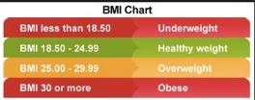
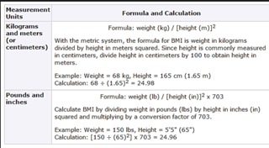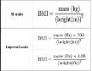

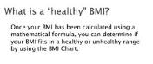

- Why healthy weight is important for us?
It’s important to maintain a healthy weight for health in addition to lowering the risk of heart disease stroke diabetes and high blood pressure, it can lower the risk of many different cancers.
Maintaining a healthy weight is an extremely important part of overall health. Being overweight or obese contributes to numerous health conditions that limit the quality and length of life including;

Hypertension, dyslipidemia, for example high total cholesterol or high levels of triglycerides
Type 2 diabetes, coronary heart disease, stroke, gallbladder disease, depression, osteoarthritis, sleep apnea and respiratory problems, some cancer endometrial, breast, and colon.

Maintain a healthy weight is not always easy. The key to success is making changes in daily eating and physical activity habits that can be maintained over one’s lifetime.
Our weight is a result of the combination of energy one takes in through foods and beverages and the energy their body uses through engaging in physical activity. To lose weight an individual need to use more calories than they consume. To maintain a healthy weight one needs to balance the calories they use with those they take in. some ways to create a caloric deficit are:

- Spend less time in sedentary activities {e.g. watching television internet surfing.

- Engage in daily physical activities eg. walking, bicycling, gardening housework.

- Eat more fruit and vegetables and reduce food portion size.



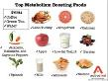

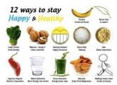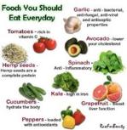

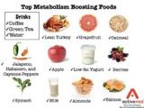

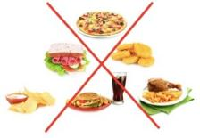
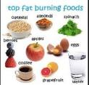

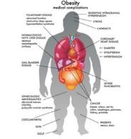

- What are the benefits of exercise for a weight control program?
When it comes to successful and lasting weight loss eating well is only part of the battle. Physical activity will help you inch closer to your goal by burning calories and building muscle, however it’s not the only reason to make exercise part of your daily life. Exercise also help prevent health condition, decrease stress and makes you feel better.
You have to get your heart pumping and break a sweat to burn a significant amount of calories
Benefits of exercise
Weight loss you must burn more than you consume to lose weight. The more you exercise the less you need to reduce your food intake. Instead of eliminating 500 calories from your food choices alone you can cut 250 calories from your daily diet and work off the other 250 calories at the gym.
Increased energy levels

Regular physical activity helps you
Oxygenate your blood efficiently
Deliver nutrients to your tissues
Rev up your cardiovascular system
Boost your circulation
Following routine exercise will help the heart and lungs won’t need to work as hard to function. This can give you more energy to propel you through your day.
Exercise also improve sleep quality. It can help you get a better night rest leave you feeling ready to tackle the day.

Disease prevention
People who exercise regularly are healthier and get sick less often.
Regular workout can help you prevent and manage many health problems including:
High blood pressure
Cancer including colon and breast cancer
Type 2 diabetes
Obesity
Rheumatoid arthritis
By increasing your activity levels, you improve your blood circulation throughout your body and improve your coronary artery flexibility. This promotes good flow and lowers your risk of heart disease including heart attacks.
Exercise also increase the number of white blood cells in your body. These are the cells that fight off pathogens which can cause illness.

Mood improvement
Relaxing mind-body yoga workout exercise can help you relive stress and feel calmer. That’s because physical activity stimulates the release of feel good brain chemicals, including endorphins.
Maintaining a daily fitness routine often requires careful time management and dedication. But the benefits of exercise are worth every moment you spend on it. From weight loss to disease prevention, exercise is a natural and proven health elixir. Make it a daily part of your life to reap the benefits for years to come. Make it a daily part of your life to reap the benefits for years to come.

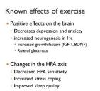

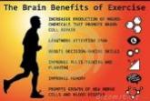

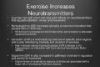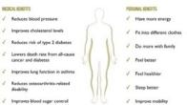

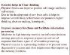
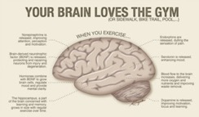

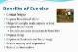

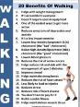

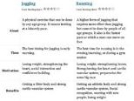

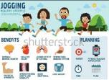

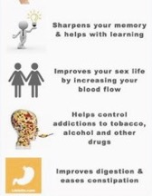
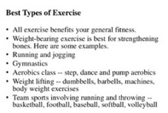

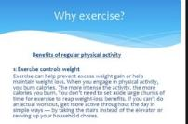

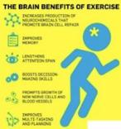

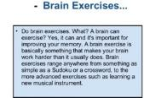

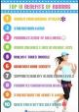

- How parents can help their children in maintaining healthy weight?

When children are young parents and other caregivers are responsible for providing a helps them maintain a healthy weight.

When it comes to nutrition and fitness the role of parents is the same no matter the weight of their children. Not all skinny kids have healthy eating habits or active lifestyles. And all overweight children develop risk factors diabetes or heart disease.
A healthy weight for kids is about much more than numbers. It is about healthy behaviors such as enjoying a variety of nutrient-rich foods and a variety of activities for strength, flexibility and aerobic capacity.
To help your child maintain a healthy weight balance the calories your child consumes from foods and beverages with the calories your child uses through physical activity and normal growth.
The goal for overweight and obese children and teens is reducing the rate of weight gain while allowing normal growth and development. Children and teens should not be placed on a weight reduction diet without consultation of a health care provider.
Balancing calories help kids develop healthy eating habits.
One part of balancing calories is to eat foods that provides adequate nutrition and an appropriate number of calories.
Help children to be aware of what they eat by developing healthy eating habits. To make favorite dishes healthies and reducing calorie rich temptation.
Encourage healthy eating habits.
Provide plenty of vegetables fruit and whole grain products.
Include low fat or nonfat milk or dairy product.
Choose lean meats poultry fish lentils and beans for protein.
Serve reasonably sized portions.
Encourage your family to drink lots of water.
Limits sugar sweetened beverages.
Limit consumption of sugar and saturated.

Remove calorie-rich temptation
Everything can be enjoyed in moderation reducing the calorie-rich temptations of high fat and high-sugar or salty snacks can also help your children develop healthy eating habits. Instead only allow your children to eat them sometimes so that they truly will be treats. Low sugar treats that are 100 calories or less:
A medium-size apple
A medium-size banana
1 cup blueberries
1 cup grapes
1 cup carrots broccoli or bell peppers with 2 tbsp. hummus.
Help kids stay active
Engage children in physical activity and avoid too much sedentary time. In addition to being fun for them.
Regular physical activity has many health benefits.
Including strengthening bones
Decreasing blood pressure
Reducing stress and anxiety
Increasing self-esteem
Helping with weight management

Helping kids stay active for examples children and teen should participate in 60 minutes’ physical activity daily remember children imitate adults. Adding physical activity to your own daily routine and encourage your child to join. Examples:
Brisk waling
Playing tag
Jumping rope
Playing soccer
Swimming
Dancing

Reduce sedentary time.
Like reading and homework is fine limit the time your children watch TV play video games or surf the web to no more 2 hours per day.


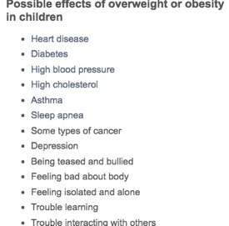

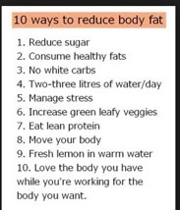
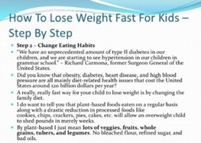

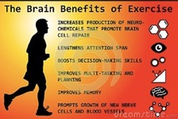

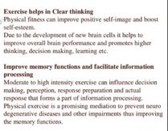

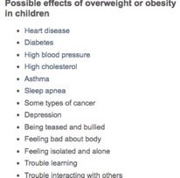





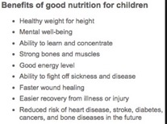

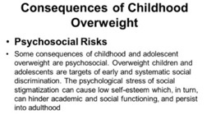

- What is resting metabolic rate or RMR?

The rate at which these processes occur is measured in calories per unit of time and is most often given in calories per day. the term Basel metabolic rate BMR is often confused and/or interchanged with RMR or resting energy expenditure REE.
Resting metabolic rate is the energy required by an animal to stay alive with no activity. Therefore, your real metabolic rate is always significantly higher than your RMR. Calculating RMR is very useful first step in calculating your real metabolic rate.
Your resting metabolic rate RMR is one of the main contributing components of energy expenditure around 70%.
Living in a cold environment can increase your RMR. I know this sound strange, but you expend more energy while moving around in cold weather its lot easier to move around in summer but more of an efferot to get in winter.

Small regular meal will increase your RMR.
Pregnancy it can increase your RMR.
Crash dieting it will decrease your RMR.
Supplements some supplement can raise your RMR.

Your resting metabolic rate will decrease as you lose muscle. Losing fat will not lower your RMR and note that you will need to fellow a very sensible program to lose fat without losing muscle.
You have probably heard that people who go on crash diet end up lowering the metabolic rate which means.
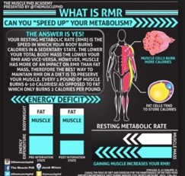

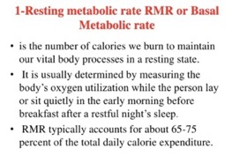
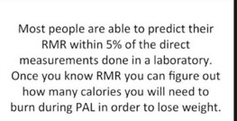

- What is thermal effect of food or TEF?

Thermic effect of food (TEF) or dietary included thermogenesis (DIT) is the amount of energy expenditure above the resting metabolic rate due to the cost of processing food for use and storage.
There is a direct correlation between meal size and the thermic effect of food. The more calories there are in a meal, the greater the thermic effect of food will be as a result of consuming that meal assuming that the relative proportions of protein fat and carbohydrate remain the same in each meal. Since the thermic effect of food is caused by digestion absorption and storage of consumed nutrients. If you consume more nutrient it follows that your body will need to expend more energy to process them.
TEF this defined as the calories your body uses or burns to digest and absorb the nutrients we eat.

Its somewhat reasonable to say that eating boost metabolic rate as energy is required to digest and absorb food but then people misinterpret this and assume that stimulating the TEF more often cause a proportionately increased metabolic rate. This is fundamentally incorrect. Assuming calories are equal, you will expend the same number of calories a day from the TEF regardless of your meal frequency.
The TEF is estimated to be around 10 percent of caloric intake in a mixed diet.
Its true that proteins require more calories to digest and absorb than carbohydrates and fats.

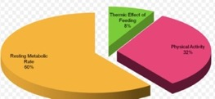

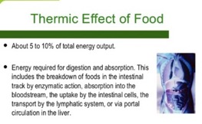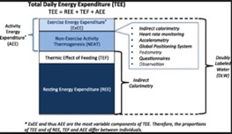
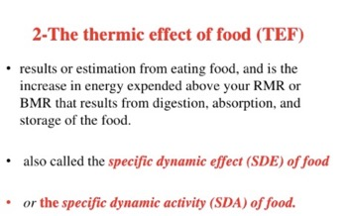
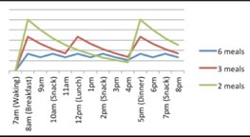

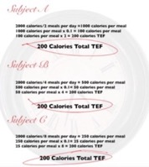

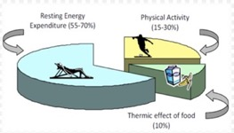

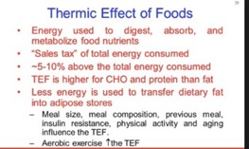

- What are the common cause of weight gain in individuals?

Cause obesity is the result of positive energy balance, which means energy intake from food and drink exceeds energy expenditure from physical activity and metabolism. There has been considerable debate about the relative contributions of diet and physical activity to obesity.
The view that physical inactivity plays a key role in the development and management of obesity has been held for long time. Both good nutrition and adequate physical activity should be promoted for prevention and management of obesity and for overall good health.
Obesity is an interaction between genetic and environment factors. Although some people are more genetically susceptible to weight gain than others. The increase in the prevalence of obesity in last two decades has occurred too quickly to be explained by genetic factors alone.

Weight gain is a common symptom of Cushing syndrome a condition in which you are exposed to too much of the stress hormone cortisol, which in turn causes weight gain and other abnormalities. You can get Cushing syndrome if you take steroids for asthma arthritis or lupus.

Depression cause obesity.

Weight gain cause:

- Genetics
Obesity has a strong genetic component. Offspring’s of obese parent are much more likely to become obese than offspring of lean parents.

- Food addiction
Addiction is a complex with a biological basis that can be very difficult to overcome.
These highly engineered junk foods cause powerful stimulation of the reward centers in our brains.

- Engineered Hyperlatable junk food
These foods are often more than refined ingredients mixed in with a bunch of chemicals.
Theses product are engineered to be cheap last long on the shelf and taste so incredibly good that we just can’t get enough.
By making foods hyperpalatable the food manufactures ensure that we eat a lot and decide to buy and eat them again and again.
Most processed foods are highly engineered products which massive budget spent on making the foods taste so good that we become hooked.

- Aggressive marketing towards children

The junk food companies are very aggressive marketers.
Children are becoming obese diabetic and addicted to junk foods way before they’re old enough to make conscious decision about these things.

- Insulin
Insulin is very important hormone that regulates energy storage among other things.
The function of insulin is to tell fat cell to store fat and hold on to the fat that they already carry.
To lower insulin is to cut back carbohydrates which usually leads to an automatic reduction in calorie intake and effortless weight loss.

- Certain medications

Like antidepressant antipsychotic diabetes medication.
These drugs don’t cause a willpower deficiency they alter the function of the body and brain making it selectively store fat instead of burning it.

- Leptin
Hormone that is crucial in obesity is leptin.
This hormone is produced by the fat cells and supposed to send signals to the hypothalamus the part of our brain that controls foods intake that we’re full and need to stop eating.
Obese people have lots of fat and lots of leptin. The problem is that leptin isn’t working as it should because for some reason the brain becomes resistant to it. This called leptin resistance and is believed to be leading factor in the pathogenesis of obesity.

- Sugar
Sugar is the signal worst part of the modern diet
The reason is that when consumed in excess sugar changes the hormones and biochemistry of the body contributing to weight gain.
Excess fructose consumption cause insulin resistance and elevated insulin levels. All of these contribute to energy storage and ultimately obesity.

- Age

As you get older you tend to lose muscle especially if you’re less active muscle loss can slow down the rate at which your body burns calories. If you don’t reduce your calories intake as you get older you may gain weight.

- Pregnancy
During pregnancy women gain weight to support their babies’ growth and development after giving birth some women find it hard to lose weight. This may lead to overweight or obesity.

11. Lack of sleep
Lack of sleep increase the risk of obesity. People who sleep fewer hours also seems to prefer foods that higher in calories and carbohydrates which can lead to overeating weight gain and obesity.
Sleep affects how your body reacts to insulin the hormone that controls your blood glucose sugar level. Lack of sleep result in higher than normal blood sugar level which may increase your risk for diabetes.

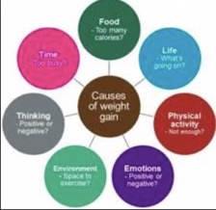

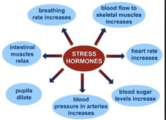

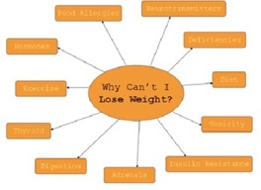

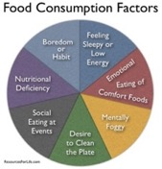

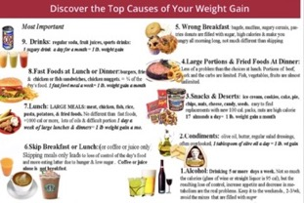

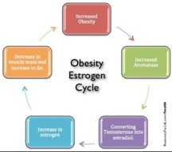

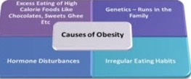

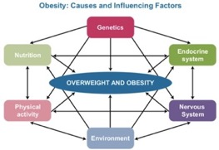

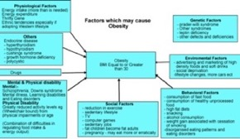

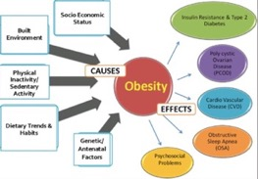

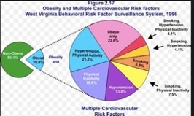

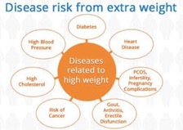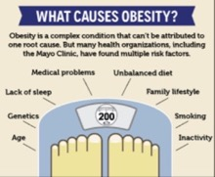

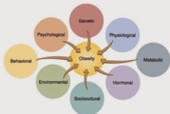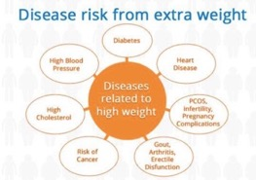

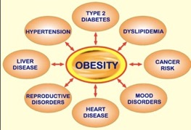

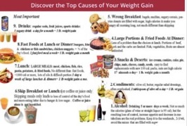

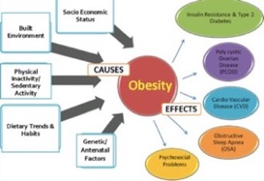

- What is metabolism? And how does our metabolism work?

Metabolism meaning in Greek metabole (change)Metabolism the main purpose of metabolism is the conversion of food/fuel to energy to run cellular processes, the conversion of food/fuel to building blocks for proteins, lips nucleic acids and some carbohydrates, and the elimination of nitrogenous wastes. The metabolism can also refer to the sum of all chemical reactions that occur in living organisms, including digestion and transport of substances into and between different cells, the cells is called intermediary metabolism or intermediate metabolism.
The chemical reactions of metabolism are organized into metabolic pathways in which one chemical is transformed through a series of steps into another chemical by a sequence of enzymes. Enzymes are crucial to metabolism because they allow organisms to driver desirable reactions that require energy that will not occur by themselves by coupling to spontaneous reactions that release energy.
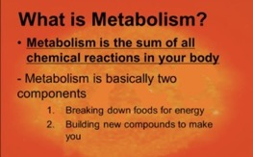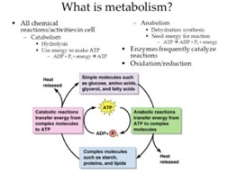

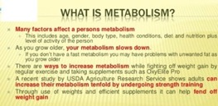

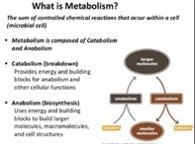

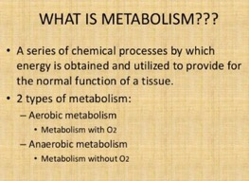

- What is waist circumference?

Waist circumference (WC) is an indicator of health risk associated with excess fat around waist. A waist circumference of 102 centimeters 40 inches or more in men or 88 centimeters 35 inches or more in women, is associated with health problems such as type 2 diabetes heart disease heart disease and high blood pressure.

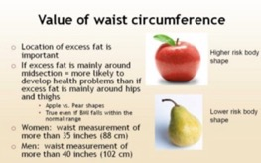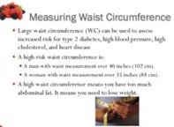
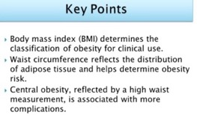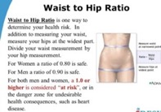

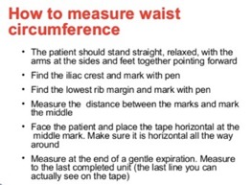

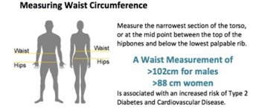
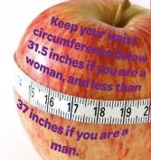

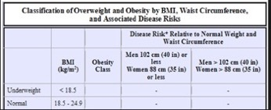
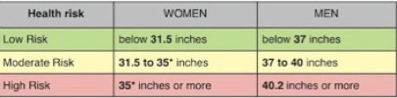

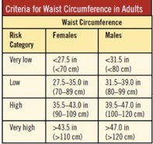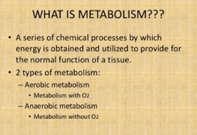

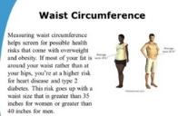

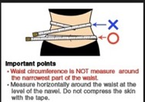

- Why is it important to balance physical activity (calories out) with food intake calories?

Regular physical activity is important for good health and its especially important if you’re trying to lose weight or to maintain a healthy weight.
When losing weight more physical activity increase the number of calories your body uses for energy or burns off the burning of calories through physical activity combined with reducing the number of calories you eat creates a calories deficit that results in weight loss.
Most weight loss occurs because of decreased caloric intake. The only way to maintain weight loss is to be engaged in regular physical activity.
Most importantly physical activity reduces risks of cardiovascular disease and diabetes beyond that produced by weight reduction alone.
Physical activity also helps to maintain weight, reduce high blood pressure, reduce risk for type2 diabetes, heart attack stroke and several forms of cancer, reduce arthritis pain and as associated and falls, reduce risk for osteoporosis and falls, reduce symptoms of depression and anxiety.

To maintain your weight, work your way up to 150 minutes of moderate-intensity aerobic activity 75 minutes of vigorous-intensity aerobic activity, or an equivalent mix of the two each week. Strong scientific evidence shows that do this not clear since it varies greatly from person to person. Its possible that you may need to do need to do more than the equivalent of 150 minutes of moderate-intensity activity a week to maintain your weight.
To lose weight and keep it off you will need high of physical activity unless you also adjust your diet and regular physical activity and a healthy eating plan.

Moderate: while performing the physical activity if your breathing and heart rate is noticeably faster but you can still carry on a conversation its probably moderately intense for example:
Walking, light snow, biking.

Vigorous: your heart rate is increased substantially and you are breathing too hard and fast to have a conversation it’s probably vigorously intense. Example:
Jogging/running, swimming laps, rollerblading/ skating, jumping rope.

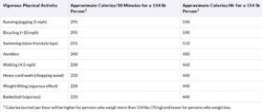

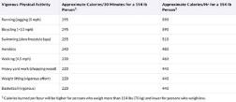

- Successful weight loss can only be achieved if a person wants to lose weight and is motivated to change eating habits. Discuss

To motivate yourself to lose weight motivate your diet and workout.
1 pace yourself
2 keep it fresh and fun
3 change the way you talk about your diet
4 count your calories/miles/steps
5 only limit, never eliminate food6 turn off the negativity
6 turn off the negatively
keep it short and sweet
get some sweet gear.
Start a motivate routine set a realistic goal saying I want lose 50 pounds in the next couple of weeks is just plain unrealistic. The weight did not go on that quickly, so it will not come off that quickly. If you set goals that you cannot possibly obtain, of course you will be discouraged.
1 consult a medical professional to determine what a sensible weekly or monthly goal should be. What is right for one person will be unhealthy for another. Depending on your starting weight, age activity level gender and so on.

2 consider getting a trainer-more on this later. When becoming more physical fit it helps to know what you are capable off and you simply may not know what is realistic and what is not. A good trainer help you to reach and develop a goal plan.

3 the slower the weight comes off the more likely it will stay off.

4 one pound is 3500 calories. Cutting 500 calories a day with no added exercise is a pound a week.

5 Find a weight loss partner. Find a partner lets you tap into power of teamwork. Having some to cheer you on be accountable to and work out with will keep you more likely to stay on back.

6 join a class exercise like horseback riding lesson or learning to ski or trying salsa lesson karate belly dance extra.

7 Start an exercise and food log this is where you’ll write down what you do every day, how many calories you’ve burned, how close you are to your goal and the food choices you’ve made. Get trainer any gym provides you with trainer.

8 don’t compare yourself to past versions of you comparing yourself at age 50 to teen version of you is unfair: teenagers typically have faster metabolisms and often have more free time to exercise.

9 toss out clothes that do not fit you some people make the mistake of trying to diet into a piece of clothing as goal. The old idea is that if you constantly feel tight and pinched and uncomfortable in your clothes, it will be a constant reminder to keep to the diet plan.

.

