
Assignment Cover Sheet

Student Name: | Husam Hasan Mahmoud Atmeh
Student Number: | 2466
Course: | Supply chain management/ Warehousing and  Material Handling
Assignment NO: | 10

Marking Criteria:
We expect the learners to write minimum one well expressed point in three lines against each allocated mark. This means one needs to write 15 lines with 5 well expressed points to get high grades for a 5 marks question.
For high grades use examples and illustrations where appropriate.
i. What are the aims and functions of warehouses?
In general, the objectives of a warehouse are to support the broader logistics function by giving a mixture of high shopper service and low costs.
More exact aims include:
• Providing necessary storage at key points in a supply chain;
• Giving secure storage of the type needed by materials;
• Keeping all materials in good condition and with minimal damage;
• Giving high customer service;
• Doing all necessary activities efficiently and with low costs;
• Getting high productivity and utilization of resources;
• Controlling all movements of materials effectively and without errors;
• Sorting materials arriving and quickly transferring them into storage;
• Picking materials departing, quickly transferring them out of storage and consolidating
deliveries;
• Being able to store the whole range of materials needed;
• Being flexible enough to deal efficiently with variations in stock levels;
• Allowing for special conditions and rotation of stock, etc.; and
• Giving safe working conditions and compliance with regulations.

ii. What is the difference between public and private warehouses?

Private warehouses are owned or leased by a business as part of its own supply chains. The business runs its own warehouses to sustain its major operations. This gives greater control over a middle part of logistics and allows incorporation of warehousing with the broader activities of logistics.
A public warehouse is run as a self-governing business, which makes money by charging users a fee. There are a lot of types of public warehouse, including bonded warehouses, cold stores, bulk storage, tankers, and various specialty stores. The facilities accessible are usually so flexible that an organization can obtain within reason, any facilities that it requires.
iii. Explain the advantages of public warehouses?

The main Advantage of public warehouses is their flexibility. Some other benefits include:
• Flexibility to deal with changing demand, possibly due to seasonality;
• Ability to supply skills and knowledge that the business does not have internally;
• Access to the newest equipment and practices;
• Avoiding big capital investment, giving higher return on investment;
• Easy access to a wider geographical regions;
• Allowing immediate tests of working in new areas;
• Use of economies of scale to lessen warehousing costs;
• Consolidating loads with other organizations to decrease transport costs;
• Certain high quality and well-organized service; and
• Flexibility to deal with varying conditions, removing risks from dated practices and technology

iv. What are manual warehouses?
This is most likely the (easiest planning to visualize), and is still one of the most frequent. Items are stored on shelves or in bins. People go around and choose items from the shelves, and put them into some kind of container for movement – like a supermarket trolley. Manual warehouses only work if the items are small and light enough to lift. Shelves must be low enough for them to achieve and close together to decrease the distance walked.
v. What are automated warehouses?

Traditional warehouses, including mechanized ones, tend to have elevated operating costs. These operating costs can be decreased as well as recovering aspects of service, by using mechanization.
Unfortunately, this requires a very high investment in apparatus, and is only actually worthwhile for extremely big stores that shift large amounts of materials.
Automated warehouses include the following components:
• Storage regions that can be accessed by mechanical equipment; these often make use of
narrow aisles up to, say, 40 M. tall to get an elevated density of materials and reduce the
distances moved.
• Equipment to shift materials around the warehouse; these are typically automated guided
vehicles (AGVs)
• Equipment to mechanically choose materials and place them into storage, including high speed stacker cranes that can arrive at any point in the thin aisles very fast.
• Equipment to move materials between the diverse types of equipment; these mechanical loaders and unloaders may include industrial robots.
• A warehouse administration system to record material locations, and manage all movements.

vi. What are the main materials used for packaging?

1-Glass is simple to clean, reuse and reprocess, but is easily broken, comparatively expensive and
hard to make;
2-Plastic is light, strong and simple to clean, but can be costly and hard to create or reuse;
3-Cardboard is light, inexpensive, and can be recycled, but has slight strength and poor
toughness;
4- Wood is strong, tough, easy to use and can be reused, but it is weighty, bulky and tricky to
clean; and
5-Metal is strong and tough, but it is weighty and can be costly.

2. Outline the activities that take place in a warehouse.

We can add a number of details and get the following list of activities that are usually included in ‘warehousing’.
• Receiving goods from upstream sellers;
• Identifying the goods, matching them to orders and finding their planned use;
• Unloading materials from delivery vehicles;
• Doing any essential checks on quantity, quality, and state;
• labeling materials (usually with bar codes) so they can be recognized;
• Sporting goods as essential;
• Moving goods to mass storage area;
• Holding them in stock until required;
• When required, moving materials from mass storage to a smaller picking store;
• Picking materials from this store to meet orders;
• Moving the materials to a marshalling area;
• Assembling materials into orders;
• Packing and packaging as necessary;
• loading delivery vehicles and dispatching the order; and
• controlling all communications and connected systems, such as, inventory control and finance.

Today, organizations try to shift materials fast through the supply chain, so their role has changed.
They are now taken more as staging points through which materials shift as fast as possible. As their role::::
in long-term storage has decreased, they have turn out to be suitable locations to do a variety of other jobs. They are, for instance, the finest place for sorting materials, packing, and consolidating deliveries.
A different type of consolidation happens when a manufacturer makes, or buys, parts of a finishing product in diverse locations. Then, it can organize for all components to be sent to a warehouse which unites the parts into the final product, and organizes delivery to customers.

3. Describe, in detail, the general layout of a warehouse. Using examples and illustrations.
One of the most significant decisions when operating a warehouse is its design. This describes the physical plan of storage racks, loading and unloading areas, offices, rooms, equipment, and all other facilities.
Layout decisions are imperative for three essential reasons:
(1) they need substantial investments of both money and effort,
(2) they involve long-standing commitments …
(3) They have important impact on the cost and competence of immediate operations.
This suggests that the necessary elements in a warehouse are an arrival bay or dock, where goods coming from suppliers are delivered, checked, and sorted -
• A storage area, where the goods are kept as stock;
• A departure bay, or dock, where customers’ orders are assembled and sent out;
• A material handling scheme, for moving goods around;
• An information system, which records the site of all goods, arrivals from suppliers, departures to consumers, and other applicable information.
The areas that should be planned are both the general storage areas and the areas for goods receipt, consignment picking and goods dispatch. It is also desirable that space should be set aside for the following activities:
- equipment maintenance and parking
- charging of equipment batteries such as pallet trucks
- refueling of trucks
- an area for garbage disposal e.g. empty packaging;
- a quarantine area for keeping rejected goods, goods to be sent back or destroyed
- an employee rest area
- washroom
- An It is worth keeping these requirements in mind during the planning of the main operating areas. Planning consideration needs to be given to the following:
- allocate space for each type of product and locating number;
- Allow sufficient space for easy access to the stacks for inspecting, loading and unloading. Stacks should be one meter from the walls and another meter between stacks;
- sizing the goods receipt and dispatch area;
- allow space for storage of cleaning materials and supplies;
- allocate areas for damaged items by consignment number;
- allow sufficient space to repackage damaged items and place it in separate stacks;
- Sufficient free space is needed to operate a warehouse effectively. When planning the size of a warehouse consider:
  - planning on having about 70-80% utilization of available space, whilst considering:
  - throughput rate
  - number of stock keeping units (SKU)
  - Handling characteristics of items, etc.
- administration office
Some relief items require special attention in terms of the type and security of the storage area. For example:
- Medical supplies and drug shipments can contain a large number of small, highly-valued and, often, restricted items, many with a limited shelf-life. Thus, a secure area is required, as well as judicious attention to expiry dates.
- Hazardous products such as fuels, compressed gases, insecticides, alcohol, ether and other flammable, toxic or corrosive substances must be stored separately, preferably in a cool, secure shed in the compound but outside the main warehouse.
- Antibiotics and vaccines may require temperature-controlled cold storage arrangements, with sufficient capacity and a reliable, as well as a back-up, power source.
- With combustible items, such as alcohol and ether, specific attention is required when storing and handling. Inventory management techniques need to be implemented to prevent wasteful surpluses and to ensure proper stock rotation to avoid costly losses due to expired goods. Procedures for controlling, preserving and releasing medical supplies and drugs should be established in consultation with the medical experts.

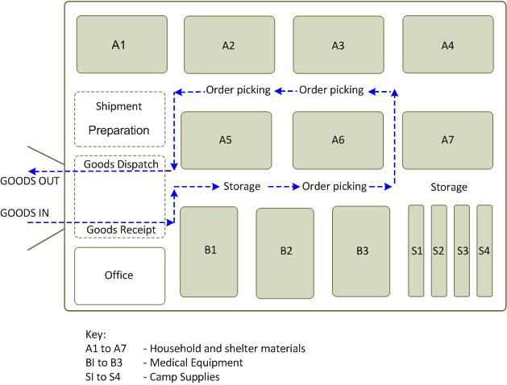

Student Statement:

By submitting this assignment, I confirm that this is my own work.

Student Signature | 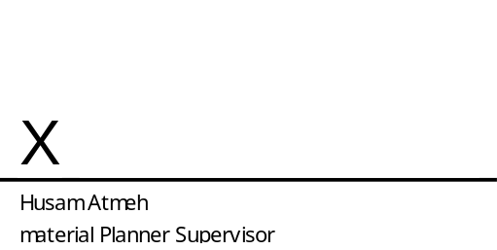 | Date: | ^{8TH} October 2016

For Tutor / Assessor Use Only
Total Marks
Marks Obtained
Percentage / Grade

