
3
Assignment Cover Sheet

Student Name: | Andrew Pettican
Student Number: | 5235
Course: | Supply Chain Management
Assignment NO: | 10 (Ten)

Marking Criteria:
We expect the learners to write minimum one well expressed point in three lines against each allocated mark. This means one needs to write 15 lines with 5 well expressed points to get high grades for a 5 marks question.
For high grades use examples and illustrations where appropriate.
Please insert your completed assignment (in word format) here:

1

- The objectives of a warehouse are to sustain the broader logistics functions by proving a mix of high shopper service and low costs. The more exact aims are:

- To provide storage at strategic points in a supply chain
- Provide security pertinent to the type of material being stored
- Keeps material in good condition and avoids damage
- Provides high customer service
- Carrying out activities efficiently and economically
- Obtaining high productivity and the best utilization of resources
- To control the movements of material effectively and error free
- To sort materials and transferring them to their correct positions
- Picking, packing and transferring them to the dispatch vehicles
- To provide storage for the whole range of products that need to be stored
- Provide flexibility to deal with fluctuations in stock levels
- To create conditions that can deal with stock rotation
- To provide safe and compliant working conditions

- Private warehouses are owned and leased by a business and forms part of its own supply chain e.g. Amazon and its warehouses throughout the country
Public warehouses are run as self governing businesses which charge customers for the use of storage e.g. port warehousing or bonded warehousing facilities, 3Pl warehousing

- The advantage of public warehouses is that they provide flexibility but there are other reasons such as:
- Providing skills and knowledge that a business may not have internally
- Access to the newest equipment and practices
- Avoids capital outlay providing a higher return on investment
- Easier access to wider geographical regions
- Allows immediate testing of working in new areas
- Provides economies of scale to reduce warehouse costs
- Can provide consolidation of transport loads to decrease transport costs
- High quality services and well organized operations
- The ability to deal with varying conditions and can remove risks from outdated practices and technologies

- Manual Warehouses are warehouses where products are stored in bins, or on shelves and the products are picked and packed into a form of container for onward movement (e.g. supermarket cages that arrive in Tesco’s). Products need to be small and light enough for a human to be able to lift

- Automated Warehouses are facilities that use mechanized handling etc. They are costly and require high capital investment and are only worthwhile for businesses with large stores and where there are large amounts of material to be stored

- The main materials used for packaging are

- Glass – e.g. ketchup
- Plastic – e.g. Washing up liquid or CHEP products used in the Automotive industry
- Cardboard – e.g. ready made pizza
- Wood – pallets or pallet sleeves that are placed around Euro Pallets
- Metal – e.g. CCU’s used in the Oil and Gas industry or cages used in the automotive industry

2.

The activities of a warehouse are seen as follows:

- Receiving goods
- Identifying the goods, linking them to the relevant orders
- The unloading of materials from vehicles that are arriving
- Quantity, quality control
- Labelling of materials
- Moving material to the designated storage areas
- Holding the materials until ready to be dispatched
- Moving materials from their storage area to a smaller picking area or store
- Picking and packing materials to meet incoming orders
- Moving materials to the dispatch area
- Assembling materials into the relevant orders
- Loading of delivery vehicles
- Controlling the communication and warehouse systems that in turn provide information about inventory levels and finance

3.

Warehouse design depend on the products that need to be stored but in most cases some form of racking or shelving is required. When looking at racking or shelving one needs to answer three different questions

- What type of racking or shelving
- What is the best layout for the racking
- Where should different items be stored on the racks

I will refer to a warehouse that I opened in France in 2004 for the GKN Group.

Peugeot had requested that finished product should no longer be stored on the manufacturing site due to the risk of fire, flood, disaster and Peugeot wanting or needing to maintain production in the event of fire or flood or disaster given the finished products were no longer being stored on site. The task therefore was to identify a facility that would accommodate the finished products. The option was private warehousing.

Firstly, we had to understand the quantities that needed to be stored, the various packaging types, the maximum dimensions of each type and the maximum weight of each packaging type. We discovered that the maximum pallets / containers that needed to be stored was 1100 bins / containers, and only 4 to 5 different packaging types but we were unable to know how many of each packaging at any one time. We therefore set about finding a facility that could accommodate racking for 1100 containers. We knew the maximum lengths, widths and weights and could therefore set about designing racking to accommodate 1100 or more containers / bins.

The challenges came however in that we were unable to agree contract length terms in line with the capex depreciation being 7 years on racking. We could have depreciated over 3 years but would have priced ourselves out of the market. We thought long and hard and decided it was not an opportunity to be missed. We therefore decided to change the size of the racking to accommodate the most common packaging types used in Europe meaning we would take the locations to 120 x 100 x 120 cm meaning that should the contract cease we could find other business for the warehouse.

The empty warehouse looked like this:

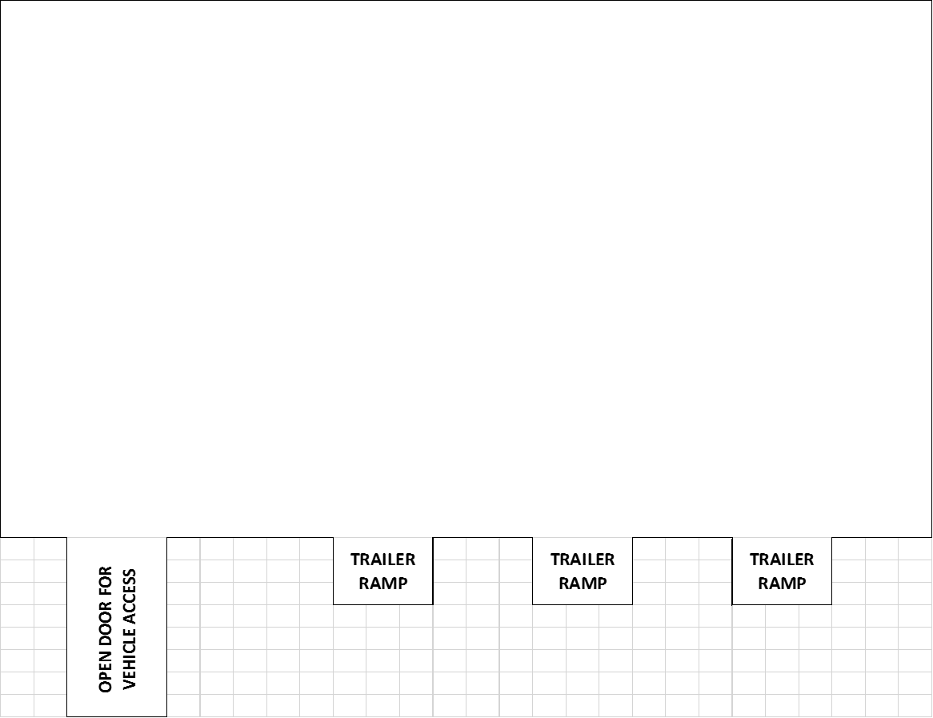

After much thought and planning and then the arrival of a further two projects for the warehouse which related to a cross docking facility and container consolidation operation we planned the warehouse as follows which thought about slow moving stock and fast moving stock and the need to reduce forklift routes and ensure that the fast movers were near the doors. We also took a warehouse or racking design that could accommodate peaks in production as we had an extra 300 racking spaces. Furthermore, we also had racking cage floors put on each racking space which meant that we could also store smaller items than the racking space and the racking supports which held the bins / containers / pallets in place. Yes the weight limit on the cage floors was lower than the racking supports but it gave us extra flexibility and the opportunity to look at the storage of other items.
The finished warehouse was as follows:

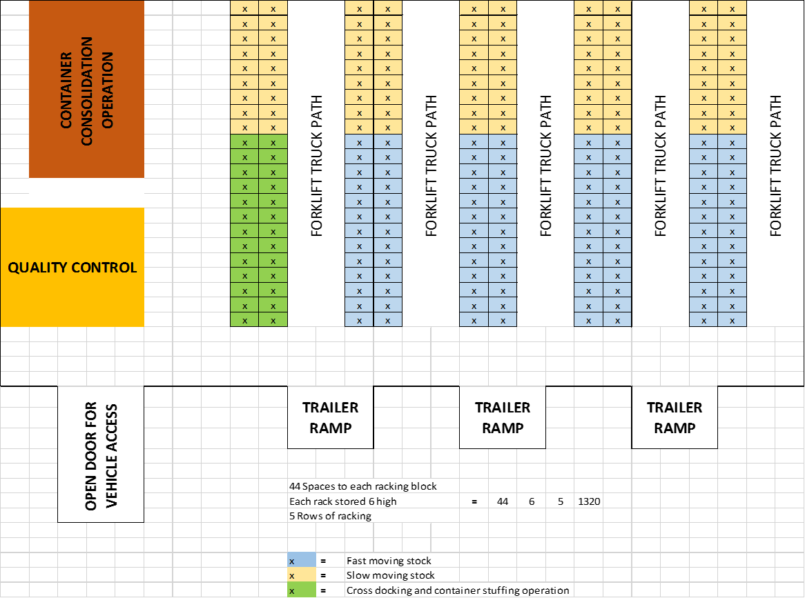

Student Statement:
By submitting this assignment, I confirm that this is my own work.

Student Signature | Andrew Pettican | Date | 1.3.2017
For Tutor / Assessor Use Only
Total Marks
Marks Obtained
Percentage / Grade

