
Assignment Cover Sheet

Student Name: | VIVEK CHERUKATTU PARAMESWARAN
Student Number: | 2427
Course: | Diploma in Logistics & Supply Chain Management
Assignment NO: | ASSESSMENT#10

Marking Criteria:
We expect the learners to write minimum one well expressed point in three lines against each allocated mark. This means one needs to write 15 lines with 5 well expressed points to get high grades for a 5 marks question.
For high grades use examples and illustrations where appropriate.
1(i.). The objectives of a warehouse are to sustain the broader logistics function by giving a mixture of high shopper service and low costs. The functions in a warehouse is receiving, storing and dispatching.

1(ii.). Private warehouses are owned or leased by a business as part of its own supply chains. The business runs its own warehouses to sustain its major operations. This gives greater control over a middle part of logistics and allows incorporation of warehousing with the broader activities of logistics.
A public warehouse is run as a self-governing business, which makes money by charging users a fee. There are a lot of types of public warehouse, including bonded warehouses, cold stores, bulk storage, tankers, and various specialty stores.

1(iii.). The main advantage of public warehouses is their flexibility.
• Flexibility to deal with changing demand, possibly due to seasonality;
• Ability to supply skills and knowledge that the business does not have internally;
• Access to the newest equipment and practices;
• Avoiding big capital investment, giving higher return on investment;
• Easy access to a wider geographical regions;
• Allowing immediate tests of working in new areas;
• Use of economies of scale to lessen warehousing costs;
• Consolidating loads with other organizations to decrease transport costs;
• Certain high quality and well-organized service; and
• Flexibility to deal with varying conditions, removing risks from dated practices and technology.

1(iv.). Manual warehouse is most likely the easiest planning to visualize, and is still one of the most frequent. Items are stored on shelves or in bins. People go around and choose items from the shelves, and put them into some kind of container for movement – like a supermarket trolley. Manual warehouses only work if the items are small and light enough to lift. Shelves must be low enough for them to achieve and close together to decrease the distance walked.

1(v.). Automated warehouses are traditional warehouses, including mechanized ones, tend to have elevated operating costs. These operating costs can be decreased as well as recovering aspects of service, by using mechanization.

1(vi.). Glass, Plastic, Cardboard, Wood and Metal

2. The basic activities in a warehouse are as follows;
• receiving goods from upstream sellers;
• identifying the goods, matching them to orders and finding their planned use;
• Unloading materials from delivery vehicles;
• doing any essential checks on quantity, quality, and state;
• labelling materials (usually with bar codes) so they can be recognized;
• Sporting goods as essential;
• Moving goods to mass storage area;
• holding them in stock until required;
• When required, moving materials from mass storage to a smaller picking store;
• picking materials from this store to meet orders;
• moving the materials to a marshalling area;
• Assembling materials into orders;
• packing and packaging as necessary;
• loading delivery vehicles and dispatching the order; and
• controlling all communications and connected systems, such as, inventory control and finance.

3. 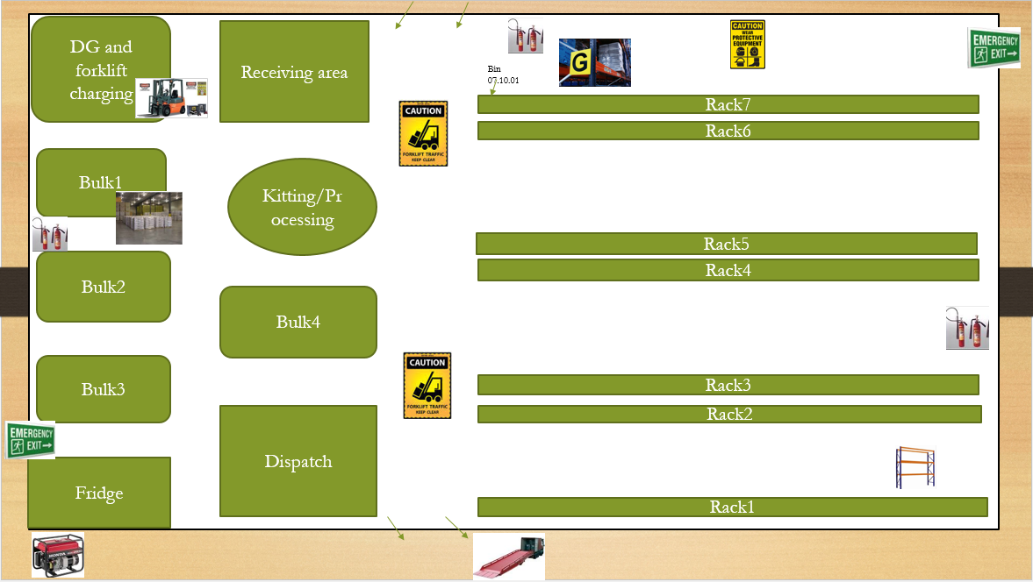

Student Statement:

By submitting this assignment, I confirm that this is my own work.

Student Signature | Vivek Parameswaran | Date | 01.12.2016

For Tutor / Assessor Use Only
Total Marks
Marks Obtained
Percentage / Grade

