
Assignment Cover Sheet

Student Name: | Marie Markey
Student Number: | 1387
Course: | Fashion & Design
Assignment NO: | The process & structure of fashion industry

Assessment 4 Total Marks: 30

1. Give short answers for the following questions: (16)

- What is meant by market segmentation?
Consumers wants & needs must be gauged via market research before any design concepts can be made. This market research is very segmented for a number of reasons. Most importantly income, social standing & occupation. These can segment the research greatly eg: consumers with a high income will no doubt purchase and have an opinion on various clothing needs for sport, social gatherings and general fashion wants. Whereby a consumer on a low income would maybe just be purchasing a uniform. The research can then be segmented further by customer loyalty, the customers intention to buy & whether they are influenced by advertising etc.

- “Design is a visual thinking, perhaps of a higher order than verbal thinking”.
Design is creative and initially ideas ‘appear’ as an end result first and are played around with. No thought is usually given to the construction/planning of the design – this comes after. Verbal thinking is well thought out and consistent and flows in an order. Design can be anything you want it to be, its unique, the whys and the wherefores to make the design true come after. Any creative/visual thinking including design could be classed as from an higher order, eg: music, poetry, philosophy as they sometimes just appear from an external source – maybe a higher order or universal consciousness. Some of the greatest musicians, inventors, artists didn’t even know themselves where the inspiration came from, it just ‘appeared’.

- Explain briefly the developing of a sample garment.
Firstly a sketch is made by the designer which is basic but must be concise enough so that a pattern can be made from it. The first pattern is made from the sketch which may be achieved by draping on a dress form with muslin or by the flat pattern method, it usually depends on the item that you are designing which works best & sometimes overall it is a combination of both. Once the pattern is made it can be laid onto the chosen fabric to make the sample garment which is then tested for fit, comfort, durability etc. by a real life model. Further alterations are made at this stage to achieve the desired result.

- What is a CAD system and how has it revolutionised the fashion industry?
Computer-aided design programs have taken a lot of the mundane, repetitive work away from designers. The silhouette is produced by the program for the designer to work on & in various sizes, so no need to continually sketch the silhouette, the designs can be saved and amended, the designers can work on amending a number of designs at once. CAD systems are used by designers & manufacturers alike so information is streamed easier. Ideas are there, stored and ready to view or amend in an instant. Some systems can make the patterns from the sketches. Some designers previously may have had some ideas that they couldn’t translate to a sketch but are much better able to with a CAD system.

Project – Market research

- Please refer to sketches below:

Dress 1 has the best fit as it is very sleek & figure flattering. It is an excellent cut, high quality and the fabric is extremely well suited to the style. It feels light yet weighed at the bottom and sways when you walk. It feels very luxurious. Compared to dress 2 which in my opinion is more innovative but dress 2 felt quite clumpy and awkward due to the beads and sequins. Because of the quality, fit and feel of dress 1 that, in my opinion is the best buy.

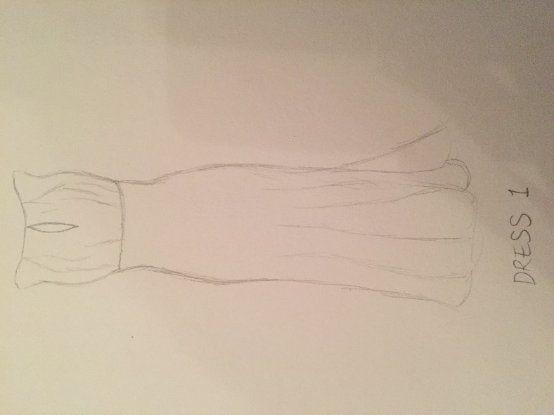

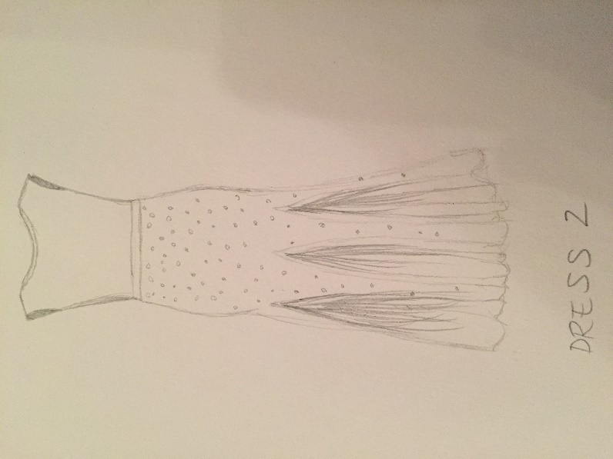

- The major manufacturers for the contemporary departments in Debenhams are: Red Herring, Dorothy Perkins, Principles, Début, Coast, Wallis.
The major manufacturers for the junior departments are: Blue Zoo, Converse, Pineapple, Regatta, Mantaray, Lands End.

The general styling differences between the contemporary departments and the junior departments is the variety of style itself, there is A LOT more different fashion styles in the contemporary departments than the junior departments. The contemporary focuses much more on fashion whereby the junior focuses much more on maybe bright colours, practicality and durability also ease of wear.

Student Statement:

By submitting this assignment, I confirm that this is my own work.

Student Signature | Marie Markey | Date | 08.01.17

For Tutor / Assessor Use Only
Total Marks
Marks Obtained
Percentage / Grade

