
Assignment Cover Sheet

Student Name: | .Asabi Beckles
Student Number: | 1217
Course: | Diploma in Event Management (Level 4)
Assignment NO: | 18

Assessment 18 Total Marks: 30

Each Question has equal Marks (15)
Q.1. Write a business plan for your business, which you have started with an investment of £30,000. Your company deals with the management of medium sized social events i.e. weddings, birthday parties etc.

The business plan must include;
a) Business name

b) Complete business description for your business

c) Description of the services you offer

d) Complete primary and secondary analysis of the industry, market trends, market
demands and competition.

e) Marketing plan including advertisement methods for your business

f) Details of your business legal requirements

g) Projected profit and loss forecast for the next 12 months.

 Royal Beacon Events

Business Plan
2015

Company Background

Royal Beacon Events (RBE) is a home grown hobby that blossomed into a business idea, through the recommendation of several clients, family members and friends. As an inventive individual with a background in costume design and creative arts, I always developed inspired spins to traditional events, though at time they could be very labour intensive.
.
As an independent company, RBE it is able to provide services to private clients wishing a professional touch to their special and important moments. Based in London’s Royal Borough of Greenwich, the company is a short distance from the city’s most famous landmarks – Cutty Sark, Greenwich Naval College, National Maritime Museum and of course the wonderful Thames River.

Catering to all budges, we focus on tailoring packages to suit our client’s needs from start to finish, ensuring a unique and personalised experience to for their:

- Wedding ceremonies
- Birthday celebrations
- Graduation parties
- Anniversaries
- Baby Showers, etc.

Our Medium and Long term goals are to:
- Develop linked online services
- Attain and sustain growth enough to expand to attain investor support – stock market trading
- Invest in the local community - educational/sports sponsorship
- Expand to 3 business locations within 10 years

We aim to expand the business for local corporate clients/schools by offering a range of services such as:
- Corporate Conferences
- Award Ceremonies and Banquets
- Team Bonding/Away Days
- Proms and Leavers Ceremonies

Market Trends, Demands and Competition

In 2014, the Events and Meetings industry generated £60 billion in the UK, this was an upward trend from previous years despite the effects of austerity. 2015 is expected to
demonstrate the same kind of increase in growth for the UK as well as across the world as can be seen in the table below:



One contributing factor towards this unprecedented increase is the development of ICT systems, especially the use of mobile phone applications, which has revolutionised the way companies interact with global clients. Jack Carter in his article State of the Industry 2015: Clients confused by event technology for Conference & Incentive Travel online magazine mentions “A fifth (20%) of the 87 event agencies surveyed said that they have also invested in mobile event apps in 2015 to meet this demand from clients, which is higher than any other area of technology, including registration systems (15%), delegate management software (15%) and digital media (5%).”

To determine whether technology was indeed worth investment and its potential effect clients selecting an event management service, a survey was conducted over a period of several weekends within 4 locations within the Royal Borough of Greenwich. Results received were separated into 2 groups - Residents and Visitors. Both groups identified technology as very useful when planning an event, indicating mobile applications that could identify local venues, provide comparable quotes and reputable event planners would be a swaying factor.

This confirms Lachezar Stamatov’s discoveries within his blog entitled 5 Innovative Trends for Event Planners Who Want to Stay in Business, as he illustrates applications are not just limited to websites but have also been developed to provide customers with interactive services such as virtual venue tours, web-castings for weddings, using social media as a distributor for guest lists, etc.

With over 600 registered conference and event management companies within the greater London area - 11 within the local Royal Borough of Greenwich area, not to mention small holdings providing services within their local community - competition within the financial district (Canary Wharf) and London’s city centre, a sound marketing within our immediate location is very high. To stay competitive with large global firms strategy is needed to maintain and increase Royal Beacon Events client levels.

Marketing Plan

Royal Beacon Events has a strategic marketing plan that focuses on providing a competitive service to clients by using the below sustainable model. Though initially costly due to set up/maintenance, using social media, online adverts, mobile applications as well as customer testimonials will be more beneficial than expensive television adverts.

- Business website

- Traditional advertising
  - Mail shots
  - Business cards and brochures
  - Radio
  - Local Press
  - Word of mouth

- Mobile Applications
  - Pinterest
  - Capsule
  - Appxy’s Planner – Event, Tasks & Notes

- Social Media
  - Facebook
  - YouTube
  - WhatsApp
  - Twitter

- Communication channels/platforms
  - FaceTime
  - Skype
  - Google Hangouts

Having a website stored on a cloud allows secure access to client information that is accessible via smart phone and laptop for work from any location. This enables the 2-way sharing of themes, inspirational images and useful details interactively via personalised client log-ins. Clients can watch their event progress by receiving immediate updates without the need for lengthy email chain messages, thus delivering a bespoke opulence and class only a vent planner can deliver.

The impact costs of supporting these platforms can be labour intensive but the benefits attained from real time customer testimonials guarantees new and repeat business, making the endeavour very rewarding.

The “Like”, “Share” and “Tweet” options on social media combined with the use of business cards encourage real and virtual word of mouth endorsement, which can be monitored, evaluated and compiled into worthwhile data for reinvestment purposes. While mobile applications provide an excellent real-time means of communication, advertising and promotion.

Using Survey Monkey will allow us to track our stakeholder satisfaction by exporting data and developing suggestions received in monthly reports, forming a benchmark comparable with customer expectations and current competition, which in itself can be turned into a means of enabling growth and expansion.

Business Legal Requirements

As Royal Beacon Events is structured as a Sole Trading business, the below must be met to satisfy legal business requirements:

- Company Name
As a sole trader is it beneficial to register your business’s trading name with Companies House. This ensures the company:
  - 1) Does not have the same/similar name as an existing enterprise and
  - 2) Is recorded as actively trading and can be contacted if necessary

- HM Revenue and Customs
  - 1) Income Tax - paid on all profits
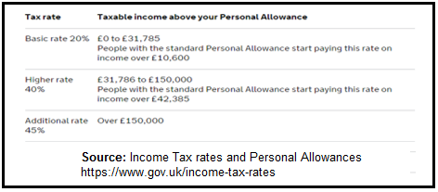

  - 2) National Insurance self-employed contributions – Class 2 and Class 4 are paid per month/year via an annual Self-Assessment form


  - 3) VAT - if the business’s taxable turnover reaches the £82K threshold. As Royal Beacon Events provides a service, its VAT tax rate would be the standard 20% on all sales.
All registrations can be done online ensuring payments are accurate and up to date.

- Business Rates – a property tax charged on the occupation of non-residential properties by local councils to provide local services. As Royal Beacon Events is a small home-based venture it is not subjected business rates. However, full to this taxation but received a small business rate relief of

- Documentation – All stationery must have the business’s name as well as the sole trader’s personal name by law; with a full record of all sales, expenses, debts and credits must be kept for a minimum of 7 financial years in the event of HMRC investigation or audits.
12 Month Profit and Loss Forecast

The forecast below is based Royal Beacon Event’s future earnings projection for the coming year. It is composed of the £30K start-up capital, Total Sales and Expenses to determine whether a Profit or a Loss will be made.
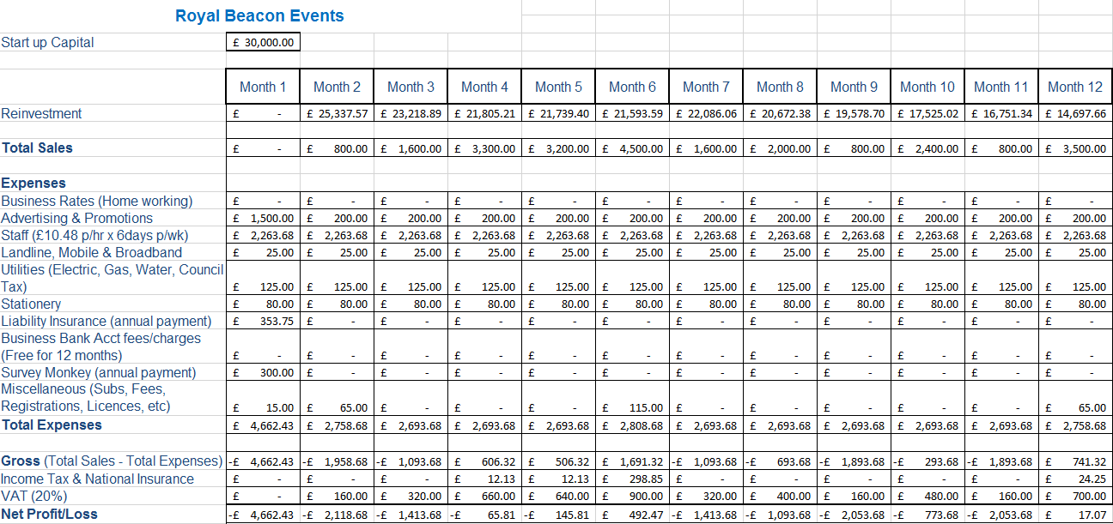

Though the forecast reads unfavourably, it conveys a strong potential for good earnings within this venture - a major factor being potential earnings lost due to insufficient staffing. As the sole employee, taking on too events could lead to clients receiving a poor quality service. However, it is clear to see business is booming as the weddings season (April – Aug) progresses, demonstrating that there is a need to hire additional staff during this period. This in turn would mean the adjustment of prices during the busier times to make allowances for the VAT and Tax spike. Some things of note include savings made due to working from home - Business Rates, utilities, and Free Business banking with Barclays for 12 months.

Bibliography

- The Events Industry Forum & The Business Visits and Events Partnership (Oct 2011), Opportunities for Growth in the UK Events Industry,

- CTW Meetings and Events (Nov 2014), 2015 Meetings and Events Forecast, GBTA Foundation

- GBTA Foundation & Carlson Wagonlit Travel (2015), 2015 Global Travel Price Outlook - Prospects for Global Air, Hotel, Rental Car, and Meetings & Events prices

- Social Atlas for London Project (SALP) (30/3/15), Household Wealth Analysis 1980-2010, Royal Borough of Greenwich

- Kamer von Koophandel (3/12/13), Starting your own business as a self-employed entrepreneur

- Food Standards Agency (21/1/03), Starting up Your first steps to running a catering business

- Pure Michigan – Michigan Economic Development Corporation (20/1/14), Guide to Starting and Operating a Small Business, Small Business Development Centre

- http://www.eventindustrynews.co.uk/features/guest-blogs/innovative-trends-event-planners-want-stay-business/
Adam Parry (2014), 5 Innovative Trends for Event Planners Who Want to Stay in Business, Event Industry News Blog accessed: 13/6/15

- http://www.citmagazine.com/article/1352227/state-industry-2015-clients-confused-event-technology?HAYILC=TOPIC
Jack Carter (19 June 2015), State of the Industry 2015: Clients confused by event
Technology Accessed 21/6/2015

- http://www.citmagazine.com/article/1352062/uk-meetings-industry-worth-216bn
Lauren Houghton (18 June 2015), UK meetings industry 'worth £21.6bn, C&IT (conference & incentive travel) magazine accessed: 21/6/15

- http://www.citmagazine.com/article/1190234/uk-events-industry-worth-60bn-reveals-mpi-study
Tom Hall and Alison Ledger (10 July 2013), UK events industry worth £60bn, reveals MPI study accessed: 21/6/15

- http://blog.planningpod.com/2014/11/12/5-revealing-facts-from-2014-state-of-the-event-industry-study/
Jeff Kear (12 November 2013), 5 Revealing Facts From the 2014 State of the Event Industry accessed: 21/6/15

- http://www.prnewswire.com/news-releases/event-management-software-market-worth-778-billion-by-2019-278227041.html
PRNewswire (6 October 2014), Event Management Software Market Worth $7.78 Billion by 2019 accessed: 21/6/15
- marketsandmarkets.com (September 2014), Event Management Software Market by Component, Software, Service, Deployment Mode (On-Premise, Cloud), Organization size, Verticals (Education, corporate, Third-Party Planners, Government, & others), and Region - Global Forecast to 2020, http://www.marketsandmarkets.com/Market-Reports/event-management-software-market-136859992.html accessed: 21/6/15

- http://www.forbes.com/sites/allbusiness/2015/05/02/9-great-apps-for-event-planners-and-wedding-planners/
Melanie Haselmayr (2 May 2013), 9 Great Apps For Event Planners And Wedding Planners accessed: 25/6/15

- http://issuu.com/simonaharizanova/docs/eventex-catalog-print/1

- http://www.royalgreenwich.gov.uk/info/100002/business

- http://www.royalgreenwich.gov.uk/info/200013/business_support_and_advice/78/business_events_in_greenwich

- http://www.royalgreenwich.gov.uk/info/200012/business_rates/609/how_much_are_business_rates

- http://www.royalgreenwich.gov.uk/info/200012/business_rates/628/small_business_rate_relief

- http://propertysearch.evolutive.co.uk/cgi-bin/db2www.exe/GreenwichDetails.d2w/input

- https://www.gov.uk/self-employed-national-insurance-rates

- https://www.gov.uk/income-tax-rates

- https://www.gov.uk/self-assessment-ready-reckoner

- https://www.gov.uk/set-up-sole-trader/overview

- https://www.gov.uk/business-legal-structures

- https://www.gov.uk/introduction-to-business-rates

- https://www.gov.uk/introduction-to-business-rates/working-at-home

- http://www.2010.voa.gov.uk/rli/en/basic/find/valuation/2010/15190738000/15364751000

- https://www.gov.uk/business-support-helpline

Q.2. (15)
a) Prepare an event management plan for a sports event being held at the stadium. Some 20,000 people are expected to attend.

World’s Strongest Couple Championships

Event Management Plan (Abridged)

The World’s Strongest Couple competition is a concept borne from the successes of its sister enterprises World’s Strongest Man and World’s Strongest Woman competitions.
This event will be composed of six exhausting trials, which see couples from around the world push themselves through the ultimate test of relationship strength, team work and endurance. These elimination rounds will take place across London’s famous landmarks, culminating at London’s Charlton Athletic Football Club a stone’s throw from the famous O2 arena.

Competitors must complete the five rounds below to reveal the champion couple:
- Vehicle Deadlifts – series of vehicles of varying weights from 800 – 3000 Kgs to be lifted in succession within 60 seconds.
- Truck Pull Maze – 3 mins to get to the other side of a 30 metre maze moving 3 Ford Rangers
- Obstacle Throws – barrels, medicine balls, atlas stones, etc in a variety of widths and weights thrown up to 30 metres.
- Salt Cart Volley – this is a case of how many reps can be completed in 90 seconds when the weight gets significantly heavier.
- Weighted Sprint – 2 bags filled with 200 litres of porridge must be carried in a circuit relay style a total of 4 x 50metres.

In addition to the exhilarating feats of human agility, there will be performances for all ages, including exciting magic acts and comedy sketches.
Stadium’s car park will house stalls providing refreshments from local eateries/breweries ranging from Meantime Ale to Asian, Nepalese and Caribbean cuisine as well as the well-loved Burgers, Hotdogs, Pie and Mash, Fish and Chips.
Spectators are invited visit our Sponsored booths to learn more about the Royal Greenwich area and its attractions (National Maritime Museum), how the competing athletes maintain their fitness (Fitness Plus) and Nutrition (Healthy Sports Foods), as well as the importance of maintaining hydration (Buxton Water/Monster Energy Company).

Event Schedule
Date: Saturday 25th June 2016
Stadium Venue: Charlton Athletic Football Club, The Valley, Floyd Road, London, SE7 8BL
Opening Ceremony: 10:00 Closing Ceremony: 18:30
Performance Times: 10:30, 12:30, 13:45, 14:30, 17:00, 17:40
Championship Rounds: 11:00, 12:00, 13:00, 14:00, 15:00, 16:00

The Plan

Audience Profile
The World’s Strongest Couple Competition is aimed at attendees of all ages. We expect the majority of spectators to come from or have a keen interest in Fitness, Body conditioning/building, Strongman & Strongwoman, Extreme Training and Athletics.
Aiming at attract 20,000 spectators, trends have shown majority of spectators at these types of events tend to be male. With this knowledge, we will strive to focus on increasing the numbers of female and under 15s spectators by 5% and 3% respectively.
To achieve this, a strategy of discounted tickets for families, women and children has been designed to work in tandem with promotion via our sponsors Ford Motor Company (UK), Buxton Water, Monster Energy Company, Stobar Group Ltd and the Healthy Sports Foods UK.

Financial & Marketing Forecasting
Strategic long term objectives:
- Branding
- Increase world recognition of our Strongest Couple name as a part of the World Strongest Man/Woman brand by 15% by 2018 through investment in community project in underprivileged countries and neighborhoods.
- Increase public knowledge of the female aspect of the sport via pop up demonstrations across the city of London, culminating in the championships at Charlton Athletic Football Ground.
- Sponsorships – increase sponsorships and promotional activities by working with developing small businesses and the Prince's Trust (UK), pharmaceutical companies using traditional medicine and organic produce.
- Local/Regional Talent – encourage the uptake of fitness and sports with local schools and colleges and the benefits it can contribute to learning process.
- Stall holder fees
- Ticket prices

Operational short term objectives:
- Increase Profits by 3% by hosting web/radio/social media competitions.
- Increase visitor spending by 5% through ticketing various entertainment acts, merchandising and bookable time with coaches and fitness trainers.
- Increase number of Female and Children spectators via family promotions and ⅓ off tickets for women and ½ price tickets for kids under 12.

The marketing and promotional strategies to achieve each target market objective emphasised the need for advertisement, which will be costly in some areas and so the cost of tickets must be sufficient, in addition to the funding/sponsorship budget to cover the cost of the event and raising a profit. The areas of focus will be:

- TV – national/international channels: specifically the sports/adventure-related - i.e. Dave, Quest, TruTV, Sky Sports, ESPN, etc.
- Radio: national/regional entertainment and sports stations (digital and analogue) - i.e. Heat Radio, Capital FM, LBC, Talk Sport, Kiss, etc.
- Print: national/regional/international press i.e. magazines, newspapers - Metro/Evening standard, South London Press, Closer, FHM, Daily Express, etc.
- Social Media: i.e. Twitter, Instagram, Facebook, YouTube and Podcasts.
- Web presents: company website and those of our sponsors

Health & Safety Plan

One of the benefits of hosting the World’s Strongest Couple’s competition in a stadium such as Charlton Athletic Football Club is the reduction of time spent filling forms to acquire permits and licences as some of the required certificates are already in place while others need amending temporarily. While utilising stadium’s Safety Advisory Group (SAG) provides access to established contacts within the local emergency services and council.
This enables set milestones to be factored in when planning the event as seen below:

Permits/Licenses Checklist
Permit  /  License Type | Application Required (Y/N) | Reasons | Milestone
Sports Ground Safety Certificate | Y | Amendment to current cert | 3 months prior to event
Special Safety Certificate | N | Covered in Sports Ground cert | N/A
Temporary event notice | N | Covered in Sports Ground cert | N/A
Food hygiene certificate | N | To be In place by stallholders | 28 days before event

A Sports Ground Safety Certificate in place grants permission for music concerts and other events to be held at the sports ground (Annex 3). In our case the certificate will need to be reviewed and finalised during the scheduled meetings (27/1/16, 9/2/16, 18/2/16, 3/3/16, 16/3/16) and the amendment of the below sections submitted to the Royal Borough of Greenwich council.

- Dynamic Loading Assessment
- Operational plans
- Safety, fire and medical risk assessments – incorporating the use of heavy machinery/equipment/vehicles by competitors and trained staff, etc
- Capacity calculations – i.e. estimations of 20,000 of the 27,111 total capacity
- Register of Incidents/Accidents and Subsequent Actions
- Written evacuation and emergency process
- Appropriate staffing numbers – i.e. specifically stewards and catering volunteers
- Proposed erection of temporary structures - i.e. stage areas, competition fencing, stalls/booths, etc.

Once in place the appropriate insurance policies need to be attained, especially assets protection (property and equipment), public liability and indemnity. These will provide coverage in the event of accident/incidents to competitors, equipment or staff. As we are using the stadium, they will also have insurance coverage in place.

Waste Management
Most of the necessary waste disposal facilities will be within the stadium itself, such as toilets, hand washing facilities and provision for the disposal of feminine hygiene products and medical waste.

Food stall will be composed of self-contained water facilities to enable the washing of food, hands and cooking equipment. Provision of 10 portable toilets to be delivered the day before the event and located in car park a suitable distance away has been arranged, to prevent catering staff from using the same restrooms as the public.

Separate food and recyclable waste receptacles will be placed around the stall area and at the entrance of the stadium, these will be checked/emptied on a 10-minute intervals prior to the start of the event. The accumulated waste will be placed in the industrial sized disposal bins to be collected the following day. Waste collection crew will be given waterproof jackets, fluorescent vests, gloves and pickers and will be asked to wear their own metal toe shoes/boots to the event.

All drinks will be served in plastic bottles/cups to prevent misuse as missiles or harmful weapons. First Aid trained staff will be present on and off the pitch area and located within the stalls and parking areas, with a dedicated team of emergency services on hand in the event of emergencies.

Staffing
Recruitment of staff is key to the delivery of the event. The sister company Strongman and Strongwoman competitions have secured an event recruitment company that delivers highly skilled and recommended volunteers and paid staff. Staff will be placed in the following groupings:

- Stewards
- Waste Collection
- First Aid
- Information Centre
- Disability/Mobility Assistance
- Team Leaders
- Sponsor Care Team
- VIP assistance
- Pitch side support
- Bar/waiting staff

Staff will receive the event Health & Safety handbook and on-site training the day prior to the event. It will ensure they are able to safely handle all necessary machinery, familiar with their zonal positioning on the site plan and are up-to-date on evacuation/fire and emergency procedures. They will also be made aware of their closest fire exit whether pitch-side or within the stands. Team leaders will receive a copy of the event contacts list (see below) attached to their guidance pack, high vis jackets/vests and 2-way radios.

Event Contacts (excerpt from Team Leader Pack)

Sponsors
Ford Motor Company Limited (UK) Fitness Plus
Marilyn Smith Jerri Field
Telephone: 02088 763 224 Telephone: 02322 500 566
Mobile: 07743 589 114 Mobile: 07931 422 107
Email: Marilyn.Smith@ford.co.uk Email: JerriField@FitnessPlus.com

Healthy Sports Foods Buxton Water
Fred Thompson Joe Johns
Telephone: 02088 763 224 Telephone: 01778 225 566
Mobile: 07931 228 301 Mobile: 07942 233 770
Email: Fred.Thompson@healthyfood.uk Email: JoeJohns@Buxtonwater.co.uk

Monster Energy Company Britain Merchandising
Carol Lewis Richard Cook
Telephone: 02086 312 027 Telephone: 02068 015 631
Mobile: 07700 188 111 Mobile: 07733 654 123
Email: Carol.Lewis@monsteruk.com Email: RichCook@merchandising.co.uk

Stobart Group Ltd Flash Photography
Toby Hilltop Zoey LeBrouche
Telephone: 02086 312 027 Telephone: 02082 888 789
Mobile: 07700 188 111 Mobile: 07772 559 335
Email: TobyHilltop@stobarttrucks.uk Email: ZLeBrouche@flash.co.uk

Venue Liaisons
Facilities Manager/SAG member Health & Safety Manager/SAG member
Alexa Manne Jim Harvey
Telephone: 020 8333 4000 (ext: 228) Telephone: 020 8333 4000 (ext: 468)
Mobile: 07337 119 054 Mobile: 0733 7119 441
Email: Alexa.Manne@thevalley.co.uk Email: Jim.Harvey@thevalley.co.uk

Stall Holders
Conference Foods UK Limited Asian Express Catering
Kimber Whelan Asha Kaur
Telephone: 02088 763 224 Telephone: 01778 225 566
Mobile: 07452 231 402 Mobile: 07854 220 005
Email: KimberWhelan@conferencing.uk Email: Asha.Kaur@asiancatering.co.uk

Meantime Brewery Crown Athletic Troupe
Melody Sharpe Janett Minor
Telephone: 02088 620 834 Telephone: 02088 263 117
Mobile: 07823 553 621 Mobile: 07900 229 312
Email: KimberWhelan@conferencing.uk Email: JanettMinor@crowntroupe.com

Greenwich and Lewisham Young People’s Theatre
Kevon Rose
Telephone: 02088 263 117
Mobile: 07900 229 312
Email: KevRose@GandLtheatre.co.uk

National Maritime Museum British Heart Foundation
Henry Forde Junior Reed
Telephone: 01721 886347 Telephone: 04810 228 741
Mobile: 07719 238 110 Mobile: 07663 874 113
Email: HenryForde@nmm.ac.uk Email: JuniorR@BHF.co.uk

Entertainment Providers
Stars Productions Fusion Sounds & Productions
-Rachael Janes Jessica Monroe
Telephone: 02086 312 027 Telephone: 02068 015 631
Mobile: 07700 188 111 Mobile: 07733 654 123
Email: RachaelJanes@stars.uk Email: JMonroe@fusionsounds.co.uk

Side Show Classics
Bobby Jones
Telephone: 01155 442 443
Mobile: 07743 602 206
Email: Bobby@eshowclassics.com

Stage/Equipment provider Insurance Providers
Stage Nation Ltd UK Corporate Insurance
Jim Jane Janet Donham
Telephone: 02478 620 001 Telephone: 02068 015 631
Mobile: 07781 110 005 Mobile: 07733 654 123
Email: JJ@stagenation.co.uk Email: Janet.Donham@VL.com

Events Team Members
Customer Relations Manager Project Coordinator
Jonathan Holmes Anna-Lee James
Telephone: 01322 687 611 Telephone: 01322 687 224
Mobile: 07664 224 131 Mobile: 07542 248 671
Email: JonathanH@heroes.co.uk Email: Anna-LeeJ@heroes.co.uk

Sponsorship Officer Contracts Manager
Jobi Olamede Ivana Kiestrel
Telephone: 01322 687 590 Telephone: 01322 687 705
Mobile: 07469 848 001 Mobile: 07771 449 800
Email: JobiO@heroes.co.uk Email: IvanaK@heroes.co.uk

Support Staff
Kayleigh Monrow Jenny Louis
Telephone: 01322 687 224 Telephone: 01322 557 880
Mobile: 07469 848 001 Mobile: 07469 848 001
Email: KayleighM@heroes.co.uk Email: JennyL@heroes.co.uk

Safety Advisory Committee Contacts
Police Fire
Naomi Cooke Jacqueline Williams
Telephone: 02086 312 027 Telephone: 02068 015 631
Email: naomi.cooke@greeneich.pnn.uk Email: jacq.williams@green.fire.gov.uk

London Ambulance Service Royal Borough of Greenwich
Duty Event Coordinator Safety Officer
Lance Spooner Sheena Phillips
Telephone: 02086 312 027 Telephone: 02068 015 631
Email: LanceSpooner@stjohns.ambulance Email: Sheena.Phillips@greenwich.gov

Transport Plan

There are several different ways to get to the Charlton Athletic Football Stadium, though using public transport is highlight recommended due to the magnitude of spectators expected.

By Car
- Via the M25 exit from Junction 2 onto the A2
- Via the South Circular follow the A205 South Circular Road to Woolwich
- From central London, from north of The Thames, take the A102 through the Blackwall Tunnel.

Many roads around The Valley there are restrictions in force. Yellow lines apply at weekends and most parking bays are free - except around the railway station. Restrictions are vigorously enforced, and local retail car parks operate a clamping policy.

Charlton Athletic Stadium has heavily restricted parking on the grounds with the exception of designated disabled parking, which will be reduced to incorporate the sponsorship/food stalls. However, access to this reduced mobility parking area is available on a first come basis and must been booked the same time as ticket purchase.
Those unable to secure parking are invited to use the established drop-off and pick-up points located at:

- West Stand: Opposite club Superstore
- North Stand: Exit Gate 1 (Harvey Gardens)
- Family Section: Exit Gate 2 (Harvey Gardens)
- East Stand: Charlton Lane (adjacent to Lansdowne Mews)
- Jimmy Seed Stand: Entrance no. 4 (Valley Grove)

Passenger drop-off should be no later than 9:30am to allow for escort to seating. Accompanying drivers/carers are invited to park away from the ground and make their way back to the stadium.

Train and Tube
Charlton railway station is a short walk from the ground and can be accessed via:
- Southeastern train - from Central London via Charing Cross, Cannon Street, Blackheath, Lewisham, Waterloo East and London Bridge. Travelling west from Kent via Dartford
- Docklands Light Railway - from Stratford, Bank and Tower Gateway via Greenwich to connect to Charlton
- Underground – Jubilee Line to North Greenwich is a short bus ride from The Valley.

Bus
Many bus services will discharge passengers on the A206 Woolwich Road, or in Charlton Village, both a five-minute walk from the ground:
- 53 - Plumstead, Woolwich, Blackheath, New Cross, central London
- 54 - Lewisham, Catford, Beckenham, Elmers End) and the 161 (Chislehurst, Mottingham, Eltham, Woolwich, North Greenwich
- 177 - Thamesmead, Plumstead, Woolwich, Greenwich, New Cross, Peckham
- 180 - Thamesmead, Plumstead, Woolwich, Greenwich, Lewisham
- 422 - Bexleyheath, Welling, Plumstead, Blackheath, North Greenwich
- 472 - Thamesmead, Plumstead, Woolwich, North Greenwich
- 486 - Bexleyheath, Welling, Shooters Hill and North Greenwich

Conclusion/Evaluation

In order to determine whether the World’s Strongest Couple has been a success, the below measures will be utilised.

- Comparison between financial forecast and actual profit/loss sheets to determine whether we have met/exceeded the required 5% growth
- Public/Spectator reaction results
- Sponsor feedback data
- Industry reaction – have we made our brand visible
- Increase spectator numbers focusing on female and children under 15 numbers

Methods for measuring performance indicators will be based on qualitative research gathered from the following to ensure mistakes made are not repeated in the coming years:

- Financial accounts comparing sales figures, ticket sales, funding and total expenditure
- Ticket Sales demonstrating gender distribution
- Surveys sent to participating sponsors, business, spectators, stall holders, etc
- Social Media responses and pre/post event trends on Twitter, Instagram and Facebook.
- Post Event Meetings held with the venue, SAG and Sponsors

After analysing these datasets and receiving comprehensive breakdowns of successes and failure an informed decision can be made on whether it is viable to host this event as an individual concept, a bi-annual series or as a combined venture within the sister competitions.

Bibliography

Charlton Athletic Football Club Information
- http://www.cafc.co.uk/commercial/pitch_hire/

- http://www.royalgreenwich.gov.uk/info/842/licence_-_sports_grounds/1409/safety_in_sports_grounds

- 2013 signed, Charlton Athletic Football Club safety certificate

- http://www.royalgreenwich.gov.uk/downloads/download/538/sports_grounds_safety_documents

- http://www.cafc.co.uk/documents/valley-stadium-plan83-219023.pdf

- http://www.cafc.co.uk/club/the_valley/index.aspx#gqMStXudjDlzXFQY.99

- 2016/17 VIP MATCHDAY HOSPITALITY brochure

Additional Research
- https://en.wikipedia.org/wiki/List_of_radio_stations_in_the_United_Kingdom

- http://cars.lovetoknow.com/List_of_Car_Weights

- http://www.ford.co.uk/

- https://www.monsterenergy.com/gb/en

- http://www.royalgreenwich.gov.uk/info/860/licence_-_alcohol_and_entertainment/716/apply_for_a_temporary_event_notice

- http://www.royalgreenwich.gov.uk/site/scripts/directory_search.php?directoryID=53&keywords=&categoryID=-1&postcode=SE18+7BB&search=Search

- http://www.charltonevents.com/exhibitions/

- http://www.charltonevents.com/facilities/

- Je’Anna Lana Abbott & Morgan W. Geddie [2001], (Event Management, Vol. 6, pp. 259–270), Event and Venue Management: Minimizing Liability Through Effective Crowd Management Techniques, Cognizant Comm. Corp.

- Maroondah City Council, (Aug) 2013, Event Planning and Procedure Handbook

Event Management course materials
- Module 14 – Waste Management and Noise Control
- Transport Management
- Event Management Plan

b) Produce a site design showing temporary site entrances and exits, parking, food stalls (adjutant to the stadium), information centre, first aid posts and toilets for the above event.

The below designs are illustrations submitted to the Royal Borough of Greenwich with Annex 5 for the amendment of Charlton Athletic Football Club safety certificate and the various Insurance companies when applying for policies.
The designs show both external and pitch-side views of the stadium and the location of:

- Food/merchandising/sponsors stalls
- Dedicated parking allocation
- Fire/Emergency evacuation exits
- Temporary structures
- First Aid points
- Seating areas (Ticketed allocation & disabled access areas)

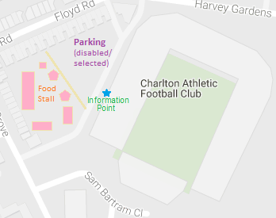
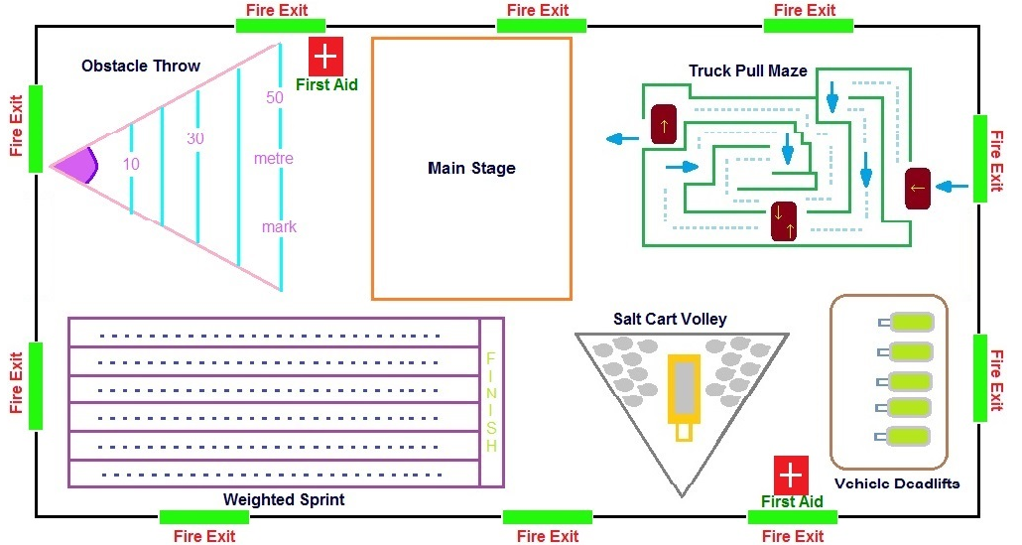

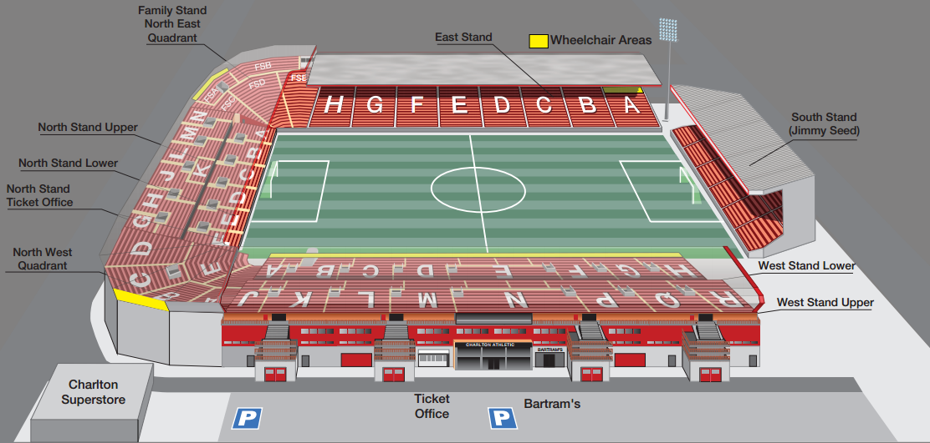

Student Statement:

By submitting this assignment, I confirm that this is my own work.

Student Signature | Asabi Beckles | Date | 12 /02/2017

For Tutor / Assessor Use Only
Total Marks
Marks Obtained
Percentage / Grade

