
Assignment Cover Sheet

Student Name: | Elizabeth Bygate
Student Number: | 3615
Course: | Diploma in Environmental Management
Assignment NO: | 1

Marking Criteria:
We expect the learners to write minimum one well expressed point in three lines against each allocated mark. This means one needs to write 15 lines with 5 well expressed points to get high grades for a 5 marks question.
For high grades use examples and illustrations where appropriate.
Please insert your completed assignment ( in word format) here:

What is Environment?

- An ecosystem is a sub-type of habitat that has its own typical set of physical and biological features, whose interactions result in a stable and naturally balanced system. These features consist of living (biotic) and non-living (abiotic) components which are continuously interacting with and influencing each other. A species or organism will form structural communities that have a functional relationship with each other and their external environment. There is a continuous cycle of production of material and exchange of energy. Mechanisms allow absorption of nutrients by the organism, who in turn produce organic matter, which is then converted back into inorganic matter as waste. The interaction between the components involves the input, transfer, storage and output of energy and essential materials which are then released back into the environment. To attain a state of equilibrium the ecosystem adjusts itself using feedback information about the population and the factors that control the living and non-living components within it.

- There are three main subdivisions of biosphere, these being the atmosphere, lithosphere and the hydrosphere. The atmosphere consists of gases in the air, the hydrosphere relates to water and the lithosphere refers to solid matter, the surface of the land, i.e. soil. The contact of all three are required to sustain life, through interaction, basic processes such as photosynthesis and respiration occur.
Soil is a useful compound for plants to grow in and it provides many minerals and nutrients that the plant uses, processes and converts into an organic form which is then accessed by organisms as food. The lithosphere assists in the metabolic process of living organisms both terrestrial and aquatic by providing the only source of the majority of the essential minerals and nutrients needed in order to sustain life.

- The functional aspect of an ecosystem can be defined as the interactions between various components involving the flow of energy and the cycling of materials.
Energy passes through an ecosystem in a continuous and unidirectional flow. From source to autotroph to herbivore and on to carnivore, when energy is passed on, it does not pass back.
During the process, plants convert solar energy into chemical energy by photosynthesis, this is then transferred on to herbivores in the form of carbohydrates, fats, proteins and nutrients, as food. This process continues along through the carnivores and then on to the decomposer level, after which is then returned to the ground. Some energy is lost during each transfer along the chain in the form of energy lost through respiration and decomposition.
Primary producers are green plants and certain types of bacteria, which trap solar energy and use it to produce food. This is then eaten by herbivores which are the primary consumers, at the same time as they become secondary producers by becoming food for the primary carnivores. There can be a number of carnivores within an ecosystem food chain ending with the top carnivores known as tertiary consumers. These different food levels are known as trophic levels:
The Trophic Level System
plants/producers = trophic level I
herbivores/primary consumers = trophic level II
primary carnivores/secondary consumer = trophic level III
top carnivores/tertiary consumers = trophic level IV
At the end of the food chain when producer and consumer are at the end of their life cycles, there are already new generations of ecosystem population developing. Dead organic matter decomposes in a continuing cycle aided by certain fungi and bacteria. The by-products of organism activity are mainly organic compounds, water, nitrogen, carbon dioxide and phosphates which feed back into the environment.

- Man-made environments need great care, supervision and management due to the excessive amount of materials and energy that are consumed by them. They have a direct impact upon the natural environment by using up many of the Earth’s natural resources.
In order to achieve a sustainable environment then a balance must be found between our economic, social and environmental needs, while avoiding the over consumption of key natural resources. Sustainability takes into account how we might live in harmony with the natural world around us, whilst at the same time protecting the ecology from damage and destruction.
When thinking about environmental sustainability we must consider the Earth’s ability to replenish its natural resources both now and in the future. Environmental responsibility can be implemented by individuals taking action by recycling waste and using renewable energy sources, but business and industry play a major role in determining the future of our planet and they must consider their environmental responsibilities and work to bring sustainable development into all aspects of their business.

- A natural environment is made up of both living and non-living components that interact with and influence each other to create a balanced ecosystem. The biological components are known as Biotic components, these relate to living things within the environment, like Microbes, Plants, Animals and Humans. Abiotic components are non-living components. These are physical factors that provide favourable conditions for different life forms to exist and grow in. Things that are classed as Abiotic components include:
- Energy
- Radiation
- Temperature and heat flow
- Water
- Atmospheric gas and wind
- Fire
- Gravity
- Topography
- Geological substratum
- Soil
Abiotic components in an environment enable important nutrients such as Oxygen, Nitrogen, Hydrogen, other gases and organic matter to be dissolved and then passed on to and absorbed by the Biotic components.

  - Every species has its own specific place in a food chain. The order in which the flow of energy passes through the organisms will identify the trophic level of each animal within the food chain.
All food chains start with a Primary Producer or Autotroph, these are green plant or bacterial life, which produce their own food through the photosynthesis of solar energy.
The consumers are called Heterotrophs, these cannot produce their own food and rely on feeding off other organisms to gain their energy. Heterotrophs can be both Herbivores and Carnivores as they are all consumers. Herbivores eat only green plant matter, they are then eaten by small carnivores, the larger tertiary carnivores are at the top of the food chain and are not killed or eaten by any other animal. These include: lions, vultures and man.

The decomposers in a food chain help to return the essential nutrients and residual energy back into the soil for use by the plants again. Animals that eat only one type of food are members of a single food chain.
The different species that are within a food chain will determine which trophic or food level an animal will be at within that food chain. Each species has its own special adaptions that make it fit into a certain place and help to balance the ecosystem.

- An ecosystem consists of a network of many interrelated single food chains which take the form of food webs. Some animals will consume a variety of different food types, so they will belong to many different food chains. They can be at a different trophic level within each chain, depending on which other organisms are in each separate chain with it. A primary consumer in one chain, could become a secondary consumer or carnivore in another. Animals such as lion, tiger or perhaps even human, are at the end of many food chains because they have no direct predators in their environment.
In a food web one separate food source, usually in the lower trophic levels, will be a food source for many different animals therefore belonging to several different food chains.

Food Chain | 1 | 2 | 3 | 4
Top Consumer | Bird of Prey | Bird of Prey | Human | Bird
Tertiary Consumer | Snake | Bird | Bird | Snake
Secondary Consumer | Bird | Spider | Bird | Lizard
Primary Consumer | Insect | Insect | Insect | Bird
Producer | Plant | Plant | Plant | Plant

From the table above, you can see how a particular animal, e.g. Insects, can belong in several different food chains and that they have a variety of predators. The table also shows that an animals trophic level can differ depending on the other organisms that make up the food chain it occupies. For example, birds are shown at different food levels compared with the other animals within each food chain.

Activity

- A rural area survey is required to better understand the cause and effect of population growth and the impact it has on the environment.
Population growth is determined by natural change in the birth and death rates and by net migration. It is the major contributory factor for housing expansion, which has a direct impact on a community, its environment and the local infrastructure: more people = more houses. Demand for housing is highest in London and the South-East, mainly due to economic factors like employment and income.

Long Spinney Development Area, Wing, Bucks

A field walk survey was carried out during January 2017 to assess a greenfield development area on the outskirts of a medium sized village. The timing of the survey is not ideal for a flora and fauna assessment, however, it will give the minimum baseline for any future surveys of the area to work from.

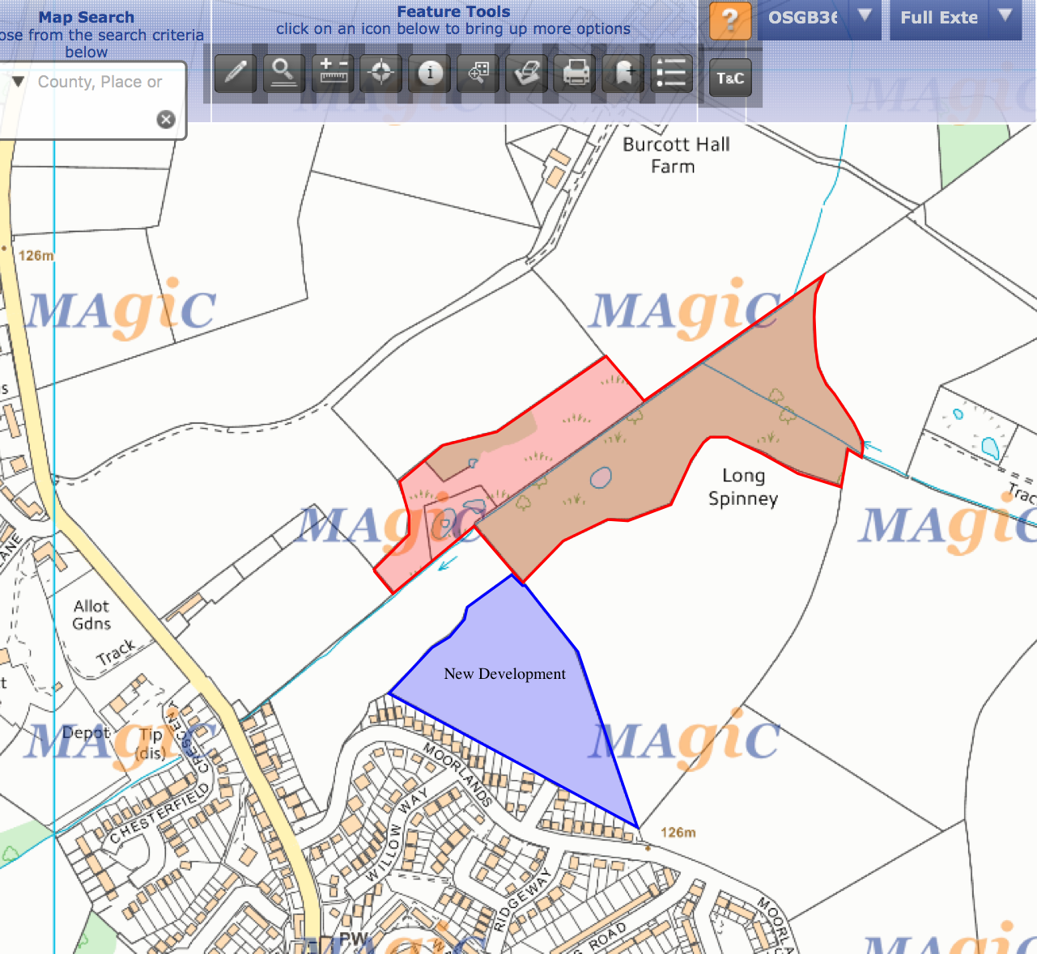
Intensive farming has affected the area, making it a Nitrate Vulnerable Zone (NVZ) to surface water containing pollutants.

Size | 3.21 hectares
Local Designation | Pasture land
 | Mixed Farming
 | Hay meadows
 | Heathland
Site Designation | Ancient & Semi-natural
 | Deciduous Woodland
 | Wet lowlands
Species | Three types of Farmland Bird:
 | Lapwing
 | Yellow Wagtail
 | Corn Bunting
Flora | Deadwood
Geology | Freely draining, Acidic soil
 | Base nutrient rich
 | Highly Fertile
 | Impeded drainage
Water | Surface water issues:
 | Pesticides
 | Sediment
 | Phosphates
 | Nitrates

There has also been some degree of neglect and a build-up of litter and organic matter has impeded drainage on the land. The lack of flora and fauna species can be accounted for by the above reasons, but the time of year the survey took place must also be took into consideration.

The greenfield development proposal of 50+ new dwellings to be built on the heathland has pushed the need for additional recreation space to be provided. This has highlighted the Spinney and pond area as high priority for a woodland improvement scheme and will help to create a much needed leisure area for village residents to enjoy.
Environmental management measures including clearance of debris, habitat provision, repair of fencing and pathways will increase use of the woodland.
Flora can be managed by removing dead matter to allow more sunlight to reach ground level and a wider variety of plant species. Removal of organic waste and litter will also aid drainage of the land and the flow of water in the stream, which will give a more suitable habitat for different plant and animal species to thrive in. Oxygen levels in the water will also be increased, so the organic life will have more chance of surviving.
The management of the flora will help to encourage fauna to the area by increasing the amount and types of food available. Shelter should also be provided for to enhance the security of life in the woods, this can be in the form of log piles and improved hedgerows.

In conclusion, the need for extra housing in the area was caused by a growth in population. The effect this has had is both positive and negative. The negative loss of the field is relatively minor, as some of this space will be landscaped by the developers and still usable. The ancient hedgerows and trees will be left in place, and an extra land drain and pond area has been created.
Prior to development, the woodland and original pond were overgrown and not in use by people or animals. There was a major degree of neglect and the ground was waterlogged meaning the plant and animal species were limited in variety.
Therefore, the effect of the housing development has been overall positive. It has made residents become more aware of their surroundings and to take action and improve them. Careful management of the woods and pond areas will not only encourage a diversity of plant and animal life, but it will also make it a more interesting and accessible space for people to enjoy in the future.

Acknowledgements

Population Matters Report 2012
CIEEM website
Magic Maps website

- Introduction – The aim of this report is to understand the attitudes of undergraduate business school students on the subject and importance of environmental education and sustainability.

- Methodology – Discussion with students from a local college on sustainable development, their attitudes towards environmental sustainability, the depth of their knowledge and the skill set they have on the subject. Further desktop research on higher education and university institutions.

- Findings – After discussing with a group of students from Aylesbury College, my findings were that the majority of them believed that Sustainable Development was an important subject to be aware of. They know that the government is pushing a ‘Green Economy’ and that sustainability is increasing in relevance and value to business in every sector.
The skill set of the students on the subject of environmental sustainability is low, with all saying that any knowledge gained had been through projects undertaken at school. They all narrowly relate sustainability specifically to the natural environment rather than the broader view of policy makers which includes ethics, health, social and economic issues, both at present and in the future.
The students have a desire to learn more about sustainable development as they believe it would enhance their employability, though none are using leisure, recreational, employment or volunteer opportunities which could further enhance their knowledge. They all feel that environmental sustainable development should be included as standard to their existing coursework as opposed to extra specialised modules.
The desktop research has shown that there is no requirement for further education institutions to include sustainable development practices in coursework. However, in recent years more colleges are highlighting the importance of the inclusion of global and environmental issues within their existing student curriculum, hoping to attract more students by offering this specialised niche.

- Social implications – Further understanding is needed by businesses on the benefits of environmental sustainability so that sustainable development skills have a higher value placed on them. Business must develop a resilience to climate change and learn to use natural resources more efficiently. Further education can help to influence these values by integrating them as standard into their syllabus.

- Evaluation - There is a need for nationally accepted guidelines and standard assessment procedure to be implemented by governing bodies and policy makers. Definitions of environmental sustainable development are vague and varied across the board, so defined indicators must be implemented. This will help organisations have a better understanding of their requirements and enable them to put positive environmental practice and behaviours in place.

- Acknowledgements – NUS Services on behalf of the Higher Education Academy. 2010-2013 annual study towards student attitudes.
IT Students at Aylesbury College.

Student Statement:

By submitting this assignment, I confirm that this is my own work.

Student Signature | Elizabeth Bygate | Date | 28/01/2017

For Tutor / Assessor Use Only
Total Marks
Marks Obtained
Percentage / Grade

