
Assignment Cover Sheet

Student Name: | Waleed Ahmed khan
Student Number: | 5652
Course: | Project management
Assignment NO: | 3

Marking Criteria:
We expect the learners to write minimum one well expressed point in three lines against each allocated mark. This means one needs to write 15 lines with 5 well expressed points to get high grades for a 5 marks question.
For high grades use examples and illustrations where appropriate.
- Where is project’s plan used? Which type of information does it contain?
A project management plan defines the parameters and purpose of individual business projects. This clarifies why the plan is being implemented and the ultimate purpose the plan will serve. The plan also is a tool for keeping everyone linked to the task on track and centering on the same details and information. For example, if a project plan is developed for creation of a company newsletter, the plan will make clear several key elements: who will write and produce the newsletter, the particular content will include, who the point audience is and what the expense of production will be. The plan will also find detail the necessary equipment, software programs and materials needed, as well as create an editorial calendar.

Types of Information
1) An overview of the reasons for your project
2) A detailed description of intended results
3) A list of all constraints the project must address
4) A list of all assumptions related to the project
5) A list of all required work
6) A breakdown of the roles you and your team members will play
7) A detailed project schedule
8) Needs for personnel, funds, and non-personnel resources (such as equipment, facilities, and information)
9) Plans for project communications
10) Plans for ensuring project quality

Briefly describe the type of information that is contained in a stakeholder analysis document?
A stakeholder examination documents information such as key stakeholders' brands and organizations, unique factual statements about each stakeholder, their assignments in the job, their effect on the job, and their degree of desire for the project.
Only project professionals and other key associates should start to see the stakeholder research since, oftentimes, the stakeholder evaluation includes delicate information.

3) Outline the main objectives of the integrated change control process?
Integrated change control involves coordinating changes across the entire project

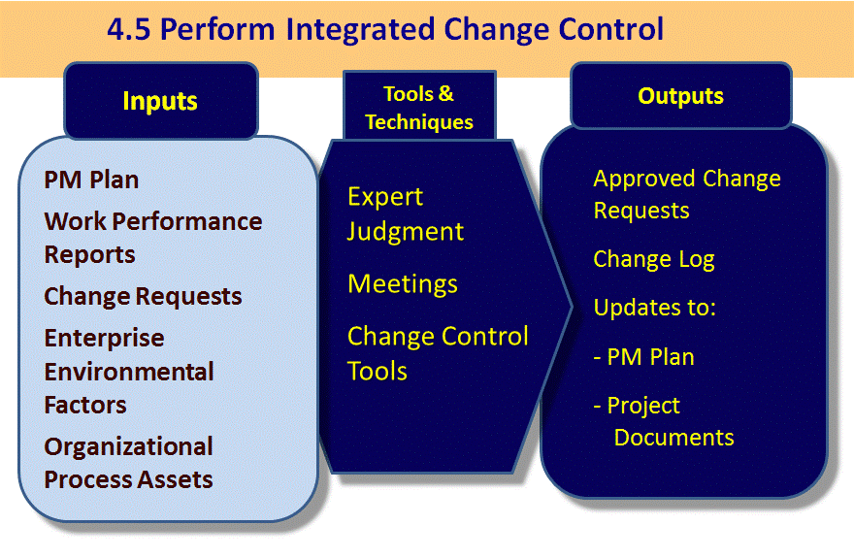
What are the major tools and techniques that assist managing integrated change control process?
Change control framework: This is an accumulation of formal, archived systems that characterize the Vital printed material, following framework, procedures, and endorsement levels important for approving Changes.

Configuration management: This guarantees that the depictions of the venture's items are right
What’s more, complete. It is performed through the recognizable proof and control of the utilitarian and physical outline qualities of the items and supporting reports.

Tools and techniques: -

i) Expert Judgment: -
Stakeholder may be asked to sit on change control board

ii) Meeting: -
Meeting of change control board referred as to change a control meeting

iii) Change control tools: -
Manual or automatic tools might be used for change or configuration management

Briefly describe the outputs of integrated change control process?
Approved change requests: - In this form of output only those changes occur which are approved by the appropriate authority
Change log: - In this form of out all changes request whether approved or rejected, get recorded in the change log
Project Management Plan updates: -
- Scope management plan (procedures for scope changes)
- Scope baseline (particularly product definition)
Change management plan (managing the change control process and documents the formal Change Control Board)

Project Document updates: -
All documents must be updated which are the part of change control

What is a ‘work break down structure (WBS)?
A work breakdown structure (WBS) is a diagram in which the basic work components, called assignments, of a venture are outlined to depict their connections to each other and to the venture all in all. The graphical way of the WBS can help a venture chief anticipate results in light of different situations, which can guarantee that ideal choices are made about regardless of whether to receive proposed methods or changes.
What are the outputs of projects’ plan development?
The outputs of the project plan are
- A comprehensive description of the project strategy and methodology – how the project will be implemented.
- Cost estimate
- Performance benchmarks.
- Key staff required for successful implementation.
- A clear and precise statement of scope.
- A preliminary work breakdown schedule.
- A schedule of events including milestones.
- Assignment of responsibilities.
- A comprehensive risk assessment and statement.
- Scope change processes.
- Communication protocol
- Stated limitations and “off limit” issues.
- A list of open decisions and pending decisions.
- Monitoring process.
- Applicable standards and specifications of outputs.

“Project integration management means tying together all of the other aspects involved in a project to make it a success.” Discuss this.
Project integration management implies entwining the majority of alternate angles required in a project to make it a success. Incorporation administration identifies with the project life cycle in that it is done in the majority of the project life cycle stages. As the venture advances, reconciliation administration turns out to be more engaged. Joining administration identifies with partners since it requires the project supervisor to know the majority of the project partners, to know their interests and worries about the project, and to oversee associations with them. Incorporation administration pulls together data from the majority of the other information regions.
One of the 9 information areas of project management is project integration control. It entails coordinating all of the other project control knowledge areas during an undertaking's lifestyles cycle. It also involves making sure that the diverse aspects of a project are coordinated with each other. The three essential classes of challenge integration control are project Plan improvement, mission Plan Execution, and standard change control.

i) Project plan development involves collating the results of other planning processes into a consistent and coherent document known as the project plan.
- • Project plan execution involves carrying out the project plan by performing the activities included therein.
- • Integrated change control involves coordinating changes across the entire project

- Describe the processes involved in project integration management?
Project integration management includes the following processes:

1. Developing the project contract includes working with partners to make the record that formally approves a project. Extend contracts can have distinctive configurations, yet they ought to incorporate fundamental project data and marks of key partners.
2. Developing the preparatory project scope explanation includes additionally work with partners, particularly clients of the project items, administrations, or results, to build up the abnormal state scope prerequisites. A decent preparatory venture scope explanation can help avert scope creep
3. Developing the project administrations arrange includes organizing all arranging endeavors to make a reliable, reasonable archive—the project administration arrange. The primary reason for project arrangements is to encourage activity.
4. Directing and overseeing project execution include completing the project arranges by playing out the exercises incorporated into it. Extend arrange execution ought to require the larger part of a venture's financial plan.
5. Monitoring and controlling task work are expected to meet the execution goals of the project. The project group ought to consistently screen extend execution to evaluate the general wellbeing of the project.
6. Integrated change control includes planning changes that influence the project deliverables and hierarchical process resources. A change control framework regularly incorporates a change control board (CCB), arrangement administration, and a procedure for imparting changes.
7. Closing the project includes settling all venture exercises. It is imperative to take after great methodology to guarantee that all venture exercises are finished and that the project support acknowledges conveyance of the last items, administrations, or aftereffects of the project

Activity

Identify a project that you would like to carry out in your particular field. It could be either a consultation project or a change project?
I would like to choose a project to design a building in designing the building we start consultation process at an point during a project, but starting consultation at an early stages is usually beneficial. Early stage consultation is likely to focus on meeting with local authority or town council
The consultation process can be a time consuming exercise and the initial reaction of countless may be difficult to change so the appointment of dedicated consultation specialist may be advisable
There are different level and types of consultation but for designing the building we need to take few steps, which are as follows
Location
Planning
Stake holder/ project scope
Investment
Working staff
Equipment required
Advertisement marketing

What problems and opportunities are you facing at work?
To design a building we might be face different challenges like
- To need for greater efficiency in HVAC and water management
- Lighting adjustment need to confirm to energy efficiency standard
- The need for environment quality with the wall of the facility.
- The use of suitable building material to reduce waste and lower cost of the overall project

These are few major challenge we might be face during design, which we discuss above
Whether its new construction or a renovate designing a building process must not assume that retrofitted structure are always easier or more cost effective.

Opportunity: -
A time or of set of circumstance that make it possible to do something. In the opportunities we give the example we design the building for school. It’s a best for the features of children’s they get the knowledge or if we design the building for flat or houses it will help peoples to live their good life.so basically we have a lots of opportunities to design the building.

What processes in your work area are creating barriers or impeding the quality of the services or products you and your department provide to others?
I am working for finance department and try to find out how we can manage the budget and do the meeting with stakeholder and my top management, we provide them services and how we manage the budget and it work for particular department. My department will only be focus on budget either the company spend by proper way and right department where we need it.

What aspects of your work are you particularly interested in?
I am particularly interested in a finance department. Here we do the meeting with stakeholder, and try to manage the budget
Always keep and spend on a right project, which will really helpful for company.

Student Statement:

By submitting this assignment, I confirm that this is my own work.

Student Signature | waleed | Date

For Tutor / Assessor Use Only
Total Marks
Marks Obtained
Percentage / Grade

