
Catherine Richardson
1427
Diploma in Public Relations
Ethics of Public Relations Professionalism
Assessment 12
Page 1
Assignment Cover Sheet

Student Name: | Catherine Jane Richardson
Student Number: | 1427
Course: | Diploma in Public Relations
Assignment NO: | Ethics of Public Relations Professionalism - Assessment 12

Marking Criteria:
We expect the learners to write minimum one well expressed point in three lines against each allocated mark. This means one needs to write 15 lines with 5 well expressed points to get high grades for a 5 marks question.
For high grades use examples and illustrations where appropriate.
Please insert your completed assignment (in word format) here:
1. Give short answers to the following questions: (20)
i. In what way is the code of Ethics important for the profession of Public Relations?
Ethics are systematic frameworks that classify moral principles. Morals are personal values unique to each person with each having his or her “moral code”. Ethics involve translating moral principles into systematic rules to help people know whether they are making the wrong decision or the right one. For example, laws on theft or murder are based on moral principles.
Morals shape and influence business ethics (Trevino & Nelson, 2004). These ethical decision-making processes consists of 3 steps:
-moral judgement (understanding that there is an ethical predicament)
-moral judgement) deciding on what is right)
-ethical behaviour (doing the right thing)
It is important for the profession because:
-systematically allows to access situations
-promotes consistent behaviour and responses to situations
-consistent with relationship building
-denotes and encourages transparency and fairness to stakeholders thus instills confidences in the preferred approach to work.
Catherine Richardson
1427
Diploma in Public Relations
Ethics of Public Relations Professionalism
Assessment 12
Page 2
Having described the brief differences of morals and ethics, the code of ethics are a collection of regulations, procedures and or laws concerning the conduct of a person or groups of people under various circumstances in a certain or given domain of human activity (Joseph, 2007). It consists not merely on what the people customarily do but in what they think it is appropriate, right or obligatory to do in that particular circumstance. In other words, it is not merely what is done; it is also what has to be done.
Codes of ethics are frameworks, provides guidance in a manner to be adhered to during particular circumstances in a particular way or behavior.
According to International Public Relations Association, there are two codes of professional conduct, Personal and Professional Integrity and the Code of Professional Standards. Both codes provide a framework to serve the interests of clients and employers, by dedicating practitioners to develop the goals of better communication, understanding, and cooperation among the diverse individuals, groups, and institutions of society.
Public relations serves a wide variety of organisations, both in the public and private sectors such as business, industry, government agencies, trade unions, charitable and voluntary organisations, religious and or educational institutions, hospitals, and so on. The PR practitioner serves as a bridge by helping to translate private aims into reasonable and publicly acceptable policy, and The information one supplies about the organization must in all cases carry mention of its source, be strictly objective by having no commercial publicity, propaganda or advertising in its content.
According to Wilkins and Coleman (2009), found that PR professionals considered ethics relevant and important to their occupation. This was evident in research were they were ranked seventh-highest in ethical and moral development among relevant professionals, behind only medical students, physicians, nurses and healthcare students. The positive viewpoint of upholding codes of ethics was that maintaining trust and honesty with the main publics is essential in public relations, professional values, and upholding standards.
The best way to use public relations is in an ethical and honest way, always to build a good reputation and to encourage and sustain good relationships.
Catherine Richardson
1427
Diploma in Public Relations
Ethics of Public Relations Professionalism
Assessment 12
Page 3
ii. What does the term, ‘relating organisational goals to the public interest’ mean?
Organisational goals are strategic objectives that an organisation establishes to outline expected outcomes and guides employees’ efforts. Most organisations use a mission statement or company vision to projective their goals (Bergstrom, 2015). To distinguish between the two, a vision statement expresses an organization's optimal goal and the reason for existence. A mission statement provides a basic outline of the organisation's strategies to adopt that vision. It does so by identifying the service areas such as the target audience, and the values and goals of the organization.
Toyota Gibraltar Stockholdings Ltd vision statement is:
To be the most admired company in our market through:
• Exceptional Customer Service.
• Operational Excellence.
• Investing in our people.

TGS Corporate Values
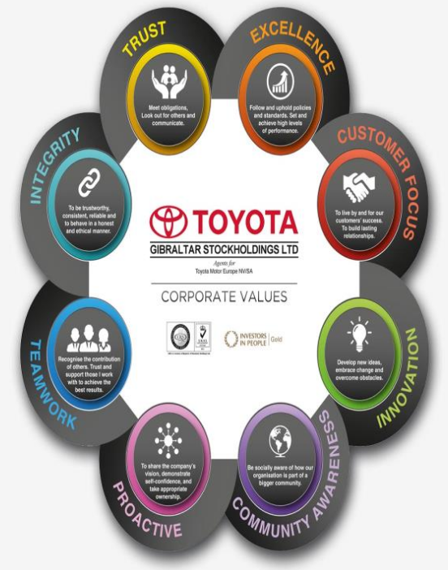
The below explains the corporate values within each category. This is found on the Toyota Gibraltar Stockholdings Ltd website, www.toyota-gib.com.
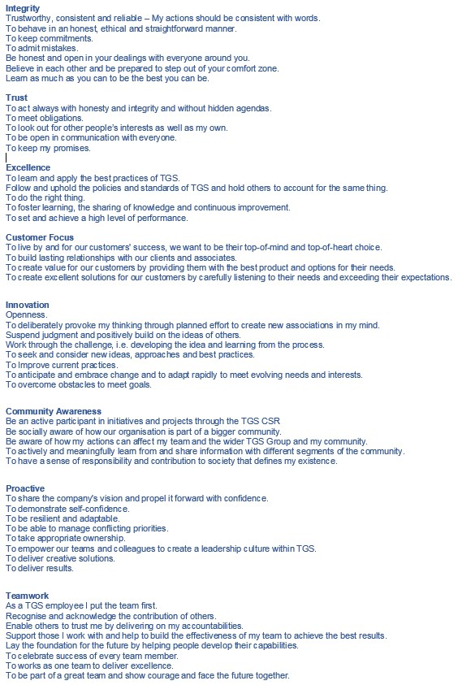
Catherine Richardson
1427
Diploma in Public Relations
Ethics of Public Relations Professionalism
Assessment 12
Page 4
The organizational goals, in particular with Toyota Gibraltar Stockholdings Ltd (TGS), are transferred through the values in how organisations operate and how they are expected to operate. When these goals become public interest, most assumptions are related to operations relating to corporate social responsibility. This will be discussed later.
Catherine Richardson
1427
Diploma in Public Relations
Ethics of Public Relations Professionalism
Assessment 12
Page 5
Other areas of interest may concern any operation that may provoke a public interest within the public sphere of that particular organisation. Public interest includes the welfare of the general public in which society has a stake and which permits recognition, promotion, and protection by government and its agencies. Examples are that organisations need to do or act in the best public interest of their organisation so that positive reputations are upheld.
Bearing the above in mind, for Toyota Gibraltar Stockholdings Ltd the public sphere may include all publics and stakeholders. They are these individuals who have a relationship and welfare issues relating to them are internal and external to the organization. The internal groups and individuals are, employees, managers, the board of directors, investors, and the external groups or persons are, clients or consumers, suppliers, investors and shareholders, society and governing bodies and government.
With the recent circumstances and uncertainty of the BREXIT, how TGS will be of public interest. This one determining factor will spiral global interest for all internal and external publics. Despite the positive and striving mission statement and underlying Kaizen philosophy of continuous improvement, such periods of uncertainty provokes publics to question the longevity of such and organization. All aspects of TGS will or may have to some degree circumstantial effects.
Corporate social responsibility has to some degree a manner of which an organization operates through their organizational goals and how these may be of public interest. The BREXIT goes beyond corporate social responsibility seeing that CSR specifically focuses on social and environmental issues affected by an organization (Shamir, 2011).
Relating these operational goals to public interest in this uncertain scenario may mean that TGS would need to ensure firstly and encourage their publics that these values and operations should remain despite the vagueness and unknown impact of BREXIT. Using the philosophy of CRS considering that an organization will need to bear in mind their corporate consciousness, the publics' interest will need to be addressed with updated transparent information. In public interest, most publics will require up to date follow-up and information about operations and longevity.
Catherine Richardson
1427
Diploma in Public Relations
Ethics of Public Relations Professionalism
Assessment 12
Page 6
iii. Discuss the need for legal consideration in Public Relations.
Being effective in public relations requires taking decisions that are appropriate within the ethical and legal boundaries. Ethical practices must consider the self-interests of the employer, their publics and their personal self-interest the public's self-interest, and the standards of the public relations profession. Public relations professionals must also meet legal standards, as there are ways they can be held legally accountable for their decisions and actions.
Invasion of Privacy
Public relations also has a legal application of other areas that pertain to specific practices, such as explaining business or institutional concerns to their publics. Public relations also deals within any business that is particularly sensitive to is the issue of privacy. This deals with employee communication, photo releases, publicity, advertising and other media inquiries about employees. The United States has several laws in place to monitor and protect employees in certain situations. For instance, whistleblowing is supported by state and federal laws to protect the right of employees if disclosing whether an organization is guilty of illegal activity. Protections for such employees are limited, and the stipulations for whistle-blowers are intricate. Public relations professionals need to research their legal protections, and keep up-to-date on changes, to ensure that they adhere to proper legal standards.
Copyright Law
Public relations involves much creative work, so it is advisable to protect their creative ideas and work. Copyright means protection of creative work from unsanctioned use. Ideas are not protected, but only the specific ways how those ideas are expressed (Hatt, 2016). Major public relations materials must be protected to prevent unauthorized use by competitors. Press releases, documents that are only successful if they are redistributed by the media, directly copy and pasted by media organizations, the organisations issuing the press releases can authorize such publications. For companies distributing press releases, this works to their advantage because what's distributed to the media is written in their own words.
Professional Codes of Conduct
The most basic code in any public relations project is the obligation of transparency with their information. Many national organizations have been founded, such as the Public Relations Society of America (PRSA), to develop a substantive code of ethics for individuals in the Public Relations profession to adhere to. Ethics are not just important for major corporations, but are also crucial for any small business involved in PR activities. The level of accountability and credibility an organisation has and displays determines the success in the industry. Abiding by professional codes of conduct helps improve the public's integrity in the PR domain and consequently helps the organisation's public relations efforts. In addition to formal codes of ethics created by institutes, organisations themselves produce codes of conduct that set standards for ethical behavior. These range from general codes to specific codes of conduct for areas like financial relations, production of video news releases, and interaction with social media networks.
Catherine Richardson
1427
Diploma in Public Relations
Ethics of Public Relations Professionalism
Assessment 12
Page 7
Ethical Dealings with News Media
It is important for a small business to engage in ethical dealings with news media when trying to promote and improve their reputation. This does not mean that the company must express all aspects or piece of proprietary information, but it is important to provide media networks the required information, so the predicted message is correct and truthful to the organisation. It is the responsibility of the business's public relations team to ensure that ethical practices are dealt with ethically when dealing with the media.

iv. What is the relationship between social audit and the observance of a Code of Ethics? According to Investopedia "A social audit is a formal review of a company's endeavors in social responsibility. A social audit looks at factors such as a company's record of charitable giving, volunteer activity, energy use, transparency, work environment and worker pay and benefits to evaluate what kind of social and environmental impact a company is having in the locations where it operates. Social audits are optional--companies can choose whether to perform them and whether to release the results publicly or only use them internally. (http://www.investopedia.com/terms/s/social-audit.asp#ixzz4EJAF0QIw)
Corporations are expected to deliver value to their customers. Considering corporate social responsibility, corporations also need to meet environmental and social standards deemed desirable for the general public. Social audits can help organisation create, improve and maintain a positive public relations image. Good public relations is key because the manner in which others perceive an organisation, whether internally and externally will usually have an impact on its bottom line.
Catherine Richardson
1427
Diploma in Public Relations
Ethics of Public Relations Professionalism
Assessment 12
Page 8
Both businesses and trade organizations typically have some kind code of ethics that their employees or members are supposed to follow. Breaking the codes of ethics and or conduct can result in termination or dismissal from the organization. A code of ethics is important for employee cohesion and unity because it clearly states the rules of behaviour and provides a preemptive warning.
Regardless of size, businesses count on management to set a standard of ethical conduct for other employees to follow. When administrators adhere to the codes of ethics or rules, it releases the concept through communication that compliance is required of every employee. Public relations serves the specific organization or client who is paying the practitioner to build and manage relationships that help the organization achieve their goals. Organisations are also expected to refrain from any action that would have a detrimental effect on the general public. According to the PRSA Member Statement of Professional values for public relations professionals, it specifies that advocacy for clients/employers is the primary goal and value of public relations. Advocacy, on the other hand, should be done responsibly and in the public interest.
According to International Association of Business Communicators Code of Ethics, "Communicators should encourage frequent communication and messages that are honest in their content, candid, accurate and appropriate to the needs of the organization and its audiences.
As an example, Walmart provides transparency by releasing a specific sourcing standards and resources publication. This publication provides information and guidance regarding supply chain and responsible resourcing. According to their California Transparency in Supply Chains Act (Human Trafficking and Anti-Slavery)
"Walmart strives to conduct business in a manner that reflects our four core beliefs – respect for the individual, service to customers, striving for excellence and acting with integrity. We hold the same expectations of our suppliers." They expected their suppliers to uphold such ethics to ensure that standards are met according to acts of legislations. They do this by implementing audits (social, safety and environmental compliance) to evaluate if these facilities meet the requirements for Walmart. If these suppliers fail to meet the requirements, they are expected to collaborate with the auditing facility to ensure that corrections and improvements are made. With such auditing, their suppliers also need to adhere to their guidance of internal accountability and abide by the Walmart Global Statement of Ethics. The suppliers are expected to sign the agreement of compliance with the effect of termination of contracts and association if conduct is not met.
Catherine Richardson
1427
Diploma in Public Relations
Ethics of Public Relations Professionalism
Assessment 12
Page 9
Walmart is working hard to train their organization to comprehend that their supply chain decisions have an impact on working conditions, training requirements for employees necessary to adhere to the importance of work practices. They believe that this educational investment is important to integrate work compliance and social responsibility to all purchasing decisions as well as to build a socially and environmentally responsible supply chain.
In short, social audits and codes of ethics have an intertwining relationship. Social audits measure the social efforts required to adhere to the codes of ethics. One without the other would cease to protect communities, businesses, and individuals with the public sphere. Social audits and codes of ethics are the binding structures of society in a global sphere like steps in macro ecosystems gaining equilibrium of survival.

Activity (10)
Look at a recent edition of a magazine. Read the advertisements of products and services in the magazine. Locate and write all the tall claims, exaggerations, dubious phrases, and distortions, which could be known as 'misleading' in the advertisement. Rewrite or rephrase them to make them more credible and yet, impressive.
For the purpose of this activity the magazine examined is “What’s On TV”. What’s On TV is a television programme guide in a magazine format created to inform their audience what the television schedules are for a week ahead.
The below advertisements are all the advertisements found in the What’s On TV magazine in page order.
1  (page 2)
Catherine Richardson
1427
Diploma in Public Relations
Ethics of Public Relations Professionalism
Assessment 12
Page 10
OLAY ageless. It’s arrived. A light cream that fights 7 signs of aging.
Want younger looking skin but hate the heavy feel of creams? New Olay Total Effects Featherweight flights 7 signs of aging with a lightweight quick-absorbing non-sticky formula. The 7 in 1 from the world’s No 1. We believe skin doesn’t have to show your age
OLAY ageless - Delicate complexion to combat the 7 signs of aging.

2.  (page 11)
Superfast Deals plus 50% off BT Broadband. All prices, BT TV and BT Sport content subject to change at any time during the contract. £49 activation for BT Infinity / £59 activation for BT TV entertainment starter pack & BT infinity . £7.95 delivery for Hub. Up to speed dependent on time of day, line and location. BT Infinity: 83% coverage across the UK, Check BT.com / infinity for availability.
Half price BT fast Broadband
3.  (page 14)
Catherine Richardson
1427
Diploma in Public Relations
Ethics of Public Relations Professionalism
Assessment 12
Page 11
Nisa. We’re here for you every day. Nisa just what you need. Visit nisalocally.co.uk to find your nearest store.
The Nisa store in London, Surrey is open every day from 0700 – 2200. For some stores customers need to request by telephone for opening times. Given the ambiguity, it may not be true that these stores are there for you every day. After comparing a few stores online they are all independent stores with different opening and closing times.
Nisa –here with your essentials.

4.  (page 89)
On this page, there are 3 different advertisements. The advert that announces interesting exaggerations is Acorn Stairlifts. The main phrase is "Regain the freedom of your home with an Acorn Stairlift.”
Acorn Stairlifts mobility throughout your home.
5.  (Last cover page)
BT Broadband. Half price for the first 6 months if you’ve got BT Broadband at home. Samsung Galaxy A3 (2016) from BT mobile. £10 a month for the first 6 months, No upfront Cost, 500MB 4G data. £10 a month for the first 6 months, then £20 a month. 24 month plan. Price exclusive to BT broadband homes. Only available direct from BT offer ends 7th July.
Got BT broadband? Half price for the first 6 months with BT mobile and a free Samsung A3!
Catherine Richardson
1427
Diploma in Public Relations
Ethics of Public Relations Professionalism
Assessment 12
Page 12
Student Statement:

By submitting this assignment, I confirm that this is my own work.

Student Signature | Catherine Jane Richardson | Date | 14th July 2016

For Tutor / Assessor Use Only
Total Marks
Marks Obtained
Percentage / Grade

