
Assignment Cover Sheet

Student Name: | Raymond Wilson
Student Number: | 5297
Course: | Diploma in Risk Management
Assignment No: | 1
Marking Criteria:
We expect the learners to write minimum one well expressed point in three lines against each allocated mark. This means one needs to write 15 lines with 5 well expressed points to get high grades for a 5 marks question.
For high grades use examples and illustrations where appropriate.
Assessment 1 Over View of Risk Management Total Marks: 30

1. Short Questions: (18)

i. Briefly describe the history of risk management.

It is believed by some Historians that the most primitive “model” of managing risk arose because of gaming where people in different ancient civilizations played games with dice and bones. People also played games over two thousand years ago that have now evolved into chess and checkers as we know them today.
There is also some historical evidence that gaming gave rise to probability theory, an important element of risk management, which comes from writings by Dante and Galileo. The famous mathematicians, Pascal and Fermat, wrote to each other about games of chance in the 1600s, a correspondence that is believed to have given rise to modern probability theories used today.

In more recent times however (mid 1950’s into the 70’s), risk managers around the world began to realize that it was too costly to manage every risk through the insurance process alone, so the correction began to expand to alternatives to insurance. Training and safety programs, as examples, were considered insurance alternatives.

Today's risk managers can enjoy the benefits of sophisticated risk management technology however as there are numerous suites of risk management information system software packages on the market that can be utilized. These sets of tools help today's corporate risk managers use information from the past and present to help minimize and manage all sorts of business risks in the future.

ii. What is the relationship between ‘Uncertainty’ and ‘Risk’?
By (it’s term) uncertainty, means the nonexistence of certainty or something which is not known. It also brings up situations where there is multiple alternatives resulting in a specific outcome, but the probability of that outcome is not certain. This is for the reason that there is not enough information or knowledge about the present condition therefore it is hard to describe or predict the future consequence or events. Uncertainty cannot be measured in quantitative terms through past models. Probabilities thus cannot be applied to the potential outcomes, because the probabilities are obviously unknown.
Uncertainty is inherent in every business which cannot be avoided, and the business person has no idea about what will happen next, i.e. the outcome is unknown.
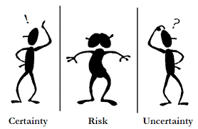
Under normal circumstances and for many businesses, risk is the outcome of an action taken or not taken, in a particular situation which might result in loss or gain. It is often labeled as chance, loss or exposure to danger, arising out of numerous factors, that can be minimized through preventive measures.
The meaning of risk in financial terms is not much different as it hints at the uncertainty regarding the expected returns on the investments made i.e. the probability of actual returns may not be equal to the expected returns (as many people know such a risk may include the probability of losing the part or whole investment).
In this sector the major elements of risk are defined as below;
- Systematic Risk: Interest Risk, Inflation Risk, Market Risk, etc.
- Unsystematic Risk: Business Risk and Financial Risk.

There is an old saying, “No risk, No gain”, so if any enterprise wants to survive in the long run, it has to take calculated risks where the probability of loss is comparatively less, and the chances of gains are higher.
iii. What is the primary objective of risk management?

The primary objective of risk management is to ensure that the risks facing businesses are appropriately managed. This management process, if correctly implemented and executed, will give all stakeholder’s the confidence to deal with or invest in the businesses concerned.

 As this simple picture illustrates there are numerous risks involved which if managed (in this case) by means such as, salting the road, fitting winter tyres or taking an alternative route then these risks can be minimized or even eliminated.
Insurance is a simple way of managing risks but of course some types of risks are uninsurable which means no reputable insurance company will cover those types of risks. Therefore Risk Management involves alternative ways to eliminate or lower this by primarily;

- Risk Avoidance
As illustrated, the risk of a car accident on adverse road conditions can be avoided by not driving the car. Companies who make cars can avoid the risk of having a component failure (such as seat belts) by simply not launching any new vehicles and sticking with the models they have.

Both the above methods avoid the risk but there may be a very high cost to pay such as
not driving the car and delivering a product on time, could result in the driver losing their job and a company that does not bring out new ranges or models will probably close down, as they are no longer competitive.

- Risk Reduction
Risks that can't be prevented should at least be reduced. The following are examples of what can be done to reduce risk;

Health And Safety - Workers on a construction site are required to use safety equipment and appropriate PPE.

Customer Service - A hotel reduces the risk of bad customer reviews by empowering all staff to handle customer complaints on the spot. For example, staff are able to upgrade a customer's room upon receiving a reasonable complaint.

Dispute Risk - A construction company reduces the risk of disputes by sending representatives to neighbors of a site to explain the schedule and what will be done to keep environmental issues, noise and impact to a minimum.

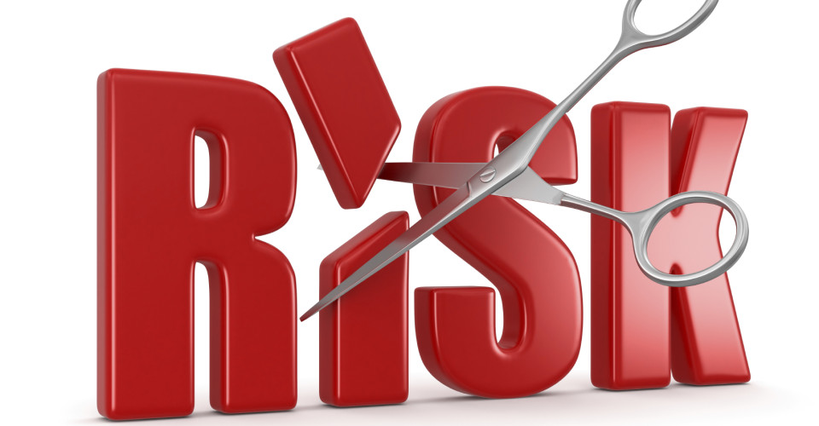

Weather Risk - A solar power company reduces weather risk by scheduling critical construction tasks during the months with the best weather in a particular region.

- Risk Assumption
Is a technique of risk management (sometimes referred to as self-insurance or retention) upon which businesses and individuals accept anticipated losses that should not be disastrous, but protects against these potential losses all the same through the purchase of insurance. An example being, a computer firm assumes the risk of nonattendance by its employees because of minor illness, but buys disability insurance to cover absences due to extended illness.
Clearly a company’s Risk Management goals and objectives should be consistent with and supportive of the enterprise’s business objectives and strategies. Therefore, the organization’s business model provides an important context for risk management.
For example it should always;
- Target the marketplaces and areas in which the firm does business.
- Specify the products and services it provides to those markets.
- Ensure the model is built on important elements such as; on the processes through which the entity converts materials and labour into products and services; on the employees the entity hires (inclusive of training and retention); on the suppliers and customers with which the organization does business; and on the shareholders and lenders that supply it capital.
iv. What is ‘Pure Risk’? Outline the main types of pure risk.

Pure Risk is a type of risk in which loss is the only possible outcome and there is no beneficial result. It is related to events that are beyond the risk-taker's control and, therefore, a person cannot knowingly take on pure risk. Pure risk is the opposite of speculative risk and the different types of pure risks (that we face day to day) can be classified under any one of the following;
Personal risks - Involves unemployment, disability and even death. Being laid off from one’s job or an accident that leaves one disabled or dead are obvious examples of personal risks. In addition to health and life issues, individual risks may negatively impact present income, potential future earnings and result in an increase of short and long term health care costs.
Property risks - Property risks involve theft or damage to one’s property. A car crash or flood that damages one’s house are examples of property risks. These risks may result in both direct and indirect costs. If a car is involved in an accident, it will need to repairing or replaced depending on the severity of the damage incurred. This is deemed to be direct cost.
If alternative transportation is required whilst the car is being repaired/replaced (unless covered by insurance) then there will be a host of outlays that are indirect costs (and losses to you).
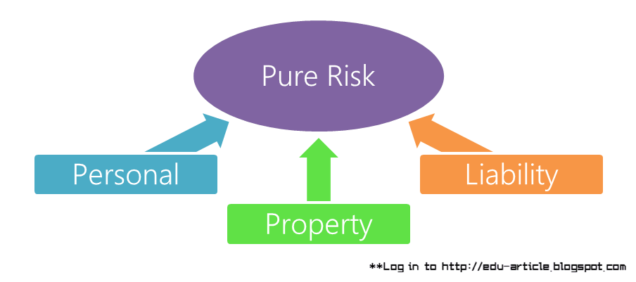

Liability risks - Involve the legal system. Examples are;
- If property damage, personal injuries, or financial loss incurred by another party are the result of carelessness or negligence on your part, you may be liable for monetary damages or other penalties.
- If you own a business and someone injures themselves whilst working for you at a construction site, you may be liable for medical costs, lost earnings and other miscellaneous costs of the injured party.
In each of the above, there must be both perils and hazards present.
A peril is merely a loss incurred by death, disability, illness, accident, lawsuit, dishonesty, carelessness, or even negligence. By default pure risks exist because of perils.
A hazard is something that increases the probability (i.e. the chance or likelihood) of a peril occurring. It may also affect the severity of the loss depending on certain criteria.
Hazards may be physical or moral. A physical hazard is a condition that increases the likelihood of a loss (peril) arising. Using a pan full of hot oil to cook food (hazard) increases the risk of a house fire (peril).
A moral hazard results from human traits such as dishonesty. Allowing staff access to the cash register (hazard) may increase the probability of employee theft (peril) are just two examples.
v. How can the risk management process be developed?
Firstly the various sources of risks need to be identified to enable the Risk profile to be developed. There are many sources as detailed and this list is not meant to be inclusive, but rather, a guide for the initial brainstorming of all risks. By referencing this list, it helps the management team determine all possible sources of risk.
Various sources of risk examples include;
Project Management
- Top management not distinguishing this activity as a project
- Too many projects going on at one time
- Impossible or unrealistic schedule commitments
- No functional input into the planning phase
- No one person responsible for the total project
- Poor control of design changes
- Problems with team members.
- Poor control of customer changes
- Poor understanding of the project manager’s job
- Wrong person assigned as project manager
- No integrated planning and control
- Organization’s resources are overcommitted
- Unrealistic planning and scheduling
- No project cost accounting ability
- Conflicting project priorities
- Poorly organized project office

External
Unpredictable
- Unforeseen regulatory requirements
- Natural disasters
- Vandalism, sabotage or unpredicted side effects
Predictable
    - Market or operational risk
    - Social
    - Environmental
    - Inflation
    - Currency rate fluctuations
    - Media
Technical
- Technology changes
- Risks stemming from design process
Legal
    - Violating trademarks and licenses
    - Sued for breach of contract
    - Labor or workplace problems
    - Litigation due to tort law legislation

Once the above sources have been identified and evaluated the Risk Analysis Process is essentially a quality problem solving process. Quality and assessment tools are used to determine and prioritize risks for assessment and resolution (as illustrated below). This in reality offers assurances that problem areas are dealt with and resolved in a practicable manner and also makes it more likely the company’s objectives and goals are realized.
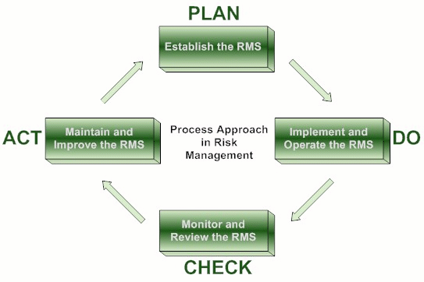
The risk analysis process is as follows;
Identify the Risk (from the listing above)
- This step is called brainstorming. Reviewing the list of possible risk sources, as well as the project team’s personal history, experiences and knowledge, will ensure all potential risks related to the scope of work are identified.
- Using an predetermined assessment mechanism, risks are then characterized and prioritized. The number of risks identified usually exceeds the time capacity of the project team to analyze and develop contingencies. The process of prioritization helps them to manage those risks that have both a high impact and a high probability of occurrence (moderate and low risks still need managing however).

Assess the Risk
- Traditional problem solving often moves from problem identification to problem solution. However, before trying to determine how best to manage risks, the project team must identify the root causes of the identified risks.
The project team asks questions including;
    - What could or would cause this risk?
    - How will this risk impact the project?

Develop Responses to the Risk
- Now the project team is ready to begin the process of assessing possible remedies to manage the risk or possibly, prevent the risk from occurring. Questions the team will ask include;
    - What can be done to reduce the likelihood of this risk?
    - What can be done to manage the risk, should it occur?

Develop a Contingency Plan or Preventative Measures for the Risk
- The project team will convert into tasks, those ideas that were identified to reduce or eliminate risk likelihood.
- Those tasks identified to manage the risk, should it occur, are developed into short contingency plans that can be put aside. Should the risk occur, they can be brought forward and quickly put into action, thereby reducing the need to manage the risk by crisis.
vi. What are the main benefits of business risk management?

Implementing a risk-management program for larger conglomerates is now par for course and may seem like an extravagant policy for a small business to consider, yet such a plan has a place from business planning, through insurance to operations planning. Risk-management programs provide both the strategic basis and the operational framework for handling crisis within any company, regardless of size, whereupon objectives are more than likely accomplished as well as providing a parent policy for crisis management.
Risk management to a financial planner has different meaning than to a manufacturing operations manager, yet in essence it refers to managing factors that interfere with achievement of each of their business targets. Business risk management programs may incorporate several disciplines, such as financial risk, liability management or health and safety initiatives, all of which may intertwine (the needs of each individual business will define the scope of the program). There is no one-size-fits-all risk-management plan but ultimately it should be designed to manage the risks by negating adverse effects and wherever practical lead to positive gains.

When the risk-management program has been finalized it identifies and prioritizes key risks that are likely to occur, which will improve a company's chances to plan and respond. This will in turn save many staff man hours which can be utilized on the core efforts of a businesses needs. For example, health and safety components may be addressed such as ergonomics and equipment safety, which will reduce lost-time injuries and more focus on Production contingency planning will give managers alternatives for re-routing production, when an important machine goes down, for instance.
The presence of an active risk-management program is also beneficial in the reputation world as it the says something about your company's brand. Workers have knowledge of expectations and leadership from the start of their employment, while the business develops a reputation as thorough and professional.
By building and supporting strategic planning through development of the risk management program, companies can establish a standard to which they can evaluate performance and adapt to ever changing needs. When risk is anticipated and managed, preparation begins, and the shock of the unexpected is dissipated.
Q.2. “Risk management can make a difference directly to profit”. Discuss (4)

The relationship between risk and profit varies depending on which expert is asked. Some professionals will argue risk needs to be present for investors or business owners, to earn significant profits, while others will argue that risk is merely an extension of unwise financial decisions and works against higher profit levels. In today’s world however it is clear that companies who put a premium on risk management are seeing better growth and increased profit margins.
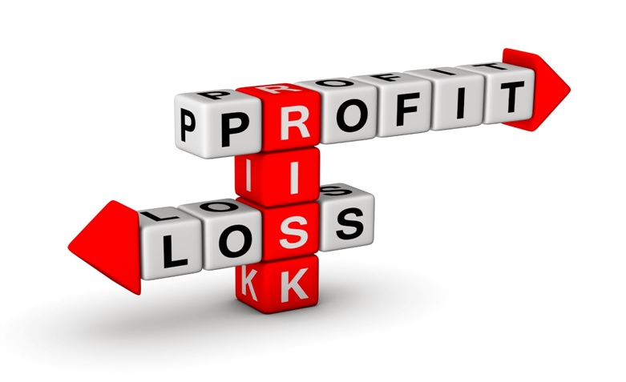
Company executives are constantly faced with making decisions to protect their businesses, while also trying to improve their financial performance. By integrating risk management into the business life cycle however these two objectives can easily come together to work in unison. Clearly developing an effective strategy requires forward thinking and investment, but the payback and competitive business advantage can be massive.
To achieve the above it is vitally important therefore that Risk Managers understand and achieve the following;
- understand how risks interconnect and impact business goals.
- have a strategic understanding of their risk appetite and are willing to take risks.
- are more aligned across the company’s business units.
- apply more sophisticated techniques where appropriate.
Once the above and other variables are taken into consideration business risk management teams will work to mitigate the effects of risk on business profits to maximize potential income. These professionals can mitigate any associated risks through detailed performance projections based on previous sales records, consumer purchasing trends and competitor analysis. This allows the risk management teams to plot courses of action, create operational budgets and plan product launch dates to maximize potential profits while also lowering the potential for problems to undermine business endeavors.
It is clear that if risk management is considered, clearly defined and executed correctly it can contribute significantly to the fundamental business’s goals and objectives by guaranteeing that the organization won't be held back from achieving the other goals and objectives by pure risk losses and also by decreasing costs through approved risk control programmes.
This ultimately ensures profitability and growth.
Q.3. Briefly describe the three general risk management techniques. (4)

A company cannot always rely on Insurance to cover their risk profile. In fact, as indicated earlier, some types of risk are just not insurable. Companies therefore have to manage these uninsurable types of risk by using one or all of the following techniques;

Risk avoidance consists of not executing an activity that could carry risk.

Examples would be not buying a business in order to not take on the legal liability of the Pension scheme that comes with it or taking a journey by flying in order not to take the risk that the airplane were to be hijacked or will crash.

Clearly avoidance may seem the natural answer to all risks, but evading such risks also means losing out on the potential gain that by accepting the risk this would have allowed, therefore by entering into a business transaction to avoid the risk of loss also avoids the possibility of earning profits.

Risk reduction (or "optimization" as sometimes referred too) involves reducing the severity of the loss or the probability of the loss from occurring. For example, sprinklers are designed to put out a fire to reduce the risk of loss by fire in Sub Stations, Kitchens etc. but this method may cause a greater loss by water damage and therefore may not be suitable. Halon (which is rarely used now) or other inert gas fire suppression systems may mitigate that risk, but the cost may be prohibitive as a strategy. The right balance and trade off needs to be found.
Recognizing that risks can be positive or negative and finding the correct balance between negative risk and the benefit of the operation or activity will ultimately determine the risk reduction and the effort needed to be applied. An offshore contractor, for example, effectively applying HSE Management within its organization, can optimize risk to achieve levels of residual risk that are tolerable.
Outsourcing might be an example of risk reduction if the outsourcer can determine higher capability at managing or reducing risks than the parent company.
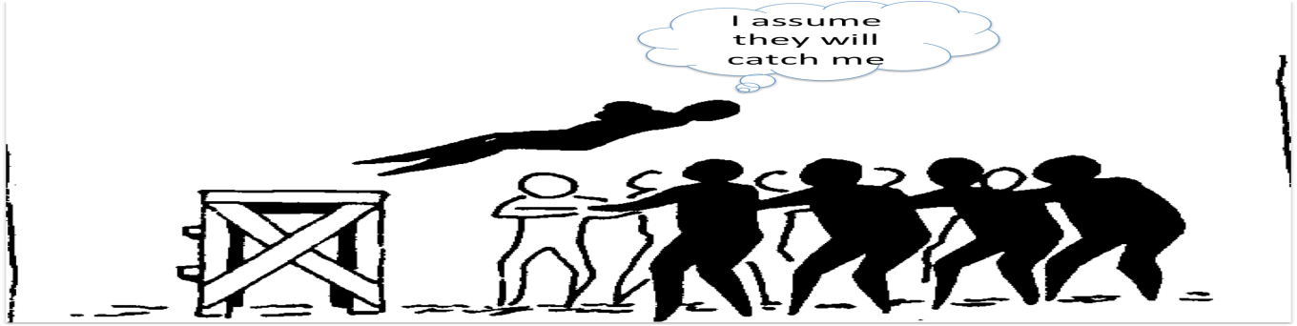

Assumptions are situations and events that need to occur for all projects to be successful, but are normally outside the total control of the project team. Assumptions are accepted as factual and are often without proof or demonstration. If the assumptions are related to constraints then these might restrict, limit, or regulate the project.
In project management, assumptions are made to enable the project to proceed as scheduled when otherwise it would come to a halt. However, some assumptions can turn out to be false, and when this happens the project can be negatively impacted. For this reason alone it’s important to actively monitor and manage assumptions to minimize any adverse impacts by monitor all assumptions with the project team, and accomplish this by using the risk management process.

Case Study (4)

William Telford established The Business Centre in 2000 as a consultancy business. With his experience and connections, the company grew quickly into UK’s largest independent creative company with over 60 staff.

The Business Centre rapidly expanded the portfolio of its clients from the UK to overseas. In 2006, William Telford began working with clients in the Middle East and formed a relationship with billion-dollar company Tameer (builder of the man-made islands in Dubai).
At the time, Tameer was the biggest developer in the region. William Telford had Tameer professionally risk-profiled, and the company seemed safe and reputable. But over the following months, Tameer became The Business Centre's biggest client - just before the GFC hit. Tameer started lagging in payments...

Previously, The Business Centre had never experienced bad debtors, so Telford believed business would bounce back and Tameer would eventually pay - it would just take time. Plus, The Business Centre had a large client base, so Telford tried to overcome the issue by leveraging income from other projects and invoice factoring to raise funds and keep business going.

In most cases, this strategy would work as an emergency measure. But due to the GFC, suddenly all of his clients stopped projects, and absolutely no income came in.
With these factors combined, The Business Centre was beyond help. The company collapsed after 10 years of operation in 2010, and William Telford lost everything he owned.
In view of the above please answer the following questions:

1. Where do you think William Telford made a mistake?
A joint venture can help your business grow faster, increase productivity and generate greater profits. A successful joint venture can offer;

- access to new markets and distribution networks
- increased capacity
- sharing of risks and costs with a partner
- access to greater resources, including specialized staff, technology and finance

A joint venture can also be very flexible. For example, a joint venture can have a limited life span and only cover part of what you do, thus limiting the commitment for both parties and the business' exposure.
Joint ventures are especially popular with businesses operating in different countries e.g. the transport, construction, IT based businesses (as is the case here) and travel industries.

 Partnering with another business can be risky and complex however and it takes time and effort to build the right business relationship. Although Mr. Telford had the company risk profiled, and they were deemed sound, he should have taken out the appropriate “insurance” that a venture like this demands as no one can foresee a major downturn that Tameer experienced even in the Oil rich states of the UAE were they operate.

Numerous problems are likely to arise, and may have contributed in this case, if;

- the objectives of the venture are not totally clear and communicated to everyone involved
- the partners have different objectives for the joint venture
- there is an imbalance in levels of expertise, investment or assets brought into the venture by the different partners
- different cultures and management styles result in poor integration and co-operation
- the partners don't provide sufficient leadership and support in the early stages
- Payment structures are not clear and secured
- Appropriate risks are not correctly reviewed, analyzed and planned for

Success in a joint venture depends on thorough research and analysis of aims and objectives. This should be followed up with effective communication of the business plan to everyone involved. In this case a major downturn in the business of one of the JV partners, Tameer (which was caused by the global financial crisis) that if analyzed correctly should have been identified as a risk and planned for accordingly.

Mr. Telford’s own Company risk management plan should also have taken into consideration taking monies off other lucrative contracts to shore up this JV without suitable measures in place to flag up short term and projected financial exposure.

2. How does the risk management strategy would have helped him?
The majority of joint ventures fail simply because the partners are not the “right fit” for each other. They may have different visions of purpose and their roles. International partners, especially, often visualize themselves as a strategic ally, active in making major decisions, while the local partner is unwilling to give up control and management and expects the other to be a passive investor.
Another pitfall, which could be a contributing factor in this case with The Business Centre and Tameer, is a lack of common vision on the exit strategy from the investment. The need to exit and monetize often conflicts with the local partner’s longer-term view of the venture, resulting in deadlock or litigation. In this case extreme global conditions and a lack of risk management focus clearly lead to the downfall of Mr. Telford’s own Company.
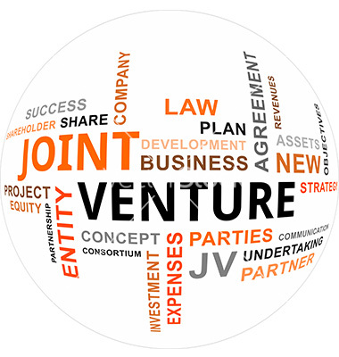Although it may be argued that the GFC could not have been envisaged in its size and force and that Tameer had been risk profiled by The Business Centre, presumably to the standard due diligence of the business (legal, accounting, regulatory, and otherwise), additional extensive due diligence must be performed on the joint venture partner, its family members, other businesses, political affiliations, and business relationships. Note: This may have been carried out of course, but it difficult to determine from case study details provided.
Joint ventures are complex and risky. Failure to identify and address the risks and challenges early on can adversely impact the venture’s success and it is worthwhile to get the right team of professionals and take certain necessary precautions at the outset to ensure success.
Due to the nature of the cash flow problems encountered by The Business Centre an exit strategy should have risk assessed and developed from the outset. Overall a clear concise risk management plan should have been used to guarantee that all the risks faced by TBC were appropriately managed. This management process would have given TBC stakeholder’s the confidence to deal with businesses overseas company concerned by ensuring Risk Avoidance, Risk Reduction and Risk Assumption were all considered and the consequences managed accordingly.

Student Statement:

By submitting this assignment, I confirm that this is my own work.

Student Signature | Raymond Wilson | Date | 18th Jan 2017

For Tutor / Assessor Use Only
Total Marks
Marks Obtained
Percentage / Grade

