
Assignment Cover Sheet

Student Name: | Eniko Surjanne Schuller
Student Number: | 2459
Course: | Diploma in Business Administration
Assignment NO: | 6

Marking Criteria:
We expect the learners to write minimum one well expressed point in three lines against each allocated mark. This means one needs to write 15 lines with 5 well expressed points to get high grades for a 5 marks question.
For high grades use examples and illustrations where appropriate.
The resources of a company are their tangible and intangible assets. They are necessary to the production. Tangible assets are buildings, machines and raw materials. Intangible assets are goodwill, patents, trade marks. Resource management is a proper and effective management of the various resources of a business for its benefit and profit.

An effective resoure management system’s main aim are:
- Increase The Revenue: help the managers easily make decisions by ensuring the organisation’s most valuable resources are maximised in a minimised cost of production.
- Conflict resolution: immediate conflict detection and resolving.
- Improve Project Delivery: help to reduce costs and increase margins.
- Reduce Administration Costs: with regularly reviewing it will help centralising and organising the resource management process and tools, therefore managers can have an up-to-date view of the entire process.

The main problems relating to managing resources are:
- if managers do not plan ahead or do not decide in time ( maintenance, ordering materials, managing employees etc. )
- if managers do not using the resource management system
- if managers do not deciding according to what the system analyzing shows
- there are so many factors that have impact on production: cost, availability, maintenance, business partners-sources, business working attitude, employees training etc.

To analysing the relationship between operation functions and resource management in a business is very important to know if there is any internal or external unpredictable threats.
If a supplier do not deliver the materials in time, or not in the right quantity or quality, the company will suffer from these complications, because if they can not start the production in time, they will not deliver the product in time to the business partners, stores etc. If they do not deliver in time, or in the right quantity or quality they will destroy their relationships or will cost more time or money to repair the product. Every part of the resource management will have an impact on operations and vice versa.

If a supplier does not deliver the materials in time, or not in the right quantity or quality, the company will suffer from these complications, because if they can not start the production in time, they will not deliver the product in time to the business partners, stores etc. If they do not deliver in time, or in the right quantity or quality they will destroy their relationships or will cost more time or money to repair the product. Every part of the resource management will have an impact on operations and vice versa.

Maintenance of the raw materials is also important because as I noted earlier every part of the resource management will have an impact on operations and vice versa. So, if the raw material does not come from a reliable source it will suffer from any kind of complications it may have. If the source is not 100% reliable, the company must ensure it has more than one source of raw materials. The resource management systems can help to managers to decide every question according to this raw material question as well.

Managing resources are the organisation’s assets. So it has to be maintained and managing as it could be money in another form. It ensures that there will be no waste or loss during the production process. Every organisation has to have a building for instance, if there is not production place, there will not be production. Businesses have to protect the building with security, environment threats, insurance, etc. Another resource is vehicles for delivering the finished products, or machines to produce the product.

Student Statement:

By submitting this assignment, I confirm that this is my own work.

Student Signature | 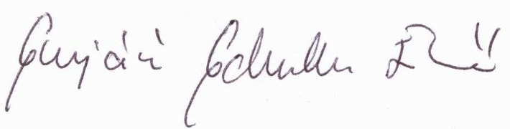 | Date | 20-Sept-2016

For Tutor / Assessor Use Only
Total Marks
Marks Obtained
Percentage / Grade

