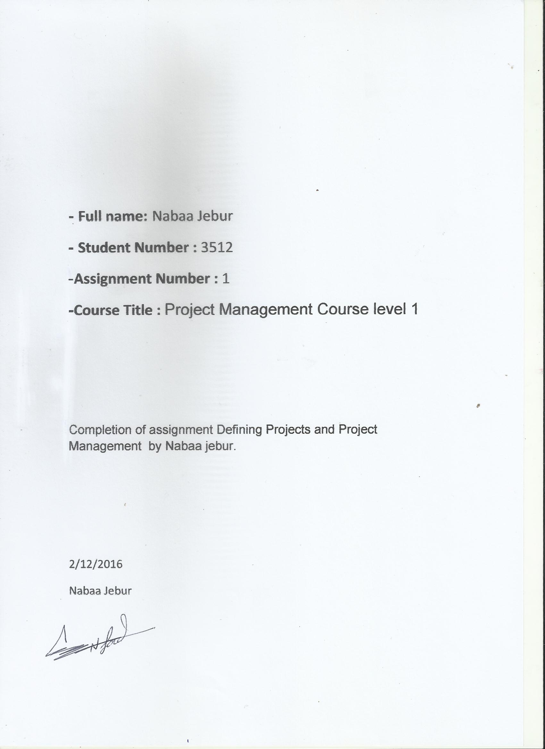

Nabaa Jebur Full name:
Student Number : 3512
Assignment Number : 1
Page Number : 1

1.1 What is a project? How do projects differ from routine work?
A project is an assignment/task/job that has to be undertaken and completed within a set time, Budget , resources and performance specifications designed to meet the needs of stakeholder and beneficiaries .
For example
The Canadian International Donor Agency (CIDA) has donated R7.5 million to provide RDP homes to 50 families living in the Joe Slovo informal settlement. On 6 February 2004, the agency signed a contract with the Department of Housing to implement the project. The following requirements, amongst others were set in the contract:
1. The RDP houses must meet specifications in line with government policy.
2. In order to ensure sustainability and affordability for the 50 families, the head of each of the 50 families must be given skills development training in small business development and small business start-up. This is to ensure that the families will be able to afford rentals, maintenance of the homes and to expand their homes to accommodate the growth of the families in the future.
3. The project must be completed within three years and the handover of the homes to the 50 families must be a high profile public event.
From the example we see:
• A clear task - build RDP homes for 50 families;
• A set time – within 3 years;
• A budget – R7.5 million;
• performance specifications to meet the stakeholder needs – houses that meet the specifications in line with government policy, training for the head of each family;
• Beneficiaries – 50 families;
• Stakeholders – donor agency, Department of Housing.
- Project is not continues work it has specific time to finish and be mature to run as continues work e.g if I want to produce new product its project until it will be successful and it must have specific time to reach successful point or failure if become successful it will be continues work but not project so project have specific time cost and scope than it ends when those is finished that is the difference between project and any other works .

Nabaa Jebur Full name:
Student Number : 3512
Assignment Number : 1
Page Number : 2

1.2 What are five process groups in Project Management?
There are five process groups:
- Initiating
- Planning
- Executing
- Closing
- Monitoring and Controlling

With the exception of Monitoring and Controlling, all of these processes correspond to the project life .

1.3 Name nine knowledge areas of Project Management.
- Integration
- Scope
- Time
- Cost
- Quality
- Human resources
- Communications
- Risk management
9. Procurement
1.4 Outline key responsibilities of a project Manager.
1. Producing documents such as the plan of action, vision statement, target chart, planning tools. Some of these projects will be done by the manager; others will be done by the team and led by the manager. 2. Keeping an eye on the big picture to ensure the progress is on track.
3. Motivating the project team and helping them grow.
4. Communicating with sponsors, stakeholders, and team members to ensure everyone is on the same page.
5. Acting as representative for the customers of the project.

Nabaa Jebur Full name:
Student Number : 3512
Assignment Number : 1
Page Number : 3

1.5 Define the project lifecycle and explain its phases.
The project lifecycle
The sequence of activities from the beginning of a project to its completion is essentially the same, whether we are talking about a small two- or three-day project or a large project that will span several months. These activities can be grouped into four different phases. (A phase of a project is a major set of
activities that must be performed within the project management process.)

Phase One: Conceptual
The first phase is the Conceptual phase, sometimes called Initiation, or the Create phase. This phase shapes the project. It often begins after the project has been selected. The purpose of this phase is to provide direction to the team, to decide what is to be accomplished, and to identify constraints and risks.

Nabaa Jebur Full name:
Student Number : 3512
Assignment Number : 1
Page Number : 4

Basic elements of this phase include determining feasibility; identifying and researching alternatives; naming prospective team members; and creating proposals, budgets, and schedules.
Once the team has been established, members will study some of the initial research before moving on to a Project Charter or Statement of Work (SOW). The team will also set a clearly defined conclusion, establish benchmarks and deliverables, and choose a course of action.
The output for this stage is the Project Charter or Statement of Work (SOW).

Phase Two: Planning
The next phase is the Planning phase, sometimes called the Sell stage. The project team identifies the steps and develops the plan for how and when the project will be accomplished. This is the most critical and most often neglected phase of the project. Poor planning or lack of planning here can have consequences all down the line. If everybody knows what is to be done, the project will go much more smoothly.
Tasks to be completed during Phase Two include setting clear goals, defining who is responsible for which tasks, refining budgets, obtaining necessary approvals, securing or designing systems needed, building and testing, analyzing results, and commencing production.
The output for the planning phase is a project plan document, a complete plan for how the project will be executed. The sponsor and other key shareholders should all approve this document.

Phase Three: Execution
After the project plan is approved the Execution phase starts, where the plan is put into action. Here is where you get down to working on the project and delivering the deliverables that were outlined in phase one. To make sure the work is on track, the team (or the project manager) must monitor progress, and, if required, recommend changes. Progress reports go to the stakeholders.
Tasks include making the time necessary to get the work done, obtaining and using resources (such as money, people, and equipment), meeting regularly with the team, and updating stakeholders.
Ensuring that the project is completed on time and within budget requires the project manager to direct and control the work underway. Tasks include establishing specific standards, monitoring performance, inspecting results and conducting interim progress reviews, auditing, and making adjustments.

Nabaa Jebur Full name:
Student Number : 3512
Assignment Number : 1
Page Number : 5

Phase Four: Terminatio

Closeout or Termination is the final phase in a project. This is when your customer will decide whether they are satisfied with the project. The sponsor assesses the project in terms of goals met and costs incurred, while the team discusses lessons learned and ways the next project can be improved. A final
status report is issued and sent to all key stakeholders. This is also the time to celebrate success and thank everyone involved with the project.
Tasks often include a meeting to produce a report or checklist upon completion, and the final production of manuals, drawings, and procedures for the client. The project team may train the client’s staff, and the lessons learned through the life of the project are documented and shared for future project work.
Finally, project team members are reassigned to pre-project work or perhaps new projects. Any equipment, space, or resources used during the project are repurposed or released.

Nabaa jebur

