
Assignment Cover Sheet

Student Name: | Attila FOKI
Student Number: | 2943
Course: | Diploma in Logistics and Supply Chain Management
Assignment NO: | 3

Marking Criteria:
We expect the learners to write minimum one well expressed point in three lines against each allocated mark. This means one needs to write 15 lines with 5 well expressed points to get high grades for a 5 marks question.
For high grades use examples and illustrations where appropriate.
1.i
The decisions in an organization can be 1. Strategic decisions, 2. Tactical Decisions and 3. Operational Decisions.
1.ii
Tactical decisions are taken to implement the strategies by focusing on resource utilization and operations. They have a medium term horizon and are less risky than strategic decisions.
1.iii
Logistics strategy creates a link between higher level strategies and functional strategies of the supply chain. Corporate defines general objectives e.g. cost leadership and logistics strategy realize these objectives following the example cost leadership means always trying to achieve the lowest possible logistics cost in delivering, storing etc. the products.

1.iv
Value added strategy is taking the consumer’s perspective by providing features in the product and its supply chain that is valued by the customer and therefore will pay for it.
1.v
When designing a logistics strategy the three factors to be considered are 1. The higher level corporate strategy 2. the business environment 3. The organization’s distinctive competence
1.vi
Logistics involves major resources including storage and transport it has direct impact on organization performance, including financial measures, lead time, customer perception of value, quality, etc. All logistics decisions e.g. supply chain designs, locations and size of facilities, supplier partnerships, etc. therefore have a direct impact on corporate strategy.
1.vii
Logistics strategy emphasizes on 1. Cost – achieving lower cost could lead to higher profit and lower price for customers, 2. Customer service – features like speed of responses, etc. can provide competitive advantages long term, 3. Timing – supply a product fast or at a right time, 4. Quality, 5. Product flexibility – tailor product to individual specification, 6. Volume flexibility – cope with the different levels of demand, 7. Technology, 8. Location – most convenient delivery of products
1.viii
Lean strategy is to use less resources and to eliminate unnecessary waste while ensuring satisfactory level of customer service.
1.ix
The main purpose of logistics audit is to gather information about details of existing operations and current performance. It reviews the business sorroundings: type of customers, demand, service levels, competitors, industry trends, etc and internally the company’s competencies, the way things are being performed and find areas for development.
2.
Steps developing a logistic strategy: 1. Logistics audit. - external audit to study the environment in which the logistics function performs and internal audit that evaluates higher strategies from a logistic point of view 2. Design the supply chain features for the required services 3. Set goals and KPIs 4. Design the organizational structure, systems, and controls to hold up the logistics network 5. Benchmark performance metrics, 6. Execute the strategy 7. Monitor performance and provide feedback for improvement.

3. Case Study
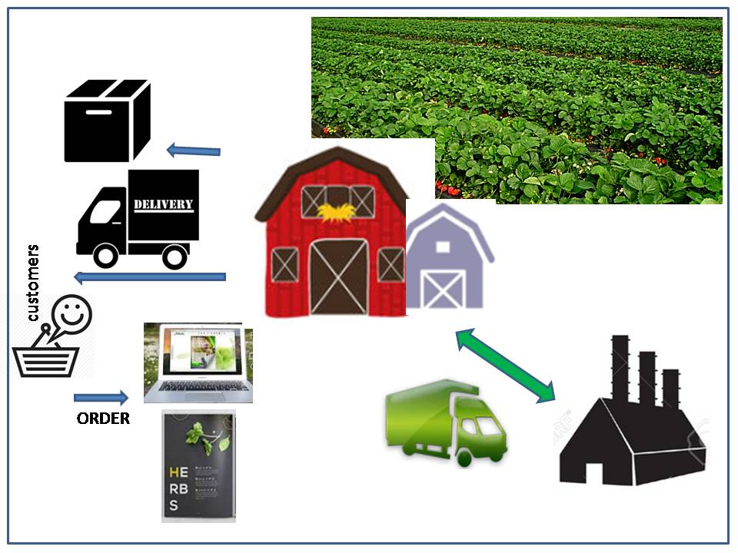
Currently the logistics activities includes 1. getting the herbs from the field to the farm building called ’herb kitchen’, 2. local deliveries up to 50 km, 3. postal parcels over 50 km and orders are received through their website.
Charlotte is planning to expand further the product range and move all the processing to an industrial estate 15 km away. First she needs to increase sales to at least 2000 parcels per week that she expects to generate through the increased use of the website and the introduction of a mail order catalogue.
Expanding the sales and moving the production to an industrial estate will increase the logistics activity and cost. She needs to run regular trucks between the industrial estate and the farm. She also will need to deliver more to local and more distant customers.
She will need to invest in buying a van (or more) or buy the transportation as a service for 1. transporting the herbs between the farm and the industrial estate, 2. increased level of local and distant deliveries. The increased logistics cost carries a risk of price increase and less profit.
Therefore Charlotte needs to carefully plan the logistic related cost to keep it at minimum while ensuring that customers are getting their orders at their satisfaction. Logistic routes, way of transport and storage costs need to be considered.

Student Statement:

By submitting this assignment, I confirm that this is my own work.

Student Signature | Attila FOKI | Date

For Tutor / Assessor Use Only
Total Marks
Marks Obtained
Percentage / Grade

