

Assignment Cover Sheet

Student Name: | Saul Christopher Denby
Student Number: | 1498
Course: | Diploma in Fashion Design (Level 4)
Assignment NO: | 2

Marking Criteria:
We expect the learners to write minimum one well expressed point in three lines against each allocated mark. This means one needs to write 15 lines with 5 well expressed points to get high grades for a 5 marks question.
For high grades use examples and illustrations where appropriate.

- I. What is fad?

A fad is for example a fashion trend that becomes very popular in a short space of
time, and then looses its popularity soon after. This can happen when styles are designed
for a very specific taste, or a certain age group, or inspired by a film or a tv series.
If a particular line of clothing by a popular brand is priced higher than the majority of
customers can afford then interest will quickly fade, this would also be called a fad.
So it is an intense but short interest in a line or style of clothing.

II. Define the term ‘fashion forecasting’.

Fashion forecasting is the educated attempt at predicting the upcoming season
or year’s trends, so that the fashion houses can adjust their upcoming designs accordingly
for maximum appeal.
This can be done by researching past trends and discovering what kind of things
influenced them, this in turn can be done via public surveys and interviews, or market and
consumer research etc.
It is then possible to reasonably accurately predict the reactions to forthcoming influences
such as films and television, celebrity behaviour, world events and even the weather.

III. How would you differentiate fashion forecasting from trend forecasting?

Trend forecasting covers a much wider area than fashion alone.
A trend is a particular inspiration that can influence many different industries at the same
time. These trends can be as broad as lifestyles changes, or as simple as a certain
colour. Many industries such as transportation, food and drink, home designs, popular
culture etc. would incorporate new trends into their products or services.
Fashion forecasting on the other hand (usually) only focuses on upcoming clothing
styles and inspirations to help fashion businesses sell their products.

IV. What is meant by fashion trends?

A trend in fashion could for example be a specifically styled item of clothing
that gains a lot of popularity, so many other designers would include the specific
styling into their own clothing ranges and therefore the new style grows and gains
more widespread popularity.

V. Outline the basic practical considerations that a customer takes into account
when selecting fashion garments or accessories.

Style and colour
The first aspect of an item to draw you in would be it’s styling and it’s colours.
Material
One might then inspect the item to see what fabrics and materials it is made from.
Washing
Some people might want to know what the item’s washing instruction is. For example
hand wash only silk or wool may not be practical for some.
Fit
An item could then be tried on to see whether the intended fit of it’s design would
compliment your body.
Occasion
One would consider if an item would be appropriate for a chosen occasion.
Price
Perhaps the most practical consideration is whether an item is within a price range that
you are willing to pay.
2. What is the difference between fashion and style?

Fashion is ever changing designs which you are told will look great on you
and improve your social standing by advertising campaigns.

Style is what you yourself think looks great on you as a means of expressing your
own individual personality.

Fashion is sometimes associated with younger people because they have the
desire to impress and conform with their peers and the society of their age groups.
The majority of the time, the standards and expectations of which to conform to are set
by fashion trends.
People whom do not follow each trend and rather focus on designs that they believe
compliments their body shape, or lifestyle and beliefs, could be called stylish as opposed
to fashionable.

As an example we could think about slim fitting jeans.
The trend of tightly fitting trousers has been around for a while now, and it may well
remain for some time to come.
For people of a slim build this trend does in fact compliment their figure, however for
people with more generous proportions, tightly fitting jeans would draw more attention to
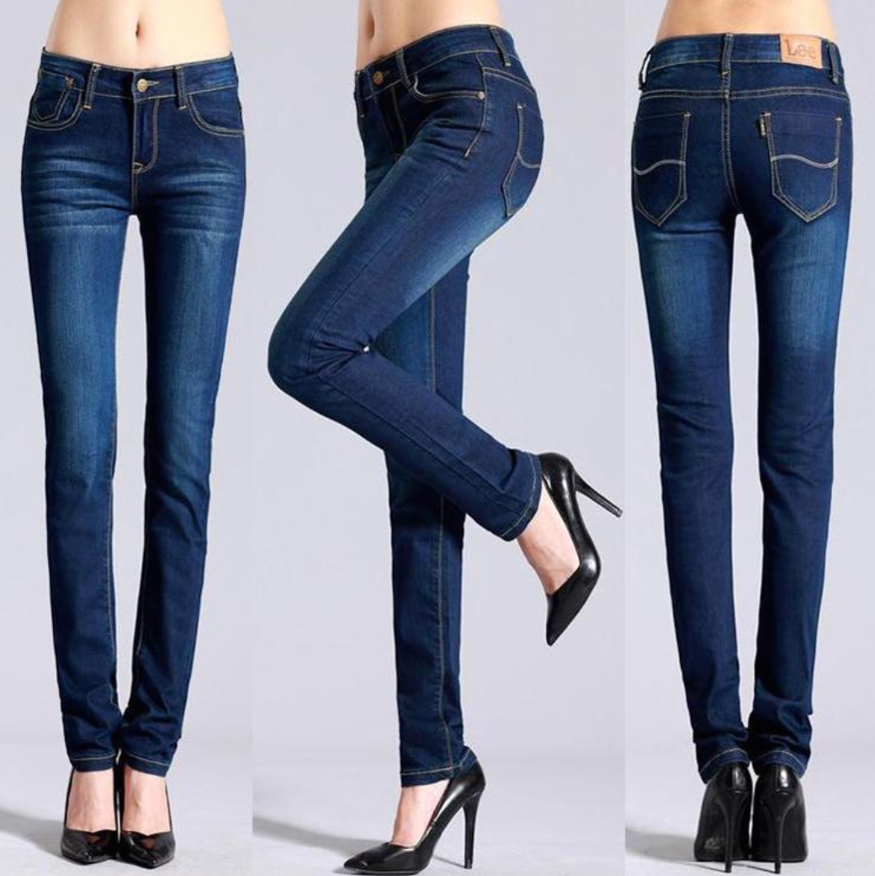
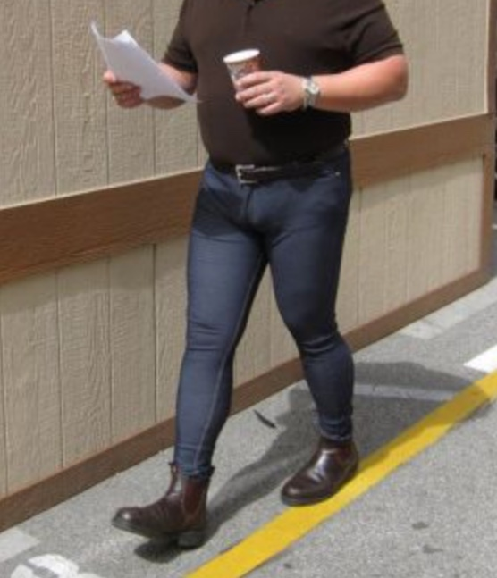
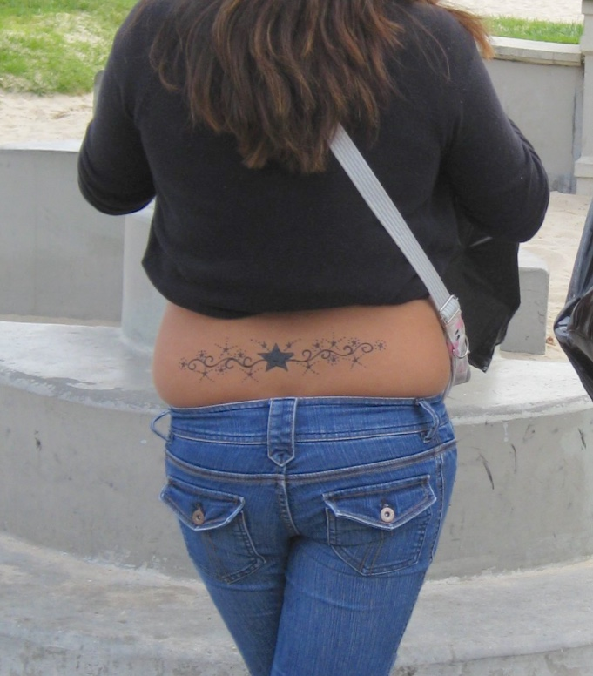
their larger build.
A larger person of style would know that slim jeans would not compliment their
body, so they would wear items more suited for them. Maybe this could include jeans
of a looser fit which would help the body look more in proportion, or maybe skirts and
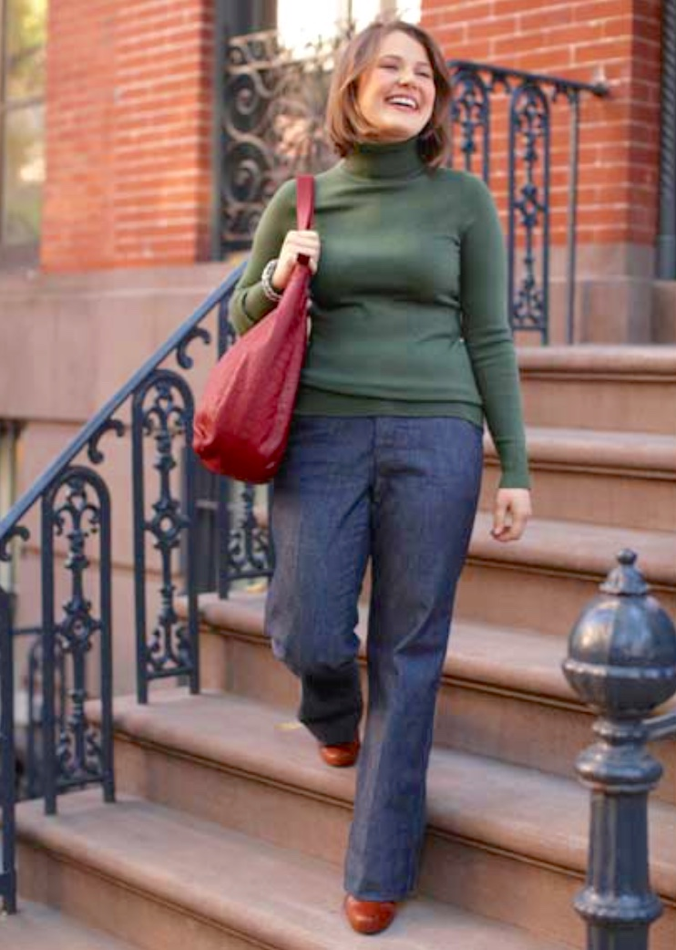
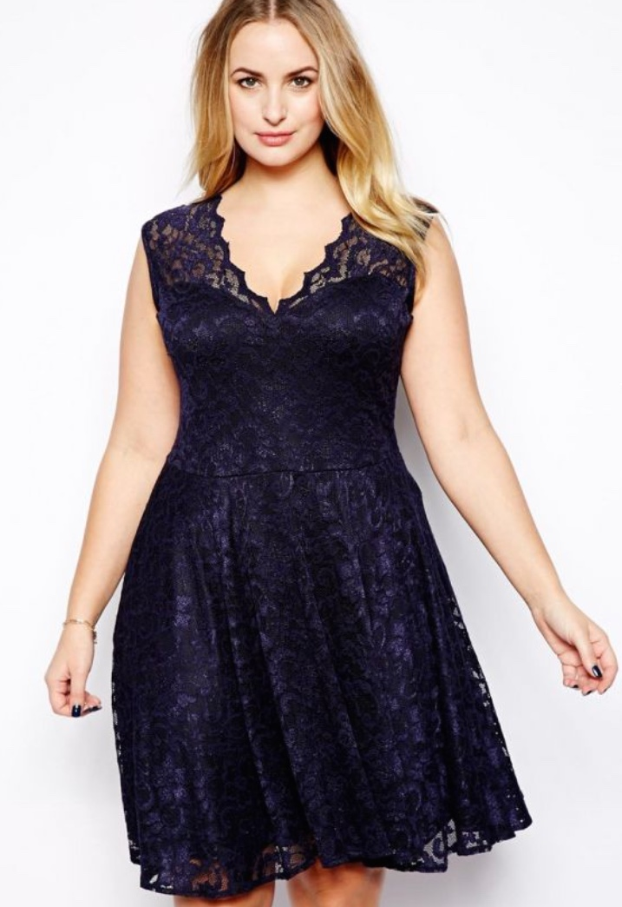
dresses.

As another example we could think about personality expression.
Fashion trends more or less depict the personalities of their designers, and of course for
some people these trends suit them down to the ground, but for many people following
trends alone does not help to express their own personalities.
Below are just a few examples of expression.

Values

Some people may take pride in their environmental awareness and choose not to
buy the latest crocodile skin hand bag, or the latest rabbit fur coat.
Religious beliefs also very much influence people’s style, perhaps a new trend
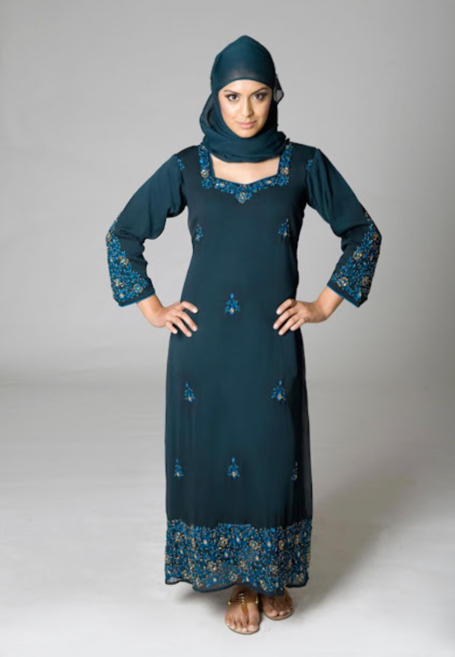

bares too much skin than is considered ‘respectable’.

Attitude

A person with a rebellious attitude may want to wear bold and extravagant
clothes to ruffle the feathers of society.
A head-strong determined attitude could choose a more formal look
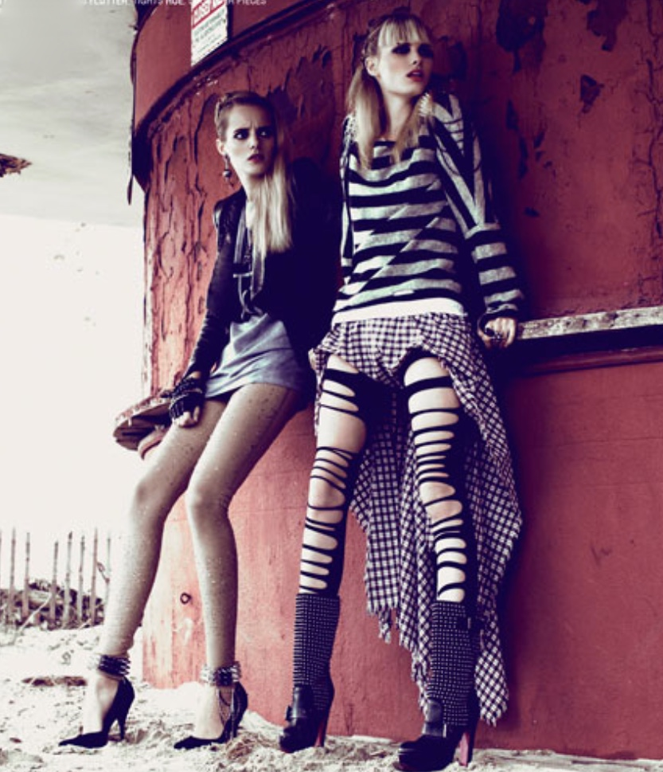
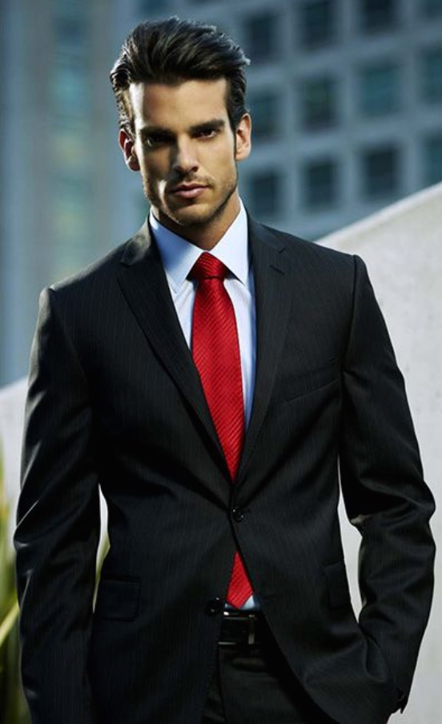
with an eye for a dominant red.

Interests

Entertainment or foreign culture interests etc. can shape a person’s style,
whether it is their favourite musicians or films, or the excitement of travel
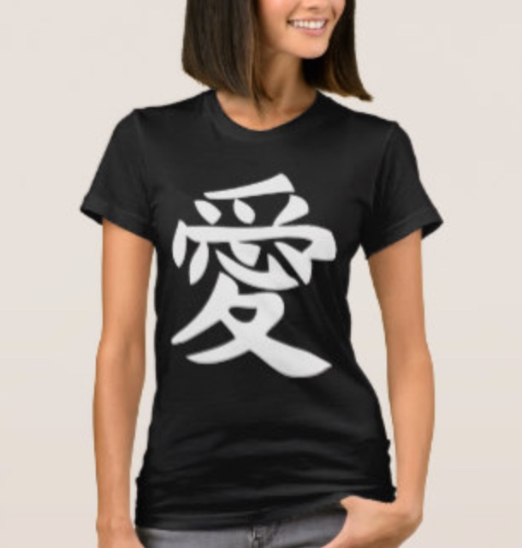
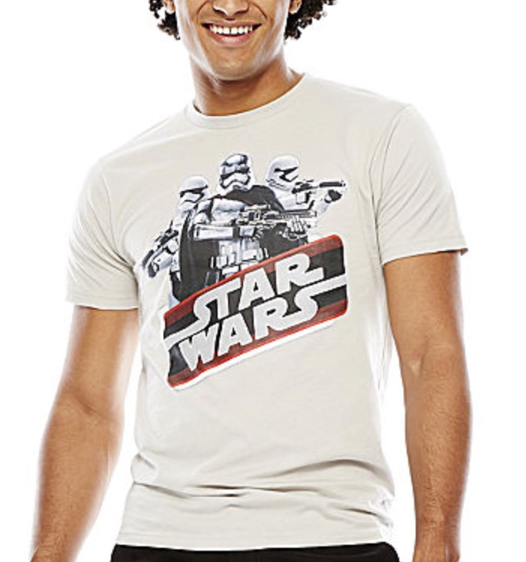
and different languages.

Skills

Another influence on a person’s style are the skills they posses,
for instance various sporting activities, they would choose clothing that
is most comfortable and practical for their particular skills and activities.

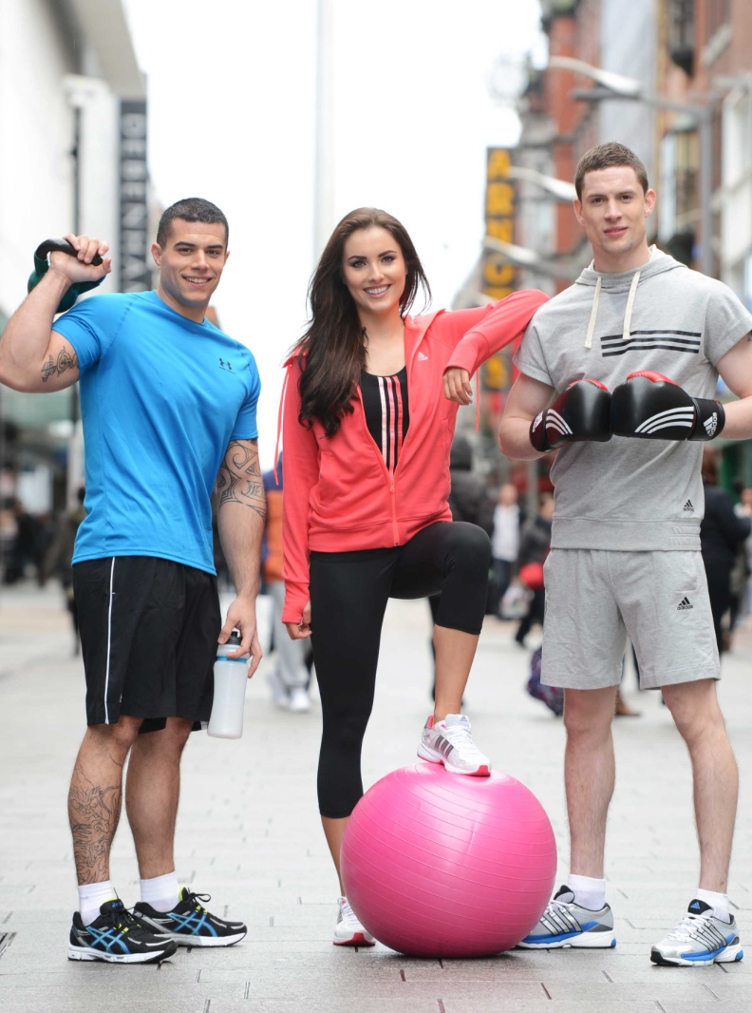
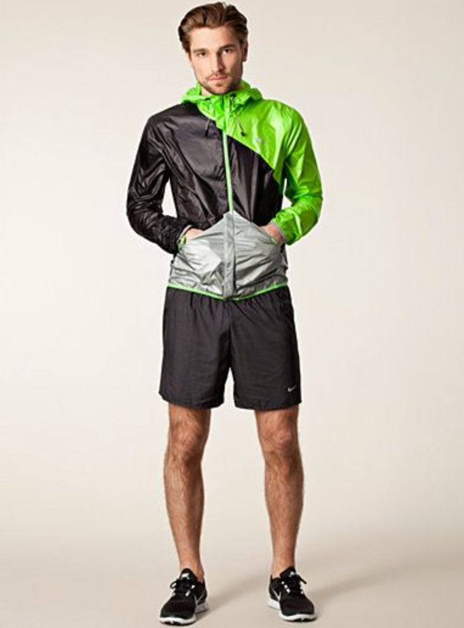

These examples are obviously only a taste of the infinite expressions of personality,
as of course every person is different.
I do however hasten to add that this does not mean that everyone who doesn’t follow
fashion is then by default stylish, no, there are many people whom have very little coherence
with their clothing choices and combinations, this can be down to ignorance and un-interest
or maybe related to their vocation, but randomly selected combinations can’t be considered
either fashionable or stylish.
Being fashionable is taking an interest in and wearing the latest trends.
Being stylish is a coherent and conscious effort to tastefully express your being through your
appearance.

Student Statement:

By submitting this assignment, I confirm that this is my own work.

Student Signature | Christopher Denby | Date | 30/12/2016

