
Assignment Cover Sheet

Student Name: | Maria Magdalena Barragan Zermeno
Student Number: | 1619
Course: | Management Level 3
Assignment NO: | 08

Marking Criteria:
We expect the learners to write minimum one well expressed point in three lines against each allocated mark. This means one needs to write 15 lines with 5 well expressed points to get high grades for a 5 marks question.
For high grades use examples and illustrations where appropriate.
Please insert your completed assignment ( in word format) here:
Question 1

How can you prepare for a meeting?
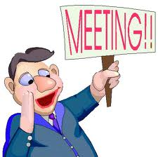
The preparation before is the most important part of a successful meeting. A very important factor in developing confidence during a meeting is planning and preparing for it. This is the crucial foundation and we should dedicate as much time to its preparation as possible. Not only will good preparation ensure that we have thought carefully about the objectives, what we want or need from the meeting but it will also help boost our confidence during the meeting, so we will feel confident and in control, coming out of the meeting feeling happy about the way it has gone.

Meetings can be an effective way of quickly collaborating, sharing information and brainstorming new ideas, or they can be a huge waste of time. It all depends on how they are run and how prepared the attendees are for them.

Meetings are unpopular because they take up time, usually that of many people. There are good meetings and there are bad meetings. They can be an excellent use of time when they are well-run. Unfortunately, the converse is also true, and it seems that time-wasting, poorly run meetings are far too common. However, attending a meeting where important issues are discussed and decisions are made can be rewarding. Effective meeting preparation and facilitation can make the difference between wasting time and getting things done. A large part of what makes a meeting successful occurs in the preparation phase.

A successful meeting is the result of much more than an agenda and refreshments. As with any initiative, its success depends on our preparation, execution, and follow-up. Actions that make meetings successful require management before, during, and after the meeting

The goals we set will establish the framework for an effective meeting plan. As Stephen Covey says in the Seven Habits of Highly Effective People, "Begin with the end in mind." Your meeting purpose will determine the meeting focus, the meeting agenda, and the meeting participants.

Once we’ve developed our meeting plan, we have to make sure that a meeting is the appropriate vehicle for accomplishing the set goals.

If we attend or facilitate frequent meetings, we may be tempted to wing it rather than spend time preparing for each one. But if we're unprepared, meetings may take longer, be less productive, and more meetings may be needed! In the end we can save time by preparing for a meeting.

One problem commonly afflicting meetings is unclear objectives. If we’re not exactly sure what we’re trying to accomplish, we can be sure it won’t happen quickly. As meeting organizer, it’s our responsibility to have clarity about objectives. We need to consult with another team member if we need to; a little extra time at the front end will save more time at the back end.

Before we even announce our meeting, the very first step we should take is to determine why we want to have a meeting in the first place. Don't hold regular meetings just for the sake of having them. Every meeting should have a clear-cut purpose, and that purpose needs to be decided ahead of time.

Example:
The purpose of our meeting may be to share complicated or important information with our team members in a quick and efficient way, to brainstorm potential options for current or future projects, to make a joint decision as a team, or to quickly check in to see how everyone is doing and what everyone needs to be doing next.

When our meetings start with a clear and defined purpose, not only do they end much faster, but we get a lot more done. So, knowing how to prepare for a meeting is important for all employees and critical for any manager or leader. Knowing when not to have a meeting is equally important. We have to run our meetings as we would have others run the meetings that we attend. Running an effective meeting, or being a good meeting participant, is all about being considerate of others.

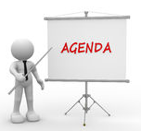
Once we know what our meeting will be about, it is essential that we let everyone involved know as well. The best way to do this is to create and distribute an agenda in advance. This way, we can gather any important information and questions ahead of time and everyone can come prepared to discuss and act on the topic at hand.

We have to be prepared and ensure that all the participants will be as well.
We distribute the meeting agenda before the meeting (early if there is a lot of advance reading or preparation to do) and make sure everyone has access to any relevant background materials. We need to create an agenda that lays out everything we plan to cover in the meeting.

Participants, of course, have the obligation of reviewing the agenda and background materials and arriving at the meeting prepared. If we as the meeting organizer have not provided adequate information about the objectives of the meeting, the participants should take the initiative to ask. No one should arrive at a meeting not knowing why they are there, and what is supposed to be accomplished.


Very often we need to read lots of reports, so reading could be the work-related skill that we use most often! It's also a skill that most of us take for granted. After all, it seems that if we can read and comprehend textbooks, then, surely, we must be good readers; but maybe not. And, given the time that reading consumes in our daily lives, it may be a skill that we can, and should, improve.

But what does becoming a better reader involve? It means getting faster and more efficient at reading, while still understanding what we're reading. An important advantage of speed reading is that we can better comprehend the overall structure of an argument. This leads to a "bigger picture" understanding, which can greatly benefit our work and career.

Speed reading is a useful and valuable skill. However, there might be times when using this technique isn't appropriate. For instance, it's often best to read important or challenging documents slowly, so that we can fully understand each detail.

While reading, external distractions have to be kept to a minimum. To improve our concentration as we read, we have to stop multitasking while reading, and remove any distractions. This is particularly important, because we may find that we read several pages before we realize we haven't understood something properly. We have to pay attention to "internal distractions" as well. Complete focus can cut the amount of reading time in a third, without any loss in comprehension. That should be incentive enough to tweak our attitude.

Simply becoming a faster reader isn't the point; we want to become a more efficient reader, but we must always be aware of the purpose of our reading and decide whether speed reading is the most appropriate approach. When applied correctly and practiced diligently, speed reading can significantly improve our overall effectiveness in reading reports, and it will free up precious time and allow us to work more efficiently in other areas.

There are many things that we can do to improve our reading, as well as our comprehension, and our reading retention, that is, how long we remember the information we're reading, but having the right information is just as important as knowing how to read it, so we need to learn how to gather information more effectively before any meeting.

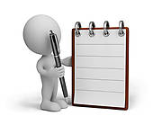
A meeting without an agenda can be disorganized, run long, and be very frustrating. While a meeting with an agenda can be effective, resolve pressing issues, and cover all needed topics. But if there is nothing to put on the agenda, the organizer should ask himself/herself whether there really needs to be a meeting.

If we are responsible for a meeting, creating a practical meeting agenda can make the meeting go smoother and keep everyone on task. When we have many people, it is easy for a meeting to get derailed and lose focus. With an agenda, a meeting can be more effective and we can ensure all needed topics are covered.

For example:
If we are preparing for the weekly management meeting, there will be many topics from multiple departments that need to be discussed. By asking each participant if they have a topic that needs to be added to the agenda ahead of time, we can have a good idea of what the meeting will cover and how long to schedule for each topic. This helps keep the meeting moving and prevents the group getting stuck on a discussion on a topic that lasts longer than necessary.


Providing agenda items several days before the meeting will help ensure the agenda has all of the necessary topics. This requires us thinking ahead and determining if we need to add anything to the discussion. The agenda should be distributed to all participants at least one, if not two, days before the meeting. This allows each person time to review the agenda, prepare for issues that will be addressed, and bring the appropriate information that may be needed. Being an active participant requires being ready with the right data, input, and insights. We can only be ready if we have enough time before the meeting to gather our thoughts and facts.

An agenda provides a meeting schedule, participant list, discussion items, and action items for review. Preparing an agenda before a meeting ensures each person has a chance to add relevant items to the schedule. During the meeting, an agenda helps keep everyone focused on the discussion items. An agenda also lists projects underway so that their progress can be reviewed. It helps ensure the meeting is effective and key issues are discussed.

Example:
Let's imagine you are the sales manager for a radio station. Each week there's a staff meeting to discuss station opportunities and issues. Over the past several months you had noticed that the staff meeting was running longer with fewer decisions being made. In fact, important issues were being ignored because the meeting was so disorganized. Then two weeks ago the station manager implemented an agenda to help keep the meeting on track and discuss all relevant issues. The agenda has already made a drastic improvement in meeting productivity.

Always briefly review the agenda including the aims and purposes as the meeting gets started. This helps participants focus their attention and understand what will be required of them. The agenda should have a section for urgent issues that must be discussed but were not planned. These are last-minute issues that cannot wait for the next meeting.

Example:
An example may be that the owner of the business stopped you in the hallway on the way to your holiday planning meeting. She explained to you that she had to be out of town the day of the party and needs to have the party moved to a different day. This is an issue that may change other decisions and should be addressed immediately. You didn't have time to have it added to the agenda and have time scheduled for the discussion because the conversation happened just minutes before the meeting started.

Having some flexibility in the agenda is necessary when last-minute changes or emergencies arrive.

Once you’re in the meeting, put that agenda up on a screen or whiteboard for others to see. This as well, keeps people focused.


For an informal meeting it is still a good idea to send out a notice so that people know the date and time to attend. At the workplace it may be sufficient to email members to ask them to attend an informal meeting.

Obtain Background Information. When meeting, it is helpful to have background, or historical information and proposed suggestions prepared in advance. This helps with answering questions or providing insight on important issues. If decisions need to be made or situations analyzed, having supporting information and documentation is helpful.

Example:
When planning our customer appreciation day for instance, we'd want to know how many advertisers have been with the station for 1 year, 2 years, and 3 years or longer. This information will help us in determining what to do at the customer appreciation event to make it succeed. It allows for questions to be answered before the meeting if clarification is needed. Then the team members are able to make an informed decision.

That is why we should always circulate supporting materials to participants in advance of the meeting. However, deciding how much information to send in advance can present a conundrum. Some people won't look at anything prior to the meeting and some will conscientiously read all the supporting information they can. To make optimal decisions team members need time to read the reports, to think about the issues and to collect the needed information.

Do extract information in a succinct outline or summary whenever possible to make it unnecessary for members to read long or ponderous documents. And don't send anything that is so complex or technical that it requires someone to interpret it. Hand that out at the meeting (or parts of it) and explain what it means.

Pre-work distributed in a timely manner, with the serious expectation that attendees will read the pre-work before the meeting, helps ensure meeting success.

Attach the minutes of the previous meeting, if there has been one. This gives members the chance to bring up anything they do not understand or disagree with.

If our meeting will involve any decision making or last more than five minutes, we need to make sure that someone in the team group takes minutes. Not only can these minutes help people who may have missed the meeting to catch up, but they also serve as an important reminder of decisions made and action steps decided for those who were there. We have to make them available as soon as possible.


Memories can be tricky. Don't give yourself or your colleague the opportunity to disagree about decisions or plans that were made. If the topic of our meeting is important enough to hold a meeting for, it is important enough to get in writing. We ask the minute’s secretary to write down the main points of the meeting for typing up later.

It is important to deliver a copy of the meeting’s minutes to each participant within a few days. This will serve as an action plan and reinforcement tool.

Facilitating an effective meeting can be a satisfying challenge, if we are prepared and familiar with. Scheduling a meeting involves also much more, it requires identifying key people who must attend and either finding times that work for them or notifying them of the meeting's time and location.

For a meeting to be effective, the right people must be present. If decision makers are not at the meeting when decisions are needed, the meeting will be a waste of time; people who have information that is relevant to meeting topics, must attend to ensure the meeting is successful. When some key people are not at a meeting, decisions may be delayed or issues may need to be revisited.

Check with the participants who must attend for the meeting to succeed. The needed attendees must be available to attend the meeting. Postpone the meeting rather than holding a meeting without critical staff members. If a delegate attends in the place of a crucial decision maker, we have to make sure the designated staff member has the authority to make decisions – or we postpone the meeting.

Example:
At the radio station, you want to host a customer appreciation event for your top advertisers. To move forward, you need to get the support of other key managers and the general manager. You make sure the event is added to the agenda. However, when it comes time to present your idea, you determine it's a waste of time because key team members are absent. This delay will either push the event back or disrupt planning.

Giving participants a specific role to play can increase focus and engagement. Consider the following roles:


- A leader or facilitator guides the discussion, making sure all sides of the issue are raised. The meeting leader or facilitator can make a huge difference in a group's productivity. The chairperson must have a strong personality in order to keep the meeting running fairly.


- A secretary: Assign a minute taker before the meeting; it should not be you or the facilitator. He captures key ideas, decisions and distributes notes (this gives shy people a way to participate). The secretary or recorder takes notes on paper, laptop or on flip charts. Meeting notes should be distributed as soon after the meeting as possible. The longer the lag, the less confidence the members have that their investment will result in action. For groups that meet regularly, the recorder is responsible for keeping previous meeting notes and agendas in one place where they can be referenced later such as from a notebook or shared network drive, etc.


- A timekeeper, who helps move the discussion along efficiently; as we have to start the meeting promptly on schedule and not to wait for others to arrive.


- Participants. Some departments or offices find themselves waiting to start a meeting until a quorum has been achieved. This makes it all the more important for members to arrive on time. A contributor keeps the discussion lively and on track. An expert shares knowledge on particular issues. One advantage: We can ask an expert to attend just part of the meeting, keeping his contribution focused.

In a perfect world, you would never need to have meetings about anything, but since we have to have meetings, we should try and do everything we can to make them as effective as possible. (Jacob Shriar, Director of Content at Officevibe)
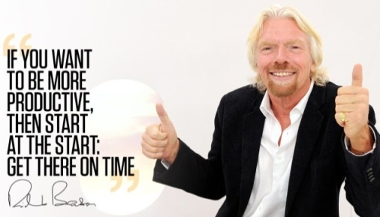
During a meeting

1. - Start and finish on Time.
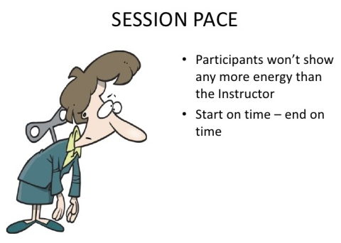
Nothing is more frustrating than starting late or having only a few of the necessary participants ready on time. Starting on time requires discipline by the organizer and the participants. Arriving late shows lack of consideration for all those who were on time. When we facilitate a meeting, we need to remind meeting attendees of the start time and emphasize the importance of arriving shortly before the start time. Way too much time is wasted on late arrivals. Certain people would be habitually late, thus regularly wasting some 5 to 10 minutes for the entire group and penalizing the punctual. A simple solution is not to wait for latecomers. Start the instant you’re scheduled to. Soon enough people will get the idea… no one likes to be embarrassed by straggling in during the middle of a cogent discussion. Doing this a few times and we’ll develop a reputation for promptness. Numerous managers have super-punctual reputations and they are respected for it.

Finishing in a timely manner is also crucial. If everyone agreed that the meeting would last an hour, the meeting should not run any longer than that. Keeping the agenda realistic is important, of course. Finally, if only 20 minutes are required to accomplish the meeting objectives, the meeting should end after only 20 minutes. It would be a waste of everyone's time to let it go on any longer than that.


A large amount of professional time is wasted by leaders who wait for more people to arrive before starting a meeting. It may require a change in the culture, but once people know that we start our meetings on time, they will arrive on time. Some groups even schedule 15 minutes of time to socialize before the start of the meeting. Don’t wait for people and don’t summarise for them what they missed when they do arrive. Ignore late-comers.

Use the time effectively. Allocate time for each agenda item and stick to it, leave time for new business. Avoid getting taken off at a tangent, if the discussion moves to something that is not on the agenda, park it; “park” issues once the time is up, they can be returned to at the end or scheduled for another meeting. Some groups maintain a "parking lot" on a separate piece of paper for important issues that come up but are not directly related to the discussion. The "parking lot" can be consulted for agenda planning for succeeding meetings.

Save tangential items for the end of the meeting. Include a time for them on the agenda and encourage people to write down their ideas during the meeting so they remember their questions or comments

Always finish on time. If there are uncovered items schedule another meeting and make sure you manage the time effectively. If new items have arisen, schedule another meeting or save them for the next meeting.

2. - Encourage Participation.
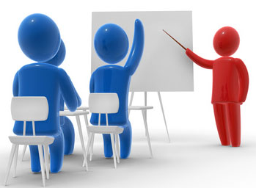
Have a purpose. Ensure all participants understand what is expected of them, are they expected to brainstorm, discuss or sit and listen?

We have quiet coworkers and people who try to dominate every platform. Whether facilitating or attending the meeting, we need to involve each attendee in the accomplishment of the meeting goals.
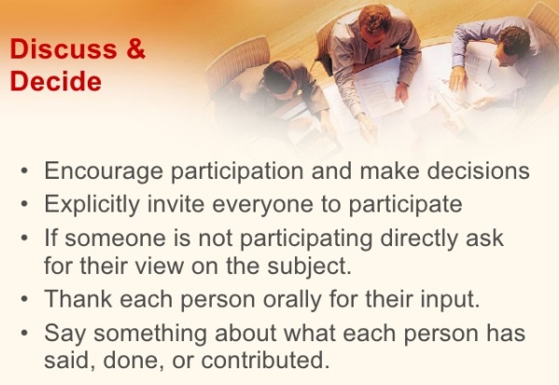
In an increasingly collaborative work environment it is important to plan and conduct meetings that involve each participant, promote a strong sense of community, and most importantly, drive the organization forward.

Effective meetings are participatory and good leaders try to get everyone involved. One effective way of encouraging meeting participation is to ask for discussion points prior to the meeting. These items can be added to the agenda and ensure every person has a chance to bring up important issues for discussion. Another way to engage all members is to ask for input from each member regarding each appropriate issue.

When we’re calling a meeting, we need to take time to think about who really needs to be there. If we’re announcing a change, we invite the people who are affected by the announcement. If we’re trying to solve a problem, we invite the people who will be good sources of information for a solution. When people feel that what’s being discussed isn’t relevant to them, or that they lack the skills or expertise to be of assistance, they’ll view their attendance at the meeting as a waste of time.

“Those meetings should ideally consist of no more than 10 people, and everyone who attends should provide input. If someone has no input to give, then perhaps they shouldn’t be there”. (Kristen Gil, VP of Business Operations at Google)

For example:
1. - If your team is discussing ways to recognize advertisers at your customer appreciation day, each person should have a chance to add their thoughts. By asking each individual for input, you ensure each person can participate without anyone dominating the meeting.

2. - If you plan to brainstorm, state that everyone should speak freely and no judgment is to be made on any idea until the end. If someone makes a judgment statement, simply say, “Let’s save judgment until we are done brainstorming” and move on.

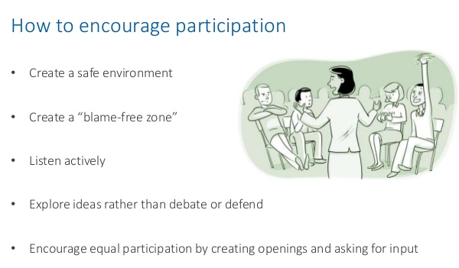

3. - Diffuse Conflict.

Some topics will be more emotional than others and may create conflict in the group. Whenever there is a roomful of people involved in solving a problem, conflict is inevitable. In fact, conflict is good, way better than avoiding problems. As managers we must learn how to harness the power of conflict in a positive way.

For example:
If one team member feels another team member is not working hard enough or meeting deadlines, the discussion could create a heated conversation.

When facilitating a meeting, we need to try to keep the discussion moving toward resolution and minimize time spent pointing fingers or getting stuck on reviewing the problem. We have to encourage participants to suggest solutions and compromise. We encourage participants to participate, and ‘provoke conflict’ if we have to.

Different types of personality conflict in meetings:
Dominating: the person takes a lot of the meeting time expressing self-views and opinions; tries to take control by use of power and time.
Rushing: encourages team to move on before task completion. The person gets “tired” of listening to others, working as a team.
Withdrawing: the person removes self from discussions of decision-making; may want to take control by withdrawing.
Discounting: the person disregards or minimizes team or individual ideas or suggestions.
Digressing: the person rambles, tells stories, take team away from primary purpose/agenda.

Example:
“Leonard Karakowsky conducted a study, and found that senior leaders were more aggressive and vocal in meetings. I can tell you from personal experience, that this is 100% true. What the study found was that the more the rest of the group disagreed, the louder and more aggressive the senior leader would become. Obviously this doesn’t work. There are two solutions to this that I can think of, but both involve being open and listening to other members of your team:
The first will give you really unique insight into whatever problem or issue you’re trying to solve. After a “brainstorming” with the team, and not having any luck, try going to a group of people in a completely different department. This might seem like a crazy idea at first, but you’d be surprised at what kind of insight they could give you.
The second idea is to create a space where employees can feel safe to say anything and not be judged or ridiculed. Not only create this space, but actively communicate that this is the case, and encourage anyone and everyone to participate. Once you remove the fear element, people will be much more likely to come up with creative ideas to help solve problems.
I obviously am a big fan of flat hierarchies, but even if your organization isn’t flat, make this meeting space flat. As crazy as this sounds, encourage a low level employee to feel comfortable challenging an idea that a senior VP came up with. It’s through this type of open, transparent communication that real innovation happens. (Jacob Shriar - March 31, 2014)

4. - Create Action Items.
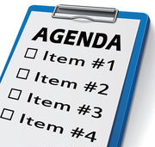
A meeting must have a specific and defined purpose. An effective meeting is one in which problems are discussed, opportunities evaluated, and plans are made to move forward. In moving forward, action items must be determined, including the responsible party and the due date for completion.

One problem commonly afflicting meetings is unclear objectives. As meeting organizer, it’s our responsibility to have clarity about objectives.

For example:
If your team determines that a venue needs to be selected for your customer appreciation event, the responsible team member may have several action items: meet with three potential venue managers, identify venue benefits and drawbacks, and make a recommendation to the team. Each of these action items will have a due date and progress will be reviewed at appropriate timeframes.

By identifying specific actions, who will complete the actions, and when results are due, our meetings can be more productive.

5. - Agree on action plan.

An action plan outlines the specifics that must be done. Not every goal needs an action plan, but for goals that involve more than one person, it's usually helpful to be specific about who will do what by when. Every goal should have a person charged with ensuring that the goal is moving forward. That person is not expected to complete the goal personally but to connect the people involved, make progress reports, and seek assistance or resources needed to keep the goal moving forward.

If the participants leave the meeting and no one is accountable for taking action on the decisions that were made, then the meeting will have been a waste of everyone's time. We need to have concrete actions and ensure that the discussion ends with definitive actions: ‘who will do what by when’.

6. – Follow up.
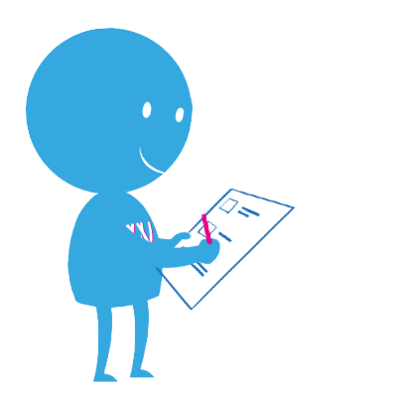
It’s quite common for people to come away from the same meeting with very different interpretations of what went on. To reduce this risk, we can email a memo highlighting what was accomplished to all who attended within 24 hours after the meeting and document the responsibilities given, tasks delegated, and any assigned deadlines. That way, everyone will be on the same page.

This is a very crucial part of effective meetings that often gets overlooked. We need a written record of what transpired, along with a list of actions that names individuals who have agreed to perform; we summarize what happened, briefly review meeting results and next steps and inform participants that we will be sending out a meeting summary

Respecting and observing deadlines and follow-up will help us achieve results from our meetings. The deadline has to be established during the meeting. Following the meeting, each person with an action item should also make a plan for their personal accomplishment of their commitment. Whether they write the steps in their planner, delegate the tasks to another staff person, or just complete the task, the individual is responsible for follow-up.

So, we can improve meeting results by following up with each person who has an action item mid-way between meetings. Our goal is to check progress and ensure that tasks are underway.

Don't assume that ideas discussed during a meeting will be put into action or even remembered. To ensure follow-through and accountability a meeting leader needs to do three key tasks after the meeting ends:

Distribute minutes
Ensure that minutes are produced and promptly distributed to all attendees including guests. Meeting minutes don't need to include everything everyone said. They do need to include the following:
- Date, time, location
- Attendees
- Key points raised and decisions made
- Motions and voting results if votes were taken
- Who is responsible for what follow-up action and by when
- Name of the Recorder
It is important to keep accurate minutes to avoid disputes in the future.

Archive meeting documents
All meeting documents including the agenda, minutes and supporting documents should be kept together and archived. These records can be checked when questions arise about past decisions or actions. It is discouraging to people or group members to rehash prior discussions or decisions because of poor record keeping.

Check on action
Often people need a gentle nudge to remind them about completing action items. Leaders need to check to ensure that action is taking place as agreed. The check can be an E-mail or phone call to the point person or a meeting devoted to checking on progress. Not checking may send a message that not much action is really expected.

Note: Every goal and action item needs a "point person". This person is responsible for reminding everyone of action items, connecting people to their work and following up with colleagues to make sure the work has been completed. The point person also reports on results.

Rapid experimentation with meetings in the past decade by startups and Fortune 500 companies alike has produced a new set of rules to consider. Here are three that seem to be universal:
- All meetings must have a stated purpose or agenda. Without an agenda, meetings can easily turn into aimless social gatherings rather than productive working sessions.
- Attendees should walk away with concrete next steps or Action Items. We love Action Items here, but we’re not the only ones. From Apple to the Toastmasters, the world’s most successful organizations demand that attendees leave meetings with actionable tasks.
- The meeting should have an end time. Constraints breed creativity. By not placing an end time, we encourage rambling, off-topic and useless conversation.

Keep your contributions short.


Nothing derails a meeting faster than one person talking more than his fair share. If we notice one person monopolizing the conversation, we have to call him out and say, “We appreciate your contributions, but now we need input from others before making a decision”. Our point is more likely to be understood and have an impact if we keep it reasonably short. We need to present our ideas clearly and concisely.

An agenda keeps the meeting tight and stops people talking about one particular subject for too long; but most groups have at least one person who tends to go off on a tangent, and then all meeting participants have the responsibility of gently guiding the meeting back to the substantive agenda items. On occasions where we find the discussion is becoming too lengthy, we should interject, summarize it, and bring it back on track. So, don’t forget, keep your message short, respectful and to the point.

Example:
“Recently, I received some feedback from my manager that I need to be “cautious of meeting etiquette,” that I should work toward not taking over or dominating the conversation in meetings and not feel as though I have to share everything that I know in a meeting. I know this feedback is warranted — I am definitely a talker, and I grew up in a household where if you didn’t interrupt someone else you never spoke because there was never a lull in the conversation. I have had similar feedback before and though my manager acknowledges that I am getting better about not interrupting my coworkers, apparently this is still an issue as I am still receiving this feedback. I’ve tried to simply remember to stay quiet and let other people talk, but then I get excited about something and forget. (ALISON GREEN on APRIL 26, 2013 I talk too much in meetings!)

“People complain about how many meetings we have and how long they last, and then they keep talking in the meetings. I speak up when I have a question but other than that, I keep quiet.”
“They’ve confused number of contributions in a meeting with value of contributions.”

Don’t take so many ‘notes’ that you lose track of what is going on.

Regardless of how good we think our memory is, we will need to take notes in certain situations to remind ourselves what was said. It is a mistake to think, when going to a meeting or attending a lecture or some other important talk, that we will remember the details of what has been said - we won’t. We may well remember the overall topic of the discussion, even some very specific details, but we won’t remember everything.

It is important to recognise that taking notes should not distract us from listening intently to what the person talking is saying. Effective note-taking involves listening whilst jotting down key points that will be important later: in a business meeting this may include action points that we have agreed to attend to; in a lecture this may include new vocabulary or theories that we can investigate further later.


Before we can take effective notes we need to be somewhat organised. It may seem obvious but we need to remember to take some appropriate note-taking equipment with us to meetings. The nature of the ‘appropriate’ note-taking equipment will depend partly on us and partly on the circumstances. The simplest low-tech way of taking notes is to use a pen and a pad of paper. Bring plenty of paper and at least one spare pen or pencil. Some people prefer to take notes on a laptop, tablet, smartphone or some other device – this is fine as long as we are very comfortable with the technology - so that we can concentrate fully on our notes – not on the actual process of writing them. If we are using some form of computer to take notes it is usually a good idea to turn off any messaging services first – otherwise we are likely to be distracted by new emails, text messages or the like.

Sometimes we just need to write down the things that affect us, things that we are responsible for doing before the next meeting or things that will jog our memory when it comes to reporting back to our employees or supervisor.

Avoid interrupting others to make your contribution. Do not let others interrupt you.

The interrupter starts talking before others are finished because he/she becomes impatient and overly excited. A strategy is to jump in immediately, telling the person for example: ‘Hold on, let her finish’. And if certain people are dominating the conversation, make a point of asking others for their ideas instead.

Now, we don’t want to be plain rude to the interrupter, thereby sinking to their level. The ability to communicate well is key to professional success, and we can’t communicate well if we’re constantly being talked over. “In general terms, the first step is to avoid sending a message that we can be interrupted.” This means trying to keep pauses short, maintaining our momentum as we speak and keeping our voice loud and clear. Lowering our tone can also add gravitas and authority to what we’re saying.

There are times when during a meeting we might find it difficult to get our contribution in, and we do have to interrupt; then we should do it firmly but politely. Once speaking, we need to be careful not to fall into the temptation of making several points for fear of not getting in again.

Keeping everyone's focus on the topic of discussion is imperative as this minimizes the number of interruptions and keeps proceedings within the set timeframe. By displaying a lack of tolerance of interruptions such as heckling or bullying tactics whilst someone is speaking we ensure that everyone is shown the same courtesy and that their contribution is valued. We should reaffirm that anyone wishing to contribute indicates their intention to the Chair, who at a convenient point will ask for their input.

Many, but of course not all, chronic talkers tend to be more extroverted. Since extroverts are more likely to think out loud, talking a lot is often just their way of thinking through a complex situation. You can then invite them to make constructive and focused contributions and keep diversions to a minimum. The more focused we are able to keep discussions, the greater others will be encouraged to contribute as they feel their input is valued

The Whisperer constantly whispers to a neighbor and makes it hard to concentrate. We need to have the courage to tell them to stop the conversation, be quiet, and look at the people talking. Ask the whisperer if he/she wants to share their conversation.

Think about your non-verbal behavior.


While researchers argue over the exact percentages, most would agree that more than 50 percent of communication is non-verbal. A manager needs to be able to read the group’s tone and body language in order to assess their level of engagement, candor, and commitment. So, watch body language and make adjustments as necessary. Perhaps a break is needed, or we need to stop someone from speaking so much.

Controlling the meeting is our key function as leaders; without control we will not be able to achieve the meeting objective. Our actions, attitudes, and body language will be major influencing factors in how well we maintain control, and should illustrate that we will not tolerate private discussions taking place during the meeting.

We need to be aware that some people may be hesitant in commenting because they are shy or withdrawn. We have to look out for body language signs, such as a subtle shake of the head or a furrowed brow, that indicate a difference of opinion, and ask for that person's view of the issue. Our ability to anticipate and defuse such situations can be greatly enhanced with preparation.

Knowing in advance the preferences and stances of the participants, and how different groups relate, will be of great assistance. It is often questions or suggestions from unexpected quarters that make others aware of a potential new approach to an issue.

Both the volume and tone of our voice are important here. If we are too quiet we will lose impact and be open to interruptions. Eye contact is also important. By actively listening to all aspects of the discussion we will quickly perceive any changes in tone, from a constructive to a confrontational mood in the group. We have to try to regain control of such situations by summarizing arguments and refocusing the participants onto the agenda item and the required outcome.

It is better to sit somewhere that makes it easy to catch the eye of the chair so that we can get our contribution in. While we are speaking, we need to distribute our eye contact throughout the meeting, but direct it at those for whom our contribution is most relevant. This enables us to judge how our contribution is being received.

If we're unaware of it, our body language will give our group constant, subtle clues about our inner state. If we're nervous, or if we don't believe in what we're saying, the group can soon know. We need to pay attention to our body language: stay straight, take deep breaths, look people in the eye, and smile. Don't use gestures that feel unnatural.

Time your contributions.

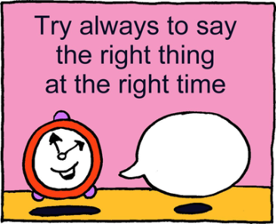
Generating a number of different options may seem to make our decisions more complicated at first, but the act of coming up with alternatives forces us to dig deeper and look at the problem from different angles. A common difficulty we experience in this area is how to time, pace and phrase our contributions so as to maximise their persuasiveness and impact.


There’s a difference between having an opposite opinion and being a problem to other people. If we’ve found that we’re regularly getting excluded from conversations or kicked out of meetings for the apparent crime of not agreeing with everyone, then it may be that the problem isn’t what we have to say, but how we’re saying it.

One of the first things to consider when we have an opposing opinion is whether there’s a real need to actually express it in the first place. The fact that we may disagree with the team doesn’t necessitate sharing that disagreement, nor does having an opinion mean that we absolutely must make our position known. Yes, we may have strong feelings about the topic… but not every thought we have needs to be shared.

While we believe in “we have a right to what we can defend”, there’s a time, a way and a place for challenging others – and many people wrongly assume that’s “any time”.

If we want to influence a discussion it is not just what we say that counts but also when we say it. We have to raise points at the relevant time for maximum impact and not wait until the last minute before airing an opposing view - if others are on the verge of making a decision they will be irritated if we suddenly come up with opposition.

If after exploring all the options we find ourselves in the minority and time is pressing, it can be assertive to "fall in" with the majority rather than prevent the meeting from progressing. We will not stick stubbornly to a point of view but willing will yield when necessary for the progress of the group.

If we’re looking to share our opinion, especially when it’s unpopular in the group, then we need to give the group the respect we’re hoping to receive from others. People may not agree with us but they will respect us… assuming that we give them that same respect, too.

If we’re able to show that we can be a part of the team and participate in it as a whole, then people are far more likely to give respect in return, even if we disagree on some subjects. Plus, being a valued member of the team means that people are more likely to listen to our opinion and take it seriously instead of just dismissing it (and us). Don’t forget to consider how people in the group might influence, or be affected by our opinion.

Use the CBI technique: If you want to control an item make your contributions early. This will make it easier for you to set the tone and direction of the meeting’s discussions. If you want to build on others’ contributions make your contributions later on, once others have made their initial points. If you want to have maximum impact in terms of people remembering you and your point, make your contribution at the end of the discussion.

Effective Meetings Ineffective Meetings
People come to meetings prepared Nobody prepared
Meetings start and finish on time Meetings start late and end late
Everyone gets to talk Certain people dominate the conversations
Decisions are made by the group Certain people dominate decisions
Actions get accomplished Nothing gets accomplished
Someone takes notes or minutes No record of meetings so discussions
occur over and over again
Agenda is prepared No agenda
Have a chance to see the agenda
ahead of time
Can add to the agenda.

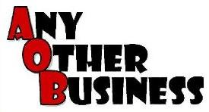

Finally, at the end of the meeting we ask if anyone has any other business, known as AOB, at the end of the formal meeting. Set a date for the next meeting and formally close the meeting.
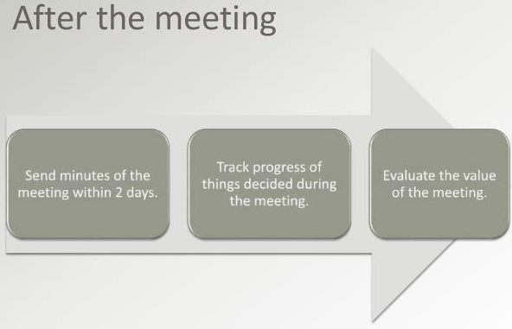

These simple points can go a long way in making meetings more productive. Implementing them is not always easy, as they require preparation and discipline, but doing so can make a huge difference to the productivity of our organization.

Examples:

Google
In a recent issue of “Think with Google,” Google VP of Business Operations Kristen Gil described how the company spent 2011 getting back to its original values as a startup, which included reconsidering how the company approached meetings.
“One of our first observations was that many meetings weren’t working as well as they should. A well-run meeting is a great thing; it empowers people to make decisions, solve problems, and share information. But badly-run meetings are a demoralizing waste of time. We didn’t want our employees to waste either time or energy, so we gathered input and made some recommendations to help make meetings more effective.” (Kristen Gil, VP of Business Operations at Google)
Some takeaways:
- All meetings should have a clear decision maker. Gil credits this approach to helping the Google+ team ship over 100 new features in the 90 days after launch.
- No more than ten people at a meeting. “Attending meetings isn’t a badge of honor,” she writes.
- Decisions should never wait for a meeting. Otherwise, the velocity of the company is slowed to its meeting schedule. If a meeting needs to happen for something to get done, hold the meeting as soon as possible.
- Kill ideas, and meetings. After Larry Page replaced Eric Schmidt as Google CEO, the company quickly killed its Buzz, Code Search, and Desktop products so it could focus more resources on less effort. Focus has to permeate every aspect of a company, including meetings.


Apple

During the Steve Jobs era, Apple constantly worked to stay true to its startup roots while becoming the largest company in the world.

- Every project component or task has a “DRI.” According to Fortune’s Adam Lashinsky, Apple breeds accountability at meetings by having a Directly Responsible Individual whose name appears next to all of the agenda items they are responsible for. With every task tagged, there’s rarely any confusion about who should be getting what done.
- Be prepared to challenge and be challenged. There are dozens of tales about Jobs’ ability to aggressively question his employees, sometimes moving them to tears. While you probably don’t need the waterworks at your office, everyone should be willing to defend their ideas and work from honest criticism. If a person has no ideas to defend, they shouldn’t be at the meeting.


Technically Media

Not exactly Apple or Google, but at my previous company, Technically Media, we worked hard to make meetings as useful as possible. We met only once a week to update one another on progress, propose new ideas and hammer out any problems. We kept to an extremely strict time table and meeting structure as detailed by my fellow co-founder Christopher Wink on his personal blog. Some key observations:
- There is no judging in brainstorming. Focus on capturing ideas before filtering and critiquing them.
- Bring solutions, not problems. Solutioning in the middle of a meeting wastes precious communication time. If you can’t bring proposed solutions to the table, save it for next time or bring it up in private conversations.
- Review “homework” from the last meeting. Not only does it remind participants what happened last week, it holds attendees accountable.
(Sean Blanda Editor-in-Chief and Director of 99U)


37Signals

If it were up to 37 Signals, there would be no meetings at all and discussion would be limited to IM and email. In the company’s best-selling book Rework, they urge creatives to remember that “every minute you avoid spending in a meeting is a minute you can get real work done instead.” In fact, the firm even created National Boycott a Meeting Day in 2011. But if you absolutely must meet, they have three rules:
- Keep it short. No, shorter than that. And use a timer to enforce the time limit.
- Have an agenda.
- Invite as few people as possible.


Question 2

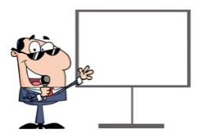
What are various tips for delivering an outstanding presentation?

A presentation is a way of delivering or demonstrating our idea to a specific audience. The idea or topic can be presented to the audience by giving a demonstration, a speech or a lecture.

Whatever our career path, presentation skills are critical to our success. Even if we are not a professional performer, sooner or later we will have to give a presentation to an audience in order to reach our goals. At that point, our chances of success will be a lot higher if we know we can deliver an exceptional performance.

Preparing a good presentation requires enormous skills. One has to keep many things in mind while preparing a presentation.

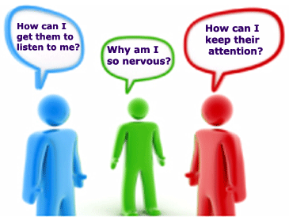

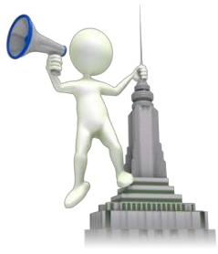
1. - To Command Attention
“The beginning is the most important part of the work.” Plato

First impressions are powerful. Believe it. The first 2-3 minutes of the presentation are the most important. The audience wants to like us and they will give us a few minutes at the beginning to engage them; don’t miss the opportunity. Most presenters fail here because they ramble on too long about superfluous background information or their personal or professional history, etc.

When we start speaking, our opening statement is essential. People who have not formed an opinion about us by just looking at us will certainly form their opinion on the basis of what we are going to say by the start of our talk.

We need to make a good impression that’s why it is important to dress professionally and appropriately; it is important to look well groomed. Make sure clothes are well fitting and laundered. We have to keep our hands out of the pockets. Always wear comfortable shoes when presenting and do not wear anything that distracts the audience.
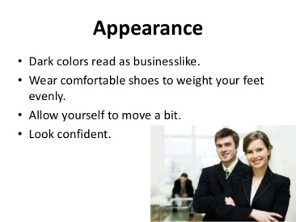

How we walk to the stage and face our audience reflects our confidence and enthusiasm. People are forming opinions about us and our presentation just by the way we walk to the stage.

Who can forget Jennifer Lawrence’s approach to the stage to accept her Oscar for Best Actress in 2013 for her role in Silver Lining Playbook? She fell. She did, however, recover very gracefully.

We certainly don’t want to fall going to the podium. We want to appear confident and in control.

For any speech, we have to remember that it begins as soon as we stand up and start moving, not when we’re centre stage about to begin our presentation. When we’re introduced we walk with purpose and confidence to the podium and shake the hand of the person who introduced us.

If we’re speaking from the podium, we set our notes down, adjust the microphone so it points to our mouth and plant our feet. Take a breath. Look up. Take another breath. If we’re giving a speech without a podium, we walk to where we want to stand, plant our feet, take a breath, look at our audience, and then take another breath.

Do not stand too far back from your audience or rest or lean on a desk or chair; try to keep your body facing forward. Stand straight and be conscious of your posture and stature, not letting hips drop. Keep your feet with shoulder width apart.

Get closer to your audience by moving away from or in front of the podium. The podium is a barrier between us and the audience, but the goal of our presentation is to connect with the audience. Removing physical barriers between us and the audience will help us build rapport and make a connection.

To be engaging with our audience we have to be free to walk among them if we can, or at least vary our position on stage, so that we will appear to be approachable to everyone in the room. We can use a remote device so that we can change slides easily on the screen without having to be stuck behind a computer.

Move, but don’t do any dancing around, no repetitive shifting your weight from foot to foot. And make your walk natural…the beat of your walk should match the beat of your talk. Your facial expression, appropriate for subject, will convey the meaning appropriately.

Don’t hide at the back of the room with the projector. Get up front where your audience can see and hear you. Also, just because you have a remote, don’t wander too much around the room; it will only distract your audience. Remember you are the focal point of the presentation.

“When we speak, we have about 60 seconds to capture our audience’s attention, establish credibility, orient them to our topic, and motivate them to listen.” (Darlene Price, president of Well Said, Inc.)

If we waste those precious opening seconds with a joke, an agenda, an apology, housekeeping details, a string of thank-yous, or a rambling pointless paragraph littered with “ums” and “uhs,” our audience’s minds are likely to drift, and we may not get them back. We need to put the art in the start, the most important part of the work.


Being prepared and knowing our goals clearly have a vital and significant role in our ability to capture the attention of our audience. Ensuring that our presentation has been tailor made and fine-tuned for the people in front of us is one of the greatest keys to enable us to command attention. We need to persuade our audience that our presentation is worth listening to.

Present your material in a well-organized manner. However, be flexible to adjust to your audience. A good presentation starts out with introductions and may include an icebreaker such as a story, interesting statement or fact. So, begin with a powerful introduction.

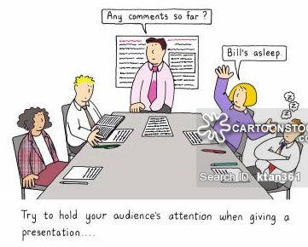
“Of all the starters, storytelling is among the most powerful and consistently successful. As humans, we’re hard-wired to enjoy and learn from stories; heroes, villains, conflict, plots, dialogue, and lessons learned draw us in, remind us of our own lives, and hold our attention. Stories are powerful tools for persuasion because they engage people at the emotional level. As soon as we start to tell a story, they drop their guard a little and go into the ‘Storytime trance’ they remember from childhood.

The most important thing is that the story will be meaningful and relevant to our specific audience. If it is a business presentation and we want to make the link between the story and our proposed action crystal clear, we use an anecdote that they or their customers can relate to from direct experience. The story can be about us personally, which tells the audience first-hand why we’re invested in and passionate about the topic. Or we can tell a story about another person who the audience can learn from. The idea is that we start with a brief narrative that launches our speech and captivates our listeners, making sure the story encapsulates the key point of our message.

We can also state a shocking statistic or headline starting our presentations. The statistic, bold claim, or headline needs to be directly related to the main purpose of our presentation. Its impact ideally persuades the audience to listen and respond positively to our recommendation and next steps.

Example:
A prop is a magnetic tool that hooks our audience and keeps them watching or listening. A visual aid can also help emphasize a point.
A sales VP at a large insurance company, happens to be an avid tennis player. He wanted to kick off his annual meeting with a bang, so he “brilliantly used his tennis racquet to emphasize ‘acing the competition,’ ‘rallying together as a team,’ and winning a ‘grand slam’ through great customer service.” Year after year, other speakers were compared to this leader’s creative ability to present a motivational message.

In business presentations, we are in charge. We are the leader. As the leader in a presentation, we are in charge of the pace, flow, and impact of our story. If we talk, change slides and keep on talking, what should the audience do? Should they listen to our words? Should they focus on the slide? What is the right place to look? They aren't sure. So, slow down and do one thing at a time. Prepare participants for what's in the next slide, before you go there. This is important. The mind can wander. It's our job to tell people where we are and what's coming next, before we go.

We must construct our presentation in a way that our audience can easily comprehend and relate to our idea.

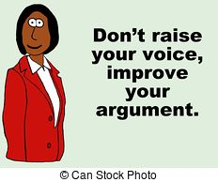
Our voice matters. An authoritative, expressive voice really can make a big difference. “There are scientific studies that show that the characteristics of somebody with authority is that they speak low, slow, and with intonation,” explains Benoit Curdy, a computational linguistics graduate from Lausanne University in Switzerland who co-founded the computerized voice coaching start-up ‘Vocalyptics’ in Dublin.

A good example of an authoritative voice, Curdy says, is the voice on the New York subway that says, "Stand clear of the closing doors" (Pellett's voice has been designated as the official "voice" of the New York City)

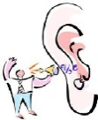

“Listening to a badly tuned voice is like a badly tuned radio,” says Alan Mars, a voice coach based near Brighton in the United Kingdom. “It tends to get people to switch off.”

Voice is power; it enables us to make dynamic and ground-breaking changes to the way we communicate, through the power of our voice, our body language and the clarity of our message.

Once audience interest is gained, we must help them to retain it. Members of the audience may drift in and out without paying attention at all times. We need to help the audience refocus periodically. It is also good to let participants know if we wish to field questions during or after our presentation.

We need to use connective sentences and phrases to remind our audience of what they have just heard and prepare them for what they are about to hear. This will help our presentation flow from one idea to another. Then we summarize and state our subordinate conclusions. Confine them to one sentence if possible, or to a small series of very short sentences. We need to choose our major points carefully illustrating them with examples or stories.

We need to keep our opening simple and exciting to engage our audience in our content. If our audience enjoys and remembers our presentation, it is because we presented it in a dynamic or compelling manner.

Audience attention is greatest at the opening and then again when we say something like “In conclusion….” This is just the human condition. So, if we have 30 minutes for our talk, we need to finish in 25 minutes. It is better to have the audience wanting more (of us) than to feel that they have had more than enough.

2. - To Control Fear

"The mind is a wonderful thing. It starts working the minute you're born and never stops working until you get up to speak in public." (Unknown)

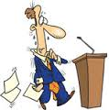
Public Speaking can be as nerve-racking as meeting a new boss for the first time. Sweaty palms, shaky voice; all this even though we have taken every public speaking course known to man and we know our technical stuff (our presentation) well.

When we have to speak in front of others, we can envision terrible things happening. We imagine forgetting every point we want to make, passing out from our nervousness, or doing so horribly that we'll lose our job. But those things almost never come to pass! We build them up in our minds and end up more nervous than we need to be.
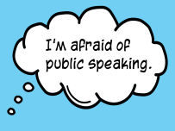
You don't have to worry, because you are not alone. Podium panic may happen to all of us no matter how many times we've stood in front of an audience.

"There are two types of speakers: Those who get nervous and those who are liars." (Mark Twain)

Cope with stage fright by remembering that it is normal and anyone could feel it. The key to minimizing its control over us is creating a strong relationship with the audience so we control their reactions to our presence. The more eye contact we have with one or two people and the more we can get even one person to react in a positive way (i.e. shaking their head or giving a chuckle) the more we are creating a personal connection-a relationship-with those individuals, and the more we will feel ourselves engaged in something similar to a personal conversation. We will notice that our heart rate slows, and our voice regains all of its strength. Ultimately, we will actually start to enjoy the repartee with our new found friends because our focus will be on the give and take between us and them instead of focusing on us up front and them out there; so, we’d better focus on delivering our message, not on how we feel.

Take a deep breath, relax, and smile. And start speaking slowly, pace your presentation. Don't underestimate the power of a long slow deep breath. It maximizes the amount of oxygen that flows to the lungs and brain; interrupts the adrenalin-pumping "fight or flight" response; and triggers the body's normal relaxation response. In the moments leading up to your presentation, breathe deeply and deliberately and try to keep in mind that mostly our audience is more interested in what we have to say, than in critiquing our ability to say it.

Nervousness before a talk or workshop is healthy. It shows that your presentation is important to us and that we care about doing well. The best performers are nervous prior to stepping on stage. We can use nervousness to our advantage and channel it into dynamic energy about the topic. We speak about what we know; keeping our presentation within the realm of our knowledge and experience will build confidence and minimize our nervousness.

The quality of our presentation is most directly related to the quality of our preparation. Rarely will you have difficulties in your presentation due to being over prepared.

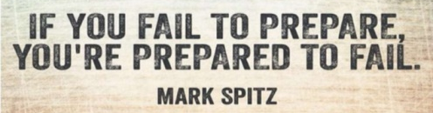
If you were an actor, you would not be performing without first rehearsing your part. Your presentation should be no different. It is a show too, so, before the actual day, we need to rehearse our presentation; we can do it with a listener or a group of listeners asking them to give us verbal feedback against each aspect of our rehearsal; what would we need to improve? Remember, our preparation will never be ‘too much’. Our comfort level with presenting will be high if we know everything about our topic. After all, the audience is looking to us to be the expert.

We can also get audience feedback before the actual speech. It is important to not just ask for a peer to watch the presentation but also provide us with critical feedback so that we can make improvements. Critical feedback is when someone tells a presenter the areas that need improvement through suggestions. If we invite a co-worker to our speech, it would be necessary to ask them example questions, such as:
- How was my eye contact?
- Is the speech engaging?
- Did I speak too quickly?
- What areas need improvement?

Have the person sit at the back of the room so you can practice speaking loudly and clearly. Ask your listener for honest feedback about your presentation skills. Make changes where necessary and run through the whole show again. Keep repeating until you feel comfortable with the process.

Do the ultimate test for yourself before the big day. Record your voice while you run through your whole presentation. Then play it back to hear how you would sound to the audience. You might be surprised.

If we have access to the spot at which we will stand while giving the speech, we can go there and do practice rounds patiently taking it from top to bottom without cutting corners while practicing at the venue.

It is important to think of things like where we will stand, where the audience will be seated, will there be light on our face, etc. to familiarize ourselves with our surroundings. Familiarity will boost our comfort and confidence levels on the day of our speech.

So take time to rehearse, and preferably in front of people, so that you can see what works and what doesn't. An added bonus of rehearsing is that we will become more comfortable with our material and the live show will not come off as a recitation of facts.

A good practice is to rehearse in front of a few colleagues or friends who have limited knowledge of your topic. Be willing to accept their constructive criticism, as they are the best audience to tell you whether your material is clear, and interesting.

What works while rehearsing at home or the office may not come off the same in the actual room where we will present; so, if at all possible, we can arrive early enough so that we can become familiar with the room setup and sit in the seats as if we were an audience member; this will make it easier for us to judge where to walk about and stand during our time in the spotlight.
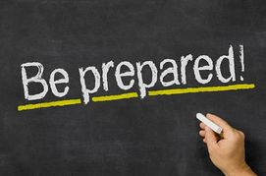
It is surprising how many people fail to properly rehearse their presentation. They might go through it once or twice and think all is well. Keep in mind that you are not your best critic. The more you practice a presentation, the more you will sound as though you are presenting spontaneously. It takes great practice to pull off a flawless, professional presentation.

Example:
Steve Jobs was a famously inspiring speaker. His speeches may have looked effortless, but, in reality, each one took days or weeks of preparation.

Careful preparation is essential. The amount of time we spend on planning depends on our situation, but it's a good idea to start early – we can never be too well-prepared.

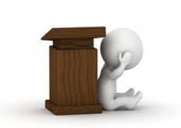
Practicing reduces nervousness and gauges a speaker's energy level. Many presenters quickly realize that giving a speech without any practice creates instant nervousness and trepidation. If we are able to practice and gain confidence, it will make our presentation engaging and professional.

We need to get a good night’s sleep the day before the presentation and then that day, to stand as if we were confident. When we are feeling scared or nervous, we tend to close our body language, round our shoulders and minimise the physical space we occupy on stage. As a presenter, we need to do the opposite if we want to establish credibility with our audience. Stand upright with feet hip width apart and toes turned out very slightly. This will make us look and sound a more confident and credible speaker.

When we say good things to ourselves in everything we do, good things will happen to us. If we keep telling ourselves that we are nervous, then our nerves will kick in and make us feel small. Discouragement is the greatest enemy to all of it. Affirmations are the antithesis to discouragement, especially when it comes to pumping up our presentation skills!

We can be very confident and still be a poor presenter. We’ve all seen public speakers who were supremely confident – but a little dull, or even intimidating. But when someone is enthusiastic about their subject, it’s hard not to feel the same, even if it’s a subject we know little about – our mirror neurons mean we pick up on the emotions of other people, and this is particularly true of listening to a presenter.

Once we tap into our enthusiasm for the subject, we’ll lose our self-consciousness and find ourselves talking easily, fluently and passionately. We’ll also be focused on the audience more than on us to see if they’ve ‘got it’ yet, which will make us even more engaging.

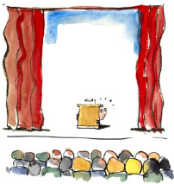
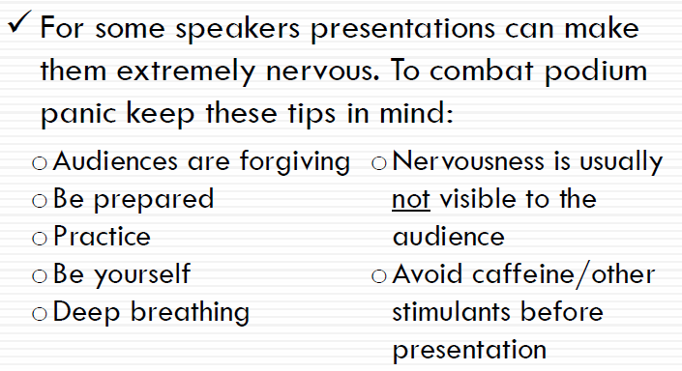

Example:
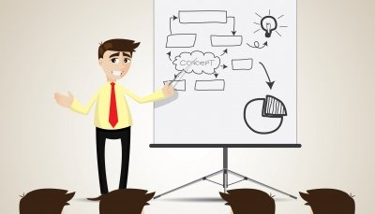
I was terrified of public speaking. As an introverted poet, the very thought of having to stand up in front of a crowded room and talk without a script filled me with dread. Don’t worry if you feel the same way, it’s quite normal. According to surveys, public speaking consistently comes out as one of our biggest fears – up there with heights, snakes, spiders and being buried alive. In my own case, there’s no way I’d have been able to build the business I have today without becoming a confident and capable presenter. Not only do I deliver training workshops, but I’ve also had to make many presentations in order to land contracts and projects. These days, presenting is one of my absolute favourite parts of my job. I’m in demand as a trainer and presenter, and regularly get rave reviews from my audiences. I’m not saying that to boast, just to show you that if an introvert like me can do it, so can you. (Mark McGuinness. The Creative Pathfinder)

Most speakers, beginners and veterans, readily admit to feeling nervous in the moments leading up to a speech or presentation. It may feel uncomfortable, but it's completely natural and even necessary. In fact, many professional speakers don't want to lose the butterflies; they aim to leverage them. They actually value this adrenalin surge because it fuels the body with the energy and enthusiasm necessary for a great performance.

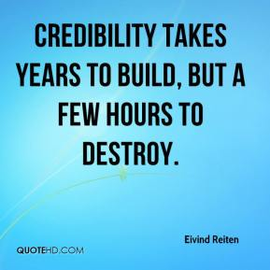
3. - To Build Credibility

A person can have the greatest idea in the world. But if that person
can’t convince enough other people, it doesn’t matter. Gregory Berns

It goes without saying that people need to be convinced by what we are saying. There is no such thing as information only; we need to persuade our audience and our stakeholders that our information is worth listening to, that it’s accurate and that it matters to them. This requires the winning combination of the right content and the right delivery; the message and the messenger. It is also good to remember that it’s not only about what we want to say to our audience, it’s what they need to hear from us.

Explain the purpose of your presentation in one sentence that is free of professional jargon and emphasizes what participants will gain.

Use a powerful quote. We can employ the wise words of a well-known person because the name allows us to tap into his or her credibility, likeability, and notoriety. The quote must have meaning and relevance to the audience.

Example:
Imagine you’re urging a group to reach consensus, or giving a talk on conflict management. You could open with: “Mark Twain once said, ‘If two people agree on everything, one of them is unnecessary.’ Even though some of us disagree on the xyz issue, each of us is necessary in the reaching a resolution.”

Maintain credibility: discuss the pros and cons, explain advantages first and then the risks and challenges. If the audience doesn't agree with you, it is important to choose your words wisely. One of the quickest ways to lose an audience is to offend them. It's best to find a happy medium to start building your relationship.

One of the first steps to developing an effective presentation is to ensure that there are visual aids to complement the speaker. Visual aids are simply a tool and strategy that helps to develop a clearer message for an intended audience. So, incorporate visual aids effectively – graphs, pictures, etc. During a presentation with a visual aid, the audience is able to use the words or images to connect with the topic at hand.

Example, if a speaker is presenting on the subject of finance, the information might be remembered easier if the audience is looking at key terms or diagrams on finance.

This is known as visual learning. When a person needs to recall information, the mind will extract the image, which helps that person relate to the information. Examples of tools that can be used to provide visual aids include the following:

- PowerPoint presentation
- Smart Board
- Overhead projector

Good slides give the impression of professionalism, thorough preparation and increase percentage of message retention. Amusing slides can add a touch of life to the presentation.

We need to have a backup plan for delivering the presentation if all of our audiovisual materials become unavailable. Do not rely on technology to work.
We have to test all audiovisual equipment and practice using our presentation slides and other visual displays. If we are using a video, we need to make sure it is set to the correct beginning point, at the appropriate volume and with captions turned on.

It is important to also prepare handouts for the meeting. Handouts are paper with relevant information dispersed to an audience at a lecture, presentation, convention, etc. There are many benefits to preparing handouts for a business presentation. Handouts are a great solution to provide additional details to our audience without holding them hostage for ten hours straight.

Handouts can also benefit the presenter by providing a road map for the presentation. Many presenters follow their own handout as a guide to stay on message and not digress. Outlines also give the audience an idea of the length of a presentation.

Audience members usually can't remember most of what a presenter has said an hour after the presentation has finished. Handouts provide instant reminders and a great source of information follow-up.

Example:
Many times during the presentations that I attended, the presenter spoke too quickly or not loud enough and I missed important information. It was reassuring to have the handouts to reference later in the day.
Handouts are a fantastic way to further support a presentation. Many excellent lectures use handouts that contain helpful information for the viewer to use to gain additional insight. For example, one time, I attended a presentation on how the local library can be a resource for small businesses. The presenter's handouts had additional links and information for small business owners to find free services to aid in business growth. (Jennifer Lombardo)

If handouts are provided, audience members can focus on the presentation material without having to worry about note taking. There is always one audience attendee who feels the need to write down every single thing the presenter has said during the lecture. There is no way that they can comprehend any of the information. Providing handouts allows the audience members to relax, focus and enjoy the presentation, knowing that they have follow-up notes to refer to later.

Nothing smacks of unprofessionalism more than a speaker making excuses for not having handouts.
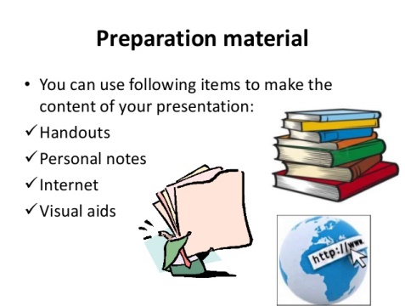

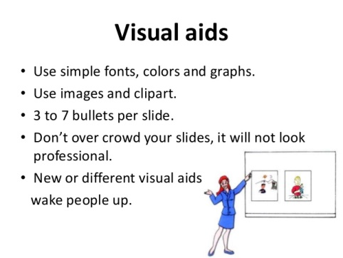

Do not read your paper. The audience wants to hear you talk, not listen to you read.
- Use short and simple sentences.
- Speak clearly and with vitality.
- Never talk while you are facing the screen. Stand at an angle that will permit a glance at the screen while maintaining full attention to your audience.
- Do not read from your slides. Format your slides so that they reflect talking points and then “talk” to your audience instead of “reading” to them.

Harnessing the Power of Three: In public speaking and rhetorical debate, as well as in much communication, three is the magic number. The brain finds it relatively easy to grasp three points at a time: people find three points, ideas or numbers, easier to understand and remember than four or more. You could therefore structure your presentation about the magic number of three.

Example:
Your presentation should have three main elements: the introduction, middle and conclusions. Within the main body of your presentation, divide your key message into three elements and then expand each of these points into three sub-points. If you are using a visual aid such as PowerPoint, limit the number of bullet points to three on each slide and expand on each of these as you go along.

It is important to try to add stories, anecdotes, testimonials, analogies, demonstrations. We can use metaphors to aid understanding and retention. We need to ensure that the language we use is appropriate for the audience. Are there any terms they may not be familiar with? If so, we need to use more familiar terms or explain the meaning.

Is our language presentation friendly? Presentations are spoken and so we need to choose accessible and easily-understood words (such as those we would use in a conversation) rather than technical or obscure words; and it is important to eliminate long sentences. Remember that you will be talking through your ideas and that the audience will be listening rather than reading. Therefore we have to keep sentences short, and their structure simple to ease the audience’s understanding.

Yes, your presentations should be full of useful, insightful, and actionable information, but that doesn’t mean you should try to condense a vast and complex topic into a 10-minute presentation.

If the information we are presenting is important enough for us to deliver orally, then it demands an appropriate amount of planning and preparation so that the information we present is memorable for the right reasons. Give a bad presentation and you'll be remembered all right: It just won't be the type of impression you want to leave in anyone's mind.

We should also finish by proving what we have just said: providing evidence that what we have just said is beyond dispute using case studies, personal examples or statistics.

“One of the biggest lessons I’ve learned over the last few years is that to be a great public speaker, it’s key to develop a personal speaking style. Since I know I’m not the most eloquent speaker in the world, I make up for it by packing my presentations with enthusiasm, unique/proprietary data, and tons of useful content as well as jokes.” (Larry Kim)

4. - To Prepare Like a Pro
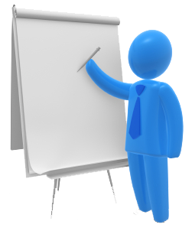
"Nothing great was ever achieved without enthusiasm."
(Ralph Waldo Emerson)

If possible, we need to be familiar with the place in which we will speak. It's always best to allow ourselves plenty of time to settle in before our talk. Extra time ensures we won't be late and gives us plenty of time to get adapted to our presentation space. So, arrive ahead of time, walk around the speaking area, and sit in the seats. It would benefit us to arrive an hour early to do a dry run through of our entire presentation and it will help us gain confidence and work out any last minute issues. Seeing the setup from our audience’s perspective will help us decide where to stand, what direction to face, and how loudly we will need to speak. We have to start preparing early; without waiting until the last few days to prepare and check the physical environment in advance. Then, arrive early and get a feel for the room, including its temperature, size, and overall set-up. Re-arrange furniture as needed.

If we're giving a talk as part of a conference, we can try to attend some of the earlier talks by other presenters to scope out their presentation skills and get some context. This shows respect for our fellow presenters while also giving us a chance to feel out the audience. What's the mood of the crowd? Are folks in the mood to laugh or are they a bit stiffer? Are the presentations more strategic or tactical in nature? Another speaker may also say something that we can play off of later in our own presentation.

It is helpful to use props and practice moving around the room. We need to practice our visual cues bringing examples, setting up our technology needs, and moving around the room as if already delivering our speech.

We have to prepare for contingencies; what if the audience is more prepared than we expected... what if there is an unexpected question - if a disruption is particularly obtrusive, we might relieve the tension with a joke or humorous comment.

It is critical to know the purpose of communication. Knowing the audience and the expectations of the audience is very important to decide what to present and how to present. We have to tailor our presentation to the audience, to their needs, desires, knowledge level and attitude towards the topic. And be concrete, specific, practical, and relevant. We need to be clear about our objective – is it to motivate, inform, persuade, or teach? And research our topic thoroughly.

The title of our presentation should be Informative and Attractive to the audience, as it is the first thing they will know about our presentation.… Effective title should answer the following 4 questions:

- Is the title correct, does it accurately represent the subject?
- Does the title state the limits of the subject?
- Is the title understandable?
- Has the title been expressed brief?

Organize your material in a way that is most comfortable to you by using a script, outline, notes, or 3 x 5 cards. Number them. Proofread all printed materials.

We will fully engage by analysing our audience to understand their needs and requirements, creating a relevant, accurate and authentic message that matters, connecting and fully interacting with our audience and inspiring and motivating our audience with a clear call to action. The most important factor to be considered for the presentation is to always keep our audience in our mind.

We have to think about our audience, be clear about our purpose and use an effective introduction to our presentation. We organize our presentation clearly and simply, using supporting material to support our point and creating an effective conclusion; sounding spontaneous, conversational and enthusiastic. We need to speak in language, images, and terms that the audience readily understands. If we need to use jargon, we define it immediately unless we know that every person in our audience understands it.

We need to rehearse our speech to ensure that we stay within the allotted time limit (e.g. 20 minute presentation and 5 minutes Q&A), and cut down on our explanations and condense until we are within the limit. This will assure adequate time at the session for discussion.

We have to be brutal when we edit our content. Although we know everything there is to know about this topic, we do not want to demonstrate all this knowledge and we have to remember that we are focusing on one key point or area, and think of ways to keep the audience interested.

Knowing what to include, and what to leave out, is crucial to the success of a good presentation. We are not suggesting we skimp when it comes to data or including useful slides, but we are advocating for a rigorous editing process. If it feels too off-topic, or is only marginally relevant to our main points, we leave it out. We can always use the excess material in another presentation.

Our members are looking for solutions. They want to know what the problems are. Hence, we have to think about what we want them to walk away with and focus on that rather than using our entire podium time to present a lot of background information.

Ideally, we should take questions throughout the presentation so that the question asked and the answer given is relevant to the content presented. If we choose to take questions at the end of our presentation, we need to end instead with a strong image that relates to our presentation's content.

When audience members ask questions or give comments, we should be gracious and thank them for their input. Even if someone is being difficult, we must keep to the high ground and at all times be a gentleman or lady and courteously deal with such individuals. The true professional can always remain cool and in control. Remember, it is our reputation, so we always remain gracious even with the most challenging of audiences.

Handling questions is important; listen attentively before responding to questions.
We have to give confident and informed responses to questions and challenges, anticipate questions and prepare responses; rehearse answers to difficult questions. If necessary, we have to offer to obtain additional information and follow up. We have to use questions to strengthen our main arguments and answer questions candidly but positively link objections to attractive features.

Ask "friendly" questions and don't use questions to embarrass or badger; avoid known sore spots, avoid asking risky questions, that is, questions that may imply lack of knowledge or intelligence; make the interchange a mutually satisfying experience; give respondents time to think and phrase their answer; help people save face by summarizing what they have said so far and asking if anyone else has something to add.

Don't let respondents wander or attempt to take control of the presentation; a polite "thank you, that's what I was looking for" can get us back on track. If extensive audience discussion is desired, we need to avoid isolated one-on-one dialogues with specific individuals.

When challenged, we have to be candid and firm but avoid over responding, maintaining control of the session and being firm and assertive without being aggressive or defensive; we don't let interruptions disrupt our composure and avoid circumstances that require an apology.

Avoid rhetorical questions - ask interesting questions that are thought provoking but not too difficult to answer; ask some open ended question with no right or wrong answers - encourage sharing experiences, feelings, opinions and put "you" elements into questions - make them relevant to the audience's personal experience.

We have to bring prepared key questions prior to the presentation; it is difficult to think of good questions on our feet.

- Anticipate Questions: think of the ten most likely questions and plan out your answer.
- Understand the Question: paraphrase it if necessary; repeat it if needed.
- Plan the Answer: particularly if you anticipated the question. Do Not Digress.
- Be Honest: if you can't answer the question, say so.
- Reinterpret loaded questions: if attacked try to show the similarity to other situations.
- Control Interchanges: if a member of the audience becomes a heckler try to enlist the audience; if a questioner digresses, try to remind the audience of the goal of the presentation.
- Use the Last Question to Summarize.

5. - To close with power
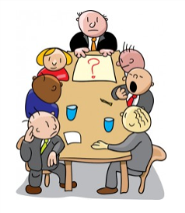
“Make sure you have finished speaking before your
audience has finished listening.” Dorothy Sarnoff

While it is important to grab our audience at the beginning, what we do at the end can make all the difference in our presentation's overall impact and success.

Last words linger, so we don’t want to waste them. The end of our talk is automatically a focal point for our audience. The last words we say provide us with a singular opportunity to embed a message into the mind of our listeners.

How often have we sat through a presentation that trails off at the end with no real point? It’s amazing how many presenters seem surprised by the ending of their talk! The final slide comes up and the speaker says, “Oh um, I guess that’s it. So…, any questions?” And yet, the end of our presentation is our golden moment to leverage all the words we’ve said until then.

Worse still, a weak ending diminishes our credibility, because when the audience doesn’t get the structure they crave, our ideas seem weaker, less important, less memorable, and less complete. And because we’re the speaker who delivered this unsatisfying combination, we don’t appear to have as much authority. People expect completion. That’s what an end is.

Conversely, having a strong, relevant ending boosts our credibility, satisfies our audience and increases their trust in us. Our last words can crystallize our message and activate our audience. Even when we engage our audience, not having a clear ending can affect their perception of the whole presentation. We have to give our audience a signal that the end is coming to prime them for our memorable end.

For example:
Face the audience. Take a big breath or long pause before your final statement. Say something like; ‘To wrap up,’ ‘In conclusion’ or ‘Here’s what to do next’.

And so, we conclude on a "high note" - including an overall and strong summary and proposed actions or options, creating an effective conclusion.

Leave an impression that lingers and do not rush as if you’re in a hurry. Pause between summary & Q-Ans session. Keep to the time schedule, but show that you value participant input by not rushing.

To be truly effective, we can take questions and then finish with a closing that is as powerful as the beginning of our presentation.

Here are three techniques for creating a memorable ending:

1. A quote
Use a quote that will stay with your audience members long after they leave the room.

Example:
I saw a fantastic presentation on what it takes to motivate a staff. The manager had provided a list of tips and techniques that worked for her, but I most strongly remember how she ended the presentation. She listed each of her approaches with this simple quote in white letters on a black background emblazoned on the screen behind her: "The simple act of paying positive attention to people has a
great deal to do with productivity." Tom Peters
Her entire presentation had been about positive reinforcement and while I can't recall all of her tips, I will always remember the quote. (Eric Holtzclaw. Company strategist)

2. A call to action
Most business presentations' primary purpose is to move the audience to action. We use the last few minutes of the presentation to reinforce the call to action we seek.

Examples of strong calls to actions:
"Join the Fight"
"Begin the Journey"
"Improve the Process"
"Donate Today"

Assume that your presentation has delivered the information needed by the audience members to move them in a direction and make your call to action definitive and instructional.

3. A compelling story
Ending your presentation on a story, especially if that story is personal or illustrates how the content presented affects others, is the best way to conclude.
Many times we see companies defaulting to a case study. While a case study is good, we need to consider how we can turn it into a meaningful story, how does or could the work being proposed influence others' lives? Creating empathy with our audience and tying the story back to points made throughout the presentation ensures our presentation will hit the mark.

Example:
One of the very best examples I have seen of this in action is the presentation given by Scott Harrison of ‘charity: water’. He starts his speech with a personal story that draws you in and ends it with a heart-wrenching story about Rachel Beckwith that you won't soon forget. You can see Scott's amazing use of a compelling story with an awesome call to action. (Eric Holtzclaw. Company strategist)

At the end of our presentation we don’t walk off until we’ve finished speaking, give a clear thank you, hold our ground to take our applause and then exit stage.

Walk off confidently too. The way we walk off is also incredibly important as it is the last thing our audience sees when we finish. If we let out a huge sigh and rush off the stage as if we cannot wait to get away, we create an impression of nervousness that will undermine all the good work we did in the walk on and during our presentation.


6. - To Sharpen Your Delivery

"I have the simplest tastes. I am always satisfied with the best."
(Oscar Wilde)

We warmly welcome participants, use eye contact and a welcoming posture, and thank participants for coming. The way we speak has an impact on the way the audience perceives our authority and believability. It’s worth giving some thought to a couple of simple things we can do with our vocal delivery to establish credibility with our audience.

- Slow down: Effective public speakers typically speak at approx. 100-120 words per minute which is around 30% slower than normal conversation.

- Get comfortable with pausing: Using longer pauses not only gives us more thinking time, it also gives us more credibility and authority. Practice getting comfortable with long pauses and you will see a direct increase in your perceived credibility.

When we're nervous, it's easy to speed up our presentation and end up talking too fast, which in turn causes us to run out of breath, get more nervous, and panic! Ah don't be afraid to slow down and use pauses in your speech. Pausing can be used to emphasize certain points and to help our talk feel more conversational. If we feel ourselves losing control of our pacing, we just take a nice pause and keep cool.

Getting feedback on our performances from a trusted peer is necessary; recording a presentation can help us identify whether the pace is too quick, and more importantly, too steady. Speakers aim to vary their pace so that 70% of the speech is relatively slow -- but 30% is faster. Slow passages draw attention to important ideas; contrasting faster passages suggest passion.

Talking too fast, especially in stressful circumstances, is a common problem. We need to develop our own internal sense of timing. Another common problem is talking too softly. Most people, if they want to be heard, have to force their voice; if we are relaxed and in control, we can breathe better and therefore our voice will not be forced.

It is better to avoid fillers or superfluous words – err, erm, you know, like; the same is for vague words – sort of, kind of…

Next, learn to vary your pitch expressively. “If you are trying to get across a critical recommendation, your vocal pitch needs to give emphasis to the word that matters,”

Do not be afraid to use gestures & long pauses. If we fail to gesture while speaking, we may be perceived as boring and stiff. Pause briefly each time you make an important point. Scan notes in small sections. Tell an anecdote.

We will instantly get attention and connection with our audience through our…
- Stature: to have a natural, strong presence.
- Use of hands: to empower our message.
- Facial expressions: to be congruent with our message.

Convey ‘controlled enthusiasm’ for your subject, the audience will forgive a lot if the speaker is enthusiastic. But don’t confuse enthusiasm with loudness; try to convey a range of emotions from concern, anticipation, excitement, dismay.

Nobody expects us to stand still throughout our presentation but they don’t want to see nervous pacing, fidgeting, rocking or swaying. Learn how to harness all these anxiety related distractions.

Finally:

"When you can do the common things in life in an uncommon way,
you will command the attention of the world."
(George Washington Carver)

“I've been doing a lot of presenting recently, and I have no problem admitting that it's tough. For those not born with natural eloquence, public speaking can be remarkably nerve-racking. But I’m getting a lot better!” (Larry Kim, Aug 29 2016)

In summary, to give effective presentations where participants gain valuable information in a dynamic way, make sure to:
- Prepare well in advance.
- Incorporate universal design principles.
- Facilitate interaction, sharing of experiences, and creative problem-solving within the session.
- Promote a welcoming and non-judgmental learning environment.

And we have to keep in mind that adult learners have a wealth of experience; are goal oriented and appreciate outcomes more than process; have set habits, strong tastes, and little time to waste; have strong feelings about learning situations; are impatient in the pursuit of objectives, and appreciate getting to the point; find little use for isolated facts and prefer application of information; and have multiple responsibilities, all of which draw upon their time and energy.

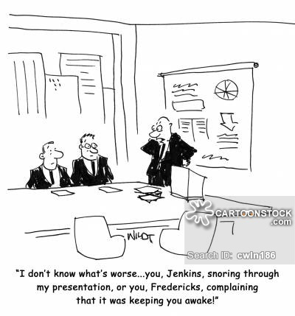
The way the audience perceives us is too important to be left to chance.

Question 3

What are seven easy steps to pump up your presentation?
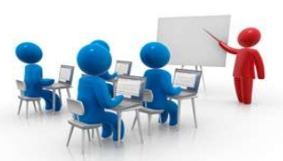
Whether we're talking in a team meeting or presenting in front of an audience, we all have to speak in public from time to time. We can do this well or we can do this badly, and the outcome strongly affects the way that people think about us. This is why giving a presentation causes so much anxiety and concern.

Presentations and public speaking are typical requirements of our professional position; opportunities that we must learn to grasp at every opportunity. They give us a chance to establish ourselves with the community and tell people about our company. Whether we are making a sale, pitching our idea to the boss, or managing a crisis, effective speaking skills are critical to building credibility and driving our message home.


No matter how well we know our product or service, we need to plan and think about what’s most relevant to our audience and put their interests first; with thorough preparation and practice, we can overcome our nervousness and perform exceptionally well.

When someone presents well, it sends the message that the person is capable, confident, intelligent, and competent. These people get noticed and that type of attention bodes well for our career. Even if we don't need to make formal or regular presentations in our current position in front of a group, we have to think about the future and keep in mind that we do have to present our ideas and opinions on a daily basis, and that there are plenty of situations where good public speaking skills can help us advance our career and create opportunities.

For example:
We might have to talk about our organization at a conference, make a speech after accepting an award, or teach a class to new recruits. Speaking to an audience also includes online presentations or talks; for instance, when training a virtual team, or when speaking to a group of customers in an online meeting.

Being a good public speaker can enhance our reputation, boost our self-confidence, and open up countless opportunities. However, while good skills can open doors, poor ones can close them.

For example:
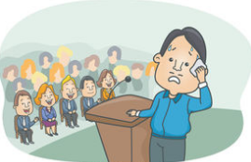
Your boss might decide against promoting you after sitting through a badly-delivered presentation. You might lose a valuable new contract by failing to connect with a prospect during a sales pitch. Or you could make a poor impression with your new team, because you trip over your words and don't look people in the eye.

So, we need to make sure that we practice our presentation well! And remember that no presentation has to be perfect. The numbers of people who aren’t good speakers far outweigh those who are good, so there’s lots of room for those who are just OK at public speaking.

Now, if we want to move our presentation from dull to dynamic, we can pump up our presentation in seven easy steps:

1. - Talk to yourself

Many believe that good presenters are born, not made. This is simply not true. Sure, some people are more relaxed and comfortable speaking in front of others, but everyone can learn the skills and techniques they need to increase their level of confidence and performance when presenting.

Positive thinking can make a huge difference to the success of our communication, because it helps us feel more confident. Fear makes it all too easy to slip into a cycle of negative self-talk, especially right before we speak, while self-sabotaging thoughts such as "I'll never be good at this!" or "I'm going to fall flat on my face!" lower our confidence and increase the chances that we won't achieve what we're truly capable of.

Practice in front of a mirror, trying to look relaxed and friendly. Stand with your arms in front of your body, with your elbows at 90 degrees and your palms at 45 degrees, leaning forward. That says, “I’m here, I’m engaged, and I don’t have a weapon.” Use positive affirmations such as "I'm grateful I have the opportunity to help my audience" or "I'm going to do well!” Use affirmations and visualization to raise your confidence. This is especially important right before our speech or presentation.

Visualize giving a successful presentation, and imagine how you'll feel once it's over and when you've made a positive difference for others. Remember to visualize the audience from your viewpoint and not their viewpoint from their seats.

A certain amount of pressure enhances performance. By changing our mindset, we can use nervous energy to our advantage. First we need to make an effort to stop thinking about ourselves, our nervousness, and our fear and focus instead on our audience: what we're saying is "about them." Our message is more important than our fear. We have to concentrate on the audience's wants and needs, instead of our own.

We have to pay attention to our gestures. Do they appear natural or forced? And make sure that people can see them, especially if we're standing behind a podium. Body language has greater impact than the words we use. We can usually trust a man with confidence, one who knows what he's talking about and not afraid to look at the audience. To be perceived as such by the audience, we should use appropriate body movements. These will transmit we know what we're talking about.

Our body communicates different impressions to the audience. People not only listen to us, they also watch us.

For example
Slouching tells them you are indifferent or you do not care... even though you might care a great deal! On the other hand, displaying good posture tells your audience that you know what you are doing and you care deeply about it.

Behave naturally and try to think of the audience as your natural ally and make sure your body language reflects what you are saying. We need to be authentic when being on stage; the audience will feel personally connected to us and our presentation will be memorable in the best way possible.

Example:
One of the most memorable presentations I have seen was delivered by Bert Jacobs, co-founder of ‘Life Is Good’. In his presentation, Bert talked about the day of the Boston Marathon bombing. Since Life Is Good is headquartered in Boston, Bert’s story was both personal and emotional. When Bert was sharing his story, I looked around the room and there were very few dry eyes.
In addition, Bert also shared a video that talked about the Life Is Good non-profit project. The video was moving and again brought tears to many eyes. Bert’s emotional angle was authentic, not forced, and that is why it worked. If his story and non-profit efforts felt fake in any way, the audience would have rejected him as a speaker. (Leslie Belknap. Ethos3.com)

Alternate moving and standing still, speaking and listening, doing and thinking; use physical space and body movement to enhance your message. Use gestures naturally; do what is natural to you:

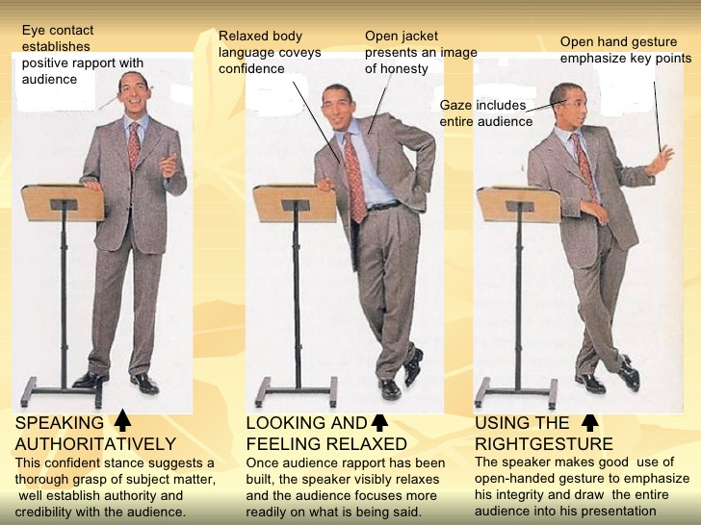

2. - Have a point.
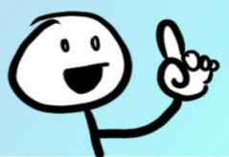
Keep the message sharp and decide on your core message ahead of time; every presentation has a message, one sentence that will summarize the whole thing. Bring the listener quickly to the point of action by crafting your theme into your introductory passages. Don't forget it. You have to keep it simple and mention it at least several times in your presentation so the audience will get it.

Always end the presentation repeating your message and with a call to action. It is important to know that you should only talk about what you have experienced. Most people do not speak from the heart and rattle off their points from a piece of paper. Some try to memorize their major points. None of these approaches will reach your audience. Even worse, it will do nothing for you in the process. To give an effective presentation, you have to be real. You need to have it engraved into your heart.

So, you can make a list of one or two important points on cue cards and write a succinct introduction; most people think that this is irrelevant, but it is one of the most important aspects when giving a dynamite presentation. When your points in the introduction are good and well-delivered, it makes your audience look forward to you and your half of the challenge of giving a presentation is already done.

When you write an introduction, make sure that it is less than 30 seconds. If it goes over 60 seconds, people start getting impatient.

Example:
I once saw a 5 minute introduction for a 30 minute presentation. By the time the speaker arrived, the woman seemed to already given the speech. Not only was the introduction better than the speech, but the audience was expecting a miracle from their next speaker---which never came. (Daniel Ally, business strategist)

Create an introduction that is succinct and informative. There is no need to have a grandiloquent introduction of all of your credentials. People don't care about what you've done; they care about what you will give them. Also, before you give your presentation, have someone read it off verbatim more than once.
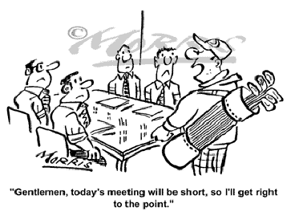


3. - Look them in the eye.


Eyes are said to be the key to the soul. They represent the first and the most effective weapon in convincing the audience with our honesty, credibility and confidence in the subject. We should use our eyes to enhance rapport with our audience, by establishing eye contact with every member of the group as often as possible. Eye contact is our primary tool for establishing audience involvement; we need to look at our audience in random rotating order. Making frequent eye contact for a few seconds with listeners in the audience will create an aura of confidence and familiarity, which will help us get our message through.

Whatever we're planning to say as the captivating opener - a witty quotation, personal story, or startling statistic – we have to rehearse the first few sentences several times, because knowing exactly how we're going to start gives us confidence, enables us to look directly into the eyes of audience members as we begin (not at notes or a slide), and creates a powerful first impression.

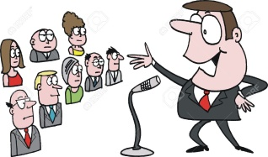
We need to visualize our audience as individuals not as a mass and we have to look at our audience one person at a time and not to address it as a whole. Speak to individuals. Due to the distance between us and our audience, other people around the person we have chosen will feel that we are talking to them.

Too little eye contact makes our audience suspicious. It’s human nature to equate truthfulness and confidence with the ability to make and hold eye contact. Too little eye contact will make us look shifty. Too much will make us look aggressive. 2-3 seconds per person is fine for small groups. For larger audiences, we have to divide the audience space into zones and make sure we cover all the zones. Be especially aware of the edges. It’s easy to accidentally ignore the people at the side of an auditorium as we focus on the front and center.

Speakers who make eye contact open the flow of communication and convey interest, concern, warmth, and credibility. Maintaining eye contact is also important because it lets us know how the audience is responding to our presentation.

4. - Know the room.

There's a good reason that we say, "Practice makes perfect!" We simply cannot be a confident, compelling speaker without practice. It is important to practice at the presentation venue to familiarize ourselves with the layout of the venue as well as the location of the stairs and other critical points that we will need to know to get on and off stage gracefully.

If we're going to be delivering a presentation or prepared speech, we need to create it as early as possible. The earlier we put it together, the more time we'll have to practice. We have to practice it plenty of times alone, using the resources we'll rely on at the event, and, as we practice, we will tweak our words until they flow smoothly and easily.

We need to get to the room early and ensure we are comfortable with the set-up. We boost our comfort level by checking out our speaking venue in advance and making sure we know the environment, including the seating arrangement. This step shows the audience we are prepared and helps ensure our presentation runs smoothly. Many people do not succeed in giving effective presentations because they do not 'own the room.' Most people fail before they start. It is very important to properly arrange the meeting room to make sure that all attendance hear and see us clearly.
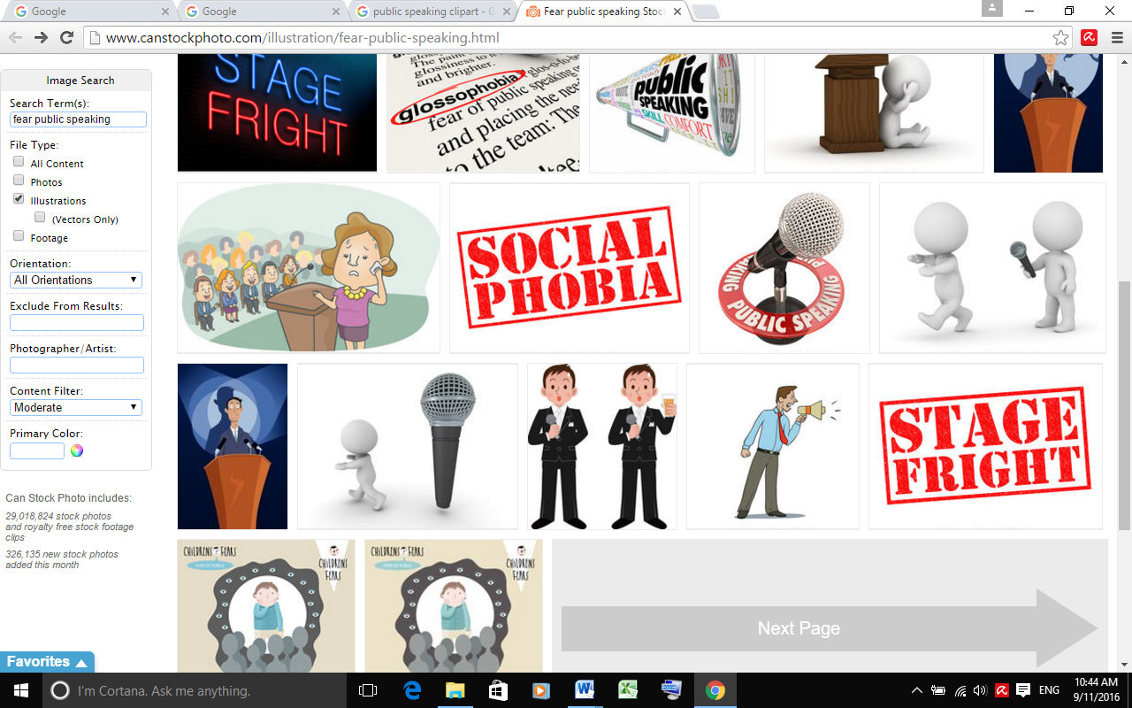
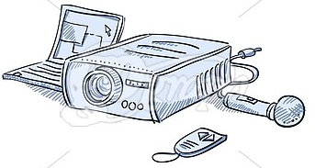
If we are using a microphone, we need to make sure it works. The same goes for the projector; we have to test it before using it. If it’s our projector, better we carry a spare bulb. Also, we need to check to see if the projector is bright enough to overpower the room’s lighting. If possible, we have to check the lighting in the room we will be presenting in, prior to our time in the limelight making sure we know how to dim the lights if the room is too bright. We have to make sure the necessary software is installed on the computer we will be using.

Practice your presentation and prepare for contingencies – rehearse. Think about what might happen and prepare - what if the overhead bulb blows out... The proper preparation and the use of all our material and equipment will give us another dimension of success.

If possible, we speak to the person who is going to introduce us, greet people as they arrive and begin establishing a connection with them.

5. - Crack a smile

Even before we begin our speech, people will look us over, checking us out. We have to look confident – even if we don’t feel it – and excited – as opposed to fearful – and we’ll start on the right foot. If the audience feels that we are nervous or unsure, they will form a negative opinion about us. We need to try hard to look confident and smile.

We will maintain a positive, pleasant expression on our face in the moments before we speak. Smiling actually relaxes the body. Physiologically, smiling emits endorphins in the brain that calms the nerves, creates a pleasant attitude, promotes a sense of wellbeing, reduces our heart rate, and helps us breathe easier. Plus, a smile conveys confidence and self-assurance. It shows our audience that we are happy to see them, enthusiastic and confident about our message, just the kind of person they want to hear.

We need to pay attention to the tone as well; a voice that carries fear can frighten the audience while a voice that carries laughter can get the audience to smile. Smiling is a powerful cue that transmits happiness, friendliness, warmth, and liking. And while we are maintaining great eye contact, we need not to forget to smile as well, unless our topic is very grim.

6. - Pump up the volume.

The voice is probably the most valuable tool of the presenter. It carries most of the content that the audience takes away. One of the oddities of speech is that we can easily tell others what is wrong with their voice, for example too fast, too high, too soft, etc.

Volume, how loud the sound is, is very important. The goal is to be heard without shouting; people need more energy than they think to make a strong presentation, so we have to use a louder voice than we think we need; and maintain a high conversational tone and volume; the audience needs to be able to hear us and understand us.

Before our message can transform our audience, the sound of our voice must be heard by our audience. It sounds really simple, but how often we have to strain to hear a presenter. Our first goal is to be comfortably heard by everyone in the audience. If they cannot hear our voice, then we cannot deliver a message to them.

Raise your volume to reach the person in the back row. Project your voice, it’s not only about speaking louder, but also speaking with more resonance. It takes practice. If a microphone is available at the venue, we should probably use it. Practice if you are not accustomed to speaking with a microphone. Articulate clearly; it is remarkable how just focusing on articulation brings our volume up considerably, and practice good posture too; stand tall and lean slightly forward. Your voice will carry farther.

- Finish sentences strong: Tailing off at the end of sentences is a common mistake made by speakers, often caused by looking back down at notes. The result? Our audience may miss the last word or two at the end of sentences, thus weakening our impact.
- Start loud: It is not a strict rule, but generally a good idea to open a notch louder than average. It grabs attention and demonstrates enthusiasm.
- Finish loud: Also not a rule, but speaking louder helps create a rousing, confident finish. This is especially true in a persuasive or motivational speech.

Example:
John Scott vividly remembers the presentation he gave last March (2012) in a competition with three other finalists for a $5 million grant from the Life Sciences Discovery Fund. He didn't win. “I felt I did not put my best foot forward,” he says. Part of the problem, he believes, was his voice. Colleagues have hinted that his presentation voice is too quiet and monotonous, he says.
Scott turned to Jan D’Arcy, a movie and TV actress who runs a speech coaching agency. D'Arcy taught him how to conquer his fear of public speaking and how to use his voice better during presentations.

It's possible to make improvements in our voice independently. And that, in turn, can make a big difference in our career. Our voice will be made more expressive by improving our breath control and working on rate, volume, pitch, quality, and articulation.
Sip water that is either warm or room temperature, with lemon if possible. This helps with dry-mouth, and clears the throat. Avoid cold food and drinks, dairy products, and carbonated beverages and ensure a glass or bottle of water is within arm's reach during your speech. Dry mouth is a common result of anxiety.

A tip for improving our voice: Suck a mint or honey flavored sweet just before you begin to speak.

7. - Don’t be a comic.

If you have a good sense of humor, use it. If you’re a wonderful storyteller, by all means tell a story. Never imitate another speaker, even a good one. You’ll sound – and feel – phony. Don’t try to be unique or interesting. Be as fully and completely yourself, unrestrained by your fears and desire to please others, and you will be both unique and interesting.

Some speakers are downright hilarious. These funny or humorous speakers entertain the crowd using jokes and other antics to generate excitement and interest. This style may work well for an icebreaker or to take a group that hardly knows one another and bring them together through laughter. Everyone loves a jokester! But use humor appropriately; make it in good taste keeping in mind that some gestures are wrong.

Used skillfully, humor can help establish rapport with our audience. It can ease tension and help in responding to a hostile question. It can help underscore a key point or message. It can help to keep our audience's attention, increasing interest in what we are saying. It lets our audience see our human side. And information conveyed with humor is more likely to be remembered.

Now, it is better to forget jokes and instead look for humor that adds to our speech, makes a point or illustrates something we are saying. If you want to have a little fun at someone’s expense, make sure it’s at yours. As the speaker we should be big enough to take a little ribbing and the audience will admire us for it. But it is better not to start our speech by telling a joke; don't start with a joke for the sake of a joke that has nothing to do with anything. You'll appear to be trying too hard, and your joke will serve only as a distraction. People tend to resist when they think we are just trying to make them laugh.

Humor in presentations isn't always a laughing matter. How do you know when it will work and when it won't? Should you use humor at all? Humor can help. It can also backfire.

Example:
At a civic club luncheon, a speaker launched his speech with an off color joke. Much to his surprise, a female club member walked to the microphone after he sat down, and said quite sternly: “I know I speak for many of us when I say that the joke our guest speaker told was offensive, and was totally inappropriate for our group.”
While negative reactions might not become vocalized like that, even silent embarrassment and resentment will establish barriers you cannot remove. (Bill Lampton, Ph.D.)


Our verbal jabs can alienate our listeners immediately, and we will have little likelihood of regaining their attention. So, be careful. If you use humor poorly, it can sink your presentation and harm your credibility.

Humor, used sparingly, skillfully, and in good taste, can establish quick rapport and indicate the speaker is personable and friendly, as well as self-assured without being cocky. The most winsome humor will be spontaneous, related to the event, and self-directed.

In starting your speech, replace jokes with witty, tasteful, and creative observations and comments that are not canned, but are customized to fit only this audience, occasion, and topic. Not only will you sidestep potential pitfalls, you will establish instant rapport and positive expectations.

You needn't be a comedian to use humor effectively. You don't even have to be good at telling jokes. You need only a sense of humor.

You might also toss in an occasional analogy—a comparison that allows you to make a point quickly. The like word almost defines the analogy, as in:
"I feel like the deceased at a wake. I'm not expected to say much, but you can't start this meeting without me. So I'll be brief."
The best humor springs as anecdotes from personal experience. As such, they're easy to tell because you've lived the experience; they spring from ordinary, real-life experiences that audiences can easily relate to.

Example:

Recently an acquaintance invited me to speak at his business club’s luncheon. He assured me he would promote attendance, and would introduce me, using the written bio I provided. Then his plans changed, as he left on an unscheduled international trip. This opportunity for timely, self-deprecating humor led me to say, “I have been speaking for many years, to a wide variety of groups, and I can assure you this is the first time ever that my host invited me to speak, then left the country before the event.” As you can imagine, my comment drew good natured chuckles, especially from those who knew Art, my absentee host.
Even when you use humor skillfully, don't expect your audience to convulse in laughter. There's no laugh meter and you're no standup comic. Your audience did not come to be entertained.

If you do use humor and you get no response, keep going. Humor, if it fails, has no consequence, unlike jokes that fail. Don't laugh at your own humor and keep it short. Humor itself is not the point. It's a means to an end, not the end itself.

Make your humor relevant to your presentation. Use humor to make a point, one that advances your overall objective. When you do, your listeners—even if they don't find your humor funny—will get the point you intended to make and will appreciate that. You can also use humor to provide a brief diversion from your subject matter. But, again, make it relevant.

Take pains to avoid offensive humor. It should go without saying: never use ethnic, racist, sexist, or off-color humor. Follow the rule: when in doubt—even the slightest doubt—leave it out. Also avoid sarcasm. People almost always feel uncomfortable with a speaker who demeans others.

Remember: the degree of overt audience response does not matter as much as the overall success of your presentation. Ask yourself: Will humor help clarify a point? Will it help hold your listeners' attention? Just what purpose do you have in inserting humor at this particular point in your presentation?


8. – Extra tip: Music

Music embedded throughout a PowerPoint presentation can sustain attention, while slipping the content into long-term memory, according to Ronald A. Berk’s study Research on PowerPoint: From Basic Features to Multimedia.

Playing music during your presentation can help your audience be more attentive, and also retain the points of your presentation. This tip is often overlooked because it is so unusual, however it is not as hard as it might seem.

If you want to play music throughout your entire presentation, try classical music that fits the mood of your presentation. In addition, play the music at a low volume so it doesn’t compete with your voice.

Playing music throughout the entire presentation will not be appropriate for many presentations, so instead, consider playing music at various points throughout your presentation. Perhaps you decide to play exciting songs during the high points of your presentation. Or, perhaps you decide to play background music when you tell stories during your talk. In addition, you might experiment with this idea by only playing music at segues between sections of your presentation.

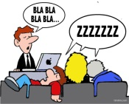
Often during presentations, attendees get sleepy not because the material is boring but because they have been sitting too long in the same seat with no movement for a long period of time. We could get attendees up and moving by playing an easy game of musical chairs for example. The silly but simple game will get attendees interacting with one another without asking too much out of the attendees. All they really need to do is get up, walk a few steps, and then sit down again. The game is easy but it is also a natural conversation starter, and will undoubtedly bring smiles to many faces.

Finally:

Many people think a presentation is a monologue. The presenter gets up on stage, talks for an hour or so, and then walks off stage. Maybe the presenter hosts a quick Q&A after they have completed their presentation but often even the Q&A is avoided by presenters. We need to be open as well to experimentation. After all, an open mind and a daring approach to life are two of the keys to success for public speakers. To take our presentation up a notch, we could skip the traditional monologue format and ask the audience questions at unexpected times. We are not talking about rhetorical questions; ask real questions that spark a genuine interest for us and the audience.

Being creative during a presentation is hard work, and that is why many presenters opt for the same-old style we have all seen too many times. We could break the mold and break a few rules to deliver a truly creative, memorable, and impactful presentation. Most attendees need something special to jolt them awake during business presentations.

If we speak well in public, it can help us get a job or promotion, raise awareness for our team or organization, and educate others. The more we push ourselves to speak in front of others, the better we'll become, and the more confidence we'll have.

References & Background Reading

- A Checklist for Planning Your Next Big Meeting. By Harvard Business Review Staff. March 26, 2015
- Better Public Speaking. Becoming a Confident, Compelling Speaker. By Mind Tools Editorial Team
- Creating a Practical Meeting Agenda. By Tara Schofield. Chapter 2 / Lesson 1. Study.com
- 7 Creative Presentation Ideas. By Leslie Belknap.Ethos3. November 30, 2015
- Don't Start Your Speech By Telling a Joke. By Bill Lampton, Ph.D. smallbizlink. Helping your business grow.
- 7 Excellent ways to start a presentation and capture your audience’s attention. By Jacquelyn Smith. Business Insider. Financialpost.com July 7, 2014
- Effective Meeting Management. The Council of Ontario Directors of Education. June 30, 2011. Advisory No. 8. Bolc Material
- Facilitation Techniques for Leading an Effective Meeting. By Tara Schofield. Chapter 2 / Lesson 4 study.com
- How to command attention and deliver a winning presentation. By Steve Knight. September 23, 2013. Economics & Finance – BLOG
- How to end a speech with power and impact. By Cam Barber, in The vivid method for public speaking. April 11, 2012
- How to Pump Up Your Presentation Skills. By Daniel Ally, Business Strategist, Investor and Business Coach. October 18, 2014
- How to Run Your Meetings like Apple and Google. By Sean Blanda. 99U.com
- 9 Meeting Facilitation Skills for Managers. By Dan McCarthy. Updated October 14, 2015
- Meeting Management. BYU Manager’s Toolbox. Bolc Material.
- Meeting Management. Unit 8. Bolc
- Meeting Management. By Dan Kramarz. DNR Training Director. Wisconsin Dept. of Natural Resources. Bolc Material
- Presentation Skills. By Seyed Ali Marjaie. Published in Education, Business. Dec 3, 2008
- Presentation Skills: Using Humor Effectively. By The Total Communicator. Volume II Issue 2, Spring 2004
- Seven Steps to Running the Most Effective Meeting Possible. By Neal Hartman. Forbes Leadership Forum. February 5, 2014. Forbes.com
- 5 Simple Steps to More Efficient, Effective Meetings. By Victor Lipman, Leadership, forbes.com March 1, 2013
- Simple Tips to Run Effective Meetings. By Jacob Shriar - March 31, 2014. Officevibe.
- Speed Reading. Learning to Read More Efficiently. By Mind Tools Editorial Team. 2016
- Strategies for Developing Effective Presentations. By LeRon Haire. Study.com. Chapter 1/ Lesson 4
- The 6 Golden Rules of Meeting Management. By Don Jacobson. Growing Leaders for the Public Service. 2002-2014 Govleaders.org
- The most powerful way to end a presentation. By Eric Holtzclaw, company strategist. August 26, 2014
- 10 Things You Should Do In the 15 Minutes before a Big Presentation. By Jacquelyn Smith. Business Insider. May 2, 2014.
- Tips for Using Effective Handouts in a Presentation. By Jennifer Lombardo. Chapter 2 / Lesson 4. Study.com
- Tips on Becoming a Better Presenter. Improve Your Presentation Skills and Be a Better Presenter. By Wendy Russell, Presentation Software Expert. About.com
- Volume and the Public Speaker: Be Heard and Be Effective. By Andrew Dlugan. Published: Aug 19th, 2013
- 6 Ways to Prepare for an Effective Meeting. By Elizabeth Harrin. about.com - October 06, 2015
- What to do before, during and after a meeting. Academic Leadership Support. University of Wisconsin-Madison. Office of Human Resource Development.
- Your Voice is Your Passport to Authority. By Sabine Louët. Jan. 27, 2012. sciencemag.org

Student Statement:

By submitting this assignment, I confirm that this is my own work.

Student Signature | Maria Magdalena Barragan Zermeno | Date | September 28, 2016

For Tutor / Assessor Use Only
Total Marks
Marks Obtained
Percentage / Grade

