
Assignment Cover Sheet

Student Name: | Tracy Kam
Student Number: | 3200
Course: | Diploma in Fashion
Assignment NO: | 8

Marking Criteria:
We expect the learners to write minimum one well expressed point in three lines against each allocated mark. This means one needs to write 15 lines with 5 well expressed points to get high grades for a 5 marks question.
For high grades use examples and illustrations where appropriate.
Please insert your completed assignment ( in word format) here:

Assessment 8 Total Marks: 30
Give short answers for the following questions: (21)

- What is meant by ‘binary colours’?
Binary colors is secondary color which is a combinations of two primary colors such as red +yellow =orange .
- Grey colour is formed when black is mixed with white. Is it a warm or cool colour what do you think and how best it can be used in creating an attractive colour scheme?
Grey is a cool color .Grey can be pair up with black or white to create contrast also it will make a person wearing on it looks not too dull .
- Which of the following colours should a stout person wear? Dark or light. And why
A stout person should wear darker color such as black , dark brown ..not too lights . Darker color can make the stout person looking more slimmer . its also can make the stout person looks not too big comparing lighter color can make a person looks big .
- If you want to create an illusion of height and slimness using colour, how would you do it?
I would suggest that person to choose single color ( one color ) outfit . A person also want choose vertical lines can make the person looks taller or increasing their height .
V. ‘Wearing black for a grey haired lady is the most suitable choice’. But how should she wear this
in the best possible way?
She can pair up with the white collar , as white bring neutal can make the person looks more attractiveness .add some dull shades , like dark grey also suitable on the outfit .
- For a person of sallow complexion which type of colours is best choice? And why?
For a person with sallow sallow complexion , the person should choose something that can shows reflect on their cheeks . Choose warm tints such as red , rose shades ,or grey .Pls avoid yellow as its about the same color of the face and its kinda looks weird . The person also can choose blue green , navy blue as can create reflections of yellow face.
- VII. Which types of colours would be more suitable for a blonde person’s dress?
For blonde person , greyish color such as blues , greens ,& violets are more suitable can warming down the brownish tones .Choose simple attire , less jewelleries .

Activity

Collect fabric swatches for different colour harmonies. Also name the colour scheme. Create a contrasting colour harmony using at least three colours of your choice.
Design a fabric using at least three colours.

These 3 colors can create harmony as it looks very comfortable . It is suitable for all skin type colors .
The color is yellow , red & shades of purple can create warm and cool feelings ,

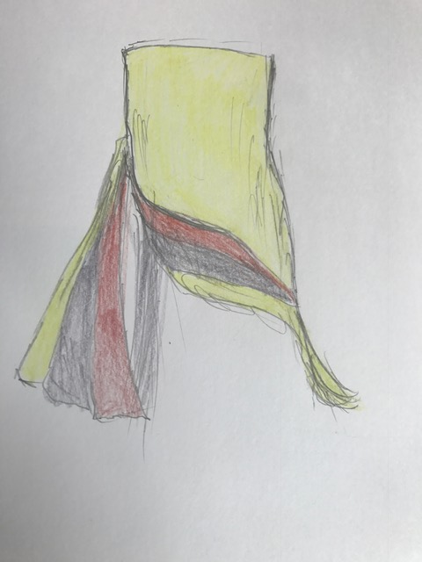

Student Statement:

By submitting this assignment, I confirm that this is my own work.

Student Signature | Tracy Kam | Date | 22112016

For Tutor / Assessor Use Only
Total Marks
Marks Obtained
Percentage / Grade

