
Assignment Cover Sheet

Student Name: | Tracy Kam
Student Number: | 3200
Course: | Diploma in Fashion
Assignment NO: | 6

Marking Criteria:
We expect the learners to write minimum one well expressed point in three lines against each allocated mark. This means one needs to write 15 lines with 5 well expressed points to get high grades for a 5 marks question.
For high grades use examples and illustrations where appropriate.

Principles of Design

Assessment 6 Total Marks: 30

Q: 1: Give short answers for the following questions: (12) I. How is the formal balance achieved in dress designing?
Formal Balance can be address as symmetrical balanceand its occurd when identical objects are equidistant from a centre point or otherwise called as the exact mirror image of the other half. The upper and lower part of formal balance are arranged , to give effort of balance .

II. How can harmony be created in a design?
Harmony is called unity design , its created when all parts of the design are related , in a regular and oerderly manner.It will gives the impression of attraction and attention of the observers . Harmony also created between shape ad form . Its more comfortable , moves easily and fir to body .
III. What is the relationship between the principles and elements in a design?
Princliples of design are guidelines for the use of the elemetnt of designs ,It is used for creating , discussing & evaluating garment deisgns and off the individual .To have a good elements , balance , emphasis , harmony , propotion , and rhytm are playing important role for the garment .
IV. Describe at least three ways for creating rhythm in dress designing.
1)Rhythm through repetition – is achieved by repetition or regular of motifd of designs , shapes , buttons , tucks , pleats , laces , edgings , colour , texture & fabric designs .It can give the feeling of peaceful and calming .
2) Rhythm through progression – by gradation .Its either gradual increase or decrease of similar garments . Color can be light to dark or texture from fine to thick, shape from small to large .Its can give the feeling of movements .
3) Rhythm through transition – Its occurred when curved lines leads the eye over an angle .

Q: 2. What are the principles of design? How do they help a designer analyse the effectiveness of a design?
- Balance – implies pose & stability .such as formal balance , informal balance ,& radial balance ( combination of formal and informal
- Emphasis – concentration o f the area of garment that become the centre of attraction .
- Harmony –unity , giving the feeling of attention
- Proportion or scale –the part of ourfir divided equally .
- Rhyhm – is the feeling of organized movement . can seek attraction over the apparel.It will become stronger whenm the pattern is repeated , most effective combine together with line, shape , space and also by changing hue , value and intensity of color .

Activity

Find pictures of some dresses from fashion magazines. Describe the beauty of each in terms of line, silhouette, shapes and spaces, colour, and texture (fabric, pattern, and trims) as well as balance, proportion, rhythm, and emphasis. Do all elements and principles work together harmoniously? What elements dominate? Find two garments that you feel are unsuccessful. Analyse them in the same way to
discover what element or principle has not been properly used. (10)

- Pic 1 & 2 shows the dresses are designed in equally shape .,Its look very classy and elegant . The colors looks warm and I feel very comfortable once seeing it .Pic 1 can create the feel of emphasis as the white shape become the hot spot or centre attention .Pic 2 can tells the lines are texture are fine and equally .

- Unsuccessful garments
Pic 3 & 4 shows the unsuccessful garments . From pic 3 , the design looks very awakward as its cant see the body shape clearly .The falir skirt can indirectly can see the person;s tummy ..Its also created unbalance of the dress , Pic 4 the lines are not equally designed,The colors look dull .

(8)

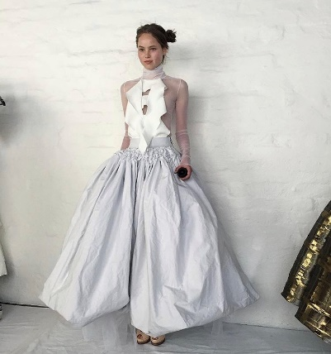 pic 1 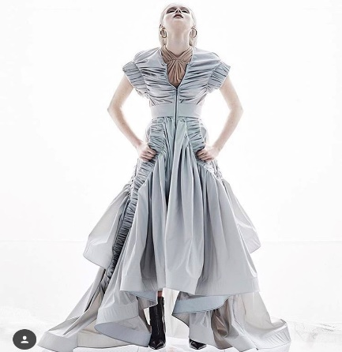 pic 2

Unsuccsful garments

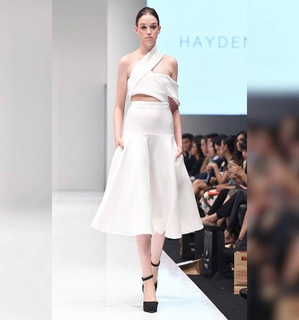 pic 3 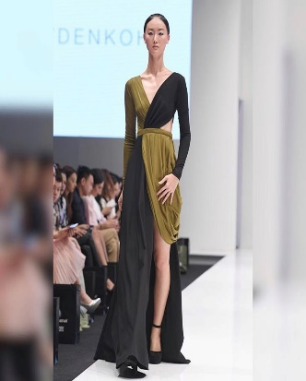 pic 4

Student Statement:

By submitting this assignment, I confirm that this is my own work.

Student Signature | Tracy Kam | Date | 17112016

For Tutor / Assessor Use Only
Total Marks
Marks Obtained
Percentage / Grade

