
Assignment Cover Sheet

Student Name: | Laurel Huxham
Student Number: | 1648
Course: | Certificate in Project Management
Assignment NO: | 03

Marking Criteria:
We expect the learners to write minimum one well expressed point in three lines against each allocated mark. This means one needs to write 15 lines with 5 well expressed points to get high grades for a 5 marks question.
For high grades use examples and illustrations where appropriate.

Please insert your completed assignment ( in word format) here:

3.1 – What is a Project Scope?
The project scope defines what is needed to complete the project successfully, on time and to budget, such as:
- Objectives
- Goals
- Tasks
- Time lines/Deadlines
- Resource
- Deliverables
- Features
- Functions
Once these things have been established the project has a defined project scope. Using the goals and objectives identified, tasks can be allocated to the identified resource and deadlines can be set to ensure the product/service of the project is created on time and to budget.

The scope sets the boundaries of the project. In other words what work is required and what work is not required to complete the project successfully.

The scope assists the Project Manager with decision making such as adding, changing or removing tasks.

3.2 – Which activities are included in Project Scope Management?
The following activities are included in Project Scope Management:

Scope Planning
Inputs – Constraints, Assumptions
Tool & Techniques – Alternatives Identification, Expert Judgment
Outputs – Scope Management Plan, Scope Statement
It is essential that the Project Manager and Project Team have documented their understanding of the projects requirements, stakeholder expectations and the business needs of the project so that these can be used to plan and write the scope statement and scope management plan. The scope statement and scope management plan are used to form an agreement between the Project Team and Stakeholders for the overall outcome of the project.

Scope Statement – The project statement needs to be well written and clear as it will determine how decisions are made later in the project (this could be changes to the project, added works or other decisions) and will also ensure everyone (from the Project team to the End Users) are on the same page. The Project Charter Document is used as an input to the scope statement as it identifies the projects goals and major deliverables which are needed for the project scope.

The scope statement should make reference to the following:
- Project Justification – The business need for the project. You could reference or link the business case, cost benefit and Cash Flow.
- Project Product – details the Project Product.
- Project Deliverables – Deliverables describe the components of objectives and goals in a quantifiable way. High-level deliverables need to be identified as these can be used to determine whether the Project is complete. All other deliverables will also need to be included to ensure they are included in the Project. Any deliverables not included at this stage will be considered outside of the project.
- Project Objectives/Goals – Project objectives and goals need to be identified as these will be used to determine the success of the project and will also be used as a guide to see how the project is running (is it on time? To budget etc).
- Project Requirements - Requirements describe the characteristics of the deliverables such as how big, what material, what colour etc it is important these are listed for the agreement of the Stakeholders.

Objectives and deliverables that determine the completion of the project are called critical success factors and must be documented in a way that identifies them as such. Not all deliverables will be critical success factors.

Scope Management Plan – The scope management plan is in place to document:
- How the scope will be managed
- How changes to the scope will be identified and managed
- How much changes will affect the project
- Define how likely/often the scope is to change and how much it can change
- How changes will be documented

Scope Definition
Inputs – Scope Statement, Scope Management Plan, Assumptions Beliefs, Constraints, Historical Information (such as old Lesson Learnt Logs), Planning outputs (such as risk).
Outputs – WBS, Scope Statement Updates, Communications Management Plan
Scope definition takes place at the Planning Stage of the project. The aim of the Scope definition is to break deliverables down in to smaller manageable chunks. To do this a Work Breakdown Structure will be created. The work breakdown structure looks a bit like a family tree with the project at the top with the main deliverables coming off of that and then sub deliverables and tasks coming off of those. Please see the example below:
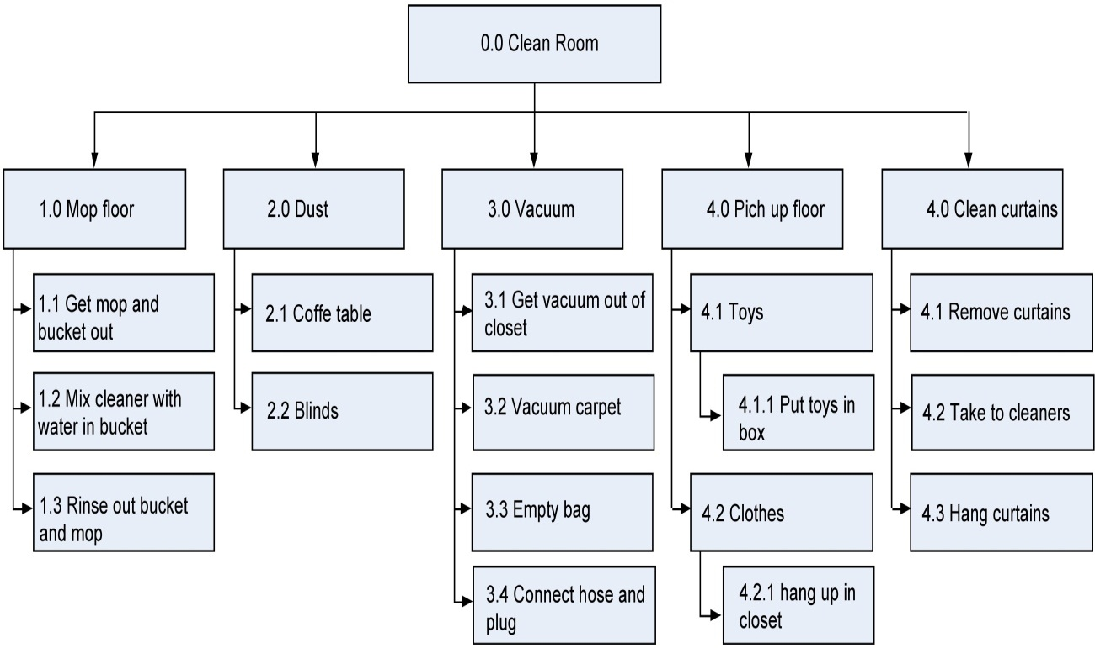
(Example from: http://cnx.org/contents/cDfUikBa@9/Project-Planning)

The WBS uses the Project Charter for the main goals and major deliverables that come from the project and then uses the scope statement to refine these into a list. The WBS will break down each into smaller tasks showing what tasks are needed to complete the deliverable, these tasks need to be split appropriately so that they do not merge as this can confuse later stages of planning. This can then be put into a logical steps to achieve the overall project. This helps to estimate cost, time and resource for the work packages.

In creating the WBS new deliverables that were not considered in the Scope planning stage may come to light and others may no longer be needed. These new deliverables will need to be added to the scope statement and deliverables no longer needed should be removed, these are changes to the scope statement so this will need to be issued to the stakeholder again for approval.

A communications plan must also be put in place so that the Project team know who to communicate with, when to communicate with them and how this should be done.

Scope Verification
Scope verification takes place at the Controlling stage of the project. It is the process of the Project Manager and end user inspecting the work that has been carried out (the deliverable) to ensure it meets the scope before it is accepted and signed off as complete. Quality control is a branch of scope verification as the quality of the deliverable determines whether the scope has been met and whether the end users is willing to accept the deliverable and sign it off. Scope verification takes place at the end of each project phase or when a critical success factor is complete. Scope verification can be used to measure how complete a task/project is before it is signed off or if the project is cancelled.

Scope Change Control
Inputs – WBS, Performance Reports
Outputs – Lessons Learnt Log
Scope Change Control takes place at the Controlling stage of the project. The Project needs a system to monitor, manage and review changes to the project scope. The scope change control ensures changes are recognised and are agreed upon. A scope change can come from a number of sources (Project Team, Management, End Users, Sponsors or Stakeholders) and in a number of ways but they must be received with evidence to support the change, it must also show the impact on the project/planning/schedule/budget.

Some examples of a scope change are:
- Changes to the deliverables
- Changes to Laws/Legislations/Procedures
- A result of a Performance Report (reports are completed to give the Project Team an idea of how the project is going)
- A cost reductions – such as a change in technology
- To mitigate a risk
- Errors/omissions
- Poor performance
Once a change has been agreed the scope will need to be amended along with the WBS document and agreed with the stakeholders. The changes will then need to go through the planning process to evaluate cost/time changes. Corrective actions will then need to be taken to ensure the project is back on track. The project baselines will also need to be amended to reflect the changes.

The projects lessons learnt log should then be updated to show what was changes and detail the reasons why. Lessons learnt can help prevent the same mistakes on future projects.

3.3 – What is the difference between Project Scope and Product Scope?
Project scope is the work required to achieve the objectives and create the project deliverables. Measured against the Project plan which gives specific attributes, features and Characteristics for the project.

The Product scope is the attributes and characteristics of the project deliverables. Measured against requirements.

A project I am working on is to build a new pharmacy. The project scope scope is to provide a Distribution Area with external door for deliveries and a dispensary with trails and clozapine room. The Product scope is the size of the rooms and what they require in them. For example the Distribution Area needs to have a lockable flammables cupboard, a quarantine area, returns area, good out space, trolley park.

Student Statement:

By submitting this assignment, I confirm that this is my own work.

Student Signature | Laurel Huxham | Date | 18/03/2016

For Tutor / Assessor Use Only
Total Marks
Marks Obtained
Percentage / Grade

