
Assignment Cover Sheet

Student Name: | Patrice De La Sayette
Student Number: | 3575
Course: | Diploma in Logistics and Supply Chain Management
Assignment NO: | 10

Marking Criteria:
We expect the learners to write minimum one well expressed point in three lines against each allocated mark. This means one needs to write 15 lines with 5 well expressed points to get high grades for a 5 marks question.
For high grades use examples and illustrations where appropriate.
1.i What are the aims and functions of warehouses?

First we need to define what a warehouse is: it is a facility in which some materials required for a supply chain are stored;
The aims and functions of a warehouse are as described below:
- Provide storage at key points for Supply Chains
- Secure the goods on a closed environment
- Keep the goods in good condition and limit/avoid the damages
- Give customer high service
- Do all necessary activities at minimal cost
- Get high productivity and optimize the resources’ utilization
- Control all movements of materials
- Sort out the Inbound materials and transfer them into storage
- Pick and consolidate departing materials
- Store the whole range of materials needed by a SC
- Be flexible to adapt to any variation in the demand (stock levels)
- Allow for special conditions and rotations
- Give high standards of working conditions.
There are more to the aims and functions. Above are the basics ones and we should keep in mind that most of the time a warehouse’s functions are tailored to answer the specific needs of a SC.

1.II Difference between public and private warehouses:

The main difference is that private ones are owned by a business, they are part of a business (fixed asset). The publics one are those, which are acting as service provider. They are selling the services associated with warehousing activities.
Most of the time Third-Parties Logistics (3PL) have warehouses. These are Public Warehouses.
Companies like Nestle or Waitrose have their own warehouses – these are private warehouses.

1.III Explain the advantages of public warehouses?

As mentioned above the public warehouses are acting as business.
There are several advantages in using such facility. The main one is that they provide a lot of flexibility – they can adapt their services to other SC requirements. If a SC does not have its own Warehouse, they the SC will hire the services of a public one.
Other advantages are:
- Flexibility to face changes in demand patterns
- Expertise is provided
- Latest equipment and practices
- Avoid capital investment
- Easy access to larger areas (bigger network)
- Business trials in specific areas are possible
- Economy of Scale
- Consolidation is possible
- Maintain high quality service
- Remove risks and adapt to varying conditions

SC directors should keep in mind that Private warehouses have small fixed costs but potentially high variable costs. But they do provide a real “peace of mind” as everything is taken care of by professionals.

1.IV What is manual warehouse?

The way the goods are stored in a warehouse can be different. Manual warehouses are those where people can handle activities easily directly. It means that the goods are stored on shelves or in bins at low height, they usually are picked by hand and moved accordingly by hand or in small trolleys. So the items are usually small and not heavy. These warehouses usually are not too big.
Example: if a warehouse stores small stickers for a big company, the picking is done by hand, the packaging as well etc. This is a manual warehouse.

1.V What are automated warehouses?

An automated warehouse is one where the human intervention is reduced to its minimum. They usually are very big warehouses with huge amounts of goods being stored, picked and packed.
All is placed on automated trolleys; all items are scanned, placed automatically in a specific bin location allocated by the local Warehouse Management System (WMS) etc.
Big firms such as Amazon are using these types of warehouses. Investment is high but it’s compensated by the high volume of operations.

1.VI What are the main materials used for packaging?

There are five types of materials used for packaging. These are:
- Glass: not often used as expensive and very fragile. Used for very specific needs only
- Plastic: strong and easy to maintain, can be expensive as well but very handy
- Cardboard: very cheap and light, can be recycled but not strong. The most common material used.
- Wood: strong and easy to use, can be recycled but heavy and not easy to handle. Used for bulky and fragile items (crating)
- Metal: very strong and heavy but expensive as well.

Depending on the nature of the goods to be packed the above materials will be used.

Example: if you relocate and you move your belongings, you will pack your things in cardboard.
If a warehouse has to pack very fragile and costly bottles, they will be packed on heavy pallets, and these will be put inside a container.
DVDs can be packed in cardboards, which in turn will be placed on pallets – these will then be shrink-wrapped.

2.Outline the activities that take place in a warehouse:

Usually the activities that take place in a warehouse are in different parts of the warehouse (receiving, picking, packing, loading, quarantine etc);
These activities are:
- Receiving goods from upstream sellers
- Identify the goods, match them against orders
- Unload materials from delivery vehicles
- Check quantity, quality and state
- Label the material
- Sport and move the goods to storage locations (location often given by WMS)
- Hold the goods until required
- When required move from bulk to smaller picking store (if applicable – most of the time it’s picked directly form storage area). Often there is replenishment between bulk and picking areas
- Picking materials against picking order
- Move items to marshaling area
- Assemble and pack as necessary
- Loading of vehicles to dispatch orders
- Control coms and systems, inventory and invoicing
There are other activities such as combining items – or do some cross-docking operations. Warehouses tend to adapt their scope of work to the demand.

Above is what we can call the commercial activities. There are lots of more activities which are related to the warehouse itself: use of a quarantine area, pest controls, Health and Safety checks and controls (fire fighting exercises), cleaning, staff training etc. There is also all the admin work: receive orders, translate them into picking orders, inventory stock check (make sure the physical matches the records), invoicing etc.

3. General Layout of a warehouse:

When a business has to be set up, it is of high importance to think about the warehouse design. If this is not done correctly then operations will not be efficient.

There are many aspects to take into consideration: nature of activities, type of goods to be stored (volumes, weight etc), picking patterns, investment (budget), short or long term storage etc.
Regarding the nature of the items: it is important to think about their popularity. The most popular ones should be stored as close as possible from the packing and loading area.
Picking routes should be defined, depending on popularity and nature of the goods.
Example: when a picking order is given to a picker, he should follow a path, walking as less as possible, walking the smallest distance as possible. If he has to go to one corer of the warehouse, then to the other side, then come back, then go to another place and come back again, then it’s all but efficient… waste of time is waste of money. So the picking order should follow path in a logical order, minimizing the distance between the bins’ locations. As shown below the picker follows a logical path between the racks:

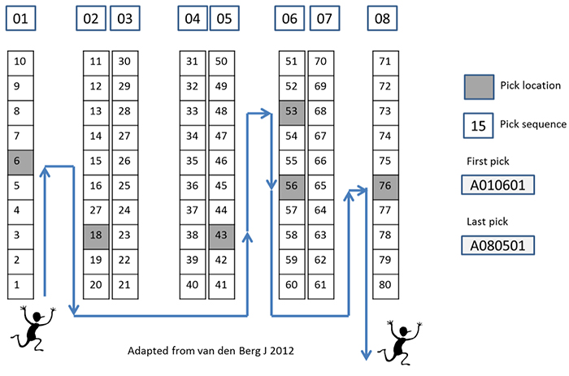

Then depending on where the main gates are, the flow of goods can be defined. It can be a U-flow:
Picking route follows a U-shape

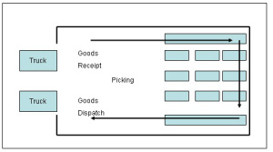

Through-flow:
Picking route is going through the warehouse

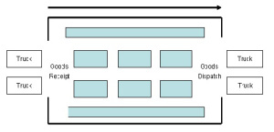

Other areas should be considered: racking, place for handling equipments, office, toilets, resting areas, places for extinguishers etc.

A good WMS is also very important. The WMS should be able allocate locations, keep the inventory updated etc. Pickers have handguns scanners which are used at each step of the activities.

Designing a warehouse is not easy tasks; There are consultants whose work is to do only design. But the main points to take into consideration have been described above.
Example:

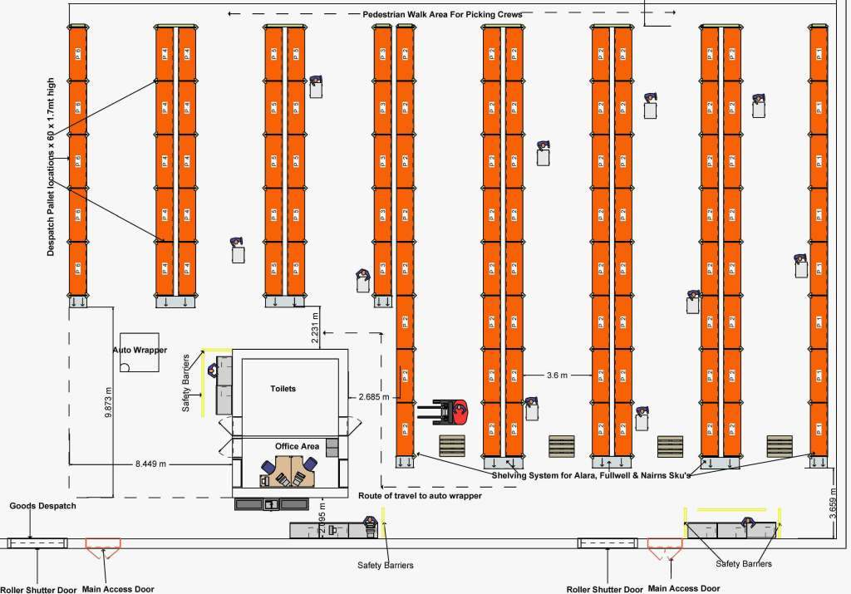

Student Statement:

By submitting this assignment, I confirm that this is my own work.

Student Signature | Patrice De La Sayette | Date | 03 January 2017

For Tutor / Assessor Use Only
Total Marks
Marks Obtained
Percentage / Grade

