
Assignment Cover Sheet

Student Name: | Michael De Bruin
Student Number: | 2469
Course: | Diploma in Logistics & Supply Chain Management
Assignment NO: | 10

Marking Criteria:
We expect the learners to write minimum one well expressed point in three lines against each allocated mark. This means one needs to write 15 lines with 5 well expressed points to get high grades for a 5 marks question.
For high grades use examples and illustrations where appropriate.
1.1) In general, the objectives of a warehouse are to sustain the broader logistics function by giving a mixture of high shopper service and low costs.
More exact aims include:
- Providing necessary storage at key points in a supply chain;
- Giving secure storage of the type needed by materials;
- Keeping all materials in good condition and with minimal damage;
- Giving high customer service;
- Doing all necessary activities efficiently and with low costs;
- Getting high productivity and utilisation of resources;
- Controlling all movements of materials effectively and without errors;
- Sorting materials arriving and quickly transferring them into storage;
- Picking materials departing, quickly transferring them out of storage and consolidating
- deliveries;
- Being able to store the whole range of materials needed;
- Being flexible enough to deal efficiently with variations in stock levels;
- Allowing for special conditions and rotation of stock, etc.; and
- Giving safe working conditions and compliance with regulations.

1.2) Private warehouses are owned or leased by a business as part of its own supply chains. The business runs its own warehouses to sustain its major operations. This gives greater control over a middle part of logistics and allows incorporation of warehousing with the broader activities of logistics.

A public warehouse is run as a self-governing business, which makes money by charging users a fee. There are a lot of types of public warehouse, including bonded warehouses, cold stores, bulk storage, tankers, and various specialty stores. The facilities accessible are usually so flexible that an organization can obtain within reason, any facilities that it requires.

1.3) Benefits include:
- Flexibility to deal with changing demand, possibly due to seasonality;
- Ability to supply skills and knowledge that the business does not have internally;
- Access to the newest equipment and practices;
- Avoiding big capital investment, giving higher return on investment;
- Easy access to a wider geographical regions;
- Allowing immediate tests of working in new areas;
- Use of economies of scale to lessen warehousing costs;
- Consolidating loads with other organizations to decrease transport costs;
- Certain high quality and well-organized service; and
- Flexibility to deal with varying conditions, removing risks from dated practices and technology.
1.4) This is most likely the easiest planning to visualize, and is still one of the most frequent. Items are stored on shelves or in bins. People go around and choose items from the shelves, and put them into some kind of container for movement – like a supermarket trolley. Manual warehouses only work if the items are small and light enough to lift. Shelves must be low enough for them to achieve and close together to decrease the distance walked.

1.5) Traditional warehouses, including mechanized ones, tend to have elevated operating costs. These operating costs can be decreased as well as recovering aspects of service, by using mechanization. Unfortunately, this requires a very high investment in apparatus, and is only actually worthwhile for extremely big stores that shift large amounts of materials.

1.6) The main materials used for packaging?
- Glass is simple to clean, reuse and reprocess, but is easily broken, comparatively expensive and hard to make;
- Plastic is light, strong and simple to clean, but can be costly and hard to create or reuse;
- Cardboard is light, inexpensive, and can be recycled, but has slight strength and poor toughness;
- Wood is strong, tough, easy to use and can be reused, but it is weighty, bulky and tricky to clean; and
- Metal is strong and tough, but it is weighty and can be costly.

2) Activities that take place in a warehouse:
- Receiving goods from upstream sellers;
- Identifying the goods, matching them to orders and finding their planned use;
- Unloading materials from delivery vehicles;
- Doing any essential checks on quantity, quality, and state;
- Labeling materials (usually with bar codes) so they can be recognized;
- Sporting goods as essential;
- Moving goods to mass storage area;
- Holding them in stock until required;
- When required, moving materials from mass storage to a smaller picking store;
- Picking materials from this store to meet orders;
- Moving the materials to a marshaling area;
- Assembling materials into orders;
- Packing and packaging as necessary;
- loading delivery vehicles and dispatching the order; and
- Controlling all communications and connected systems, such as, inventory control and finance.
3) Layout decisions are imperative for three essential reasons: (1) they need substantial investments of both money and effort, (2) they involve long-standing commitments … (3) they have important impact on the cost and competence of immediate operations. This suggests that the necessary elements in a warehouse are an arrival bay or dock, where goods coming from suppliers are delivered, checked, and sorted –
- A storage area, where the goods are kept as stock;
- A departure bay, or dock, where customers’ orders are assembled and sent out;
- A material handling scheme, for moving goods around; and
- An information system, which records the site of all goods, arrivals from suppliers, departures
- To consumers, and other applicable information.
There are a lot of variations on this fundamental outline. The most general one – which is also used in most supermarkets – in fact, has two storage areas. Goods arrive and are put into a mass store (the backroom in a supermarket) which is the major storage area.
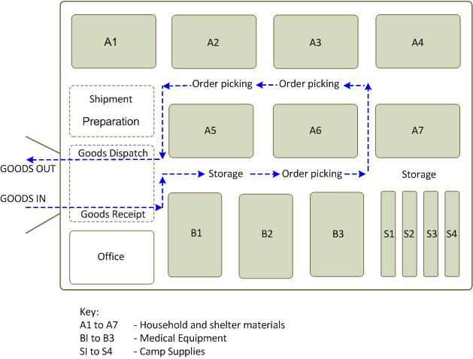

Student Statement:

By submitting this assignment, I confirm that this is my own work.

Student Signature | Michael De Bruin | Date | 30/11/2016

For Tutor / Assessor Use Only
Total Marks
Marks Obtained
Percentage / Grade

