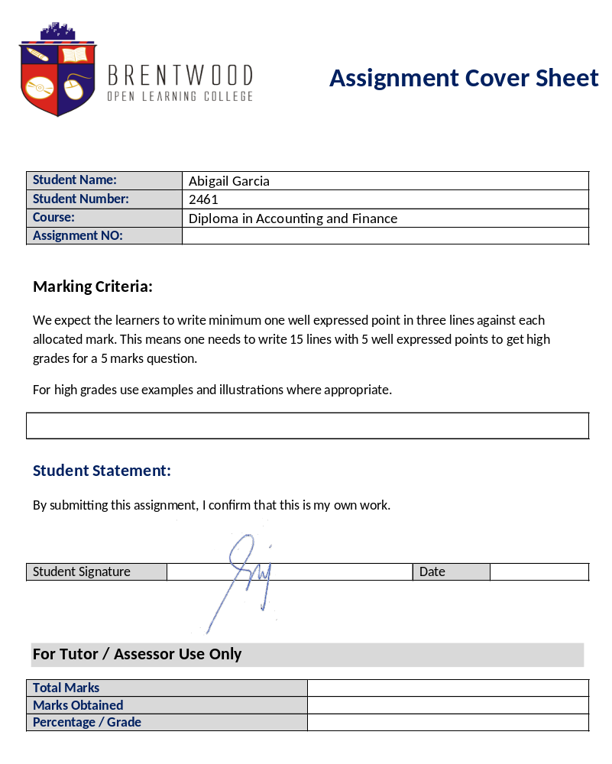

Assignment Cover Sheet

Student Name: | Abigail Garcia
Student Number: | 2461
Course: | Diploma in Accounting and Finance
Assignment NO: | 2

Marking Criteria:
We expect the learners to write minimum one well expressed point in three lines against each allocated mark. This means one needs to write 15 lines with 5 well expressed points to get high grades for a 5 marks question.
For high grades use examples and illustrations where appropriate.
1.i. An accountant performs many different role in the company. He/She is responsible for account keeping. His/her job starts with bookkeeping to preparing financial statements and keeping all financial record of the organization. Accountants can identify problems with the organization’s operations and its financial position and provide solutions, as well. It is an accountant’s job to manage the company’s taxes in a way that there is minimum tax liability. An accountant must have the best interest of the business owner in mind. His/her activities should seek to maximize profits for the business in addition to making sure that ethics are being conformed to.

1.ii Roles and activities of an account accounts varies, but not limited to the following:
- Internal Auditor – They perform audit on all data of organization and in the process set up and maintain system of internal control in the company. They verify and scrutinize entries in the account books and authenticate accounting of assets while checking if all legal aspects are being conformed with.
- Controller – Controller heads all the accounting and internal audit activities. He provides financial reports to external users.
- Treasurer – Treasurer deals and safe keeps cash and bank transactions. He oversees credit related reviews and receivables collection.
- Finance Officer – Makes financial decision together with the other financial managers of the business.

1.iii Controller duties include managing the accounting system, financial statements preparation and reporting, overseeing audit reviews, exercising cost control and budgets, tax preparation and management, and reporting to the business owners of current financial situation.

1.iv Double entry system is an accounting method where a transaction is recorded in at least two different accounts with equal amounts. It involves the following steps:
a) Preparation of Journal: This is the step where transaction is first recorded in the books.
b) Preparation of Ledger: Transactions are posted to respective accounts in the ledger.
c) Trial Balance Preparation: It is a summary of all transactions that have taken place and their effects in the form of a list.
d) Preparation of Final Account: Financial statements are made at the end of the accounting period to reflect the organization’s financial performance and its general financial position.

1.v Debit and credit can be associated with either increase or decrease in financial amounts. This is determined by the kind of account. It is important to note that the sum of debits must be equal to the sum of credits.

1.vi Hybrid Basis Accounting is a combination of cash basis and accrual basis of accounting. It is not widely practiced because of inconsistencies that may occur from using this method.

1.vii Real accounts are transaction relating to properties or assets. They can be classified as either tangible like equipment and cash, or intangible like goodwill and patents. Personal accounts are transaction made against a person or a group. Example of this are capital accounts and drawings.

1.viii Cash basis accounting is done by recording the transaction only when payments have been made or received.

2. The main objective of bookkeeping are maintaining a permanent record of the transaction, ensuring the financial health of the company by analysing the company’s assets and liabilities, calculating profit and loss, keeping customer and vendor profiles along with payments made, received, owing and owed, aids in taxation, and provide comparison over the years.
Bookkeeping and Accounting may seem alike but they are separated by a thin line. While bookkeeping is the recording of the transaction, accounting involves analysing the transactions to make a sound report on the company’s financial situation. Accounting checks for accuracy and rectifies error committed during the bookkeeping process.

3.i The quantity of goods at the end of the year
3.ii Creditor
3.iii Total amount that the owner has invested in the business.
3.iv Expense
3.v Customers

ACTIVITY
Accountant
- Mr. Wasif Nuhullah (Z&H Technology Distribution) – He is responsible for all payments made and received. He issues the invoices and manages cheque preparation.
- Mr. Saud Akber (Digital Devices) – He is responsible for following up with customers on the receivables. He takes care of all financial transactions for the branch.
- Ms. Diane Olaivar (Fiber Security Systems) – She is responsible for processing invoices and making sure that payments are received on time. She handles the issuance of petty cash.
Chief Accountant
- Mr. Mohammad Hassan (Al Zarah Group) – Confirms and approves payments to be made. He reports and meets with the Chairman regarding new business ventures.
- Mr. Elsayed Hegazy (Emirtec LLC) – Confirms and signs cheque payments. Meets with suppliers regarding new project and budgets.
- Mr. Saad Bashir (DDG Group) – Meets all the accountants from all the branches to discuss the financial situation. Constantly checks the back status of the company.
Internal Auditor
- Ms. Elizabeth Castro (Dreamscape UAE) – Ensures compliance and procedures laid down by the company and in accordance with the government’s standards.
- Ms. Agnes Bituin (Deerfields) - Perform and control the full audit cycle including risk management and control management over operations’ effectiveness, financial reliability and compliance with all applicable directives and regulations
- Ms. Angela Pangan (Nestle UAE) – Handles audit independently and report the findings to the management.

Student Statement:

By submitting this assignment, I confirm that this is my own work.

Student Signature |  | Date | 08/09/2016

For Tutor / Assessor Use Only
Total Marks
Marks Obtained
Percentage / Grade

ASSESSMENT # 2 Total Marks: 30

1. Give short answers to the following questions: (16)

- Who is an accountant?
An accountant performs many different role in the company. He/She is responsible for account keeping. His/her job starts with bookkeeping to preparing financial statements and keeping all financial record of the organization. Accountants can identify problems with the organization’s operations and its financial position and provide solutions, as well. It is an accountant’s job to manage the company’s taxes in a way that there is minimum tax liability. An accountant must have the best interest of the business owner in mind. His/her activities should seek to maximize profits for the business in addition to making sure that ethics are being conformed to.

- Describe various roles and activities that accountants perform.
Roles and activities of an account accounts varies, but not limited to the following:
• Internal Auditor – They perform audit on all data of organization and in the process set up and maintain system of internal control in the company. They verify and scrutinize entries in the account books and authenticate accounting of assets while checking if all legal aspects are being conformed with.
• Controller – Controller heads all the accounting and internal audit activities. He provides financial reports to external users.
• Treasurer – Treasurer deals and safe keeps cash and bank transactions. He oversees credit related reviews and receivables collection.
• Finance Officer – Makes financial decision together with the other financial managers of the business.

- What type of duties does a controller perform?
Controller duties include managing the accounting system, financial statements preparation and reporting, overseeing audit reviews, exercising cost control and budgets, tax preparation and management, and reporting to the business owners of current financial situation.

- What is a double entry system? Outline the steps involved in Double entry system.
Double entry system is an accounting method where a transaction is recorded in at
least two different accounts with equal amounts. It involves the following steps:
a) Preparation of Journal: This is the step where transaction is first recorded in the books.
b) Preparation of Ledger: Transactions are posted to respective accounts in the ledger.
c) Trial Balance Preparation: It is a summary of all transactions that have taken place and their effects in the form of a list.
d) Preparation of Final Account: Financial statements are made at the end of the accounting period to reflect the organization’s financial performance and its general financial position.

- What is the meaning of ‘Debit’ and ‘Credit’ in accounting?
Debit and credit can be associated with either increase or decrease in financial amounts. This is determined by the kind of account. It is important to note that the sum of debits must be equal to the sum of credits.

- What is meant by ‘Hybrid basis’ accounting? How the entries are recorded using this method?
Hybrid Basis Accounting is a combination of cash basis and accrual basis of accounting. It is not widely practiced because of inconsistencies that may occur from using this method.

- What is the difference between ‘Real Accounts’ and ‘Personal Accounts’?
Real accounts are transaction relating to properties or assets. They can be classified as either tangible like equipment and cash, or intangible like goodwill and patents. Personal accounts are transaction made against a person or a group. Example of this are capital accounts and drawings.

- How do we record the entries using cash basis accounting method?
Cash basis accounting is done by recording the transaction only when payments have been made or received.

2. What are the main objectives of book-keeping? How would you distinguish book keeping from accounting? (4)
The main objective of bookkeeping are maintaining a permanent record of the transaction, ensuring the financial health of the company by analysing the company’s assets and liabilities, calculating profit and loss, keeping customer and vendor profiles along with payments made, received, owing and owed, aids in taxation, and provide comparison over the years.
Bookkeeping and Accounting may seem alike but they are separated by a thin line. While bookkeeping is the recording of the transaction, accounting involves analysing the transactions to make a sound report on the company’s financial situation. Accounting checks for accuracy and rectifies error committed during the bookkeeping process.

3. Multiple choice questions, Tick the correct answer. (5)

i. Stock is?
- The quantity of goods at the end of the year
• The total value of all the goods purchased during the year
• Items purchased to sell at a profit
• The value of goods left over at the end of the year
• Fixed assets acquired during the year

ii. Which of the following is not an asset?
- Creditors
• Fixed assets
• Cash
• Debtors
• Petty cash

iii. Capital is?
• The total amount of cash in the business
• The amount the bank has invested in the business
• Total of the fixed assets and current assets
- The total amount the owner has invested in the business
• The total amount owed by the business to the bank

ASSESSMENT # 2 Total Marks: 30

iv. Interest paid to a bank is an example of?
• Income
• Liabilities
- Expenses
• Drawings
• Fixed assets

v. Debtors are?
• The owner
• The bank
Activity

• Suppliers
• Employees
- Customers

(5)

Please meet one or more of the following personnel in any organisation and talk to them about their respective roles within the organisation.

Accountant

- Mr. Wasif Nuhullah (Z&H Technology Distribution) – He is responsible for all payments made and received. He issues the invoices and manages cheque preparation.
- Mr. Saud Akber (Digital Devices) – He is responsible for following up with customers on the receivables. He takes care of all financial transactions for the branch.
- Ms. Diane Olaivar (Fiber Security Systems) – She is responsible for processing invoices and making sure that payments are received on time. She handles the issuance of petty cash.

Chief Accountant

- Mr. Mohammad Hassan (Al Zarah Group) – Confirms and approves payments to be made. He reports and meets with the Chairman regarding new business ventures.
- Mr. Elsayed Hegazy (Emirtec LLC) – Confirms and signs cheque payments. Meets with suppliers regarding new project and budgets.
- Mr. Saad Bashir (DDG Group) – Meets all the accountants from all the branches to discuss the financial situation. Constantly checks the back status of the company.

Internal Auditor

- Ms. Elizabeth Castro (Dreamscape UAE) – Ensures compliance and procedures laid down by the company and in accordance with the government’s standards.
- Ms. Agnes Bituin (Deerfields) - Perform and control the full audit cycle including risk management and control management over operations’ effectiveness, financial reliability and compliance with all applicable directives and regulations
- Ms. Angela Pangan (Nestle UAE) – Handles audit independently and report the findings to the management.

