
Assignment Cover Sheet

Student Name: | Linda C Chapman
Student Number: | 1644
Course: | Diploma Level 4 Child Psychology
Assignment NO: | Three

Marking Criteria:
We expect the learners to write minimum one well expressed point in three lines against each allocated mark. This means one needs to write 15 lines with 5 well expressed points to get high grades for a 5 marks question.
For high grades use examples and illustrations where appropriate.
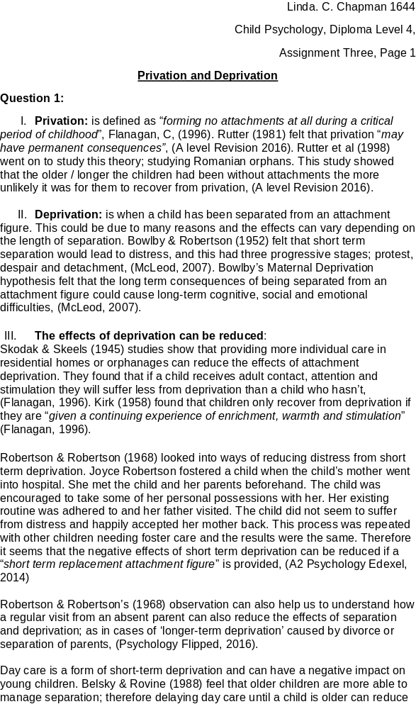

Student Statement:

By submitting this assignment, I confirm that this is my own work.

Student Signature | Linda C. Chapman | Date | 05.04.2016

For Tutor / Assessor Use Only
Total Marks
Marks Obtained
Percentage / Grade

