
Assignment Cover Sheet

Student Name: | Maria Magdalena Barragan Zermeno
Student Number: | 1619
Course: | Management Level 3
Assignment NO: | 04

Marking Criteria:
We expect the learners to write minimum one well expressed point in three lines against each allocated mark. This means one needs to write 15 lines with 5 well expressed points to get high grades for a 5 marks question.
For high grades use examples and illustrations where appropriate.
Please insert your completed assignment ( in word format) here:

Question 1

Define time management
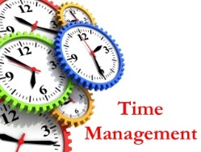
The increasing salience of 'time management' is reflected in theoretical as well as practical publications. A number of authors discussed the need for better incorporating 'time' in theoretical models and research designs (e.g. Ancona et al., 2001; George and Jones, 2000; Wright, 2002). Others focused on the ways in which people in organizations manage their time and on ways in which these efforts can be improved (e.g. Macan, 1994).

McCay (1959) developed a concept for a time-management training program, which is still being used. Critical elements are: giving insight into time-consuming activities, changing time expenditure, and increasing workday efficiency by teaching people how to make a daily planning, how to prioritise tasks, and how to handle unexpected tasks.

The term “time management” is actually misleading. Strictly speaking, time cannot be managed, because it is an inaccessible factor. Only the way a person deals with time can be influenced. Time management can be viewed as "a way of monitoring and controlling time" (e.g. Eilam and Aharon, 2003). In this regard, it would be more appropriate to speak about self-management with regard to the performance of multiple tasks within a certain time period. But in the literature, the term self-management has a different meaning. It refers to monitoring and regulating oneself, but without any specific reference to techniques for monitoring time use. Therefore, we stick to the common use of the term 'time management'.
Myth
Time management is about managing time

Reality
You cannot manage time, you can ONLY
manage YOURSELF relative to time.

There is no agreement on the definition of time management in past studies. Although many authors referred to Lakein (1973), who suggested that time management involves the process of determining needs, setting goals to achieve these needs, prioritising and planning tasks required to achieve these goals, several other definitions were suggested.

Thus, time management has been referred to as:

- Techniques for managing time (Jex and Elacqua, 1999; Davis, 2000; Macan, 1994, 1996; Macan et al., 1990; Mudrack, 1997).
- A technique for effective time use, especially having enough time to accomplish the many tasks required (Orpen, 1994; Slaven and Totterdell, 1993; Woolfolk and Woolfolk, 1986).
- Planning and allocating time (Burt and Kemp, 1994; Francis-Smythe and Robertson, 1999a).
- The degree to which individuals perceive their use of time to be structured and purposive (Bond and Feather, 1988; Strongman and Burt, 2000; Sabelis, 2001; Vodanovich and Seib, 1997).
- A way of getting insight into time use (Koolhaas et al. 1992).
- A technique to increase the time available to pursue activities (King et al. 1986).
- Practices intended to maximize intellectual productivity (Britton and Tesser, 1991).
- An application of self-regulation processes in the temporal domain (Griffiths, 2003).
- The use of procedures that are designed to help the individual to achieve his or her desired goals (Hall and Hursch, 1982).
- Ways to assess the relative importance of activities through the development of a prioritisation plan (Kaufman-Scarborough and Lindquist, 1999).
- Clusters of behaviour that are deemed to facilitate productivity and alleviate stress (Lay and Schouwenburg, 1993).

Besides time management, other terms, such as time structure (Bond and Feather, 1988), have been used interchangeably with essentially the same meaning.

Based on certain literature, a definition of time management is presented as “behaviours that aim at achieving an effective use of time while performing certain goal-directed activities”.

This definition highlights that the use of time is not an aim in itself and cannot be pursued in isolation. The focus is on some goal-directed activity, such as performing a work task or an academic duty, which is carried out in a way that implies an effective use of time.

These behaviours comprise:
* Time assessment behaviours, which aim at awareness of here and now or past, present, and future (Kaufman et al., 1991) and self-awareness of one’s time use (attitudes, cognitions, e.g. Wratcher and Jones, 1988), which help to accept tasks and responsibilities that fit within the limit of one’s capabilities.

* Planning behaviours, such as setting goals, planning tasks, prioritising, making to-do lists, grouping tasks (e.g. Britton and Tesser, 1991; Macan, 1994, 1996) which aim at an effective use of time.

* Monitoring behaviours, which aim at observing one’s use of time while performing activities, generating a feedback loop that allows a limit to the influence of interruptions by others (e.g. Fox and Dwyer, 1996; Zijlstra et al., 1999).
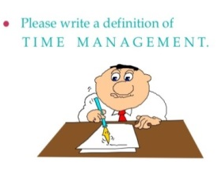
There is a variety of more or less similar
definitions of time management:

"Time management is the act or process of planning and exercising conscious control over the amount of time spent on specific activities, especially to maximize personal effectiveness, efficiency or productivity. It involves analyzing how time is spent and then prioritizing different work tasks".

"Time management is a process of organizing time commensurate with the schedule of daily life".

Time Management refers to ‘assigning specific time slots to activities as per their importance and urgency in order to make the best possible use of time’.

In a layman’s language ‘Time Management is nothing but to manage time well and doing things when they actually need to be done’.

Another definition of time management:
Time management includes the processes required to accomplish timely completion of the project. The project Time Management process includes the following:

- Define Activities
- Sequence Activities
- Estimate Activity Resources
- Estimate Activity Duration
- Develop Schedule
- Control Schedule

Time management refers to “managing time effectively so that the right time is allocated to the right activity”. In effective time management, specific time slots are given to activities according to the order of importance.

Basic time management includes:
- Effective planning
- Setting goals and objectives
- Setting deadlines
- Delegating of responsibilities
- Prioritizing activities as per importance
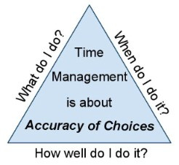
- Spending the right time on the right activity

Time management is ‘the conscious control of the amount of time spent on work activities, in order to maximize personal efficiency’.

"Time management is the skill of organizing your time so that you can accomplish what you need to do, analyzing how working hours are spent, planning, and prioritizing tasks in order to maximize personal efficiency in the workplace and avoid wasted time".

"Time management is an art. It is arranging, organizing and budgeting time for the purpose of accomplishing something within a time. It is having control over the amount of time spent on a particular activity. Hence time management helps an individual to be more organized and more productive".

Time management means the development of a process and tools that help you to be more productive and efficient:
- It is the ability to manage yourself within a given time.
- It is about making sure that you get things accomplished in a time limit.
- This can be applied at work or at home.
- You can be happier and efficient person all together.

Time management is ‘systematic, priority-based structuring of time allocation and distribution among competing demands’. Since time cannot be stored, and its availability can neither be increased beyond nor decreased from the 24 hours, the term 'time budgeting' is said to be an appropriate term as well.

As I mentioned before, time itself can't be managed. It is constant and it always goes forward, never backwards. Everyone has the same amount of time in a day. Therefore, if we are managing time, we are not trying to manipulate time; we are trying to make the best use of our time.

Time management is ‘the act of taking conscious control over the amount of time spent on specific activities’. We exercise time management to increase productivity, effectiveness and efficiency. We practice skills and use tools and techniques to aid us when accomplishing tasks, projects or are working toward goals and deadlines.

Time management is about effective scheduling of our time, goal setting, prioritizing and choosing what to do and what not to do, delegating tasks, analyzing and reviewing our spent time, organizing our workspace, keeping our concentration and focus at our work, motivating ourselves to work towards a goal.

Time Management is not wasting time! Procrastination could be the opposite of effective time management. Spending time on activities that produce nothing of value to our life or to someone else’s life is considered wasting our time.

Time management is ‘the process of organizing and planning how much time we spend on specific activities’ ‘the way that we organize and plan how long we spend on specific activities’. Its scope is to help ourselves become aware of how we use our time as one resource in organizing, prioritizing, and succeeding in our studies, in the context of competing activities of friends, work, and family.

The modern concept of time management as ‘the act of planning the amount of time we spend on which activities’ really began with Frederick Taylor's scientific management techniques. His goal was to increase worker productivity. To do this, he conducted time and motion studies and began to focus on the best ways for jobs to be performed to maximize the work completed in a given amount of time.

In her 1994 book, Thinking Smarter: Skills for Academic Success, Carla Crutsinger defined effective time management as the process of:
- Setting goals
- Prioritizing those goals
- Deciding how much time to allocate to specific tasks
- Adjusting plans as they change
- Revisiting the goals and priorities regularly
- Observing results

Some people misunderstand time tracking for time management, though time tracking is the first step to gather the relevant data that would be utilized to manage time effectively. The use of a time management log shows the areas that need to be modified, as it would obviously reveal the ways in which time is wasted. Setting priorities and making plans ensures proper control, efficiency, as well as self-confidence.

This time management system, therefore, helps unfold the inherent potential of individuals, giving an insight into priorities, plans and their implementation.

Time management is a choice over which we do have control, and it is a habit, which requires practice to learn.


Time management involves making the best use of time, and getting more done in the time available. It means not wasting time on irrelevant things, instead focusing on important parts of the job. Ultimately this means working calmly and effectively, avoiding the panic and anxiety of the last-minute rush.

In the western world, time is treated as a valuable resource which people spend. Most managers claim that they do not have enough time. Often this is blamed on the organisation and colleagues for making too many demands. However, we all have at least some control over how we spend our time. We can and do make choices. Recognising this is the first step on the path to effective time management.

"Time management means taking more control over how we spend our time and making sensible decisions about the way we use it". But what do people actually mean by "I manage my time very well"? Do they? Or are they just good at taking on less work than what they are capable of doing?
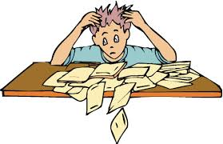
Many people just spend their entire lives living in a disorganized manner which primarily inhibits them from exploring their true potential. The management of time, as a word, seems like a self-explanatory expression. However, the real meaning of time management runs much deeper and involves strict measures that have to be taken in order to incorporate it within our life.

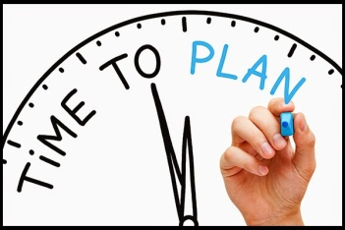
Time management entails planning out our activities and tasks as specifically as possible in a manner where they will complement each other and will constitute the best use of our time. In other words, the meaning of time management is very closely related to organizing our tasks, but with the additional dimension of taking into consideration our own personality traits and the nature of the tasks at hand in order to maximize the usage of our time.

Question 2

Why time management is important?
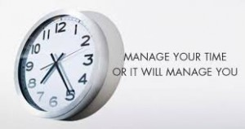
The interest in time management is by no means new. The problem of how to manage time was already discussed in the 1950s and 1960s, and several authors proposed methods on how to handle time issues on the job (e.g. Drucker, 1967; Lakein, 1973; Mackenzie, 1972; McCay, 1959). They suggested simple remedies such as writing work plans down on paper (so-called “to-do lists”) in order to increase job performance. At the same time, some authors (e.g. Drucker, 1967) recognized that planning tasks and activities does not always lead to the completion of planned work, especially when time pressure is high.

During the last two decades, there has been a growing recognition of the importance of time in the organizational literature. According to Orlikowsky and Yates (2002), the temporal dimension of work has become more important because of expanding global competition and increased demands for immediate availability of products and services.

Garhammer (2002) has pointed at the increased pace of life shown in doing things faster (acceleration), contracting time expenditure (e.g. eat faster, sleep less), and compressing actions (making a phone call while having lunch).

Time management is important in any situation and most people have difficulty getting started. Time management is a skill that we have to learn. Time management is a life style. The best place to begin working on time management is by changing our behaviors.

You can only harvest the advantages of time management by efficiently managing your time! While it sounds pretty straight forward, many don't fully understand the advantages of managing their time efficiently. As a result, they spend very little effort in understanding how to manage their time.
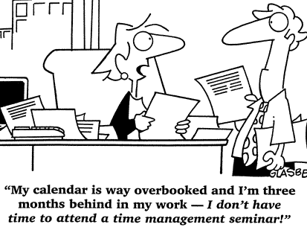
There is so much to do, yet so little time, leaving us in a constant state of rush and overwhelming exhaustion. For some they don't even have the time to apply Time Management in the workplace! They think it's wasting their time. Yet, there are some quick and simple tips that will make us efficient in the workplace and will ensure that we keep a balanced work life.

Of course implementing behavioural changes isn't an easy task, but we become a little more persistent once we understand the benefits that they will bring us.

It seems that there is never enough time in the day. But, since we all get the same 24 hours, why is it that some people achieve so much more with their time than others? The answer lies in good ‘time management’.

Time management is important because it is an irreplaceable resource. Each second that becomes part of our past will never be part of our present or future ever again. Using each second, minute and hour of the day wisely is important.

The highest achievers manage their time exceptionally well. By using different time management techniques, we can improve our ability to function more effectively even when time is tight and pressures are high.

Learning time management skills is extremely important for anyone who wants to maximize his/her leadership potential and establish a prosperous career. Often, we feel so overwhelmed with our day to day tasks that focusing on learning time management skills isn't a pro-active measure, but one that becomes an alternative to a burn out!

Good time management requires an important shift in focus from activities to results: being busy isn’t the same as being effective. Ironically, the opposite is often closer to the truth. Spending our day in a frenzy of activity often achieves less, because we’re dividing our attention between so many different tasks. Good time management lets us work smarter – not harder – so we get more done in less time.

It may seem counter-intuitive to dedicate precious time to learning about time management, instead of using it to get on with our work, but the benefits are enormous:

- Greater productivity and efficiency.
- A better professional reputation.
- Less stress.
- Increased opportunities for advancement.
- Greater opportunities to achieve important life and career goals.

Failing to manage our time effectively can have some very undesirable consequences:

- Missed deadlines.
- Inefficient work flow.
- Poor work quality.
- A poor professional reputation and a stalled career.
- Higher stress levels.

Spending a little time learning about time-management techniques will have huge benefits now – and throughout our career.

Time management has come up as a subject in the management field to reach the goal of increasing productivity, especially among white-collar workers for whom work output may be hard to measure.
For example, an assembly line worker's output of 60 widgets per hour can be compared to a factory average and deemed as acceptable or not. However, white collar outputs tend to be difficult to compare to standards.
So, modern managers in these areas look for ways to monitor worker productivity in terms of time use.

The payoff for becoming an excellent time manager is huge. It is the outwardly identifiable quality of a high performer vs. a low performer. All winners in life use their time well. All poor performers in life use their time poorly. One of the most important rules for success is simply to “form good habits and make them our masters.”

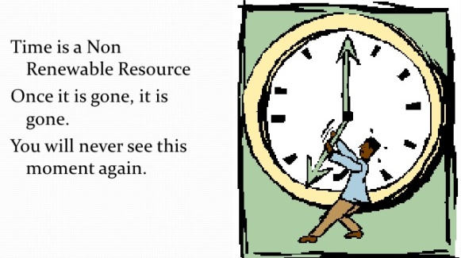
Remember that time management is really life management. Good time management and personal productivity begins by valuing our life, and every minute of that life. Our self-esteem is largely determined by the way we use our life and time in the development of our full potential. Our self-esteem increases when we are working efficiently, and our self-esteem goes down when we are not. The flip side of the coin of self-esteem is called “self-efficacy,” defined as the degree to which we feel we are competent, capable, and productive, able to solve our problems, do our work, and achieve our goals. The more competent, capable, and productive we feel, the higher our self-esteem. The higher our self-esteem, the more productive and capable we will be. Each one supports and reinforces the other. People who manage their time well feel positive, confident, and in charge of their lives.

Our ability to manage our time, like any other practice in our career as an executive, will determine our success or failure. Time is the one indispensable and irreplaceable resource of accomplishment. It is our most precious asset. It cannot be saved, nor can it be recovered once lost. Everything we do requires time, and the better we use our time, the more we will accomplish, and the greater will be our rewards.

Time management is essential for maximum health and personal effectiveness. The degree to which we feel in control of our time and our life is a major determinant of our level of inner peace, harmony, and mental well-being. A feeling of being “out of control” of our time is the major source of stress, anxiety, and depression. The better we can organize and control the critical events of our life, the better we will feel, moment to moment, the more energy we will have, the better we will sleep, and the more we will get done.

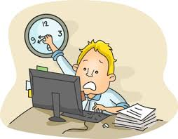
We feel that we have too much to do in too little time, and that we are not really in charge of our time and our life. Most of what we are doing, hour after hour, is reacting and responding to external events. It may seem like there aren’t enough hours in the week to get everything done. That may be true or it may be that we are not using our time as efficiently as possible.

There is a big difference between action that is self-determined and goal-directed and reaction, which is an immediate response to external pressure. It’s the difference between feeling positive and in control of our life and feeling negative, stressed, and pressured.
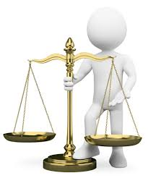
Another point about time management is the concept of balance. The most important thing that we can instill in our life is balance and moderation, and practicing methods, ideas, and techniques, are great help so that we can become a master time manager, and have more time for our work, our family and our personal life.

The main purpose of learning and practicing time management skills is to enhance and improve the overall quality of our life, to increase the amount of pleasure and happiness we experience.

The benefits of managing our time effectively are not just important for the development of our career but they also have significant impact upon our personal life. Failing to properly manage our time in one area of our life will have an impact on the other area. In order to avoid such compromising situations we need to understand that learning about time management is really about implementing a lifestyle change. In other words, we need to adopt values that are coherent with effective time management. For example, it's pretty hard for someone that doesn't embrace punctuality as a value to be effective at managing his/her time.

Often, people take time management programs so that they can increase the number of things that they can do on a day-to-day basis. However, as the wise man said, “There is more to life than simply increasing its speed.”

Michael C. Mankins in his article ‘Stop Wasting Valuable Time’ (Harvard Business Review Sept 2004) writes:
A very real constraint on the financial performance of most companies is top management’s capacity to reach good decisions quickly. Both quality and pace are important. Obviously, poor decisions made too quickly will lead to actions that destroy shareholder value. But good—even great—decisions made too slowly can depress company performance as well. Unfortunately, research shows, few companies manage executive time in a disciplined or systematic way.

Learning time management methods is a skill no different than learning to speak another language or figuring out how to word process!! If you want to get better at it, you can!

Time Management:
- Gives us a chance to decide how to spend a valuable resource
- Allows us to get the most out of the least
- Helps us organize and learn how to spend our time

Like many of us who are out there trying to make a change in our lives for the better, you too must have control of an essential part of your live, and that is time management. That's why you sometimes wonder how it is that some people seem to have enough time to do everything and others are always rushing.

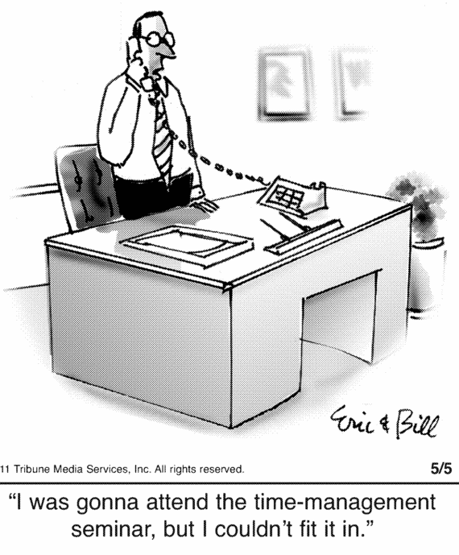
It’s more likely that they are using their time more effectively with good time management skills. Time management seems like a simple process to follow, but when put into practice it can be very difficult. It requires us upfront to take a time to prioritise and organise. Then with a few changes, we will find our day, week and month, fall into place, allowing time for everything we need to do.

Time management is important for our personal life and career success. It teaches us how to manage our time effectively and make the most of it.

There are lots of different ways to tackle the issue of time management — we can download apps, adjust our sleep time, create lists, etc. But if we don’t fully understand why it’s important for us to better manage our time, those apps and lists aren’t going to help us. If we don’t have the motivation to use them, we won’t.

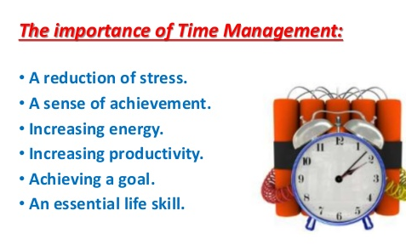
Here are a few more reasons why time management is so important, and how it can help us use and manage our time more advantageously:

1. Time is a special resource that we cannot store or save for later use. Everyone has the exact same amount of time each day. Time not well used cannot be retrieved. So plan your life wisely. No matter how we slice it, there are only 24 hours in a day.
That applies to me, to you, and to your coworker who only seems able to do half the amount of work you do. But it also applies to the former coworker who consistently accomplishes more than you, and was promoted as a result. If we want to rise through the ranks, we have to acknowledge the importance of finding a way to manage this limited resource.

2. Most people, feel like they have too much to do and not enough time. They blame lack of time for their poor finances, stress, bad relationships, and for not exercising their body. Wise time management can help us find the time for what we desire, and for what we need to do. When we learn to take control of our time, we improve our ability to focus. And with increased focus comes enhanced efficiency, because we don’t lose momentum. We’ll start to breeze through tasks more quickly (the workday will also seem to fly by).

3. We need time to get what we want out of life. If we wait for extra time to appear, we might lose the game of life. Through right time management, we can “create” the time we need, and not just wait for it to come. By planning our time wisely, we will have more time to do more things.

We can learn to find the time for the things that are important to us. Even a small amount of time once a day, or even once a week, will take us closer to our goals, and we will be surprised at the progress we make.

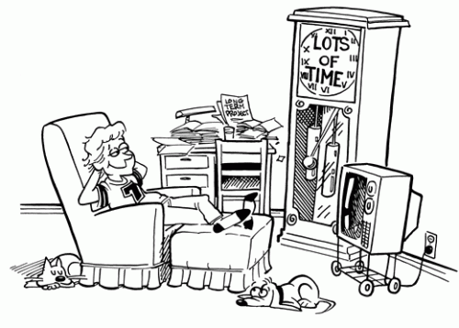
Using time wisely allows us to complete tasks in an allotted time period, take on additional work, or spend more time with family, etc.

Free time is necessary; everyone needs time to relax and unwind. Unfortunately, though, many of us don’t get enough of it. Between jobs, family responsibilities, errands, and upkeep on the house and the yard, most of us are hard-pressed to find even 10 minutes to sit and do nothing.

Having good time management skills helps us find that time. When we’re busy, we’re getting more done. We accumulate extra time throughout our day that we can use later to relax, unwind, and prepare for a good night’s sleep.

4. Life puts in front of everyone so many choices each day, and the question is, do we follow what appears on our way, or do we consciously choose what we want to do? It’s easy to see the multiplicative effect of time management. Good time management allows us to accomplish more in a shorter period of time, which leads to more free time, which lets us take advantage of learning opportunities, lowers our stress, and helps us focus, which leads to more career success. Each benefit of time management improves another aspect of our life.

Time management will help us set up our priorities and improve our decision-making ability. Whether we rely on a time-chunking technique or discover the power of list-making, we’ll soon find that a nice side benefit of good time management skills is the ability to make better decisions. When we feel pressed for time and have to make a decision, we’re more likely to jump to conclusions without fully considering every option. That leads to poor decision making.

Time management helps us make conscious choices, so we can spend more of our time doing things that are important and valuable to us.

Time management is a huge part of managing ourselves. If we cannot manage time and won’t manage our limited resources, how do we plan to achieve our goals? I find that learning to manage time helps to discipline ourselves.

Time management is the key to success. It allows us to take control of our life rather than following the flow of others. As we accomplish more each day, make more sound decisions, and feel more in control, people notice. Leaders in our business will come to us when they need to get things done. And that increased exposure helps put us in line for advancement opportunities.

5. We reduce stress. When we don’t have control of our time, it’s easy to end up feeling rushed and overwhelmed. And when that happens, it can be hard to figure out how long it’s going to take to complete a task.
Think of a time when you were about to miss a deadline and were frantically trying to finish the project. If someone dumped a surprise on your desk at that moment and asked you how long it would take to finish the surprise task, how could you even begin to answer their question?

Once we learn how to manage our time, we no longer subject ourselves to that level of stress. Besides it being better for our health, we have a clearer picture of the demands on our time. We’re better able to estimate how long a given task will take us to complete, and we know we can meet the deadline.

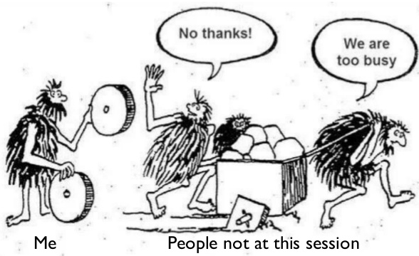
6. We become more productive using improved time management skills and tools, and can accomplish more with less effort and time. Time management can help us reduce wasted time and energy, help us become more creative and productive, and enable us to do the right thing at the right time. We will get more done in less time. When we plan our time, we will see the amount of work that needs to be tackled. That puts into context how much time we need. Inevitably, we will know not to laze our time away. This will of course lead to more balance and fulfillment in our life.

Obviously, the more we learn the more valuable we are to our employer; and great learning opportunities are around us, if we’ve got time to stop and take advantage of them.

When we work more efficiently, we have that time. We can help out with that new product launch our development team’s been working on. Volunteer to help host our company’s open house. Even just enjoying a nice lunch with teammates in other departments can prove eye-opening. The more we learn about our company and our industry, the better our chances of making a positive impression on the C-suite.

7. Life today presents so many distractions, and therefore, it is very easy to lose time on unimportant activities. We need to ask ourselves if watching this or that TV program, reading this or that gossip or participating in a certain activity is going to add anything to our life. Is the time spent on a particular activity well spent, or is just a waste of time and energy?

Once we have a list of things we need to tackle, we need to see what we should do first. What are those that are important and time sensitive? That way, we set out to do those first.

When we practice good time management, we leave no room for procrastination. The better we get at it, the more self-discipline we learn. This is a valuable skill that will begin to impact other areas of our life where a lack of discipline has kept us from achieving a goal.

There are many things we can do and tools to use to manage our time effectively. There is a lot of time wasted each day, which can be put to better uses. There are changes we can make, which will effectively increase the time we have at our disposal every day. Remember:
“Time once gone never comes back.”

Doing the right thing at the right time is an art and comes with planning and understanding. Time Management is nothing but making the best possible use of time.

Thinking, planning, finding out how others manage their time, and reading books and articles on time management, will develop these skills and give us good ideas. Try to get rid of the feeling that you have much to do and not enough time.

Every organization works on deadlines. An individual constantly needs to be on his toes to finish off assignments within stipulated time frame. It is essential for employees to understand the value of time for them to do well and make a mark of their own at the workplace.

One of the greatest assets a business can have is an employee who uses his or her time to its fullest potential. Time management is not an instinct, and instead, must be learned.

Prioritizing our work and using a facilitative leadership style for coaching our staff on how to be efficient at time management will augment our overhaul efficiencies and it is definitely within the family of stress management techniques.

Time management enables leaders as well to organize their personal and professional lives and develop time management skills. The result is balanced leaders leading organizations.

More reasons for “Why Time management is important?”

* It forces us to do things we do not like: This is most interesting. Why? Simple, when we write down what we need to do – it is there staring at us. We are forced to tackle it. ‘To me it is a target I have given myself and so I must live up to the challenge regardless of how much I hate doing it’.

* It keeps us on track: Whether it is a daily work list or a long-term career plan, time management keeps us on track. With our goals stated and time allocated, the likelihood of us staying within the boundaries we have given ourselves is higher.

* Making sure we deliver what’s promised: How would you deliver what you promised on time if you do not manage your time? Have you ever disappointed your colleagues on the delivery of your part of the project?
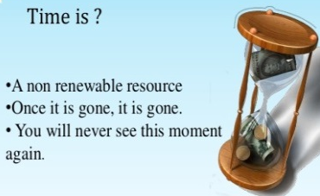
Perhaps we aren’t doing well with time management. Making sure we deliver what’s promised should be reason enough why time management is important. Time is limited, time ticks away regardless we like it or not. Why is time management important? Well, because time is limited. Once lost, we cannot gain it back.
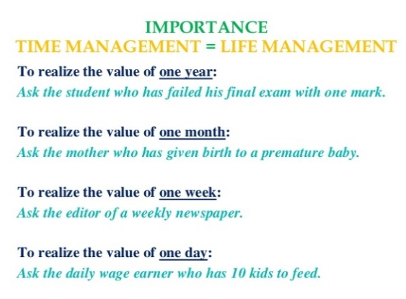
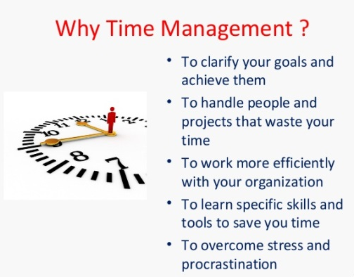

Another example of why time management is important is found in an article written by Michael C. Mankins in the September 2004 issue of ‘Harvard Business Review’ called ‘Stop Wasting Valuable Time’. Here I put some excerpts:

A few days before AnyCo’s biweekly top management team meeting the CEO’s assistant sends out an e-mail asking attendees to submit agenda items. A hodgepodge of suggestions comes back. The head of HR wants to update the team on a nasty age discrimination lawsuit that’s about to go to trial. The executive vice president for the European business division wants to discuss disturbing competitive trends in her region. The CIO asks for a few minutes to review plans for Sarbanes-Oxley compliance. The manager of the largest North American business unit needs to present a major capital investment proposal for a factory automation program. The marketing senior vice president has to show some alternatives for a big print-advertising campaign. And the CEO himself wants to kick off an effort to revamp the company’s annual planning and budgeting process.

The assistant creates a draft agenda, listing the items in the order they were submitted, allots a best guess of the time needed for each, and runs it by the CEO. He reorders the agenda a bit, putting the routine, operational items up front to ensure that the bulk of the meeting is focused on strategic issues; but when the meeting takes place, his plan goes awry.

The group has a long, drawn out debate about the look and feel of the advertising campaign, and the discussion of Sarbanes-Oxley turns into a gripe session about the IT department. The executives end up with little time to devote to the deeper business issues. They give the factory automation plan a green light after a cursory examination—to the CFO’s great discomfort. They put off consideration of European competition for a future meeting. And they have an unfocused and ultimately inconclusive discussion about the CEO’s new planning process.

When the meeting breaks up—an hour late—people leave in a sour and cynical mood, complaining to themselves about another waste of valuable time.

The scenario I’ve just described is played out on a regular basis at almost any company you might name, including, most probably, your own. For although time is the scarcest resource in any company—after all, no amount of money can buy a 25-hour day—the sad reality is that few top executive teams manage their time at all well.

The price of misused executive time is high. Apart from the frustrations that individual managers suffer, delayed or distorted strategic decisions lead to overlooked waste and high costs, hastily conceived and harmful cost reductions, missed new product and business development opportunities, and poor long-term investments.

But … a few deceptively simple changes in the way top management teams set agendas and structure meetings can make an enormous difference in their efficiency and effectiveness. (Michael C. Mankins)


Question 3

Explain the importance of Email for time management

In this day and age of the internet, email communications comprise many of our daily communications between friends, family members, and co-workers. Emails are a huge part of our life but some of us simply take them for granted.

Because the use of it is so prevalent, we often take it for granted as to how important the communication really is. After all, all we have to do is hit a button, type a few words, and hit another button. This is far easier and timelier than the process of sending a letter or even making a phone call; because of this, many people really misuse email many times.

No other aspect of technology is as much a part of our daily life as email. From communications between people at your place of business, to those in your family, we are using email constantly. Therefore, it is important to understand exactly how to use it so that it is as effective for us as possible.

Email is the fastest and easiest way to keep up and communicate with family, friends, students, and coworkers. Email is easy to write and can be sent by almost all consumers with just a fraction of computer knowledge. If consumers can type, use a mouse, and have Internet service, they connect themselves with the world via email.

Students can Email their instructor homework when they are sick and cannot make it to school. At the office, users can send memos, projects, and reports with ease from anywhere that has email access twenty-four hours a day. These are just a few small conveniences that email provides for everyone. There are many more and much bigger conveniences as Andrew Leonard points out, “Books are written, campaigns conducted, crimes committed”. All of this is possible with little cost to the consumer.


At home, computer users receive Emails from loved ones. At the office, workers receive important memos from colleagues. At school, students send jokes and projects from school to home and vice versa. This Electronic mail is a cheap, fast, convenient, and an easy way to communicate to almost anyone. In addition to being a huge convenience for consumers, Email connects the world with a simple click; however, not everyone loves checking their Email because of all the unwanted messages and computer user’s days become less productive as they are constantly reading, writing, and replying to emails.

Email is widely used as a form of business communication and overall it is a highly effective communication tool. Email is inexpensive, only requiring an Internet connection that is generally already present in the business. Although it cannot and should not replace all face-to-face communication and others forms of communication, internal email usage can cover many areas within the business.

Example:
Sending simple messages to an entire workforce with just the click of a mouse is fast, easy, convenient and can save the company money and ‘time’. If saved, the email can function as proof of a message sent or received, and is easily accessible to remind the recipient of pertinent information. Many businesses use email as part of its marketing efforts to share information with prospects, customers, and vendors.

Email has been revolutionary in the world of business communication because information is quickly passed along with instantaneous efficiency and effectiveness. Employees are able to access information from a computer, phone or PDA nearly anywhere, and so are the company’s current and potential customers. The use of email within a business can greatly increase productivity for employees and can be a quick way to increase sales as well. More companies are using email communications as part of the marketing mix to communicate and interact with its target markets.

Email allows a quick response from the other party and keeps a record of a conversation which is searchable and can be referred to later.


We need just to think of how long it would take to either write a letter or memo, or to have to call someone. This way we can send it to more than one person at once.

We remember the old days when we would have to phone each person or send a message via internal mail to inform them of a meeting. Time would be wasted by people visiting colleagues to deliver a message. Business communication email and electronic communication have changed all this. With email communication messages can be conveyed in a flash for example, informing employees of an update to policy or a deadline. The time it takes to get everyone together for a meeting is time wasted. Depending on the size of the business, this could take hours. While with email a message reaches everyone concerned in a matter of minutes.

Another key role for email is the addition of attachments. Instead of spending time making copies and distributing them to all concerned, sending an email with an attachment that the recipient can print out, or read on the computer, is far less time consuming. It is a reliable form of communication and avoids the time it would have taken to track each person down.

Email is an extremely useful communication tool in business. Less intrusive than a phone call, email is convenient and fast. It empowers entrepreneurs to run their businesses from just about anywhere. You can communicate with clients and customers, check in with employees and set up important meetings from your office or on the go, which is ‘time-saving’ by all means.

The fact that email has great importance in modern business communication is undeniable. Every day, millions of emails are sent from companies to customers and suppliers, from employees to their managers and from one coworker to another. There are several reasons for the preponderance of email when compared to other methods of communication.

Email is sent and received almost instantaneously, whether the recipient is a few doors down or thousands of miles away. Because of this, using email streamlines both internal and external communication, making it faster and easier to transmit and disseminate important information and allowing for almost real time status updates. In turn, the continuous flow of relevant information makes employees and executives alike more efficient and productive, enabling quick responses to any issue that may arise.

In a work place, communication is extremely important. Employees are now luckily able to make use of the many advantages of email. Many workplaces rely on email to help employees stay connected and to communicate with clients.

Some advantages of the use of emails:

- It is very easy to communicate effectively with anybody within the office or anywhere in the world regardless of where they are situated.
- Another advantage of having business email communication at work is that we can respond to clients quickly and easily. This means that we no longer need to spend hours on the phone, trying to get through and leaving messages with receptionists.
- Messages can be sent quickly, in an instant.
- The cost of sending an email is very low, unlike postage and other methods of communication.
- It is easy to use, we simply type the name of the recipient, a subject line and our message and click the send button.
- Email saves time. No need to spend valuable time going to someone else's office.
- Emails can be responded to in our own time, when it is convenient for us. It is not invasive like a visitor or phone call which requires immediate attention.
- It speeds up the workflow process, documents can be sent for comment, and corrections can be made quickly.
- Emailing saves paper and printing costs.

Technology permeates our existence, and the business sector in particular has come to rely on it for every aspect of its day-to-day operations: from travel and correspondence to management and production. Although the overall effect of technology on business is undeniably positive, it also has several aspects that can have a negative impact on the way we work.

We’ve been conditioned to think we’re managing our email when, in fact sometimes, it’s managing us. Our inboxes chirp, and we stop—mid-thought—to read each one and fire off a few more. For most of us, achieving “inbox zero” is very difficult. Silicon Valley is, of course, teeming with entrepreneurs hoping to be the great email killer. But as great as these souped-up instant-messaging services are, they will not kill email. That is because, for all the scorn we heap on email, it remains a miracle of modern life. And here’s why.

- It’s free.
- It’s universal.
- It’s works very fast.
- It’s so easy, your great-uncle Ned and your grandma have mastered it.

When used inappropriately, email can hinder productivity. More than one-quarter of a worker's day on average is spent answering and reading emails, according to research released in 2012 by the McKinsey Global Institute. Its survey found that email is the second-most time-consuming activity for workers, next to "role-specific tasks."
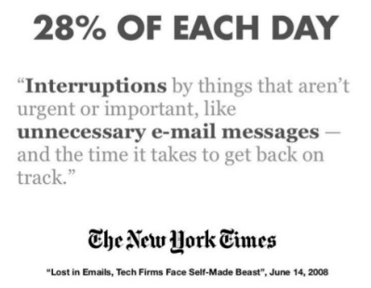
The average worker spends up to 28% of her/his workweek—more than 12 hours—reading and responding to email. And sure, a modest 40 emails a day adds up to about 10,000 a year, to be opened, scanned, processed, acted upon, filed and just as often ignored.


Email giveth and email taketh away. While it has improved business communication beyond what many of us ever thought possible, email has also become a big pain that sucks up time that could be used for more important things. (From: Resources for entrepreneurs)

Email in the Enterprise has grown into a necessary evil for corporate leaders. In today’s workplace, email has become as much a staple as the copy machine. Because of its speed, low cost, and efficient use of technology, it is a management headache for every C.I.O. on the list of Fortune 1000. Besides the worry of ever changing viral and worm threats, supervisors have to monitor and manage the personal use of the company’s email system. There is also the need for companies to provide a certain amount of email archiving to allow for data recovery without exposing the company to unnecessary expenses in the event of retrieving evidence in legal matters. Another consideration is the way email has grown from an informal Internet line of communication to a high level and formal way of communicating in the modern workplace. Email in the Enterprise has brought on new challenges for the CIO, forcing the Chief Information Officer to safeguard against mal-ware, to be prepared for legal responsibilities, and to establish guidelines for use.
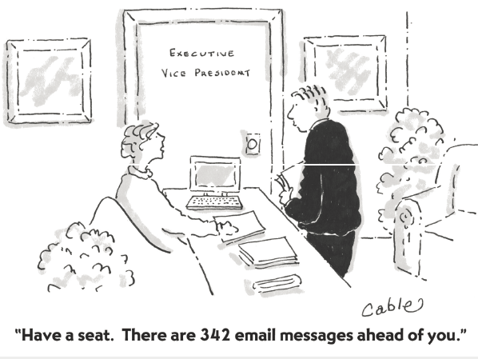
Business leaders, CEOs and managers often receive hundreds, if not thousands, of emails a day. Reading and responding to every message can become a drain on time and energy.

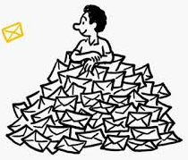
Email has several pitfalls, which managers must learn to deal with. Of these concerns the more serious and prolific are the guarding against mal-ware, preparing for disasters, and the onslaught of the unsolicited email known as Spam. All of these problems can cost a company a lot of money and ‘time’ to safeguard against and prepare for. For most companies this means managers are trying to do more with less personal and resources in today’s competitive global economy.

An increasingly problematic area for employees is the management of emails. Whether you’re the manager or an office assistant, if you have emails, you must ensure that these are categorised and dealt with accordingly.

Obviously for those who get more emails than others this will be imperative, but simply learning how to manage our inbox means that work can be completely far more efficiently, and some tasks won’t get missed.

A cluttered email inbox -- filled with old, unopened or unimportant messages -- will not only frustrate us, it will prevent us from maximizing our time and distract us from other obligations.

Example:

It's Monday morning. As Linda sits down at her desk she experiences that familiar sinking sensation in her stomach... She's not dreading the day ahead of her – she's dreading her email inbox! Linda is in charge of a large team, and she receives at least 50 emails every day. Reading and responding to all of this mail takes a long time, and most of her work takes back seat to this daily chore. As a result, she's notoriously behind on projects, and she's started staying late, just to catch up.

When we use it appropriately, email is an incredibly useful communication tool. But, like Linda, many of us feel overwhelmed by the amount of mail that we receive and need to respond to; however, there are ways to manage our email so that we're more productive.

Most of us feel overwhelmed by email. Although it's a great communication tool, people often overuse it. When we manage it effectively, we can significantly boost our productivity.

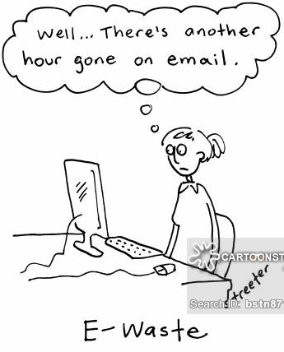
Jeff Weiner tells us:
I'm always struck by the number of people who complain about the amount of email they receive and how much they despise their inbox -- not because their complaints aren't valid but because my own view couldn't be more different.
By design, my inbox has essentially become the central hub of my workflow -- it's the way I routinely communicate and exchange information with our 4,300+ employees operating in 26 cities around the world.
That's not to say I've always been a fan of email, or that I haven't had my own Sisyphean inbox experiences. However, over the years I've developed several practical guidelines that have enabled me to manage my inbox effectively and ensure it's not managing me. (Jeff Weiner)

Email can be a valuable productivity tool when used properly. It can also be equally destructive when it's not.

One of the most egregious examples of the latter is using email to communicate highly nuanced, sensitive subjects that are bound to generate controversy if not a flat out aggressive response. It never ceases to amaze me what people will convey in an email when they get triggered by something -- words they would never choose to use when in the presence of the same audience. One former colleague of mine described this dynamic as "going strong to the keyboard."

If you find yourself in the throes of what is clearly becoming an antagonistic discussion online, do yourself a favor: Stop. Then either pick up the phone or head over to the person's office to have the discussion in person. Face-to-face interaction will reintroduce all of the important sub-text that will be completely lost in email and help prevent unnecessary arguments or douse heated flame wars before they begin. (Jeff Weiner)

Business-relevant tasks such as checking email and answering phone calls can be extremely detrimental to our ability to focus and get things done. Responding to e-mail takes time and saps productivity away from other more important jobs. According to a 2005 study, constantly trying to juggle work and incoming messages affects our intelligence and productivity comparable to missing a full night's sleep. But we can manage e-mail and minimize its effect on our time and productivity.

As we know, e-mails are an absolutely fantastic communication tool, but it's incumbent on us to do it better, not just avoid it and give up.
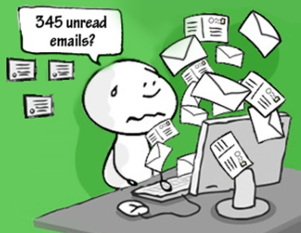
Although a completely empty inbox (also called "inbox zero") might be unrealistic for many of us, keeping our main inbox cleared can make us more organized, and help eliminate stress.

To gain control of our inbox, we have to start by checking and processing email only at certain times during the day. If we're concerned about the delayed response, we will let people know that we don't check our email constantly.

Clearly, in some roles, we will have to check email on a regular basis, especially if our business uses email as its main communication tool. As with all of these strategies, we have to use our judgment, based on our circumstances.

Also, we need to try to keep our inbox as clear as possible, and organize our mail using folders like "Action," "Waiting," and "Archives," And when we do check mail, we have to use the two minute rule – immediately handling any email that we can read and respond to in two minutes or less.

We can also reduce our incoming mail by asking people to send us less, and by advocating effective email and communication strategies in our organization. We have to make sure every e-mail we send is important, and is worthy of our employees' time and attention.

Our email inbox may seem to be our highest priority, but “inbox zero” can lead to “energy zero” if we are not careful.

There is a new book by 99U called Manage Your Day-to-Day: Build Your Routine, Find Your Focus & Sharpen Your Creative Mind. The recurring advice across many of the 20 experts who contributed essays to the book is simple: don’t start the day by dealing with your email. Instead, the experts overwhelmingly suggest that we start with our hardest work of the day and defer the distractions of email for later.

In some work environments this may seem impractical, or even impossible, but the principle can be applied to any situation. We start with email not only because we need to respond to others, some of them clients or superiors, in a timely manner, but also because re-acting is easier than pro-acting. Generally whatever is most important to do is difficult and requires skills that we uniquely possess.

So beyond the suggestion to not let others shape our own priorities, starting our day with email can literally have a detrimental effect on the rest of our day.

Taken as a whole, the suggestions in ‘Manage Your Day-to-Day’ urge us to take responsibility for our own time and energy by not letting email or other forms of reactivity blunt our focus. It is, of course, important to be responsive to other people, but as James Victore writes, “we are losing the distinction between urgent and important—now everything gets heaped in the urgent pile.” As hard as it may seem to buck the trend and not answer every message immediately, our assertion of priorities will make it easier for our co-workers to assert theirs. The more people in an organization take this approach, I think, the less superfluous emails will get sent. If we don’t assume an immediate response we will often just figure it out ourselves. All right, one less email-exchange! Taming email is a group endeavor, but it starts with ‘you’.

Technology is supposed to make life easier, right? But for many small business owners, technology - specifically e-mail - has made life a lot more difficult. Unlike conventional letters and memos, e-mails can be quickly and easily dispatched for the most trivial reasons. What is the result? Email boxes filled to overflowing with messages demanding a response.

When it comes to e-mails, brevity is always best. No one has time to read lengthy, drawn out e-mail messages. We can make a world of difference for our colleagues, boss, and clients when we write effective emails. This will not only save them stress and frustration, but succinct, relevant emails can also save an enormous amount of time – ours and theirs.

Although there is a variety of advantages and disadvantages of email, the advantages outweigh the disadvantages by far.

The always-on state of technology has blurred the lines between work and personal time. A 2012 survey of executives conducted by Forbes Insights found that 98 percent send work-related emails at night and during weekends, while 38 percent deal with business matters even while on vacation, and more than half occasionally or regularly step away from meals and family gatherings to do so. Although this can increase productivity, it also increases stress and frustration.

Kelly Kirk, who works for a trade group in downtown Washington, D.C., says checking e-mail comes between her work and her personal life:
"I'm constantly ducking my head under tables during events to check my e-mail. I hid behind a tree once when my boyfriend said I wasn't allowed to check my BlackBerry," Kirk says.
To get "real work" done, she says she now turns off the computer and her BlackBerry.
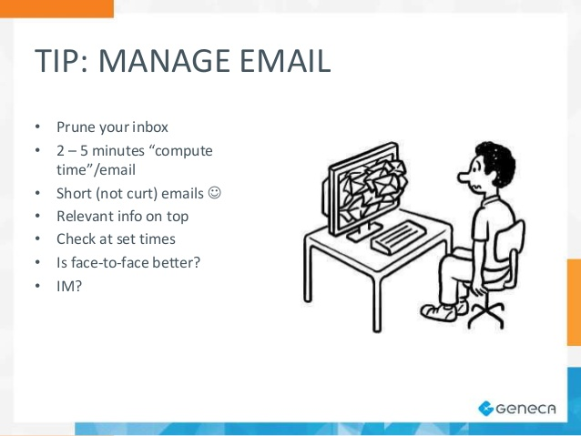

Question 4

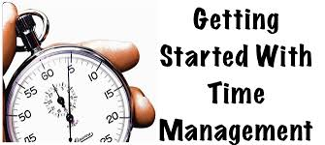
Enlist ways to improve time management skills

Time management implies we manage time, now, time can’t be managed; the typical mindset on Time Management is about applying techniques and tips, things outside of us. But there is a step we must take first: the key to creating an extra hour a day is changing our mindset to self-management!

What is self-management? Mark Victor Hansen in the book One Minute Millionaire says: it is accepting responsibility and not laying blame.

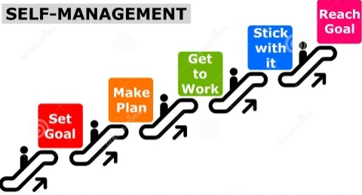
Self-management is about acknowledging we are responsible for our lives. It is our choices that have created our life. Not our boss or our parents or the government or anything else. Yes, those things have an impact, but how we choose to see the circumstances, how we choose to interpret and respond determine our life.
This is scary and exciting. It can be scary to think about being totally responsible for our life but this means that we can choose to take control and create what we want in the future.
To create and extra hour a day then, we need to start by adopting a mindset of self- management where we accept responsibility for our life totally. Then we can start to see new options and opportunities that will create more time. Not time management then, but self-management.

“I often come across people that are plagued with an arsenal of bad habits! Even before they get out of bed they're already behind schedule! They wake up late and spend the rest of the day in catch up mode. Eventually, they cut an appointment short to make up the lost time. But the reasons that lead them to being late for their first meeting will be the same for their next meeting.” (Taken from: ‘Learning Time Management Skills’ Leadership-Central.com Copyright © 2010 - 2016.)
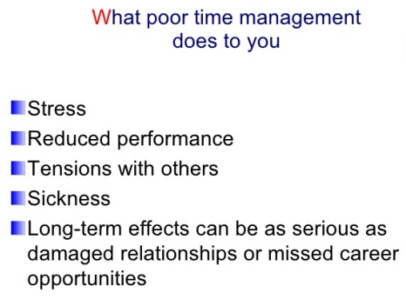

Poor time management is one of the greatest sources of managerial stress. It leads to feelings of incompetence and anxiety, the debilitating symptoms and consequences of stress. If we are living an unproductive and disorganized life, we just have to remember that it's never too late to change and start learning time management skills. In fact, holding the belief that we will change by focusing on learning time management skills is the first and most important step for us to take. An easy way to motivate ourselves is to really understand why time management is important as well as seeing the value that it will bring into our life.

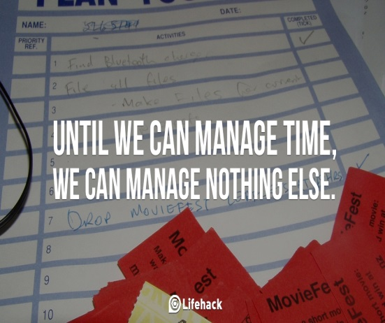
We can take all of the courses on time management, read all the books, and practice the various systems, but if we perceive ourselves as being poor time managers, nothing will help. If we have developed the habit of being late for meetings and appointments, or we believe that we are a disorganized person, those habits become our automatic behavior. If we do not change our beliefs about our personal levels of effectiveness and efficiency, our ability to manage our time will not change, either.

We can improve our time management skills by using a range of tools and techniques for specific tasks. Some elements of effective time management are the productive environment, setting priorities and reducing distractions. Poor time management can be caused from procrastination, as well as lack of self-control.

A first way to improve our time management skills is to pay attention to The Four Ds of Effectiveness:

- The first D is desire: We must have an intense, burning desire to get our time under control and to achieve maximum effectiveness.

- The second D is decisiveness: We must make a clear decision that we are going to practice good time management techniques until they become a habit.

- The third D stands for determination: We must be willing to persist in the face of all temptations to the contrary until we have become an effective time manager. Our desire will reinforce our determination.

- And finally, the most important key to success in life, the fourth D, is discipline: We must discipline ourselves to make time management a lifelong practice. Effective discipline is the willingness to force ourselves to pay the price and to do what we know we should do, when we should do it, whether we feel like it or not. This is critical for success.

Time management is a business skill, and all business skills are learnable. Time management is like riding a bicycle, typing on a keyboard, or playing a sport. It is made up of a series of methods, strategies, and techniques. It is a skill set that we can learn, practice, and master with determination and repetition.


Our self-concept is made up of all of our ideas, pictures, images, and especially our beliefs about ourselves, especially regarding the way we manage our time. Some people believe themselves to be extremely well organized and efficient. Others feel continuously overwhelmed by demands of other people and circumstances.

We need to be clear about what outcomes we desire. As Stephen Covey said, “Start with the end in mind.” What is the final result, outcome, or accomplishment that we are striving to achieve? Where do we want to end up at the end of the day? As we scramble up the ladder of success, we have to be sure that it is leaning against the right building.

“You can’t climb the ladder of success
with your hands in your pockets”

A long-term vision helps to create a base for setting goals, connecting the present and the future. Setting goals helps us focus time, as well as effort on important items.


Example:
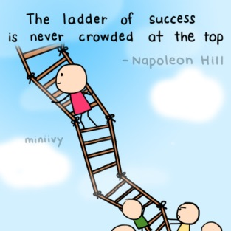
A young woman decides that she wants to be very successful in business in her adult life. With this clear long-term perspective in mind, she works many extra hours to get excellent grades in high school so that she will qualify for a good college. In college, she takes harder courses and studies much longer than her peers to graduate as close as possible to the top of her class. As a result of many years of hard work and study, and putting off the immediate gratification of parties, sports, and social life, she graduates at a high level from a prestigious university and is then hired by a large company, where she has the opportunity to get paid more and promoted faster than classmates who were not really thinking about the future at all.

When we are clear about where we want to be sometime in the future, it is much easier for us to make better decisions in the present. The rule is that long-term vision improves short-term decision making.

The habit of developing long time perspective is quite powerful. By projecting into the future and looking back to the present, we will often see steps that we could take, and mistakes that we could avoid. Doing this will help us to crystallize our values. It will give us the internal tools to organize our time and activities so that what we are doing today is moving us toward the creation of our ideal future.

If good time management is about taking control, it involves finding those areas where we do have control, and also finding those where we think we don’t, but really we do. For example we may have far too many things to do and this makes us feel helpless, but maybe we have the option of renegotiating some parts of our work, or even delegating some activities. There may still be some areas where we don’t have control – for example if a key part of the job is to be available at a certain time to provide advice to others, we cannot just decide to be absent. Or we may have a coursework assignment to submit – some deadlines are not renegotiable. In these areas it is more sensible not to waste time railing against these commitments; instead we concentrate on finding those areas we do have the power to change, and make the changes that will help us to become more effective.

It's true that some people are genetically better at planning things out and are inherently more organized. That is why they are better at managing their time. However, if we were to ask a professional, he would probably tell us that an individual who is able to manage his time well will always be able to finish his tasks on time without dropping his productivity.

Many people spend more time looking for the best time management planner than they do actually using it! The reality is that it doesn't matter which time management tools we use, we just need to consistently use them! Why them and not it? Simply because we need to realize that there are various sources as well as locations by which we are assigned a task:
- Phone
- Email
- In person

- In a meeting

To have effective time management skills, we need to see it as a process that uses time management tools as well as time management techniques.

Here are some time management tips recommended by ‘Forbes’ (Frances Booth; Forbes Aug 28, 2014) that we can use to help us get productive and stay balanced at work as well as outside the office.

We can use whichever tips resonate with us. There should be something here we can put into action straight away. We might also find it useful to come back to these tips at a later date and see what else we can do to boost our time management skills:

1. We often talk about not having enough time. Rather than focusing on that, and complaining to yourself or others about not enough time, think about what you do have enough time for. We can start talking or thinking about that instead.
2. Start within five minutes of sitting down at your desk and switching on your computer. Half an hour or an hour wasted here on procrastination or distraction is costly.
3. Value your time and other people will do the same.
4. When things get really pressurised and you’re tight for time, ignore email completely.
5. Get into the habit of switching off email whenever you can, even if this is only for 15 minutes or 30 minutes at a time.
6. Use your time for the things that are worth it.
7. If you’re procrastinating, rather than getting frustrated or annoyed, simply ask yourself why you are procrastinating. Are you scared of the task ahead? Is it too difficult, too easy, or boring? Are you tired? We can waste a lot of energy and time on the things we’re putting off.
8. End your working day at a fixed time. Don’t let work creep to fill your entire evening. You can also have two finishing times, one for an ideal day, and one latest time that you won’t work past.
9. If you’re using social media for business, schedule some of your updates. You don’t have to be there all of the time.
10. Do a time audit for one week and look at exactly where your time is going; notice where you spend your time on a regular week day. Notice how you use time at a weekend. Then, think about where you might want to redistribute a little of your time. What could do with a little more time spent on it? What are you spending time on that you don’t really enjoy or value? When are the main points in the day you waste time?
11. What, to you, constitutes time well spent? Write a list.
12. Who or what drains your time? Limit the things that drain your time and energy. Then, with the time you do have you’ll get more done in a focused way.
13. You can actually get an awful lot done in half an hour. Don’t just float because you’ve only got half an hour until your next meeting or appointment.
14. Take mini breaks when you need them during the day to recharge and refocus. Take lengthy breaks away from work at the weekend, in the evening and on holiday to help you stay productive long term.
15. Identify anything causing a regular, repeated drags or drain on your time. These might include technology, systems, workflow or people, for example. One by one, take these things and fix them, address them, or change them to free up more time.
16. If you’re doing a task where you’re likely to get distracted and spend longer than you want to there (for example, on social media, email, or internet searching), take off your watch and put it on the desk, noting what time you started and how long you intend to spend there. Check back in regularly on time passing.
17. We regularly underestimate how long something will take us. Factor this in!
18. Do you like the pressure of working to tight deadlines or not? For example, do you only feel motivated to get started on a project the night before it’s due in, or do you prefer to leave yourself plenty of time? Either way is fine, but you need to get to know which method works for you and use it to your advantage. Either set yourself more deadlines, or make sure you leave time to plan and deliver well in advance.
19. Are you trying to force things to happen in a certain time frame? Could you let it go and let things happen in their own time instead?
20. Anything that marks the end of one year or the start of a new year is a good time to look back at how you’ve spent your time in the year just gone, and see how you want to spend your time in the year ahead. Will you spend it in the same way, or make some changes?

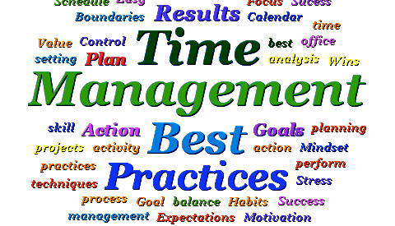
Time can get away on all of us, but if this happens regularly, we will never get caught up! Here are some more time management tips that are collected from peak efficiency experts. We will find that if we implement even a few at a time, our productivity will improve enormously.

Lost time is never found again. (Proverb)
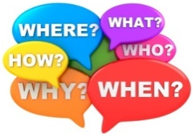
1. - A planning checklist:

We have to identify first our ‘priorities’ and distinguish tasks that are urgent from tasks which are important. Urgent tasks have an immediate impact. Important tasks have a significant impact. Then, for every plan we make, we should try to cover all these aspects: ‘what, where, when, how, who’.

We try to prioritize important tasks. Don’t be tempted to fill in odd moments with low-rated tasks. Try and at least start a more important task. If we don’t watch out we’ll find at the end of the day that we haven’t done any of the important tasks but have merely cleared away some of the less important ones!

We have to be clear what the critical 20 per cent of our tasks are. Pareto’s Law suggests that 20 per cent of the work produces 80 per cent of the results. So, be clear what the critical 20 per cent of your tasks are and prioritize them.

Some people may be working hard but without having clear priorities, or without planning. There could be other reasons for taking on too much work, being too busy or feeling driven, and for spending too much time on things that are not at all important, giving the illusion of working hard but not working productively.

When working, we have to get into the habit of beginning our planning with the most difficult part of the task. We'll be fresh, and we have more energy to take them on when we are at our best. For more difficult tasks, we have to be flexible: for example, building in reaction time when we can get feedback on the task before it is due.

Learning how to delegate and plan together with our team so that we are not doing everything ourselves is another important part of planning as well as finding ways to prioritise what is urgent, and negotiate time for tasks that are less important or can be managed by someone else.

2. - Putting plans into action with scheduling aids

The Chinese adage of the longest journey starting with a single step has a couple of meanings: First, we launch the project! Second, by starting, we may realize that there are some things we have not planned for in our process. Details of a task are not always evident until we really begin working on it. Another adage is that "perfection is the enemy of good", especially when it prevents us from starting! Given that we build in review, roughly draft our idea and get going! We will have time to edit and develop later.

Here are some useful short term planning aids:
- Create a simple daily “To Do List”
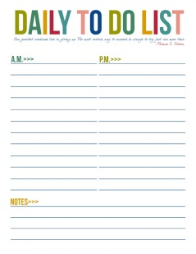

We all know the value of a To Do List, but few actually use it! Some think that they are smart enough to keep a mental log of every task. But the question is why we would? Keeping a mental log robs away some valuable brain power as we have a tendency to unconsciously ensure that we aren't forgetting a task, thus keeping our brain's CPU busy. Writing them down frees us from that, and allows us to fully utilize our mental capacity for the task at hand.
Our To Do List should contain enough details so that anyone somewhat familiar with our workload would comprehend what are the objectives of the given task. For each, we should also indicate its duration. This will provide us with an understanding of task completion and more importantly the impact that one task falling behind schedule would have on the completion dates of the others. Knowing this information will give us some control and will allow us to properly develop an effective alternative plan.

Ideally our To Do list should be portable, as we will want to add to the list whenever we think of a new task and this may not occur when we are at our desk. This will prevent us going ‘off task’ every time we remember another thing to do. We simply add it to our list and return to the task in hand. Writing things down will help us remember them and is a better recorder than our memory.

We need to devise a system to suit us, but many people have a general list, and then a specific daily or weekly list of tasks to be achieved within a certain timeframe pulled out from the general list. A lot of people find it helpful to rank the items on their ‘to do list’ in order of importance. Not everything is of equal importance.

- Daily/weekly planner
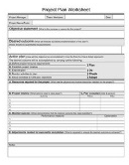
Write down appointments, classes, or meetings on a chronological log book or chart.
If we are more visual we sketch out our schedule.
First thing in the morning, we check what's ahead for the day.
Always go to sleep knowing you're prepared for tomorrow.

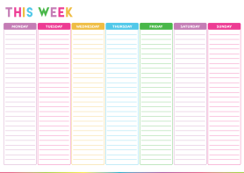
- Weekly reviews
Weekly reviews and updates are also an important strategy. Each week, like a Sunday night, we review our duties, our notes, and our calendar.
Be mindful that as deadlines approach, our weekly routine must adapt to them!

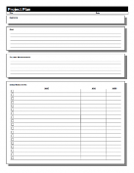
- Long term planner
We can use a monthly chart so that we can plan ahead.
Long term planners will also serve as a reminder to constructively plan time for ourselves.

3. - Organizing our work area and our paper work


a. - Do it now
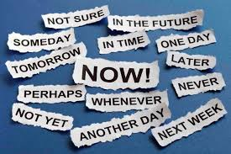
‘While we are postponing, life speeds by’ (Seneca)

Poor time management can be related to procrastination, as well as problems with self-control. Skills involved in managing our time include planning for the future, setting goals, prioritizing tasks, and monitoring where our time actually goes.


Procrastination is a great time bandit, and the irony is that all it does is increase feelings of anxiety. Anticipatory anxiety is 9 times out of 10 worse than actually getting on and doing something. Work out where your block is – and gently lift it out of the way.

One common pattern is to put the fun, exciting, interesting, easy things first, and put off doing the boring, dull, difficult tasks until later. It is a kind of pleasure principle – going for the short-term gains, surrendering to wants and desires as they arise – immediately; and so, increasing the anxiety of another day gone by without completing the task.

Usually we procrastinate because we don't know how to do the task or because it's something that we don't like to do. Whatever the reason is, we should get the task completed and move on to the next one. At first it might not be a considerable amount of wasted time, but as time goes on this task will add up and eventually we will be spending our precious energy re-organizing or explaining to someone why the task isn't completed. Many even go to the point where they spend more time avoiding the task than what it would take to actually get the work completed.

Don't under estimate the power of procrastination. Procrastinating is by far the biggest time waster because we don't accomplish anything other than wasting our valuable time and squashing our motivation. Finding a task too difficult is not the only reason for delay; and sometimes it is not even anxiety that makes us defer, but indecisiveness. In 95 per cent (at least) of cases we won’t have better information later so we might as well begin immediately and clear the task.

On the flip side, when we do these task we feel relieved and motivated! Use that feeling as your stimulus to get over the procrastinated task. Doing so will not only get the task done, but will ensure that we are effective in our leadership role.


Following the pleasure principle will lead us to doing things we enjoy instead of focusing on our priorities. It is a mistake to think that taking the easy route will improve things in the long run. In reality, giving in to the pleasure principle in the short term results in a mess later on, because over time what happens is the accumulation of a whole mountain of tasks that have been ignored. This can lead to misery, anxiety and depression; creating time for a balanced, enjoyable life takes planning and self-discipline.

b. - Dump
Why do people let paper hover round their workspace? Often because they are indecisive, they don’t know what to do with it. We need to stop deferring decisions and not to hoard items to read later – we won’t. We never have so far, so it is unlikely we are about to start. The bin is a ‘business information neutralizer’ that should be used more often, and the ‘delete’ button on the computer is an underutilized tool – We have to use them, rather than letting clutter build up and paralyse us with a pile of ‘indecisions’. Of course there is some material that doesn’t need immediate attention, and we may be about to get started on something important and don’t want to allow bits of paper to divert us from that important task. In that case we mark the material we need to return to later with the relevant date and put a note in our diary, our ’to do list’ to remind us. Or set up a reminder system and use recall notes. Sometimes people use computer packages such as Microsoft office and calendar to input dates so that the computer reminds them when to turn attention to a task or activity.

c. - Sort and group

We do need to have a place for everything, and everything in its place. If we have allowed our workspace to become untidy and cluttered tackling it can seem intimidating. It is made more daunting by the likelihood that it is full of those papers we don’t know what to do with, are too indecisive to deal with, find too difficult to tackle, so that we don’t know where to begin. So how do we start? Dealing with all new material first. As for the rest, we need to schedule a time in our diary, in a low energy time of day, to catch up with filing.

Begin by obtaining whatever equipment you need: filing cabinets, files and folders, and try and make them appealing to look at. Then start by tackling the papers on your desk. Once you have a clear desk you will feel more relaxed at work. Try and move all paper extraneous to whatever you are working on out of sight – it will be less likely to distract you then. Next, move to the other surfaces and then the floor. Horizontal filing (in filing cabinets) is more time effective than vertical filing (piles on the floor).

Some paper is difficult to throw away because it represents our history. Other bits of paper may be useful at some point in the future. If you are really not certain, box the material up, label it and put it in a loft or somewhere out of the way, and then see whether you need to get it down over the next year. If you haven’t, you could then throw it away.

d. - Set up a system
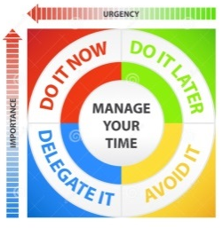
Time management can become an overwhelming task. When we do not have control over our own self, how can we control time? We can begin with task-oriented self-discipline and build from there. Self-discipline can be considered a type of selective training, creating new habits of thought, action, and speech toward improving ourselves and reaching goals. Self-discipline can also be task oriented and selective. We need to develop criteria for adjusting our schedule to meet both our working and our personal needs.

Know your targets well. Do not hesitate to speak to your Boss if targets are unrealistic and unachievable within the allocated time slot. It is always better to discuss things at the initial stages than cutting a sorry figure later on.

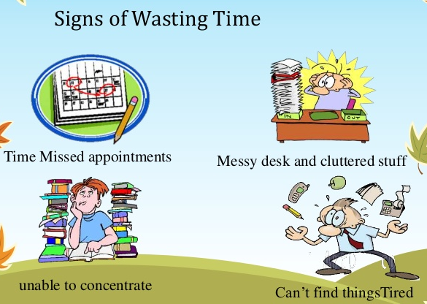
Use your free time wisely. The bottom line is to put your time to good use.
Postpone tasks or routines that can be put off until your work is finished! This can be the most difficult challenge of time management. We often meet unexpected opportunities that look appealing, but then result in poor performance. Distracting activities will be more enjoyable later without the pressure of the task hanging over our head. Think in terms of pride of accomplishment. Instead of saying "no" learn to say "later".

Stick to the schedule and track your progress; at the end of the allotted time, keep a record of accomplishment that builds over time. Scheduling helps us focus on our priorities. Avoid acting on impulse. As you control tasks, you build self-discipline. As you build self-discipline, you build time management. As you build time management, you build self-confidence.

e. - Don’t save papers you can easily find somewhere else
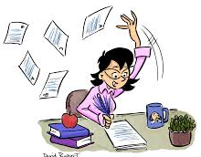
Some people allow a mountain of paper to pile up on their desk, around their floor – a trail of paper that doesn’t allow them to be able to find anything they need. They can waste lots of time trying to find things, and the paper mountain doesn’t make for good office sculpture, it festers and exudes stress and incompetence.

4. - Optimize your ‘down time’

Optimally utilize "down time" which is defined as the brief period of time when you haven't set any productive objectives. Down time can be something as simple as waiting for everyone to join the meeting. In general, we waste those small windows of time by not thinking about anything important. However, those small nuggets of time can be utilized to complete small tasks. For example, bring some articles with you wherever you go. Then read them during down times.

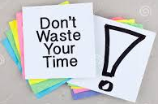
It has been calculated that people lose up to 20 per cent of their time waiting. All that time spent sitting on the train into work, or waiting for the printer to finish, or a lecture or meeting to start are wasted periods that could have been used to complete a small task, or even begin a bigger one. Sometimes a commuter journey is the ideal space in which to plan the day, write out a schedule, or maybe even concentrate on reading an article or report. Finishing a small task, such as filling in a form, or even beginning a larger task can be slotted into these moments.


5. - Multitasking

‘Helen arrives at work, puts her coat on the door peg, sits down and turns on the computer. She intends to spend the morning writing the proposal for the new performance appraisal system – a very important part of her job. But first she listens to her telephone messages and realises Gerald wants her to produce some figures for a meeting the following week. She accesses her computer to pull out the figures, and notices she has 21 e-mails, and begins trawling through these. The first few she just looks at and leaves open to come back to later, the sixth one asks her to give some dates for a meeting and she opens her diary to look at dates, and sees that for one of the dates she has a presentation to give on that day. Oh she must remember to take the files home for preparing the presentation so she can do it at the weekend. She gets up and opens her filing cabinet to retrieve them. .... Oh dear, she is feeling rather giddy... she hasn’t got anything done and she has been at work an hour already. ... Oh she feels so confused, she thinks . . . I’d better go and get a coffee’.

One result of not planning or sticking to priorities can be the ‘butterfly’. This is someone who flits from task to task in a downward spiral of panic and anxiety, getting in a mess, never getting the boost and closure of completion. Many managers have to be butterflies, for example Mintzberg (1973) and Kotter (1982) showed that managers spend nine minutes or less on 50 per cent of their activities, are subject to constant interruptions and that management is a very fragmented activity. Good time management brings order to this fragmentation, rather than exacerbate it.

But contrary to popular belief, we see that in the world of business, multitasking is almost impossible! So, don't waste your time trying to be efficient at multitasking. However, learning time management skills does include being able to switch tasks quickly and effectively. A good practice is to dedicate ourselves to a given task until we reach its completion. If the task is substantial, break it down into manageable work packages. These packages should have a duration for which we are capable being focused, for most these should be between 60 and 90 minutes. Then we can take a small break between tasks. Try not to drift between tasks – as you complete one task, don’t float onto another.

6. - The last-minute rush and adrenaline junky

‘I don’t seem to be able to get going early enough on my distance learning course assignments and so I often end up staying up into the early hours to get it in the following morning. The work is rushed and mediocre as a result, and I am then tired for days after.’ (Taken from: ‘Time Management” CIPD)


Some people like to live fast and furiously, and so working in a calm systematic way can seem very boring. Waiting for a burst of energy, or the adrenaline rush that comes with the fear of a deadline looming can become a way of life, but that usually means that when the job actually gets done, it is done in a haphazard panicky way, leaving the person exhausted after late-night working and long hours in order to finish it on time. In the long run health can be affected, as the fight or flight impulse that triggers adrenaline is intended for moments of danger, not a lifetime of stress.

Do not keep things pending at your end. Escalate matters immediately which need approval of higher authorities. Do not keep ignoring things. They would create problems for you sooner or later.

7. - Interruptions, interruptions

‘I set myself priorities but because I also work as a support service for other people in the organisation, I get inundated by e-mails and requests from others. I spend all my time meeting other people’s demands and my priorities go out of the window!’ (Taken from: ‘Time Management” CIPD)

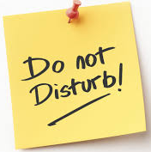
There are two types of interruptions: interruptions from others that distract us from our work, and ‘self’ interruptions, ways in which we distract ourselves from our intended activities.

Some people work in open-plan office environments where they cannot help but get drawn into conversations with others.

‘I work in an open-plan office. I constantly get distracted by people talking on the phone, chatting across desks, stopping to talk to me. I just cannot concentrate on my work, and I end up frittering my time on superficial tasks whilst at work, and then working well into the night at home to catch up with the tougher parts of my work.’

We need to learn to manage our interruptions, especially if we are concentrating on something really important and somebody starts casually chatting to us as they pass our desk or door.

The proliferation of communication technologies has meant there are a myriad of ways in which we can be interrupted at any time of day. The ding of a new e-mail arriving in the computer, the ringing telephone, the mobile phone, just ensure you are available 24 hours a day 7 days a week.

We also interrupt ourselves, for example, maybe by not being able to resist surfing the Net for another couple of hours, just having a look at a couple more search paths for a holiday or outing.

Some individuals are self-interrupters, maybe finding it difficult to concentrate they just have to go off for another coffee or go and chat to someone else, because they can’t quite get down to it. This can be even worse at home – when we spot the washing or ironing or vacuuming out of the corner of our eye. It is amazing how we can suddenly feel the urge to do a bit of gardening. Even jobs we normally hate, like cleaning the cooker, suddenly seem compelling when we are trying to get down working on a challenging report.

8. - Saying ‘no’ and delegating

Not all tasks are relevant or appropriate for us to do. We’ll learn to ask ourselves what will happen if we don’t do a certain task. Does it matter? Some tasks can be deprioritised, or put on hold, or we can say ‘no’ if we decide not to do them at all.

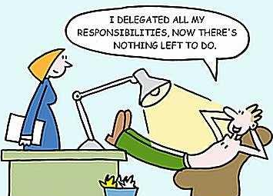
Alternatively some jobs are more appropriate to delegate. As we become more senior we may find we need to change our work role so we are doing less directly ourselves, and spending more time delegating work to others. Delegation is not activity dumping, we need to check that the task is suitable for the person, and we need to clarify with them what needs to be done and to what performance standard and check they have the ability to do it and that it is appropriate to their role or development. We may also need to provide them with some coaching and other support, and ensure they have the responsibility and authority required.

The D-I-Y enthusiasts think they can do everything themselves, never giving a thought to delegation or sharing the work with others. Moreover, when they get into trouble, they don’t go and ask for help, getting nowhere except lost and desperate. If we have too much to do, or are stuck, we can look to see how the work can be allocated differently, or we can call in for help or the support of others.

Take care of yourself; value yourself enough to give yourself time to relax, time off. So work productively rather than to burnout. Do not confuse wasting time with good relaxing breaks. These are needed to replenish our energy so we can focus and concentrate better then.

We are all fallible human beings, even experts at the top of their profession. Generally we try to do the best we can. No one has foresight, so all we can do is make the best decisions we can in the circumstances and move on, even if events later prove us to have been wrong. So stop beating yourself up, and do the best you can. Put mistakes down to experience and move on constructively.

Employees must have an easy access to their Boss’s cabin. Proper coordination between employees and their team leaders is essential for effective time management. It is important to give approvals on time and make sure our team members do not indulge in unproductive tasks.

Aristotle talked about the habit of the good life. The good life is not an abstract idea, it is a habit that is nurtured and acted upon over a period of time. Time management is a habit. It is likely we are accustomed to our habits, maybe even be comfortable with the way we do things, and they won’t be easy to change because that requires effort and persistence. Therefore it won’t be enough to merely identify what we should be doing differently. We have to break a habit, create a habit, and persevere to maintain it.

We are trying to change deeply entrenched habits. This takes time. It is better to adopt one new habit at a time, and move from theory to practice . . . and keep practising it, dipping our toe in the water and having a go will show us that we can do it.

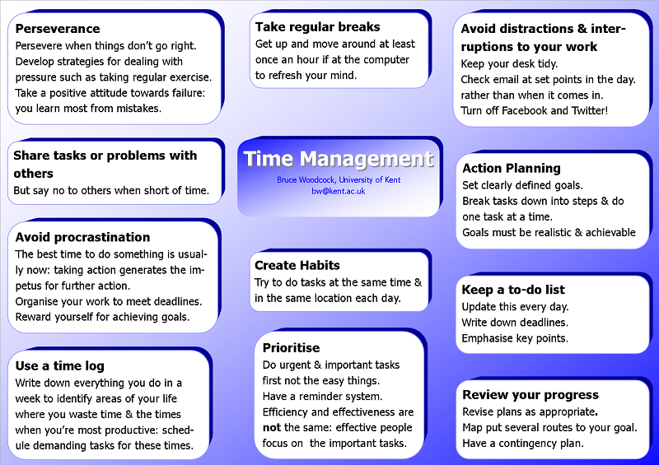

References & Background Reading

- A Review of the Time Management Literature. By Brigitte J.C. Claessens, Wendelien van Eerde and Christel G. Rutte (Technische Universiteit Eindhoven, Eindhoven, The Netherlands) and Robert A. Roe (Universiteit Maastricht, Maastricht, The Netherlands) Dec. 15, 2005
- Business Email Management. Tame your Flooded Inbox for Better Time Management. By Helene Segura
- Email Etiquette 101: A Timely Response is Crucial. By Mac Cassity for Gaebler Ventures
- Email isn’t the Problem. The problem is us. By David Fielding. February 27, 2015.
- Email Overload: Time Management Tips for Managing Email. By Holly Reisem Hanna
- Four Tips to Better Manage Your Email Inbox. By Jacqueline Whitmore. 2016
- Importance of Time Management. By Remez Sasson
- Make It Stop! Crushed by Too Many E-Mails. By Yuki Noguchi. Heard on “Morning Edition”
- Oxford Dictionary on-line
- Personal Effectiveness. By Diana Winstanley. Published by the CIPD 2005
- Seven Ways to Manage Email so It Doesn’t Manage You. By Jeff Weiner. August 5, 2013
- Six Ways to Manage Your Email Account. By Guest Blogger on Jan 24, 2015 in ‘how-To’s’, Online Life.
- Stop Wasting Valuable Time. By Michael C. Mankins. Harvard Business Review. Sept. 2004 issue.
- The Use of Email in Business Communication. By Kristie Lorette. Demand Media
- Time Management. Academic Advising & Career Centre. Division of Student Affairs. University of Toronto. Sept 2010
- Time Management. By Brian Tracy. American Management Association. 2013
- Time Management. By Maurice Jackson. November 9, 2015
- Time Management Chapter 9. By “Foundations of Learning”
- Time Management. Time Management Series. Studygs.net
- Time Management for the HR Professional. By Chris Croft. July 21, 2015
- Time Management for Researchers. Session 1. By Judith Shawcross. University of Cambridge.
- Time Management Training Tips to Implement into your Business. By Business training Skills. WordPress.
- What is Time Management? By Instructor Carol Woods. Lesson transcript.
- What is Time Management? Working Smarter to Enhance Productivity. By the Mind Tools Editorial Team Print.
- What ‘Organizational Bootcamp’ Taught Me About Tidying Up. By Carol Toller. January 11, 2016
- Why Is Email Important in Business Communication? By, Laurel Storm. In ‘Opposing-views’
- 30 Time Management Tips for Work-Life Balance. By Frances Booth. Aug 28, 2014. Forbes Magazine.

Student Statement:

By submitting this assignment, I confirm that this is my own work.

Student Signature | Maria Magdalena Barragan Zermeno | Date | May 8, 2016

For Tutor / Assessor Use Only
Total Marks
Marks Obtained
Percentage / Grade

