
Assignment Cover Sheet

Student Name: | Christian Blackmore
Student Number: | 1394
Course: | Construction Management
Assignment NO: | 11

Marking Criteria:
We expect the learners to write minimum one well expressed point in three lines against each allocated mark. This means one needs to write 15 lines with 5 well expressed points to get high grades for a 5 marks question.
For high grades use examples and illustrations where appropriate.
Assignment 11

- Give short answers for the following questions:

I What are the economic objectives of quality control and how are they achieved?

Many companies promote quality as the central customer value and have considered it to be a very critical success factor for competitiveness. If attempts are made to improve quality, costs associated should be taken into account as improvement programs are not only aimed to meet customers’ requirements but to essentially do it at the lowest cost possible without affecting quality aspects. This reduction can only be achieved by reducing the costs needed to achieve quality; these costs should be considered vital to the improvement process and must be identified and measured by the manager.

The cost of quality is generally known as the sum of conformance plus non-conformance costs.

Conformance costs (prevention of poor quality) – inspections, quality appraisals, testing, training of personnel

Non-conformance costs (poor quality caused by product & service failure) - rework, scraped items

Quality costs now are carefully controlled and are known to be an essential part of project budgets as they involve costs incurred in:-

- Design
- Implementation
- Operation & Management of quality management systems
- Resources necessary to achieve quality improvements
- System costs
- Product & service failure costs

II What are the features of field quality control?

Field quality control should be implemented on all projects to assure that quality requirements and standards are being addressed correctly. The quality of work carried out by skilled operatives must be acceptable and consistent with construction practices. Responsibility is placed on the construction team to assure that deficiencies and errors are not present when construction is completed. Preventive inspection should be practiced in order to avoid defects or at least identify them before expensive and time consuming rework is necessary. This can be achieved by:-

  - Preparing quality control procedures
  - Material control
  - Qualified operatives
  - Monitoring on-going work tasks

It is the responsibility of a qualified laboratory manager to determine the requirements and distribution of equipment during quality control checks. For quality control to be effective, priority ratings for each activity should be implemented to ascertain which could be the most and least essential activities. Field quality control consists of but not limited to:-

  - The need to provide an excellent service as a whole
  - Experience and expertise is used to complete each task
  - Determining the most effective way of accomplishing all activities
  - Business opportunities are created for the contractor
  - Each operative can be proud of their effort deployed in completing activities

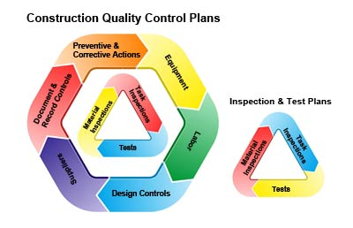

III How can contractor quality control be implemented effectively?

It is essential that the contractor develops a quality control plan to assure the developer that all participants are aware of all the processes required to achieve quality products. This consists of developing, implementing, and maintaining a quality control system to ensure that the specified quality is achieved for all materials and work performed at all stages of construction.

The quality control plan should cover all aspects pertaining to quality control and shall address but not be limited to all specified testing and inspection requirements. This system shall include a rigorous examination of construction material, processes, and operation, including testing of material and examination of manufacturer's certifications as required, to verify that work meets contract requirements and is performed in a proficient manner.

Before any work begins the contractor will meet with the developer and discuss the proposed quality control system. The developer and the contractor shall develop a mutual understanding regarding the quality control system. The contractor's quality control records shall document both acceptable and deficient features of the work and corrective actions taken. All site activities, site inspections, and field testing of materials will be recorded on a daily basis, along with any unacceptable site occurrences or deficiencies and their associated corrective actions. Each daily entry into the report will be signed by the quality control manager; these reports will be submitted on a daily basis during all field construction activities.

Quality control consists of but is not limited to:-

  - Field sampling procedures
  - Staffing
  - Types of material & equipment to be utilised
  - Performance methods
  - Documenting
  - Enforcing quality control operations of both contractor and subcontractors

IV Why are specifications important?

Specifications are essential documentation as they provide written instructions that describe how a project should be built, whereas drawings will provide visualisation and quantitative measurements.

Specifications consist of explaining:-

  - Quality standards
  - Materials description
  - Detail of technical requirements of project

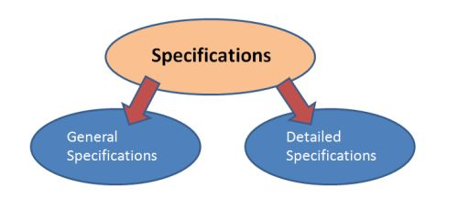

Each project specification section will describe a unit of work and end product, these specification sections can be broken down into three sections:-

- General summarises of work covered in section, this will also cover all applicable industry standards required, reference will be given to other sections and documents, establishes quality assurance, lists specific code and testing references, notes specific site conditions and required maintenance services.

- Describes products and refers to specific manufacturers, material descriptions and performance data, requirements of fabrication and finishes.

- Installation requirements for products and accessories, all processes and conditions on site which must be maintained when product is utilised this also includes field quality assurance testing.

There are many types of specifications which may be written and presented in various different but accepted ways. Generally they are written with the combination of:-

  - Performance specifications
  - Descriptive specifications
  - Prescriptive specifications
  - Reference specifications
  - Proprietary specifications (closed/open)

It will be the duty of the quality manager to reject any items which do not reach adequate quality standards after testing has been performed.

V What are incentives and penalties in specifications?

Incentives and penalties are written into the specifications contracts to reward contractors if for example; a specific stage of construction is completed before scheduled finish date or to penalise them if completing after scheduled finish date. Penalties are usually known as liquidated damages and are typically stated in terms of an agreed amount of money per day beyond a specified date.

When penalties are included in a contract the relationship between contractor and developer may not transpire as it should do, including penalties in a contract should be avoided as it could create a certain level of negative feeling between operatives, contractor and developer. Incentives will have a positive effect on operatives ensuring that works are carried out effectively and to quality specifications.

- How can you achieve quality control in the field?

The correct planning of quality control on site is vital to achieve the best quality of items at the lowest cost. This can be achieved by:-

  - Providing professional operatives who have the expertise required to commence and terminate works with the quality specified by the contract at all stages of construction.
  - Specifications, drawings, designs and field models should be clear and accurate enabling items to be converted into quality items on site.
  - Equipment and materials should be protected at all stages of development
  - The contractor’s site management team should take part in the design process and quality control specifications.
  - Effective research should be carried out to ensure that the correct tools and equipment are used at all times in the construction process.
  - Use up to date technology and knowledge in quality control to function effectively.
  - Both contractor and contractor’s operatives must be aware of the importance of quality control on site and be trained adequately in this area.
  - Give assistance in the establishment of quality control on site.

  - Site visits should be made to verify that quality procedures are being followed and if necessary assist in solving quality control discrepancies.
  - An engineer should be available with the skills necessary to deal with any quality problems.
  - The contractor must inform all sub-contractors of their responsibilities and objectives to complete.
  - Records must be kept of all quality issues that occur and data should be passed on to engineers to prevent future occurrences.
  - Personnel from the design team should be involved in solving problems that occur on site.

- What are the advantages and disadvantages of contractor quality control'?

Prior to work commencing the quality control plan is discussed by all parties involved, insuring there is a clear understanding of quality control and the steps required to achieve and maintain good quality products.

Some advantages of contractor quality control:

- The contractor is in a stronger position to anticipate problems and take the necessary steps to adjust the work to solve the problem.
- Misinterpretations and disputes between the contractor, suppliers and quality control department could be avoided if all quality issues are made the sole responsibility of the main contractor.
- Testing by the contractor can help him improve on his performance or efficiency at a relatively lower cost.
- There will be more time available to the owner’s quality control team to focus on solving more general problems on the site.
- Integrating statistical specification into the contractor’s daily activity and displaying this information for other workers to view on a daily basis will improve overall quality.

Some disadvantages of contractor quality control:

- The contractor may not have enough capacity to perform satisfactory quality control programs.
- Skilled quality control experts will be essential to assist the contractor to meet quality control targets. Unfortunately, personnel with these kinds of skills are very hard to find.
- Contractor quality control is only suitable when the end pint specifications are available. However, not all projects have end pint specifications due to incomplete project plans.

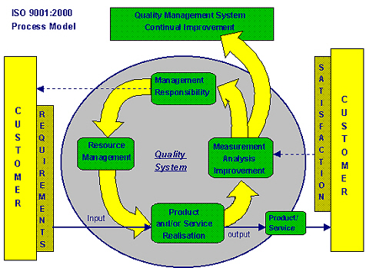

Student Statement:

By submitting this assignment, I confirm that this is my own work.

Student Signature | Christian Blackmore | Date | 08-06-2016

For Tutor / Assessor Use Only
Total Marks
Marks Obtained
Percentage / Grade

