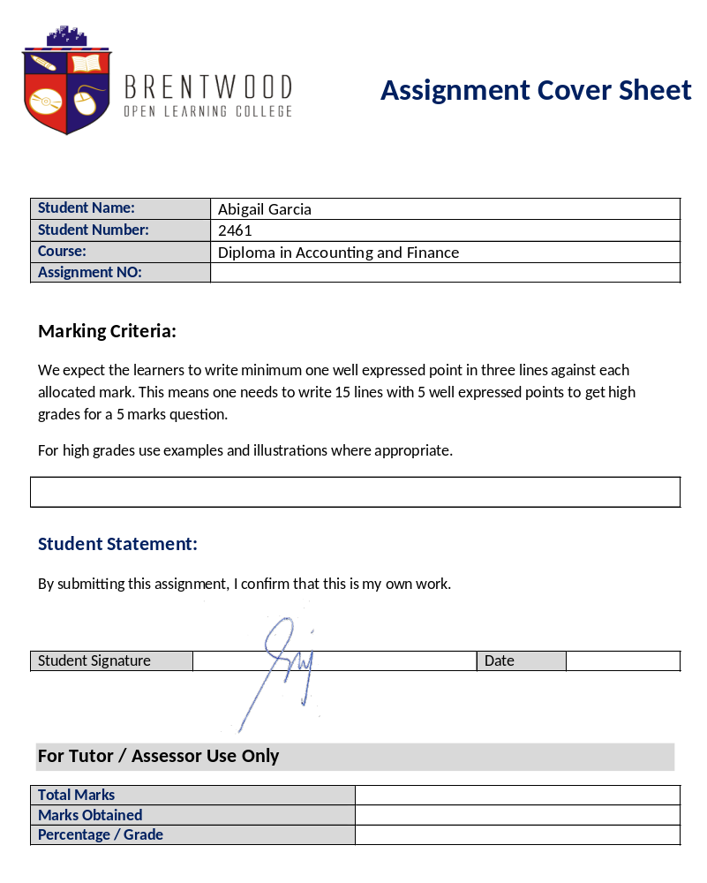


Assignment Cover Sheet

Student Name: | Abigail Garcia
Student Number: | 2461
Course: | Diploma in Accounting and Finance
Assignment NO: | 3

Marking Criteria:
We expect the learners to write minimum one well expressed point in three lines against each allocated mark. This means one needs to write 15 lines with 5 well expressed points to get high grades for a 5 marks question.
For high grades use examples and illustrations where appropriate.
1.i. Dual Aspect Concept is the underlying base for the double entry system of accounting. This means that the amount debited should always be equal to the amount credited for every transaction made.

1.ii Convention of Materiality indicates that small or trivial matters should not be considered or often disregarded. It focuses on the important transactions, or those with significant value to the company’s financials.

1.iii Assets = Liabilities + Capital

1.iv Generally Accepted Accounting Principle

1.v • Liabilities
Liability is the obligation to pay, in kind or cash, another party for the value of service or product received. They are classified to current and non-current liabilities.

• Assets
Asset is an owned resource. This may have resulted from a past transaction and would yield probable benefit in the future.
• Revenue
Revenue or income is the increase of net asset of a company/entity for an accounting period. It may arise from a sale transaction or a gain.

2. Accounting Concepts
- Business Entity – This concept suggests that business transactions must be separately recorded from those of its owners.
- Money measurement – This concept only records transaction that has numerical figures and terms. Anything expressed in monetary terms are included, and those are not, does not appear in the books.
- Continuity – This concept assumes that the business operation is ongoing, and will stay in that situation for a long time. Liquidation of assets and closing the business is not a plan for the future in this concept.
- Cost – This concept records assets at the cost the time it was purchased or acquired. This changes in value may be caused by accounting for depreciation.
- Accrual – This concept is where incomes and expenses are recorded in the period they occur, even if the transaction is not on cash basis. In the same light, this concept accurately record the transactions for the financial period.
- Conservatism – This concept records and anticipates minimal revenue and asset value, while anticipating high liabilities and probable losses.
- Materiality – This concept Materiality indicates that small or trivial matters should not be considered or often disregarded. It focuses on the important transactions, or those with significant value to the company’s financials.
- Consistency – This concept advises a business to maintain one way of recording similar transactions.
- Periodicity – This concept reporting can be done throughout the financial year as it seems necessary, like quarterly, monthly and annually.
- Objectivity – This concept denotes that every transaction must have an objective basis. It should not just be dependent on assumptions.

3. Accounting standards are in place to make sure that accurate information is properly presented to all concerned parties. This ensures that financial information is not manipulated to benefit only one or more specific user. If no standard is in place, it would not only affect the business entity but also the economy or market where is operates.

Student Statement:

By submitting this assignment, I confirm that this is my own work.

Student Signature | 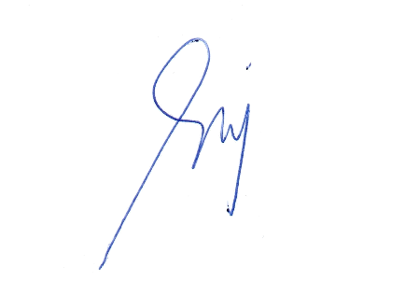 | Date | 19/09/2016

For Tutor / Assessor Use Only
Total Marks
Marks Obtained
Percentage / Grade

Accounting Concepts & Standards

ASSESSMENT # 3 Total Marks: 30

1. Give short answers to the following questions: (15)

- What is a 'dual aspect concept'?
Dual Aspect Concept is the underlying base for the double entry system of accounting. This means that the amount debited should always be equal to the amount credited for every transaction made.

- What do you understand by the term 'convention of materiality'?
Convention of Materiality indicates that small or trivial matters should not be considered or often disregarded. It focuses on the important transactions, or those with significant value to the company’s financials.

- What is accounting equation?
Assets = Liabilities + Capital

- What does GAAP stand for?
Generally Accepted Accounting Principle

v. What you understand by the following terms?
- Liabilities
- Liability is the obligation to pay, in kind or cash, another party for the value of service or product received. They are classified to current and non-current liabilities.

- Assets
- Asset is an owned resource. This may have resulted from a past transaction and would yield probable benefit in the future.

- Revenue
- Revenue or income is the increase of net asset of a company/entity for an accounting period. It may arise from a sale transaction or a gain.

2. | Explain the various types of accounting concepts.  - Business Entity – This concept suggests that business transactions must be separately recorded from those of its owners.  - Money measurement – This concept only records transaction that has numerical figures and terms. Anything expressed in monetary terms are included, and those are not, does not appear in the books.  - Continuity – This concept assumes that the business operation is ongoing, and will stay in that situation for a long time. Liquidation of assets and closing the business is not a plan for the future in this concept.  - Cost – This concept records assets at the cost the time it was purchased or acquired. This changes in value may be caused by accounting for depreciation.  - Accrual – This concept is where incomes and expenses are recorded in the period they occur, even if the transaction is not on cash basis. In the same light, this concept accurately record the transactions for the financial period.  - Conservatism – This concept records and anticipates minimal revenue and asset value, while anticipating high liabilities and probable losses.  - Materiality – This concept Materiality indicates that small or trivial matters should not be considered or often disregarded. It focuses on the important transactions, or those with significant value to the company’s financials.  - Consistency – This concept advises a business to maintain one way of recording similar transactions.  - Periodicity – This concept reporting can be done throughout the financial year as it seems necessary, like quarterly, monthly and annually.  - Objectivity – This concept denotes that every transaction must have an objective basis. It should not just be dependent on assumptions. | (7)
3. | Why do we need accounting standards'? Discuss  Accounting standards are in place to make sure that accurate information is properly presented to all concerned parties. This ensures that financial information is not manipulated to benefit only one or more specific user. If no standard is in place, it would not only affect the business entity but also the economy or market where is operates. | (8)

Accounting and Finance Level 4 Brentwood Open Learning College Page: 1

