
Assignment Cover Sheet

Student Name: | GLYNIS A WILKES
Student Number: | 13406
Course: | DIPLOMA IN ENVIRONMENTAL MANAGEMENT
Assignment NO: | 06

Marking Criteria:
We expect the learners to write minimum one well expressed point in three lines against each allocated mark. This means one needs to write 15 lines with 5 well expressed points to get high grades for a 5 marks question.
For high grades use examples and illustrations where appropriate.
Please insert your completed assignment ( in word format) here:

Question 1.

An environmental policy forms the foundation of environmental improvements made for a business. It sets out key aims and principles.
Having an environmental policy can provide significant benefits to a business. These include:
- helping you to stay within the law
- improving information for employees about their environmental roles and responsibilities
- improving cost control
- reducing incidents that result in liability
- conserving raw materials and energy
- improving your monitoring of environmental impacts
- improving the efficiency of your processes
However, the benefits are not restricted simply to internal operations. By demonstrating commitment to environmental management, one can develop positive relations with external stakeholders, such as investors, insurers, customers, suppliers, regulators and the local community. This in turn can lead to an improved corporate image and financial benefits, such as increased investment, customer sales and market share.
It's important to bear in mind that these benefits are unlikely to be achieved if an environmental policy in place. If an environmental management system (EMS) is set up this requires the implementation of a program to systematically deliver the policy in a strategic way.

Fig 1 Shows a clear picture of Environmental policy and benefits.
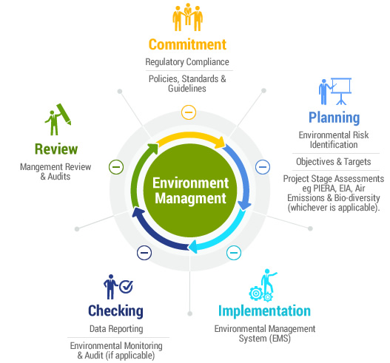

Question 2.

Understanding the needs and expectations of interested parties is a new requirement. One should allow time to develop an understanding of its business’s internal and external stakeholder interests that might impact upon its Environmental Policy’s ability to deliver its intended results, or those that might influence its business's strategic direction.
This information should be gathered, reviewed and regularly monitored through formal channels, such as management review meetings. It is suggested that undertaking analysis of interested parties to determine the relevant interested parties and their requirements that relate to its business activities, and those which impact the Environmental Policy.
In order to determine the relevance of an interested party or its requirements, an organization needs to answer:
- ‘does this interested party, or their requirements, affect the organization’s ability to achieve the intended outcomes of its Environmental Policy?’

    - If the answer is 'yes', then the interested parties’ requirements should be captured and considered when planning its Environmental Policy.

Fig 2. Shows a clear picture of Internal and External Stakeholders needed in a business.


Question 3.

The key requirements checklist below may help one to draft an Environment policy appropriate to one’s business:

- Comply with environmental legislation and other requirements, such as approved codes of practice

- Importance of environmental issues to your business

- Assess the environmental impact of all historic, current and likely future operations

- Continually seek to improve environmental performance, e.g. by doing a regular walk-around survey of your business to see if you are using energy and water efficiently and whether measures to reduce waste and pollution are effective

- Reduce pollution, emissions and waste, e.g. emissions from transport, oil leaks and spills, excessive noise, heat or vibration generated by the activities of your business

- Reduce the use of all raw materials, energy and supplies

- Raise awareness, encourage participation and train employees in environmental matters

- Expect similar environmental standards from all suppliers and contractors

- Assist customers to use products and services in an environmentally sensitive way

- Liaise with the local community

- Participate in discussions about environmental issues

- Communicate environmental aims and objectives to employees and external stakeholders

- Agree to commit to environmental principles and continual improvement at the highest level in your business

Fig 3 shows a clear description of an Environmental Policy.



Question 4

The ISO 14001 standard is probably the best reference standard for the development of an environmental policy. In summary, an environmental policy must be:

- Appropriate to the organization;

- Include a commitment for continual improvement and prevention of pollution;

- Include a commitment to comply to relevant legal and other requirements; and,

- Provide the framework for setting and reviewing environmental objectives and targets.

Also, consideration should be given to the reader's expectations. From a customer perspective they would like to clearly know:

  - What the organization does and how it does it (e.g. do they follow best practice and embrace cleaner production, if so how?);

  - Understand whether the organization is greener or browner than similar organizations;

  - Understand whether the organization presents a direct environmental risk to their operations;

  - Understand whether the organization presents a risk to public perception if they are engaged;

  - Understand whether the organization present an environmental risk by not understanding and not complying with legal & other requirements; and,

  - Understand whether the organization has any environmental programs to reduce environmental impact and improve their environmental performance.

The level of detail is up to the organization. Consideration however should be given to making it meaningful as first impressions last.

References:

http://www.environmentalpolicy.com.au/
http://www.iso9001help.co.uk/4.2%20Interested%20Parties.html

Student Statement:

By submitting this assignment, I confirm that this is my own work.

Student Signature |  | Date

For Tutor / Assessor Use Only
Total Marks
Marks Obtained
Percentage / Grade

