
Assignment Cover Sheet

Student Name: | Mandy Fairbank
Student Number: | 21662
Course: | Beauty Therapy Certificate level 3
Assignment NO: | 2

Marking Criteria:
We expect the learners to write minimum one well expressed point in three lines against each allocated mark. This means one needs to write 15 lines with 5 well expressed points to get high grades for a 5 marks question.
For high grades use examples and illustrations where appropriate.
Please insert your completed assignment ( in word format) here:

Name: Mandy Fairbank
Student Number: 21662
Assignment Number: 2

- Explain the different stages of the hair growth cycle (7 Marks)
There are hair follicles all over the body. Within the follicles there are stem cells, blood vessels, sebaceous glands and hair. The follicle lies within the second layer of the skin: the dermis. This is the living part of the hair. The outer hair that can be seen is dead.
There are two types of hair growth on the human body; the first type is, called Vellus Hair. Vellus hair is soft downy hair that grows out of shallow follicles and grows all over the body, with the exceptions of the lips, palms and soles of the feet. Vellus hair grows slowly and takes about 2-3 months to grow after waxing. (Nordmann,2011.p31)
The image below shows Vellus hair:

Google Images
The second type of hair growth on the body is known as Terminal hair and grows from the scalp, eyebrows, underarms, pubic area, and other parts of the body. There are approximately 100 000 hairs on the scalp ( Nordmann, 2011.p26)
The image below shows Terminal hair:
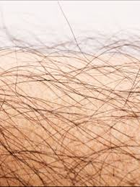 Google images
The picture below shows the two hair types and the depths of the follicles of which they grow from.
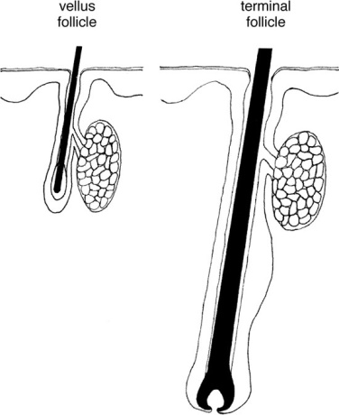Picture: Google Images.
Hair is a keratin (protein) filament (hair shaft) that grows from follicles found in the dermis (skin). Humans develop hair follicles during fetal development.
Hair is composed of three parts the outer layer of overlapping scales known as the Cuticle, beneath the Cuticle is the protein rich structure known as the Cortex and then the core of the hair shaft is Medulla. The medulla is not present in all hair shafts and may not be present in the full length of the hair. (McMillan-Bodell & Taylor, 2011.p99)
Literature (Nordmann, 2011.p32.Brentwood Open Learning College course materials,2011, McMillan-Bodell & Taylor 2011) states that hair goes through three stages in its growth cycle, Anagen, Catagen and Telogen. See image below.

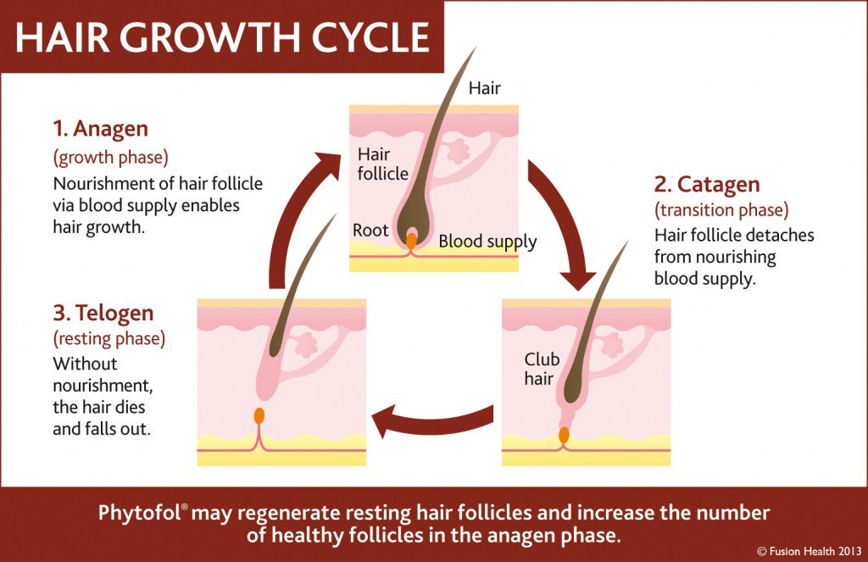

Picture: Google Images

Anagen
Anagen is the growth phase. The hair receives nourishment from dermal papilla (indentation at the base of the bulb of the hair) through blood. The older dead cells are pushed outside the hair bulb and the baby hair starts to grow. The Anagen phase lasts for about 3 years. On an average each hair grows by half an inch each month.

Catagen
Catagen is the resting phase or transitional phase. The hair stops growing when it enters the Catagen phase and stays in this phase for about a month. At this stage the hair follicle from which hair strand has grown starts to shrink. Though, the hair does not fall out and stands firm for some time.
Telogen
Telogen is the final phase and also known as the falling phase. This is the time where the mature hair falls off. This phase lasts for about 3 months. Once the hair falls out, the hair follicles re-enters the Anagen or the growth phase.
The following factors can cause a disruption in the natural hair growth cycle (Nordmann, 2011.p32. Brentwood Open Learning College course materials, 2018 ):
- Hormones
- Genetics
- Stress
- Diet – A poor diet which lacks with proteins, minerals, essential fatty acids can lead to hair growth problems
- Medications
- Post pregnancy

- Briefly describe different functions which the skin performs in our body (7 Marks)
The skin is one of the largest organs in the body in surface area and weight. The skin consists of two layers: the epidermis and the dermis. Beneath the dermis lies the hypodermis or subcutaneous fatty tissue.
Literature (Nordmann, 2011pp15-16) refers to the main functions of the skin as:
- Protection and warning
The Epidermis is the outer layer of the skin which is only a few cells thick. This outer surface is bactericidal, helping to prevent the multiplication of harmful organisms and prevents many substances from being absorbed (unless the skin is broken). Langerhan cells are also found in the epidermis they help cells of the immune system recognise dangerous chemicals and microorganisms.

The pigment that gives colour to the skin is known as melanin (melanocytes). This pigment also protects the skin from the sun’s ultraviolet rays.
Redness and irritation of the skin indicates that the skin is intolerant internally or externally to something.

- Heat regulation
The Dermis is the thick layer of the skin or connective tissue beneath the epidermis. The main structural element of the dermis is collagen and is responsible for the skins strength. Another protein in the dermis is elastin and gives the skin its elasticity. The upper part of the dermis is the papillary layer. The blood vessels in the dermal papilla play a role in body temperature regulation, tightening or dilating to conserve or dispel heat.

- Excretion and moisture control
Sebaceous glands are found all over the body except on the palms of the hands and soles and tops of the feet. These glands produce a substance called sebum which keeps the skin and hair from drying out and inhibits the growth of certain harmful bacteria.
Waste products such as urea, water and salt are excreted from the body in sweat gland through the skins pores.

- Sensitivity
Merkel cells found in sensitive hairless areas of the body such as the lips are located in the deepest layer of the epidermis. These cells contact nerve endings in the dermis below and function as a touch receptor.
Hair follicles and glands are anchored in the Reticular Layer the lowest layer of the dermis and contain several sensory receptors.

- Nutrition
Fat is stored in the skin which provides and energy reserve. Vitamin D is also produced in the skin created by a chemical reaction when sunlight comes into contact with the skin.

- Referring to the nail structure, briefly describe the structure of the following:
- Matrix
- Lanula
- The nail wall
- The cuticle (8 Marks)
Nails on the fingers and toes are made of hard keratin filled epidermal cells. Nails grow as epidermal cells below the nail root and transform into hard nail cells. The part of the nail that is visible is called the nail plate. There are no blood vessels in the nail plate. It is the nail bed that has blood vessels which provide the nourishment needed for continued growth and sensory nerves for protection. The part that extends past the end of the digit is called the free edge; this is the part of the nail that is filed.

The diagram below shows the structure of the nail:

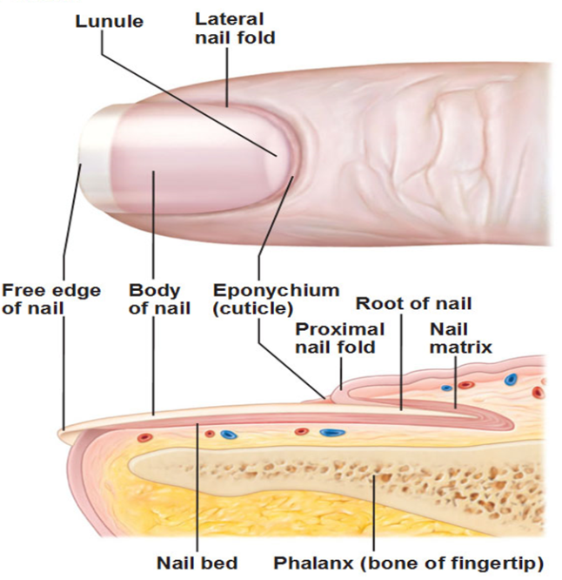 Image: Google Images

The Matrix - or nail root is where the nail is made. It is the only living part of the nail, and contains nerves and blood vessels so that cell reproduction can occur. The function of the matrix is to produce new cells.

The Lanula – is the pale semi-circular (half-moon) shaped area where the matrix and nail bed meet. It is white due the thick layer of epidermis that does not contain blood vessels and has no function.
The Nail Walls - The skin overlapping the sides of the nail plate its function to cushion and protect the nail plate and grooves from damage.
The Cuticle – is the overlapping epidermis skin surrounding the nail. Its job is to protect the matrix from being invaded by bacteria and physical damage.

- How does the massage affect blood flow? (8 Marks)

According to Nordmann (2011) an increase in blood circulation to muscle tissue is one of the most promoted positive effects of massage. One reason for this is that improved blood circulation is supposed to deliver more oxygen and other nutrients to the muscle tissue and helps to expel metabolic waste.

There are specific massages that boost circulation to the extremities. Good circulation is essential to good health because the circulatory system delivers oxygen-rich blood and nutrients that is required to heal.

Therapeutic massage can increase the circulation of blood as well as the flow of lymph. The lymphatic system plays a part in protecting the body from infection. The stimulation of nerve receptors causes blood vessels to dilate and this facilitates blood flow. Lymph does not circulate the same as blood so its movement largely depends on the squeezing effect of muscle contractions.

Massage facilitates circulation because the pressure created by the massage technique moves blood through congested areas. The release of this same pressure causes new blood to flow in. The squeezing and pulling also flushes lactic acid from the muscles and improves the circulation of the lymph fluid which carries metabolic waste away from muscles and internal organs, resulting in lower blood pressure and improved body function.

Improved blood circulation is just one benefit of massage therapy. Combined with a balanced diet and regular exercise, massage can have the following benefits:

- Enhanced blood flow
- Lowers blood pressure
- Improves body function

Bibliography & References:

Brentwood Open Learning College, Beauty Therapy: Unit 2 Course material [online] available at: http://bolconline.co.uk/student/dashbord.php [Accessed 27/08/2018]

Nordmann, L. 2011. Professional Beauty Therapy: the official guide to level 3.City & Guilds pp 15 -32

McMillan-Bodell, C & Taylor, S. 2011. Hairdressing and Beauty Therapy. Essex. Pearsons.p99

Student Statement:

By submitting this assignment, I confirm that this is my own work.

Student Signature | Mandy Fairbank | Date | 29/08/2019

For Tutor / Assessor Use Only
Total Marks
Marks Obtained
Percentage / Grade

