
Assignment Cover Sheet

Student Name: | Nicola Young
Student Number: | 24904
Course: | Diploma in wedding planning Level 4
Assignment NO: | 2

Marking Criteria:
We expect the learners to write minimum one well expressed point in three lines against each allocated mark. This means one needs to write 15 lines with 5 well expressed points to get high grades for a 5 marks question.
For high grades use examples and illustrations where appropriate.
Please insert your completed assignment ( in word format) here:
Assessment 2
- (i) “A double wedding is when two wedding parties get married in the same ceremony.” Outline at least two advantages and two disadvantages of having a double wedding.
The two advantages of two couples sharing their special day is they are sharing the cost. It becomes much more affordable with two couples sharing the cost of one venue, rather than paying for two. Also, each couple can lean on the other to give each other support on their day.
The two disadvantages of two couples sharing their day is that they may not agree on the same style or theme of their wedding and also having to share the spotlight with someone else.

(ii) Why are some couples interested in themed weddings?
A theme can be anything from a movie theme to an historical era or even comic book superheroes. There is the same amount of planning in a themed wedding as there is in a traditional wedding except everything that is booked is related to the overall theme.
A themed wedding is a great way to explore your creativity and to give a fun and unique experience. It is also a way of the bride and groom expressing their personalities.

(iii) How does a themed wedding help to set the mood for the wedding ceremony?
A themed wedding is all about the décor and linking everything together, for example, a floral theme would run through all aspects of the wedding from the invitations right the way through to the cake. It is the art of creativity which would set the mood and bring together the celebrations as a whole.

(iv) Outline the most important points to consider when choosing a wedding venue.
The number of guests you’ll need to pick the right sized venue for the amount of guests. The budget needs to be set, what date the wedding is to be able to check with venues and vendors if the date is available. The style and theme of the wedding and the location, this is important because the location of the venue can sometimes deter some guests from attending.

- “Planning a themed wedding can be a challenging task for a wedding planner”. Discuss
There are many challenges to tackle when it comes to planning a wedding. The budget can be a very difficult task, especially when it comes to everyone expectations. It is your job as the wedding planner to be able to give the couple the best for their budget.
If it is a church wedding and the reception at a different venue you have to consider the distance for all guests.
You have to look at accommodation for guests who are travelling a long distance to come to the wedding.
You have to consider the amount of guests that are coming to the wedding by checking the capacity at the venue. You have to check all amenities specifically if there are disabled guests and the elderly and that all the facilities are suitable for all.
Finally staying organised throughout will help to keep things calm
- How can the wedding theme be made evident in wedding invitations? Give at least one example with a designed wedding invitation.
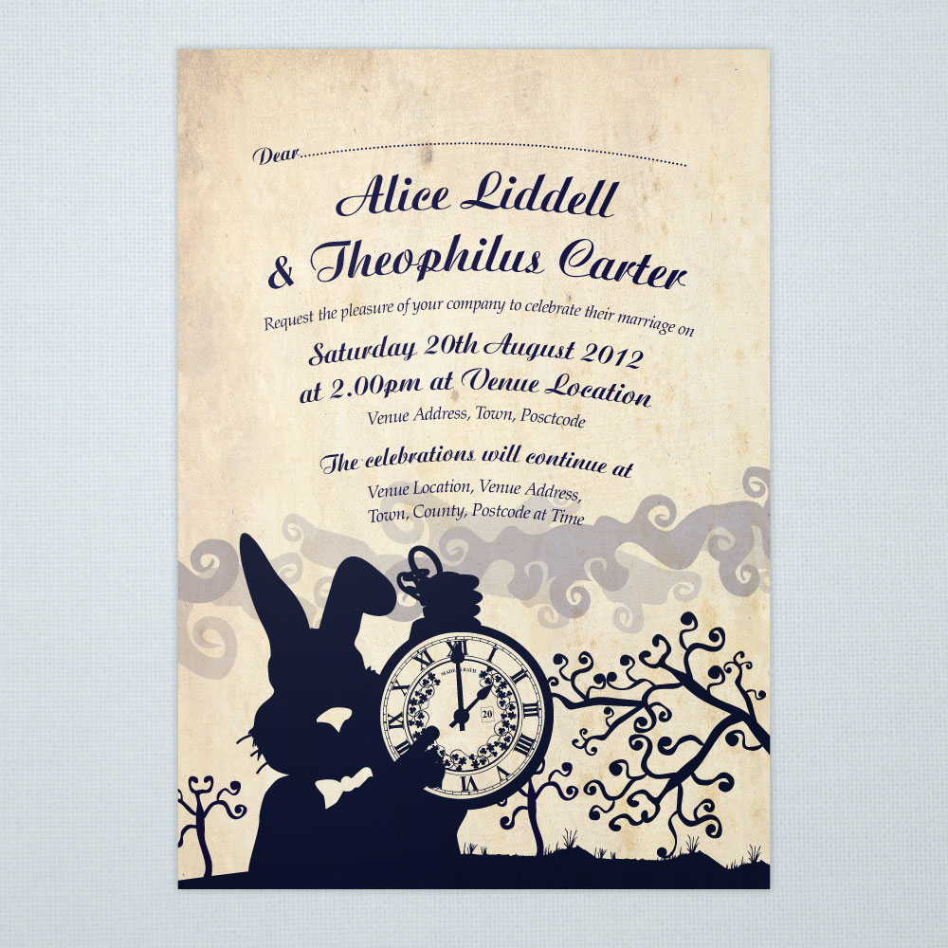
Alice and wonderland themed wedding invitation

Case study

- How will you help them in choosing the location?
By choosing the location you will need a budget so by having a budget you can then give the couple options within their budget.
- What are the benefits of having a destination wedding?
The benefits of having a destination wedding are that it can be considerably cheaper than that of a traditional wedding and that you can restrict the guest list to just close personal friends and family or even just the couple and two witnesses.
- Why do you think a destination wedding is cheaper than a formal wedding? Especially, when there is travelling and accommodation costs involved, as well. Discuss.
It is cheaper because some destination weddings are a package deal, where flights accommodation and meals are all included. Also you can only pay for yourselves if you don’t have the means. Even though destination weddings last a few days if not longer they work out considerably cheaper also the honeymoon is usually part of the wedding.
- ‘It is important for you, as a destination wedding planner, to have awareness about the local politics and laws where the wedding is to take place’. Why?
This is because there are different laws in different countries and cultures. You will need as a wedding planner to know all the laws and politics that are involved with each and every destination wedding. For example in Puerto Rico your witnesses have to be over the age of 21 and have passports with them to prove this.
You will also need to check that there has been no disasters like hurricanes or floods at the couples venue.

Student Statement:

By submitting this assignment, I confirm that this is my own work.

Student Signature | N.Young | Date | 07/10/2018

For Tutor / Assessor Use Only
Total Marks
Marks Obtained
Percentage / Grade

