
Assignment Cover Sheet

Student Name: | Ray Wilson
Student Number: | 1336
Course: | Project Management
Assignment No: | 9

Assessment 9 Total Marks: 30

1. Give brief answers for the following questions: (20)

I. Which processes are involved in project communication management?
Project Communications Management consists of the following processes:
- Identification of Stakeholders
- This process involves the identification of all stakeholders that can impact the project. This Project Management Communication process involves documenting their level of interest, power, influence, and potential project impact. Tools and techniques used in this process are stakeholder analysis and expert judgment.
- Plan Communications
Involves documenting the communication needs of the stakeholders identified in the Identify Stakeholders process. To effectively plan project communication, you need to use the Stakeholder Register and the Stakeholder Management strategy created during the Identify Stakeholders process. The key tools and techniques in this process are Communication Requirements analysis, Communication Technology, Communication Models, and Communication Methods.
The main output of this process is the Communication Management Plan. Over time other project management plans may need to be updated, as the requirements of stakeholders are revealed.
- Distribution of Information
The Distribute of Information process involves effectively executing the Communications Management Plan. Simply put, it is in this process that you implement the communication needs of stakeholders. For example, daily status meetings are a type of communication. Tools and techniques in this process are Communication Methods and Information Distribution Tools. Communication Methods, such as communication via emails, are known as pull methods or communication via Intranet is considered as Push Communication

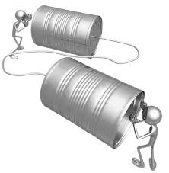

- Management of Stakeholder Expectations
The Manage Stakeholder Expectations process involves using the various communication methods, interpersonal skills, and management skills to ensure the communication needs of stakeholders are addressed. This will involve resolving workplace conflicts, facilitating meetings with stakeholders, and generally building trust.
- Reporting on Performance
The Report Performance process involves ensuring performance, progress and forecast information are communicated to the identified stakeholders. Variance analysis and forecasting methods, are key tools and techniques in this process. The others are communication methods and reporting methods. The key output of this process is performance reports.

II. At which stage in a project is project communication planning is completed?

Typically, Communications planning is completed during the early stages of the project. The communication requirements of the stakeholders are identified and documented as part of this planning. Preferences of the stakeholders needs to be taken into consideration as some may prefer a hard copy document or report rather than an email version and these needs can change over the lifespan of the project. Therefore throughout the project, the stakeholder’s needs, the type of information requested, and the modality of the information should be reviewed for correctness—and restructured if needed.

It goes without saying that suitable time and effort must be expended during this planning phase to ensure all needs are identified and a robust system is developed to ensure stakeholders are informed of events and relevant information in a timely manner, with no surprises!!
III. Which type of information is contained in project communication management plan?

This Communications Management Plan sets the communications framework for this project.

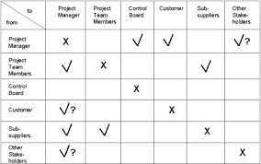

This plan identifies and defines the roles of persons involved in this project and can be formatted in various formats and includes tables as per the sample above. It may also include a communications matrix which maps the communication requirements of this project as illustrated below. An in-depth guide for conducting meetings details both the communications rules and how the meetings will be conducted, ensuring successful meetings. A project team directory is included to provide contact information for all stakeholders directly involved in the project.

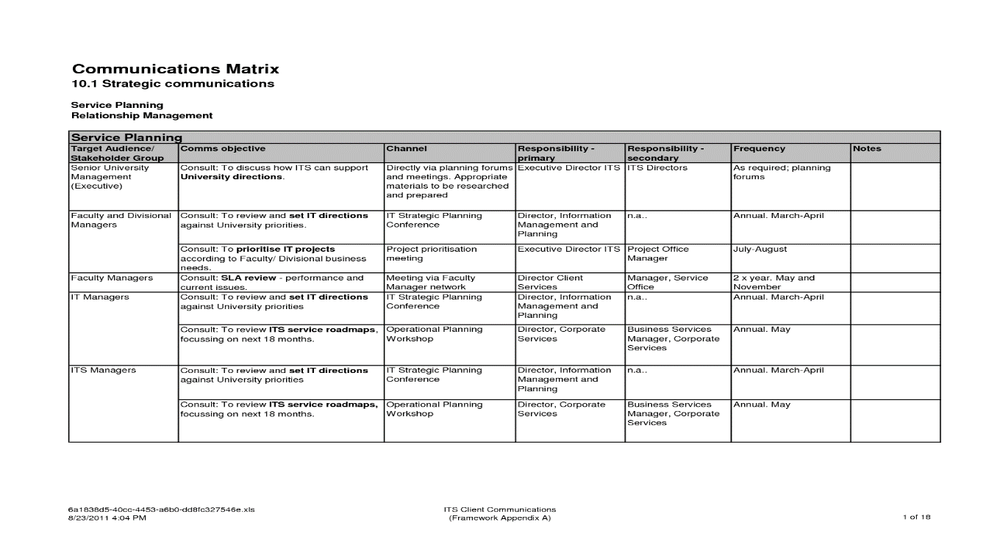

IV. What are the inputs to information distribution?

Information Distribution is about assuring the right information is available to the right people at the right time. Information Distribution executes the communication plan and responds to the unexpected requests for information.

The main input to information distribution is the Communications Management plan as this describes the methods of obtaining and distributing project information. However there are two additional elements that serve as inputs to the distribute information process as illustrated and detailed below;

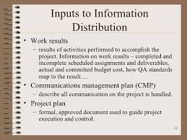

- The results of the ongoing works, good or bad, serve as inputs to communication because they show quality issues, progress or lack of it, and other relevant information (also see narrative within illustration).
- The Project plan may have data, necessities, or described situations that are integrated with communications (also see narrative within illustration).

V. What are the various communication modalities used by project managers?

The project manager and his team need to identify all of the required and approved methods of communicating during the communications planning stage.

It is important not the send all recipients within the plan, all of the information, as in some cases the communications may contain sensitive and classified information and not all the stakeholders need to be aware of it. Other projects may contain information that’s open for anyone to explore. It is the project manager responsibility therefore to identify new and existing requirements, if any, for the communication modalities.

Communication modalities can include but not be limited to progress reports, memos, emails, meetings (informal and recorded), and so on. The favored systems of communicating must be clearly identified by the project manager and nominated team members, based on the conditions of the message to be communicated.

The following needs to be considered, which may have a detrimental effect on the communication plan:

The length of the project can have an influence on the project technology. A long-term project’s communication model may be replaced due to the ever changing technology improvements and software. A short-term project may initially not have the same technology requirements as a long-term project but could nevertheless benefit from the successful model and performance capability a larger project uses.

Regularly scheduled information reports and updated revisions etc. may be required by the project stakeholders (such as management and the customer). If conditions within the project affect the project success or reputation, immediate communications may be required.

The Project lifecycle may need technology changes, required to fulfill the project essentials, because of the extreme nature of the project evolution. The project may require an internal web site or intranet, for example, that allows the transfer of large volumes of data and details the project advancement. If these sites are not available to the Project, then man-hours and budget will need to be allocated for this communication requirement.

The project manager should regularly evaluate the abilities of the project team. This is to determine if there is appropriate project staffing levels of competency existing within the team, so as to fulfill the communication requirements or ensure they receive suitable training to enable the information distribution service is maintained.

2. Discuss in details how the project communication plan is created? (5)
Before starting the task of putting together a communication plan, it is important to ensure vital prefaces are in place. It is important that the project objectives and scope and communication objectives have been clearly stated bearing in mind different projects will require different communication strategies. The other preliminary that must be taken care of is the stakeholder analysis. Without this vital information, the communication plan will lack strength and direction.
- 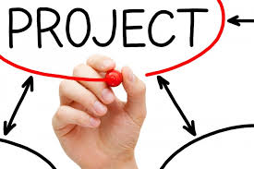
Stakeholders are those individuals who have interest and influence in the project. These are the people that will be communicated with during the project lifespan. One final study that is helpful to have performed is the risk analysis - as this is one of the places where communication will be vital.
Once preliminaries are in place, the project manager and his team can begin to put together the communication plan ensuring that various scenarios are covered including status updates, risk management, and budgeting concerns. Determine how issues will be recorded - should team members email you, everyone, or keep a spreadsheet and bring up the issues at the next meeting? Creating a communication plan will take care of any ambiguity.
A Communications Management Plan can organize and document the process, types, and expectations of communications therefore it is important that during its creation the plan provides:
- Particulars on in what way the information is to be distributed and systematized, the level of expected detail for the types of communication, and the language/terminology expected within these communications.
- A means of when the various types of communication should occur, usually a schedule is developed for regular communication types, such as status meetings, weekly reports etc. however some other types of communication may be driven by circumstances within the project.
- Instructions on exactly how the Communications Management Plan can be updated as the project advances.

- A method to collect, organize, store, and distribute the right data to the appropriate stakeholders, customers etc. The system needs to include include procedures for correcting and updating incorrect information that may have been distributed.
- Details on how needed information flows through the project to the correct individuals. This structure must identify the process from where the information will originate, to whom the information will be sent and in what format, and in what modality the information is acceptable.
- Methods to retrieve information, such as stored e mails, progress reports as and when needed.
Once the project is finished, evaluate the communication plan. What worked? What didn't work? Incorporate these findings into your next plan.
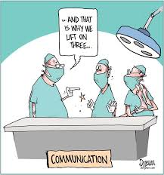

3. What is performance reporting? How the information relating to performance is conveyed to various stakeholders? (5)
Project managers need to monitor and control projects to ensure completion within the scope of defined budgets, forecasts, and schedules. Project performance reporting provides the manager and other stakeholders/customers with an at-a-glance comparison of actual versus planned performance as defined in project budgets and forecasts and identify any potential risks.
The perceptive information provided by project performance reporting enables the PM to make informed decisions. He can view project performance information at the project, task, and resource levels by time period. After viewing the financial metrics for tasks and resources, he can also drill down to view detailed transaction information such as commitments, expenses, and events. This enables him and his team to analyze expenses already incurred for a particular task and to be aware of future expenses that are currently pending (for example, commitments).

Quality is another issue that needs reporting on a regular basis. If the quality of the work is substandard, this defeats the object for completing the project on time and on budget. This will in fact, result in the project team having to carry out costly rework, result in loss of future business, loss of company and personal reputation or even result in personal injury as a result of the poor quality of the project work, or a combination of all of the these.
Performance reporting should always include the following as a minimum;
- Status reports
- Progress reports
- Scope
- Quality
- Risks
- Forecasting

Once the Performance reporting strategy is agreed it is vitally important to ensure that the right people (such as stakeholders, project team members, project sponsors, etc.) get the right information at the right time for project status and to make decisions on projects and this requires a great deal of planning. Effective distribution of information relies on the selection of the right tools and methods to ensure you reach the people you need to reach in the manner best suited for them to evaluate and/or make decisions.
The method to communicate that you select should be based on the following;
- The type of information to be distributed
- The audience requirements
- The timeline for a required response
There are pros and cons to different methods of distributing (communicating) project information. It is important to weigh the pros and cons against availability of certain tools/methods, expectations of the individual being communicated to about the project, expectations around formal or informal messages, the need for formal record keeping, etc.
The three basic general communication categories include:
- Face-to-face (individual or group meetings)
- Hard-copy (letters, memorandum, reports)
- Electronic (email, conference calls, web conferencing)
Face-to-face communication allows more easily for gauging others’ reactions to what is being communicated, which allows the PM to ensure they are hearing what he intended them to hear and understand what he are saying.
Meetings may be costly if there is a need to bring individuals in from other states and/or countries to participate. However, it may be a good idea, for global projects, to have at least a face-to-face meeting as a project kickoff and another meeting mid-way through or near the end of the project. To ensure meetings are productive, be sure to plan for them ahead of time and send to all participants an agenda prior to the meeting. If participants are required to have information with them for the meeting, make sure they know they are expected to be prepared for the meeting.
Hard-copy communications can really be combined with the category of electronic communications. In today’s information age with easy access to computers (in nearly all situations) hard copy reports, if desired, could be followed up with electronic version. The PM may choose to provide a hard copy status report to an executive if he or she prefers that format of communication, but he would want to retain an electronic version for recordkeeping, along with information about the distribution of the hard copy – such as a copy of the memo to the executive with the attached report.
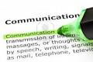 Clearly e mail communication is a major tool used in today’s communication process and these can be individually or group based communications and readily stored for future use/access.
A project portal or intranet site is also a viable method of getting project data out to others and of sharing information via discussion forums or through chats to make decisions or get input.
If there is a need to pull a large group together, and a face-to-face meeting is not possible, there are options nowadays to use a collaborative meeting tool, such as GoToMeeting®, or a similar tool, to communicate with the team. Such tools allow for collaboration as video can be an option – if individuals are able to see each other there is a higher likelihood of collaboration. Many such tools also provide white boards and other collaboration options for document sharing, editing, etc.

Student Statement:

By submitting this assignment, I confirm that this is my own work.

Student Signature | Raymond Wilson | Date | 9th Jan 2015

For Tutor / Assessor Use Only
Total Marks
Marks Obtained
Percentage / Grade

