
Assignment Cover Sheet

Student Name: | Darren Holtom
Student Number: | 29173
Course: | Development and Organisation of Construction Projects
Assignment NO: | 2

Marking Criteria:
We expect the learners to write minimum one well expressed point in three lines against each allocated mark. This means one needs to write 15 lines with 5 well expressed points to get high grades for a 5 marks question.
For high grades use examples and illustrations where appropriate.
Darren Holtom
Student ID. 29173
Assignment 2 : Development and Organisation of Construction Projects
Diploma in Construction Management 4

- There are a number of things which could cause a project to over-run or the cost to increase. Once the project starts, there may be unexpected issues that arise which cause the scope of works to change ( for example during an excavation it is found that the earth is too soft to take the construction of a building so a new design will need to be made to ensure the structure is stable and secure). The cost of materials, labour, equipment or overheads could change between when the contract was first agreed and when the project is completed. Weather also has a huge impact. Wet or cold weather can stop works from continuing due to health and safety risks, and also prevents wet works etc to be able to carried out. A strong management team is required to ensure that all elements of the project co-ordinate well so that there are minimal delays as the project progresses . Delays are caused in all streams of work due to the unreliability of the human body, illness etc means that some day’s the project will be understaffed. And everybody is liable to make mistakes which need to be rectified adding time to the project.

- the main resources of project finance are :

personal investment
bank loans
government grants and subsidiaries
Venture capital ( where a company/individual helps towards the cost of the project and in return take a percentage of the profit)

Iii During the controlling phase, it is the site manager /supervisor’s responsibility to co-ordinate all works, including personnel, equipment and materials. It is their duty to overlook all works to ensure that the project is progressing and if not, bring it to the attention of the project manager so that changes can be made to get he project back on track. The control phase includes:
• The overall scope change control
• Resources control
• Schedule control
• Cost control
• Quality Control
• Risk response
• Performance reporting
• Contract administration

i.v At the end of the project and final items are completed and the client is offered to inspect the project. The client will “snag” the works carried out and highlight any issues they may have. These works are then addressed by the site manager and once complete, the project is then offered again to the client to inspect and approve( this is normally completed by all parties signing a hand-over certificate) . All administrive elements are then closed out.

v. A feasibility study is used to show the viability of the project. It will list all material requirements and cost estimates. It will highlight the potential positive and negative aspects of the project. The results of this study could save a lot of time and money being invested in an unsuitable project. The feasibility report should contain the following information:
i) Project background and description
ii) Market and plant capacity
iii) Materials and input
iv) Location and sites
v) Project engineering and investment cost
vi) Plant organisation and overhead cost
vii) Manpower
viii) Implementation schedule
ix) Financial and economic evaluation
x) Prepare a summary sheet for every component
xi) Make a top sheet covering all components, providing separate columns for foreign exchange,
local cost and total cost

Vi.

A Project Completion Report is a formal document which closes out the project. Included in the report will be a background of the project from start to finish.
In this will detail the following:
-An assessment of the project performance, comparing it to the initial plan.
-Customer satisfaction
-A description of the success of the project (and possibly the failures)
-Lessons learned
-Further actions to be taken

2:

- A project is defined in the dictionary as “an individual or collaborative enterprise that is carefully planned to achieve a particular aim”. This relates to very small jobs to massive jobs in all industries.
There are 4 main sections which make up a project:
*The initiation
*The planning
*The execution and control
*The close

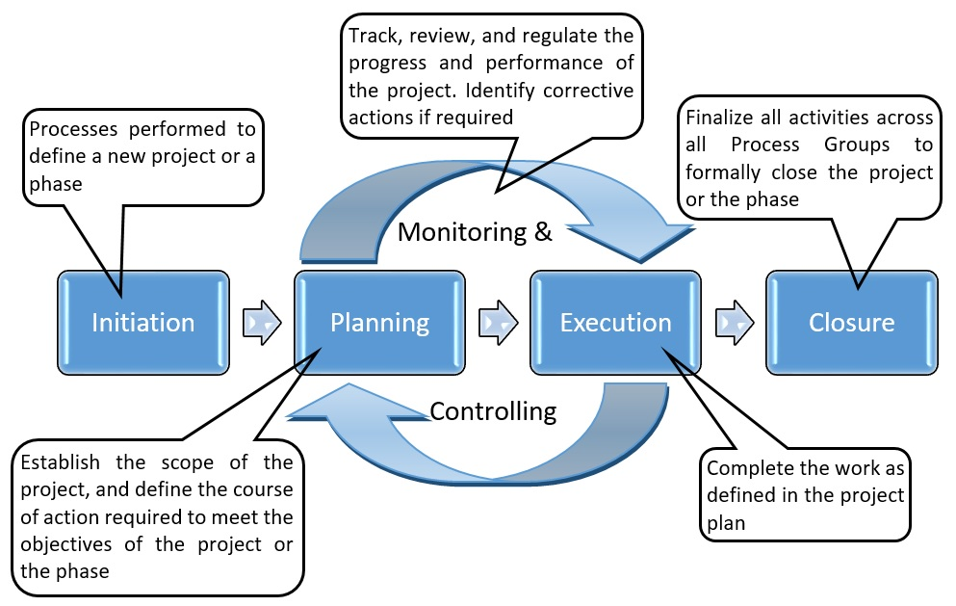

1) The initiation process is where it is determined if the project is viable, finacially and physically, defining its purpose, scope and objectives. It will assess the reasoning for the project and if it is required. It will identify which resource’s are needed to complete the project and how easily obtainable they will be. . Any permissions wil be sought during this stage i.e planning permission
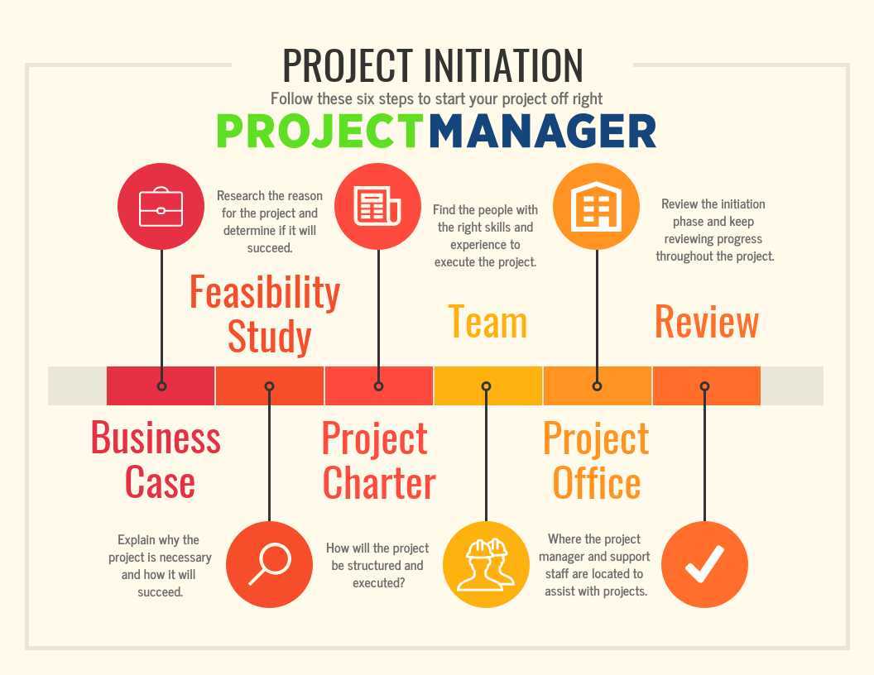

- During the planning stage of the project, a realistic plan is made for how the project will be carried out and within what timescale. The project will be designed including any drawings which may be required. A budget will be made to ensure that the project does not run at a loss. A contingency plan may also be included in case of any unforeseen problems. A risk assessment will be undertaking to highlight any possible health and safety issues and how they will be addressed. This will help reduce accidents onsite and prevent delays in the project. A scope of work is agreed on so that all parties are aware of what is be undertaken during the project and the quality of the finished product. Communication between client and contractor is organised. Any plant or materials with a long lead time are procured at his point to avoid delays later in the job.Once this is in place, a suitable contractor is assigned to the project
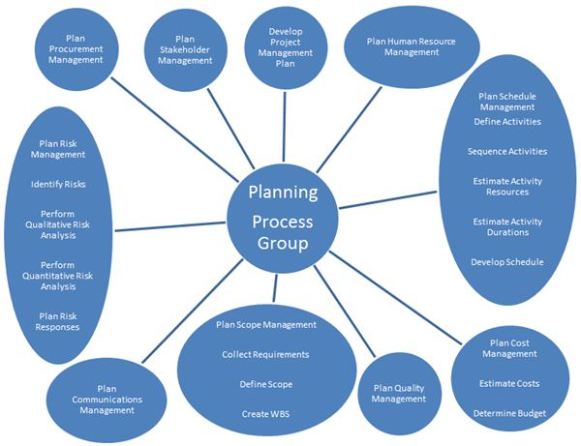

- The execution and control phases of a project are separate phases but run concurrently. During the execution and control phase of a project, it is the responsibility of the project manager to ensure that the project runs smoothly and within budget. He/she is there to encourage and motivate the workforce and to direct them so they know exactly what is required of them, both with their work and their conduct while on site. All materials, plant, labour need to be in place and monitored. Health and safety also needs to be monitored to prevent accidents to the staff, workforce or general public. The works need to be continuously checked for quality, if not the works could all be condemned which would cause a big loss financially and a big loss of wasted time and materials. It is during this time that unforeseen problems can arise and these need to be controlled as soon as possible and a new plan of action put into place. Once all is complete, the project is offered to the client who, when satisfied with the works, sign’s off the completion of work.
- 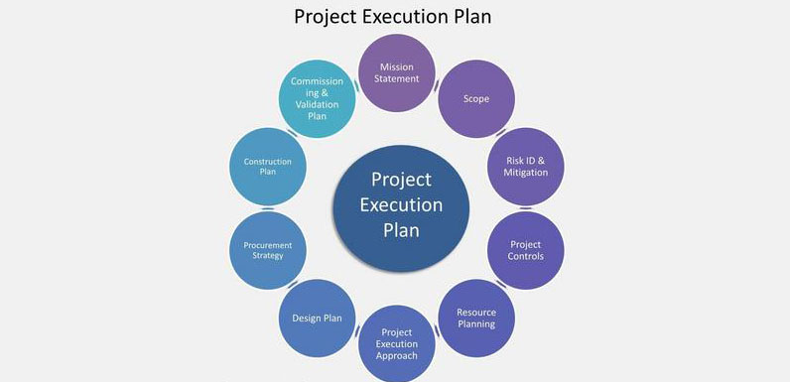

The close phase is when the physical work is all complete and handed over to the client. All financial and administrative works are completed. It is at his time where a thorough check over of the project is undertaken to asses how well ( or badly) the project has performed. A project completion report will be made and presented to the client. This will include a number of things including: the scope of works, the schedules in place for the works, the contact details of suppliers of any materials, the full product information of any materials used ( this enables replacement materials to be sourced in the event of breakages at a latter date, and will allow the client to research the materials used so they know if any special requirements are needed for cleaning etc ). Any maintenance documents/ requirements will be presented. All important dates during the project are noted, these will include when certain elements were achieved or when machinery etc was installed) . All costs will be included so it can be seen if the project run under, over or on budget. Any problems which occurred during the time of works taking place will be listed including what course of action was taken to either rectify the issues or change to the scope of works. It is rare for a project to run smoothly from start to finish, so it is important to list any lessons learned during the works. This will help the contractor alleviate these problems on further jobs and help the client understand any delays etc in works, and how they may have been able to help. Any minor outstanding “snag” items will detailed with information and when and how they will be carried out. 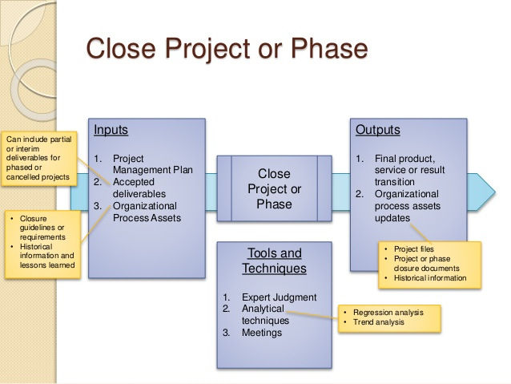

Student Statement:

By submitting this assignment, I confirm that this is my own work.

Student Signature | Darren Holtom | Date | 6/2/19

For Tutor / Assessor Use Only
Total Marks
Marks Obtained
Percentage / Grade

