
Assignment Cover Sheet

Student Name: | EHIOGHIREN BROEN OSAYANDE
Student Number: | 11371
Course: | Diploma in Construction Management
Assignment NO: | # 2

Marking Criteria:
We expect the learners to write minimum one well expressed point in three lines against each allocated mark. This means one needs to write 15 lines with 5 well expressed points to get high grades for a 5 marks question.
For high grades use examples and illustrations where appropriate.
i The general causes of project cost and time overruns are

- Poor execution of project tasks can lead to increased costs; you can link less obvious reasons to the processes of project management and the underlying nature of complex projects. Effective project management identifies such possible sources of cost overruns early and mitigates their effect.

- Estimates are common reason for cost overruns is the inaccuracy of cost estimates. When the bids for subcontracts or the actual costs come in, they are often higher than anticipated. Such cost overruns are due either to incorrect estimates or to changed conditions in the marketplace. You can review cost estimates before placing orders to identify mistakes or changed conditions. An overall review may find that increases in some areas are compensated by decreases in others.

Design Sometimes, the designs or drawings that form the basis of the project are not realistic. You may find that a combination of specified features is difficult to achieve or that drawings show an incorrect arrangement. Executing the project as specified will either cost extra or cause problems that must be resolved later at additional cost. As project manager, you have to continuously compare plans with executed work to find such discrepancies early and correct them.

Planning the project progresses according to a plan that assigns durations to project tasks. If the projected durations can be too short, the projects take longer than anticipated and cause cost overruns. Monitoring project tasks on the critical path, which is the task sequence from project start to finish that takes the longest to complete, helps reduce the risk of delays. Project tasks off the critical path have slack times, or free times between tasks, that you can use to compensate for delays.

Scope Changes in the scope of supply within a project frequently cause cost overruns. These changes result from new requirements that the owners introduce and fixes for functions that don't work as specified. As project manager, you must make sure the owners understand that additional requirements result in higher costs, which you can classify as improvements rather than cost overruns. When you discover that parts of the project don't work as specified, you must explore different solutions and present them to the owners. Sometimes, you can find acceptable levels of functionality that don't cause cost overruns.

Ii Project Finance is a method of funding in which the lender looks primarily to the revenues generated by a single project, both as the source of repayment and as security for the exposure. Project Finance transactions play an important role in financing development throughout the world. This type of financing is usually for large, complex and expensive installations that might include, for example, power plants, chemical processing plants, mines, transportation infrastructure, environment, and telecommunications infrastructure. The main resources of project finance are

- Commercial banks

- Public Banks

- Debenture or bonds

- Suppliers credit

- The capital markets

- Loan stock

- Government sources

iii. Project Control Phase are the data gathering, management and analytical processes used to predict, understand and constructively influence the time and cost outcomes of a project or program; through the communication of information in formats that assist effective management and decision making. This definition encompasses all stages of a project or program’s lifecycle from the initial estimating needed to ‘size’ a proposed project, through to reflective learning (lessons learned) and the forensic analysis needed to understand the causes of failure (and develop claims). The following processes are used in the controlling phase
- Scope Verification and Change Control.
- Schedule Control.
- Cost Control.
- Quality Control.
- Performance Reporting.
- Risk Control
- Contract Administration.
- Complete Monitoring and Controlling Phase Review.
- Resources control

IV The Project Closure Phase is the last phase in the project life cycle. In this phase, you will formally close your project and then report its overall to your sponsor. The client’s project team is responsible for handing over the project to the client upon completion of the Project. The projection completion report has to be completed and handed over. This report details the scope of work and the schedules used to complete the works, important events that transpired, the contract executed, the contact details of material and equipment suppliers, the maintenance manual, costs of the projects, problems during construction, any lessons learned and minor defects detected at the time of handing over.

- A contractor who is familiar with the newly finished structure is chosen to provide maintenance when the project is completed and handed over.

- There is the need to maintain correct record of operating instructions, as well as, the construction drawings.

- Before building takeover, staffs are trained in operating and maintaining the building.

- Unwanted and unused materials must be removed from the site.

- Before issuing completion certificate and making final payment to the contractor, the client makes sure that his interest is protected.

V
- Feasibility study is an analysis of the viability of an idea. An analysis and evaluation of a proposed project to determine if it is technically feasible, feasible within the estimated cost and profitable The feasibility study focuses on helping answer the essential question of “should we proceed with the proposed project idea?” All activities of the study are directed toward helping answer this question.
- The feasibility study covers the following area.
- Market demand for the projects end product and plant capacity

- Materials and inputs

- Location and site

- Project engineering and investment costs

- Plant organization and overhead costs

- Manpower

- Implementation schedule

- Financial and Economic evaluation

- Statutory clearance

VI
Project Completion Report (PCR) is a structured reporting format provided by the project teams at the completion of the project to the Project owners. Items included in Project Completion Report are

      - Scope of work of the projects.

      - The schedules used to complete the works of the projects.

      - Important events that transpired in the projects.

      - The contract executed in the projects.

      - The contact details of material and equipment suppliers in the projects.

      - The maintenance manual of the projects.

      - The costs of the projects.

      - The problems during construction of the projects

      - The learned and minor defects detected of the projects at the time handing over.

2
i

- Project is the discipline of initiating, planning, executing, controlling, and closing the work of a team to achieve specific goals and meet specific success criteria. A project is a temporary endeavor designed to produce a unique product, service or result with a defined beginning and end (usually time-constrained, and often constrained by funding or deliverable) undertaken to meet unique goals and objectives, typically to bring about beneficial change or added value. See diagram below.

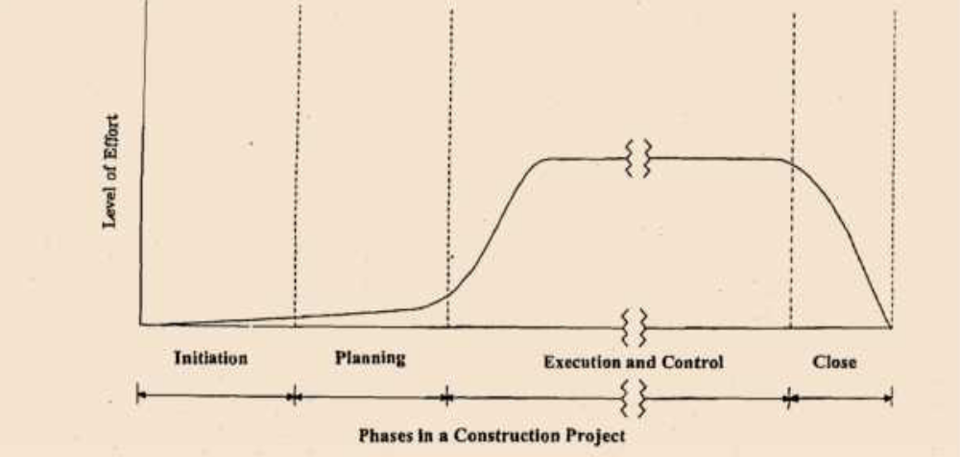

ii

- Planning Processes, Planning is of major importance on a project, you are doing something unique and you only get one chance to get it right. As a result, there are relatively more detail processes in this section. However, the number of processes does not mean that project management is primarily planning—the amount of planning should always be commensurate with the scope of the project. Carry out high-level planning for the whole project at the start of the project, then do more detailed planning for each phase at the start of each phase. Ensure that you have the right people, resources, methodologies, and supporting tools in place for each planning phase, so that you can deliver the project on time, on budget, and to appropriate quality standards. The Planning Process involves

• Basic design and drawing planning

• Time planning

• Resource planning

• Cost planning and budgeting

• Communications planning

• Quality planning

• Organizational planning

• Risk management planning

• Procurement planning

• Project development integrated plan

- Designing Processes. As already discussed, the project scope is defined by the designs, drawings and specifications. It is with the design that the various components of the proposed facility can be determined. The designs also help in the development of drawings, the estimation of project cost, the amount of work involved, the duration of construction and even the prediction of the financial dynamics of the whole project. The design phase involves the collection of project information which is analyzed, shared with the appropriate teams and then stored for use in the project scope framework. The three sequential processes are

- The schematic design process. The design architect assesses the client’s requirements and them discusses the alternative options available with the client. A conceptual design is subsequently generated for the client to approve. The schematic design portfolio consists of the site plan, facility drawings, the outlined specification and the design for major constituent systems such as the mechanical, structural, and electrical among others.

- The design development process the design development phase begins immediately after the schematic drawings described above have been approved. This process provides detailed information on constructability, system integration and the aesthetic element as well. Drawings for the plan, elevation and various sections of the facility are provided during this phase. this process may include the following:

• Design of foundation and structure of the buildings

• Structural design of precast elements of the building

• External filtered and unfiltered water supply

• External sewerage system and storm water drain

• External gas supply

• External electric services

• Fire alarm system

• Clock system

- Drawings and specification documentation. Drawings are important assets to people connected to the project. Owners, engineers, contractors, architects, sub-contractors government institutions, lenders, Licensing Authorities and insurance agencies all make use of the drawings, and Specification provides the client with guidelines on the quantity of materials, final product and the size workforce which form the basis of the project design. It also highlights procedures for inspection and acceptance when the project is completed.

- Procurement Process Procurement is an important practice in the construction sector. It involves the acquisition of services, materials and goods which are needed for the entire project. The approach adopted for procurement of essential components for the project can be classified into three categories

- Contractual (client engaging the services of contractor)

- Departmental (client setting up

- Organization to execute the project and consultancy (construction manager is approved to manage the project).

- Execution Process is carrying out the project plan by performing the tasks identified therein and managing the various technical and organizational interfaces the function of project executives include:

• Project organization

• Resources mobilization

• Quality Assurance organization

• Site mobilization

• Team development

• Safety management

• Information distribution

In a large construction project, the project manager is assigned the position of project leader. He is expected to provide directions, vision, motivation and inspiration for the workforce. Other personnel are also expected to assist the project manager with leadership responsibilities in their various areas of expertise.

- Project Control Process Project must be measured regularly to identify variances from the plan as well as to determine when the project is finished. Variances are fed into the control processes in the various knowledge areas. To the extent that significant variances are observed (e.g., those that jeopardize the project objectives), adjustments to the plan are made by repeating the appropriate project planning processes. For example, a missed task finish date may require adjustments to the current staffing plan, reliance on overtime, or trade-offs between budget and schedule objectives. project control process involves

- The overall scope change control

- Resources control

- Schedule control

- Cost control

- Quality Control

- Risk response

- Performance reporting

- Contract administration

Student Statement:

By submitting this assignment, I confirm that this is my own work.

Student Signature | EHIOGHIREN BROWN OSAYANDE | Date | 22/OCT/2017

For Tutor / Assessor Use Only
Total Marks
Marks Obtained
Percentage / Grade

