
16
Assignment Cover Sheet

Student Name: | Berkant Tahirov
Student Number: | 11734
Course: | Diploma in Travel&Tourism
Assignment NO: | #8

Marking Criteria:
We expect the learners to write minimum one well expressed point in three lines against each allocated mark. This means one needs to write 15 lines with 5 well expressed points to get high grades for a 5 marks question.
For high grades use examples and illustrations where appropriate.
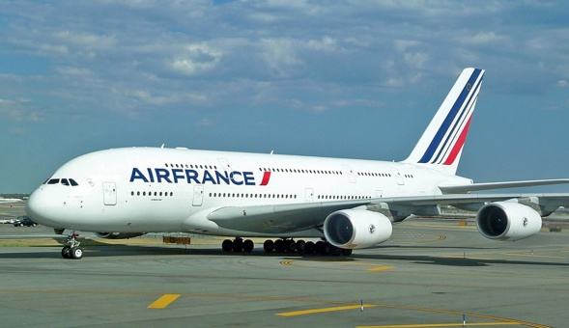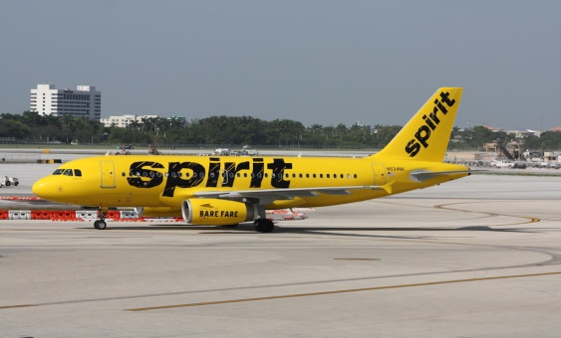

I.The difference is very simple between full cost survice airline and a low cost one.Since in the last decades transportation changed significantly,there is more oppurtunities for transport than ever.More choices in price,timing and quality.Today everyone can choose a convenient mode of transportation on their own wishes and needs.Airplanes are larger,airports wider and with more space.,not like in the past in the times where airplanes were still a new venture for society,where they had less choices in pricing,qulity and for the timing.Today there are not only two types of airplanes/carriers,but more.Now in the last two decades the numbers of flights has increased ten times over due to the development of both big and small airplanes and airlines.Now there are in most countries full cost (big) airlines and low cost (small),where the full cost is inclusive in quality and timing and can fly into bigger distances (which makes travelling more expensive).And low cost airlines which are occupied/equipped with smaller aircrafts and travel into shorter distances and offering lower prices and with a good quality.In those types of airlines are booming in the last decades since is more cheaper for people that they can travel to shorter distances instead of doing it with a bus or a car.

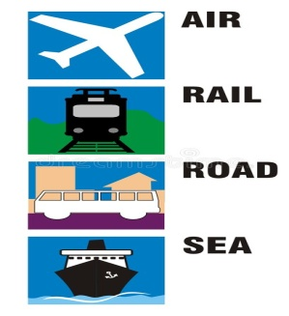
Planning is choosing a particular way of action.And doing it is harder than on theory,and during the plan there will be lot of challenges.Because of that reason.there has to be always a plan B in advance.Planning in the area of transportation,might look easy in theory,but actually is challenging,especially in less developed countries,when the organization has no reputation(newly established),or working in a unfamiliar destinations.Again,transportation requires a good research and preparation of the market and the already decided mode of transportation.Research of the prices,quality and the destinations’ infrastructure.As a tour operator for establishing your own organization,transportation is very important of the organizations overall success and image.So to start and improve the transportation part of the business these factors must be considered:

Creating definintive goals like:
a) Pricing
b)Quality
c)Efficiency and costumer satisfaction

Research of the transportation market.Which mode of transportation is more effective than the other one,and why?

Carefully choosing the staff by its skills and experience levels.Staff requirenments,needs and salaries.

Doing often feedbacks and gathering past datas and results,in order to find the “gaps” or improve a service.Also observing tips and making comparisons with already other successful organizations.

Forming business relationships and contacts with tourism and transportation providers like: hotels and accommodation facilities,bus companies,railroad companies,airline companies,taxis/cabs services and etc.

III. The necessity for planning in transportation management ,is for the organizations’ own success and improvement.Nobody would like to run an ‘’last-minute’’ organization,without planning and without a marketing strategy.It’s very simple it is a choice between more success and less deficit in money and quality,and less success and more costs and bad reviews.The planning should be examined carefully and not only with a plan A.Since this unit focuses on tourisms’ most important part (transportation) there is always going to be delays and other technical problems within the schedule.And it is up to only the transportation company to manage that but also the tour operators’staff.They require good patience skills,good communication and creative ideas in consoling the unhappy clients during these nerve wracking situations.These possible future events have to always be considered even with the best planning or strategy even with the best organization reputation or image and so on.



IV.Issues in in transport management that are crucial for the success of a organization.
Issues are also understanded as ‘’gaps’’ and certain regulations within the transport business.As already said before with the increase of different types of transportation vehicles,there are has to be more precautions on the destinations resources and infrastructure culture and etc.This exact research is vital and understandable.For example you can’t employ or establish only ‘’on-road transportation services,while you are in an exotic place with many islands ,for example countries like:Greece,Indonesia,Australia Philipines and etc.The touris coaches must carefully examine the preference of transportation and most suitable choice depending on the destination,the market and the number of tourists .The transportation staff and personel have to be informed of the same regulations,informations and considerations during the trips.The input/support of the Tourism employers is crucial in this process for running a successful transportation business.And also In the transportation business an organization is not only required to practice its own services the way they want and with their own goals,but they also have to follow certain laws and regulations given by the authorities.Here are some of the main regulations and terms of operations:

Some vehicle are designed and sued for a certain routes and places.

The transportation company and its personel must be aware of required road fees and taxes in specific destinations.

Knowledge of additional costs,conditions and permissions of using certain vehicles and routes.



V.As already mentioned in the Unit 5 and again in this unit of transportation and management wherever services are provided there has to be a good execution of a marketing plan. It is an activity which two parties agree and make a deal to exchange their goods.Advertising is also part of marketing and it is again a cornerstone of marketing,so is the overall market research(trends, tourism seasons.)The ways of marketing a business have to be defined before its actual process.As already mentioned some organizations focus on pricing and some on quality.And for the beginner organization the quality has to be a top priority.Only with this element of marketing an successful organization can be run.And this success of quality is defined by Image,results and and constant research for new progress.Without the quality,transportation services can’t endure.And there is a term in marketing that every organization MUST use and consider: The 4PS and also an additional element of TIMING

Place:Where are these services available?

Promotion: How is it advertised? In which platforms and ways it is advertised? (Social media platforms,local newspapers,flyers and etc.) Is there something better offered here than the usual ones of the other companies? How it’s already viewed by clients and opinion formers?

Product: What kind of services are offered?(rental cars,buses/coaches,trains,cruise ships).
How much does the company value quality and consumer satisfaction,protection and recovery?

Pricing: Is it cheaper and more affordable than the other transportation companies?

VI.Although forecasting is not always very correct and safe,especially in a changegable industry like transportation,there are still some methods and ways of forecasting the needed or required transportation.Most tourists nowadays make more and more advanced bookings and reservations and the transportation services and demands are included in the package which makes it even more challenging and complicated for the organization and the tour manager.But as already mentioned transportation is mandatory for the trip logically and it requires more skills and good business relationships with the major suppliers. The First method is simply by collecting and researching the markets’and th clients’ future demands in transport.Second is to gather information,tips and important notes from already existing and active transportation staff or organization.And the last is to and observe the statictical aspects of the transportation market.Note:Once again in this part of tourism a good research is required!When we put the few methods of,now comes the main factors and ways in forecasting:

The total Tourism expenditure per capita

Total number and statistics of trips taken by the tourists

Share and contribution of the tourists’ ‘’Gross National Product’’ (GNP)



VII. As we all know since the increased number of the populations and the increase of new type vehicles with more powerful engines and speed limits ,there increased consumption of natural fuels ,plenty of choices in car models and horsepowers.But with the increase of these new technologies and a booming engeneering ,there is also a HUGE impact on the air pollution and global warming.Due to these alarming environmental facts and risks some new car companies started to develop electric cars instead of with fuels in the last 10 years.New companies like Tesla and Smart develop only electric cars today while the other top ranking companies like BMW,Renault,Toyota,Nissan and etc. have already developed their own model cars powered by electricity.This is some kind of improvement,but there is a long way too go,because still half of the world relies on fuels due to its cheaper prices and the lesser expenses of fuel cars.There are more developed countries that make a positive progress towards a greener society and in decreasing air polutionThese are Norway,Japan,Germany,Sweden,Singapore and more.Their governments fund and create new ,programs,green environment organizations and even policies on helping to decrease/minimize the air pollution that can cause serious health risks to the societies. Government funded and sometimes non profitable organizations encourage and offer simple tipps like using the public transport,using bicycles in the cities and if possible buying and using electric cars (which the govermnets and cities offer exlusive benefits like:free parking,less yearly taxes ,no road fees and free charging of the cars and more.)



Case Study:

So everytime within the transportation business delays and cancelations will be present.It is almost inevitable and it’s a fact that can hurt the organizations’ image and overall success.And the managing skills of the organizations is vital.It is obvious that problems will arise and the way they are handled is important,and in the right way.Even the smallest step/attempt of recovery can be play a huge role in saving the situation.Because by doing that you show that you’re also bothered about the situation and you care about the costumer.What would I do personally,is similar but anyone who is involved in tour managing has to be really creative,calm and confident during crisis.

1.Everyone who is promised and expecting a smooth and satisfying trip will be upset and disappointed by delays or even cancellations.Punctuality is one of the biggest challenges in transportation,and that challenge will be always present.

2.Since the delay happened,we have to talk about past present.About the coach delay it could’ve been done nothing,because the delay can be caused by heavy traffic .The stop by the gas station can be judged,because before a paid and planned trip the transportation provider must be prepared.It is important how to manage such situations,sometimes as already mentioned even the willingness of taking a decision and step of recovery is necessary and can be actually helpful.Me personally In this situation,within these 10 minutes I would keep contact with the bus coach staff and discus the current situation and circa how long will it take them to arrive in the hotel.And then I would examine the possible steps according to the circumstances.I would try to inform the tourists about the duration of the delay and ask them for patience.Next (if is possible) I would offer them a trip free of charges to some attraction or destination near the hotel where the tourists are staying.And sometimes that may not be enough,because managing people is difficult and some people can be really rude and disrespectful.Everyone among the tourists will have their own judgement and needs and different opinions about the situation.And they have their reason to be.

Student Statement:

By submitting this assignment, I confirm that this is my own work.

Student Signature | Berkant Tahirov | Date | 16.06.2018

For Tutor / Assessor Use Only
Total Marks
Marks Obtained
Percentage / Grade

