
Assignment Cover Sheet

Student Name: | Julia Cornelius
Student Number: | 10150
Course: | International Diploma in Project Management
Assignment NO: | 2 – Project Life Cycle

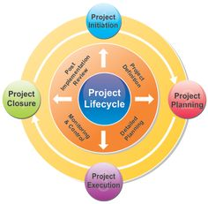

1. Short Questions: (15)
i. You are a project manager working on gathering requirements and establishing estimates for the project. Which process group are you in?

- Executing b. Initiation Planning c. Controlling

Gathering requirements and estimated will be done in the planning phase.

- What does the term ‘project deliverables’ mean?
Project deliverables are measurable results and outcomes or items to be produced for the project /project phase to be complete. It could refer to a report or a product or a project milestone. Deliverables must be specific and verifiable.

- What is the purpose of determining a project’s goals and objectives?
Goals and objectives describe the purpose and end result of the project. The project is to do something (objectives) and the final results are the Goal.
It is important to understand what the goal of the project is and how to know when it has been achieved.

- At which stage of the project is the project’s constrains identified?
Project constraints are identified in the initiation phase. Constraints that project managers deal with are such as budget, time and quality.

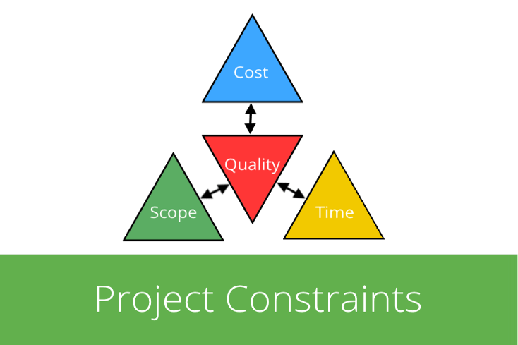
https://inlooxcdn.azureedge.net/var/corporate_site/storage/images/media/images/blog/project-constraints-header/947019-2-eng-GB/project-constraints-header.png

- Explain the term ‘project charter.’ Which type of information does it contain?

The project charter is the official, written acknowledgement of the project, it should include the following elements:

- An overview of the project – project title, analysis, conclusion
- Project deliverables
- Goals and objectives
- Resource and cost estimates
- Business Case/Need for the project
- Key milestones, start date
- Feasibility study (if applicable).

It should also include a description of preliminary roles and responsibilities of the project team - project manager, sponsor, staff and executive management.

All the information gathered in the initiation phase should be included in the charter and given to stakeholders to review and get feedback. Once all parties involved are happy the document is finalized and signed by the project sponsor.

The initiation phase is completed by the publication of the signed project charter. This is the authorization for the project to begin.

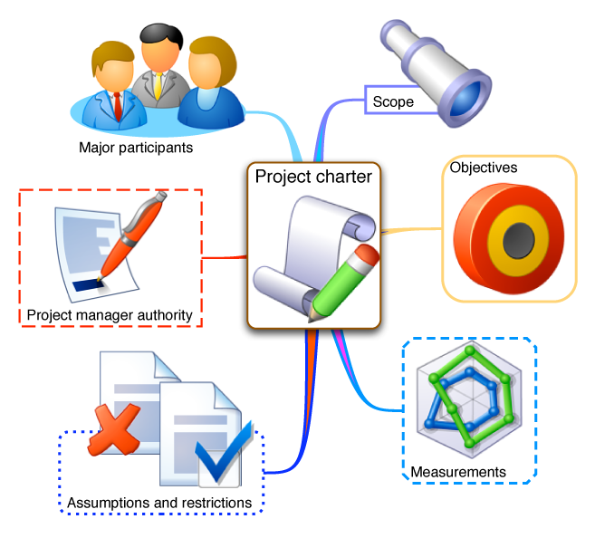
http://www.sixsigmadaily.com/the-importance-of-a-project-charter/

2. “Properly planning your project up - front dramatically increases the project’s chance for Success.” Discuss this. (5)

Benjamin Franklin > Quotes > Quotable Quote


“If you fail to plan, you are planning to fail!”
― Benjamin Franklin
The advantages of properly planning your project upfront are as follows:

Direction – the project plan is developed and the direction of the project to meet its goal is set. The project team has a clear path to follow.

Accountability – The PM and team are assigned tasks and clear accountability is determined. Each team member is aware of their role and responsibilities.

Resources – Planning involves determining adequate resources in advance. Each task is listed and the labour and resources required to complete the task are determined to eliminate the possibility of not having the right person, doing the right job at the right time.

Labour Allocation – In construction and other sectors, the labour may be used on multiple projects at the same time because of their skill set. To ensure you have the right person for the job, the labour allocation must be planned in advance.

Problems – are anticipated in advance during the planning phase. Problems may be employee absence, lack of funds or materials, missed deadlines. The Project team has to look for likely issues and put in place contingency plans to deal with them, should they arise. Taking the time to foresee potential problems can reduce time wasted and money lost in the event.

Reliability – Companies which plan their projects have less down time, less surprises and can usually meet their project deadlines on time. This adds to the company’s reliability and credibility, which will lead to future contracts.

Lessons learned – The project team records data and evaluate to learn lessons for future projects. This helps to ensure that mistakes are valuable lessons learned, that can reduce issues in the future.

Some of the potential disadvantages of project planning are listed below:

Loss of flexibility – there is no room for individual freedom. The team works to a set plan, with set goals to meet the projects end.

Misdirected Planning – The stakeholders may use the planning to fulfill their own objectives, rather than the interest of the company.

Time Consuming – The collation of data, reporting, communication sharing via emails, meetings, and reports may all take a lot of time and may not be suitable for some projects requiring quick delivery.

Probability – planning based on estimates and forecasts may not be accurate. Changes may throw the plan out the window, if they have not been properly planned in advance.

Sense of security – Managers who fail to update and evaluate the plan as the project evolves may have a false sense of security until they realize that the plan failed due to their inability to be proactive.

Expense – collation, analysis of the information and putting together a skilled project planning team may seem expensive. According to Koontz and O’Donell, ’ Expenses on planning should never exceed the estimated benefits from planning. ’

The disadvantages listed above would only seem viable to a company that does not have a skilled project management team. In my opinion, it is important to plan the project so far as is reasonably practical. You cannot expect to be successful, if you have not prepared.

3. What is the Project Planning Phase about? Which plans are made during this stage? (5)

In the planning phase the steps required to meet the project’s objective are planned in great detail.
The scope management of the project’s tasks, resource requirements and strategy are identified in the project plan.
The following plans are made during the planning phase:

Project Plan
Work Breakdown Structure is created to detail all of the phases, tasks, dependencies and activities for the project.

Resource Plan
This plan allocates resources (labour, equipment, materials). A detailed schedule is created.

Organizational Plan
Details the roles and responsibilities for people and groups throughout the project and the reporting relationships.
Project Interface – types of reporting relationships (formal or informal) and technical interface relationships.

Staffing Management Plan
The plan list how and when resources are introduced to the project and released from the project. A resource histogram may be used (see image below).

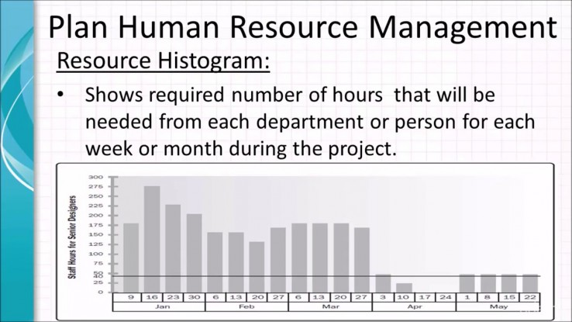
https://mcttrainingconsultant.com/wp-content/uploads/2017/02/1486197680_maxresdefault-738x415.jpg

Financial Plan
A financial plan details the funds required for each stage of the project. Total cost of labour, equipment and materials is calculated and an expense schedule is created.
The Project manager uses the financial plan to see the forecast spend vs actual spend for the project.

Quality Plan
To clearly define the quality expectations and see they can achieved so far as is reasonably practical. Quality targets for each deliverable, with a set of targets and standards to be achieved. Documents the responsibilities of team to implement quality and resources needed.
Quality Control Plan – identifies techniques to be used to achieve quality level needed.
Quality Assurance Plan – plan of activities that assure the customer that the quality targets will be met.

Communications Plan
Details how what information will be shared plus when and how it will be shared throughout the project.

Risk Management Plan
The project manager should understand the organization and stakeholder’s tolerance to risk and then evaluate and rank the risks involved in the project.

Procurement Plan
The procurement plan details the goods and services to be procured from external suppliers and the procurement schedule. It also references the tender process and the procurement process. Justification must be given to using external suppliers as opposed to internal.

4. Outline the activities performed during the Project Closure Phase. (5)

The closing phase is the final phase of the project, which focuses on delivering the final product to the customer.
A project closure report is handed to the customer and project sponsor for approval.
When all activities on the project closure report are completed, the project can be signed off and officially closed.

Other tasks included in this phase are:
- Handover of project documentation to the client and share information regarding the project close to the stakeholders eg Operations and Maintenance manual.
- Terminate supplier contracts,
- Release project resources – man power, plant & equipment
- Lessons-learned analysis is done to examine what worked and what didn’t. This information will help future projects.

The final activity for a project is an external review of the project performance. The final review will look into the following areas:

- Financial Plan – did it deliver within budget?
- Business Case – did it result in the benefits defined?
- Quality Plan – Did the deliverables meet the quality critieria?
- Project Plan – Did the project deliver within schedule set?
- Terms of reference – Did it achieve the objectives set and operate within the scope?

Student Statement:

By submitting this assignment, I confirm that this is my own work.

Student Signature | J. Cornelius | Date | 10.9.17

For Tutor / Assessor Use Only
Total Marks
Marks Obtained
Percentage / Grade

