
Assignment Cover Sheet

Student Name: | Darren Green
Student Number: | 20996
Course: | Level 4 Diploma in Risk Management
Assignment NO: | 4

Assessment 4 Total Marks: 30

- Give Short answers for the following questions: (14)

- What type of information does a business risk analysis give?

There are several key types of information provided by a risk analysis:

- What the business does, and in general terms what is its background.
- What the specific risk/s is or are, i.e. this project, or this IT system etc.
- The timescale that the above, should be managed within.

Basically, the analysis is; what are the risks of doing ‘this’, by ‘when’, and benefits the business by:

- Providing assurance that greatest risks have been identified and addressed.
- Affording an increased understanding of risks to the business.
- Presenting a mechanism for reaching consensus.
- Allowing greater support for needed controls.
- Providing improved means for communicating results.

- What are the outputs for a business risk analysis?

In very generic terms, the output, is the information that is gained, from the analysis. This information must be recorded and presented in the analysis report. All documentation must be referenced, and easily identified in case of future need.

There are many areas of risk within the business that must be included in the outputs, including:

- Product risk.
- Security risk.
- Information technology risk.
- Project risk.
- Financial statement risk.
- Fraud risk.
- Market risk.
- Credit risk.
- Customer risk.
- Supply chain risk.
- Strategic risk.
- Operational risk.
- Compliance risk.
- Internal audit risk

- Outline the constraints which could be involved in a business risk analysis.

There are three primary constraints with any business risk analysis, these can be described as:

- The risk culture of that business. Are all employees happy to part of, say, an ERM culture? Are they “all on board”? i.e. maybe they are afraid about their own potential job loss, so why fully co-operate?

Similarly, there may very well be areas within the organisation who are not really that enthusiastic? of so, they may well provide little commitment, and the information gathered is not as accurate as it should be.

- Do the resources have the appropriate amount of time to conduct the analysis? Are they trained correctly and is there an adequate budget? A ‘short cut’ from the board to get an analysis done quickly, may have resulted in a cost saving on time and resource, and a report, but how accurate is the analysis and report? How accurate is the information, that is now going to be used.

- The final constraint is the direction or brief of that analysis. If there is no clear direction (from the CRO, or board), then project timetables are not the same between areas of operation, what is to be achieved or expected is not universally known. The target and goal of the analysis between areas is different. Even, who does what, in undertaking the analysis, may not managed.

- ‘Ratio analysis’ is one of the tools of risk analysis’. How is it performed?

Ratio analysis is a form of ‘financial statement analysis’, that is used to obtain a quick indication of a firm's financial performance in several key areas.

These ratios are catergorised, for example as; short-term solvency, debt management, asset management, profitability, and market value ratios.

The business’ financial director will oversee this being performed, and the final report, presented to the board.

Another analogy is that, it is the financial analysis of a company used mainly in the planning, management and evaluation of a company’s well-being, and should provide a good understanding of a business’:

- Profitability. The return on investment made, the amount of capital over all expenditure, including taxation, that the company is making.
- Efficiency.
- Liquidity. Especially important to insurance or the banking industry
- Gearing
- Investment returns for shareholders

Ratio analysis, has the primary aim of presenting the financial ‘health’ of the company, which is turn will affect the company’s direction, determined by the board.

- How is the SWOT analysis performed for a business?

The SWOT analysis headings offer a structure for reviewing a business, or any specific issues including a strategic alternative, an opportunity for an acquisition, a possible partnership, a new product, a business proposal, or outsourcing an activity. [Brentford Open Learning College – Diploma in Risk Management 2018]

The SWOT acronym stands for:

- Strengths – What is the business is good at? i.e. delivering goods within 24 hours.
- Weaknesses – What area/s does the business need to improve? i.e. improved I.T so as customers can order more easily on-line.
- Opportunities – Where can the business grow? i.e. new warehouse in a key location is available for lease.
- Threats – What danger is the business facing? i.e. is a competitor opening a branch near to your key customer base location?, or is new legislation coming into effect?

The diagram below presents this in a clear format.

Strengths and opportunities are helpful to a business, and weaknesses and threats, harmful.

Likewise threats and opportunities are more likely to be external to the business, where as strengths and weaknesses internal.

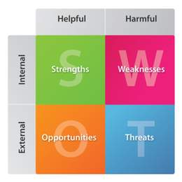

By listing, then plotting onto this chart the SWOT analysis, a clear presentation of where the business stands is made.

Areas to be listed include; market situation, general environmental issues, financial health, and the businesses portfolio of products, customers and any legislative change that may affect it.

SWOT analysis should also be regularly undertaken, as it is only a ‘snap shot’ of the business at any one time, and change is always occurring.

- “PEST analysis is a useful tool for analysing a business and, understanding market growth or decline." Discuss

A business must understand the market it operates in, and the potential for growth and decline. A PEST analysis is one way to understand this.

PEST is an acronym for the; political, economic, social and technological factors effecting that business. Therefore, for an organisation to be able to plan and prepare, it must be constantly aware of how the changes within these four factors are affecting it.

It must also be reactive quickly to changes in the macro environment, in which the business does not have any control.

Using for example, a manufacturing operation the business has in a foreign country, where a coup has recently taken place. Will this political unrest see the market decline within the industry? Perhaps, but perhaps not. Was the business aware already of the coup potential, having undertaken local market research.

If they had researched, then it is likely the business would be better prepared, and a ‘snap’ reaction, (which could potentially be incorrect), avoided. E.g. pulling all operations out of the country, when in fact the new political regime had plans to help the industry, and offer incentives for the business to develop further.

- What is the importance of a marketing plan in the risk analysis of a
business

The marketing plan is very important as it is used to identify the competitive position of the business when compared with its rivals.

A business must be able to react quickly to a competitor’s new product launch for example, and to do this an analysis of competitors must be made.

This analysis should include the following areas:

- Existing positioning or strategy.
- SWOT and PEST analysis.
- Probable strategy changes.
- Financial strength.
- Operational strength.
- Resource strength.
- Research and development strength.

Markets are however extremely complex and unpredictable. The business should not wait to see what a rival is going to do, before it reacts to it.

The words ‘anticipation’ and ‘preparation’ are used, so as any advantage gained by a competitor is only momentarily, and because of the sound marketing plan, then your business can make a counter-move and enter this new market rapidly.

- Discuss the outputs of a business risk analysis. (6)

This question was partly answered in Q1 (II) – (What are the outputs for a business risk analysis?), and as mentioned previously, the output, is the information that is gained, from all areas of risk within the business, including:

- Product risk.
- Security risk.
- Information technology risk.
- Project risk.
- Financial statement risk.
- Fraud risk.
- Market risk.
- Credit risk.
- Customer risk.
- Supply chain risk.
- Strategic risk.
- Operational risk.
- Compliance risk

Analysis Process Illustrating the Inputs, Outputs, Constraints, and Mechanisms

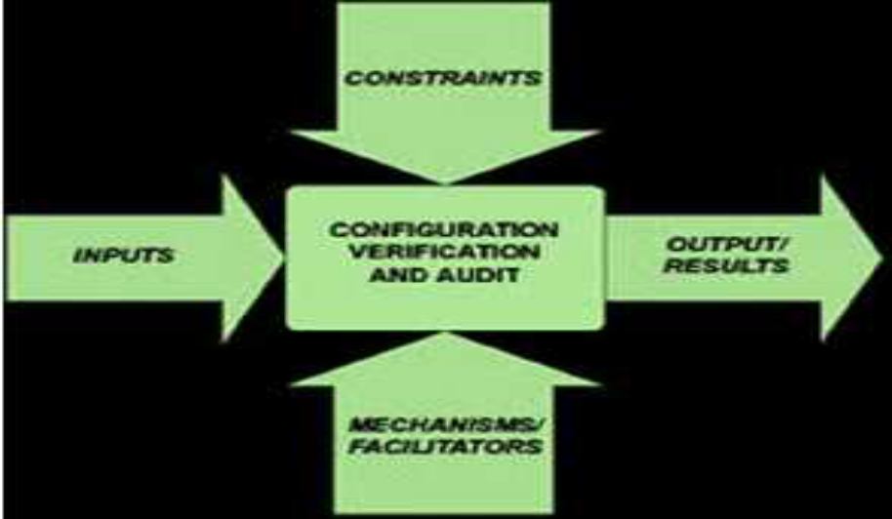

The above diagram; [Brentford Open learning College – Diploma in Risk 2018], demonstrates where the outputs of the risk analysis have come from.

The various outputs have been subjected to verification and audit, with additional mechanisms, facilitators and constraints being included. All documentation must be referenced, and easily identified in case of future need. There would have been a lot of time and effort required, so once the analysis has been completed, what are the primary outputs?

Firstly, outputs identify and provide the business with quantified information on those risks to each operational area, (as shown above), that pose the greatest risk to your organisation.
Secondly, the output will allow a critical path analysis to be undertaken using decision trees, or PERT (Programme Analysis & Review Technique). The output helps you understand which risks will have the greatest impact to your project to move factory, for example. In addition, a sensitivity analysis can be used.
Finally, accurate outputs allow for a simulation exercise to be undertaken, and this will let the business know the likelihood of meeting costs and schedule objectives etc.
The business can also use the simulation to note project performance trends. For example, if you run the simulation once per quarter and find that the probability of hitting your budget target is progressively going down, you’ll want to take some corrective action now.
Overall, the output must give a very clear recommendation/s for managing the specific risk that has been identified

Case Study

Question (10)

- How do you think that CRO has gathered this information?

It is likely the CRO has undertaken a detailed market research exercise of the country in question, using one or more independent research organisation’s that specialise in that country or region.

In addition, there are other sources of information available, including:

- The media.
- Our own governmental body reports.i.e Foreign Investment Review from the CMA (Competition and Markets Authority - GOV.UK).
- The Foreign Office.
- Our bank.
- Our company legal advisers.
- What have the business’ competitors done in this country.

- What should be the company’s approach based on this report?

Firstly, the company needs to review the business plan it has for the need that they have for wishing to enter this country, and undertake a detail risk analysis, to include particularly, a PEST analysis, but also a SWOT analysis.

Following this the company should use the following process:

Risk Analysis
↓
Risk Identification
↓
Risk Assessment
↓
Risk Evaluation
↓
Risk Planning
↓
Risk Management

The report the CRO has produced has identified a number of significant risks (as noted in blue in the above process), namely:

- The country has a bad reputation as an unpleasant business environment.
- It is rife with rumours of bribes.
- There are licensing irregularities.
- There is unwarranted government intervention.
- Organised crime and extortion is prevalent.

The risk assessment and evaluation (in green) with then catagorise each risk into a probability and impact matrix, as demonstrated below, with each risk given a score from 1 – 10 (With 10 being the greatest risk of occurrence and impact).

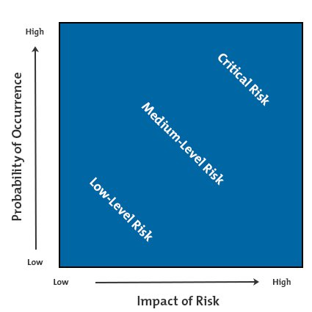

For this business, the risks identified will likely be in the upper right area, as represented by the white diamonds. This demonstrates that the risks have a high chance of occurring and have considerable impact on the company.

The risks of entering this country must be considered carefully by the board, against the opportunities and cost savings and additional profit, that the new venture will bring. However, there are too many unknowns. The country may support terrorism, the factories may be confiscated when built, there is no control over what the country’s government may do, key staff may be threatened or kidnapped, with ransoms demands and equipment may be stolen.

As a global energy company, it is likely however the risk of a loss of reputation to its customers, due to it using bribes or under-hand methods in securing contracts will greatly outweigh the financial gains.

In addition, our own government, EU or the UN etc may have sanctions in place, resulting in heavy fines and prosecution or even suspending the company’s license to trade.

Most likely these risks will be deemed too great, and the company’s approach should be to avoid this country, and find an alternative more stable environment to expand.

3. If the company goes for investing in this region, should they follow the prevailing business system, or should they continue working in their own way?

As previously said, I do not believe that the company should invest in this country, however if they did, then under no circumstances should the company follow the prevailing corrupt business system.

There are three reasons for this, touched on above:

- There could be major reputational damage, and global customers may see this organisation as underhand too, along with the practices in this country.
- Fines and sanctions may be imposed on the company, resulting in further financial loss.
- It is too insecure.

If they did invest, they should use similar models that that have done when entering other countries, albeit, more stable ones. Security too, will be a massive issue, with so much organised crime.

Student Statement:

By submitting this assignment, I confirm that this is my own work.

Student Signature | Darren Green | Date | 03/05/2018

For Tutor / Assessor Use Only
Total Marks
Marks Obtained
Percentage / Grade

