Question 1
i. What makes construction industry different from other industries?
Construction impacts the quality of life for every human being and plays an influential role in our society. There are very few professions where you can look around and actually see the difference you are making in the world. (Jackson, B. 2004). The construction industry has given the world the spectacular buildings and cities which can never be compared to the product of any other industry. The product delivered by the construction industry lasts for centuries. Therefore, it can be said that the ever growing construction industry is very different from other industries.
Another way in which construction differs from other industries is that no two projects are ever alike. The uniqueness of each project is influenced by the weather and ground conditions due to various site locations. (Introduction to Construction Management, page 3)
Within the construction industry there are a vast number of employment opportunities. Workers are given the chance to travel all around the world to work on diverse projects such as large towers, small buildings, villas etc. Not all industries give this flexibility. This opens the door to a lot of work for construction workers, in particular in countries where there is very little work.
According to (Jackson, B. 2004) The days of the individual master builder do not exist anymore. No longer is it practical to expect one person to design, engineer and build construction projects. The construction industry requires the use of its share of professionals; including civil engineers, architects, draughts men, contractors, overseers etc. All these professionals are required to work in collaboration in order to contribute their knowledge and expertise.
The construction industry also differs from other industries in terms of safety. From management to labors, there is a huge responsibility for safety as the risk of accidents are higher because of carpenter’s, steel fixers, plumbers etc. using many machines.

ii. The accident rate in construction industry is four times higher than that in any other industry. Why?

One of the most hazardous and accident – prone working environments is the construction site. On a daily basis, construction workers are exposed to site dangers that could result in injury or even death.
A typical construction project is tremendously dangerous because of the high risk of an accident occurring. The broad range of varying working conditions involving supported structures, moving equipment and labor make the site a highly unpredictable environment. Consequently, there is the need to put in place safety measures to prevent accidents from occurring. (Introduction to Construction Management, page 6)
Keeping the job safe is the obligation of everyone on the work site. That is why it is so important to constantly engage the workforce in safety and training and the implementation of the safety plan on a regular basis.
In Modern years, due to the rapidly changing conditions, larger scale projects are being built. Complex buildings with high towers require the use of more dangerous machines, resulting in workers going to a high level without a safety belt. This increases the risk of an accident occurring. Some construction site jobs like building houses, roads, workplaces and repairing and maintaining infrastructure include many risky tasks and conditions such as working with height, excavation, noise, dust, power tools and equipment. Common fatalities are caused by the fatal four: falls, struck by object, electrocutions and caught-in/between.
Here are some examples:
- A worker carrying a sheet of plywood on a flat roof stepped into a skylight opening and fell to the level below.
- A roofer, while attempting to remove a roof opening cover, fell approximately 21 feet to the concrete floor below and was killed.
- A construction worker was working from a carpenters' wall bracket scaffold without safety belt.
- A working using a cutting wilding machine without any gloves, mask or fire extinguisher.
According to the HSE government, 3% of workers sustain a work related injury each year.

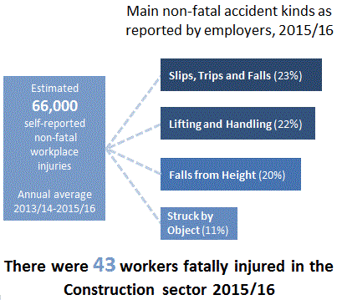

"Statistics - Construction Sector". Hse.gov.uk. N.p., 2017. Web. 17 Apr. 2017.

There are numerous construction products which are hazardous and contain various solvents and chemicals which are dangerous. Workers need to be aware of the risks coming in contact with these chemicals can cause.
Poor quality and accidents can cost the industry a lot of money and cut into the profits. This is not an ideal situation when on a deadline to completing a project.
High quality and safety standards are at the core of successful construction management. Given the complexity and unpredictability of the construction job site, some accidents are unavoidable. However, careful and adequate research needs to be conducted to determine the most effective types of safety procedure to implement on the site because losses resulting from construction accidents may be significant to the extent that they may result in bankruptcy.
In recent years, many construction companies have recognized that the establishment of good safety culture can help in controlling and reducing construction costs and increase the efficiency of their ongoing operations in long term. (Che Hassan, C.R. et al., 2007).

iii. Outline the main duties and responsibilities of the construction supervisor.
A construction supervisor is an employee who supervises the overall construction project. However, his responsibilities are not only restricted to site supervising. He is an influential person for a construction project and his responsibilities are crucial from the starting to finishing of a project. He is responsible for planning, organizing, and controlling projects; completing quality inspections; supervising sub-contractors and staff.
Construction supervisors are the lowest level of management who take instruction from the mid-level and report back to them. The responsibilities of the construction supervisor include making sure that all work meet the right quality, cost does not overrun budget due to mistakes and the work is completed on time. (Introduction to Construction Management, page 7)
Construction supervisors oversee the work of relevant employees within their company. They are also responsible for a number of managerial tasks such as employee supervision, guidance, and scheduling.
The construction manager must ensure safety standards are followed at all times and provide discipline to employees as necessary. It is essential that managers/supervisors are able to assess the work of others and coach them toward improved productivity.
Duties of Construction Supervisor
- The supervisor instructs workers on what to do
- Motivates workers to accomplish all objectives
- Encourages teamwork spirit
- Ensure workers are disciplined
- Deal with all manner of conflicts arising at the work site
- Promote a good relationship between the workers and the general public
- Ensure plans and schedules are adhered to by regular inspection and quality control
- Trains and develops the workforce to meet new challenge
(Introduction to Construction Management, page 7)

The construction supervisor and management team are critical to the success of every construction project. They are responsible for ensuring plans and specifications are adhered to. Since there is little room for costly mistakes, the supervisory team must be cautious to ensure that mistakes are detected instantly and corrected immediately.
Construction supervisors are also responsible for implementing company policies, government policies and other policies related to construction.
"Responsibilities of A Construction Supervisor". Acivilengineer.com. N.p., 2017. Web. 16 Apr. 2017.

2. Discuss some important features of the construction industry.
The organizational, physical, and operational features of projects have a considerable impact on the initiation, planning, organization, decisions, and management and consequently contribute vastly to construction project delivery success or failure.
Some of the important features of the construction industry are described below:
Complexity
The modern construction industry involves complex interactions between a vast array of resources, such as thousands, who are skilled in labour, equipment, such as, cranes, earth movers, logistics etc., all interconnected into thousands of activities. Activities may overlap at the same time or in sequential discrete steps or even randomly (Introduction to Construction Management, page 3)
Generally, project management understands the project as an ordered and simple – and thus predictable – phenomenon which can be divided into contracts, phases, activities, work pack- ages, assignments etc. to be executed more or less independently. The project is also seen as a mainly sequential, assembly-like, linear process which can be planned in any degree of detail through an adequate effort and executed in accordance with the plans. As a consequence, project management acts top down, mainly by management-as-planning as proven by Koskela and Howell (2002).
Uniqueness
One way in which construction differs from other industries is that no two projects are ever the same. In other words, each project is unique. (Introduction to Construction Management, page 3)
Each project has a different nature of work, employ different personnel, located at a different workplace and produce different type of products. These variables are sufficient to cause the existence of continuous hazard at workplace throughout project life cycle.

"Welcome To Universiti Teknologi Malaysia Institutional Repository - Universiti Teknologi Malaysia Institutional Repository". Eprints.utm.my. N.p., 2017. Web. 15 Apr. 2017.
The uniqueness of construction projects also mean that the external influences and limitations would be diverse. These can include rates of technological change, suppliers, finance, market forces, climate change and politics.
Mobility of Facilities
The industry is remarkable for the great mobility of its companies and workers, from one company to another.
Companies in the construction sector are continuing to expand their digital footprint and providing greater mobile capabilities to their operators. The inclination represents slim and lightweight devices that can perform in a range of challenging environments — from office work to strict environments.
In Focus: A Changing Technology Landscape for The Construction Industry - Area Development". Area Development. N.p., 2017. Web. 17 Apr. 2017.

One major difference between the construction and mainstream manufacturing industries is that products resulting from construction are stationary, while those, which results from manufacturing, tend to be mobile during value addition. Construction industry entails moving resources such as labour, equipment etc., from one place to the other to create products under dynamic and hazardous working conditions. Alternatively, manufacturing industries require products at various stages of product lifecycle to move from one facility to the next for value to be added. Products are standardized and easy to control unlike construction where new techniques or adaptations to existing techniques have to be developed to deal with the constantly changing working environment. (Introduction to Construction Management, page 3)

Multiplicity of Agencies
In every country, public – owned corporations and the government are very important clients of the construction industry. Government’s responsibilities, however, are far more extensive than their role as a direct purchaser of construction goods. According to Hillebrandt (1985), “government’s main concerns in managing the economy are: balancing the domestic national budget, achieving a healthy balance of payments, controlling inflation, and ensuring a reasonable level of employment.”
Many agencies are involved in construction projects, from the conception of the product through to the completion of the project. Each agency is expected to play an explicit role in the course to the project lifecycle. These agencies may include governmental agencies, land authorities, planning agencies, fire department, and Town and Country Planning Councils, etc. They carry out inspections and provide certifications for various activities on site. Their roles may change but basically, they ensure that the project complies with the laws of the land. (Introduction to Construction Management, page 3)
Organization
A construction company’s organizational structure refers to both the arrangement of job roles and the reporting and operational relationships between and within these roles.
The owner of the construction project normally advertises the project and invites tenders from future contractors to undertake the project. The contract is awarded to a successful bidder after a competitive bid process. The winning contractor then engages the services of sub-contractors on contracts to execute various planned activities within a specified time frame. Sub-contractors may also employ hundreds skilled workers. During the construction of larger - scale projects, it is common to have thousands of employees working on diverse aspects of the project site. The complexity of large scale projects means that there is the need of a great deal of organization and management of a large group of people who interact with each other in many ways to produce the final product within a limited time period. (Introduction to Construction Management, page 4)
Generally, a construction company contains basic function units including:
HR, Purchasing, Project, Engineering, Financial and Marketing department.
See below.
"Construction Company Organizational Chart – Introduction and Example". Orgcharting.com. N.p., 2017. Web. 15 Apr. 2017.
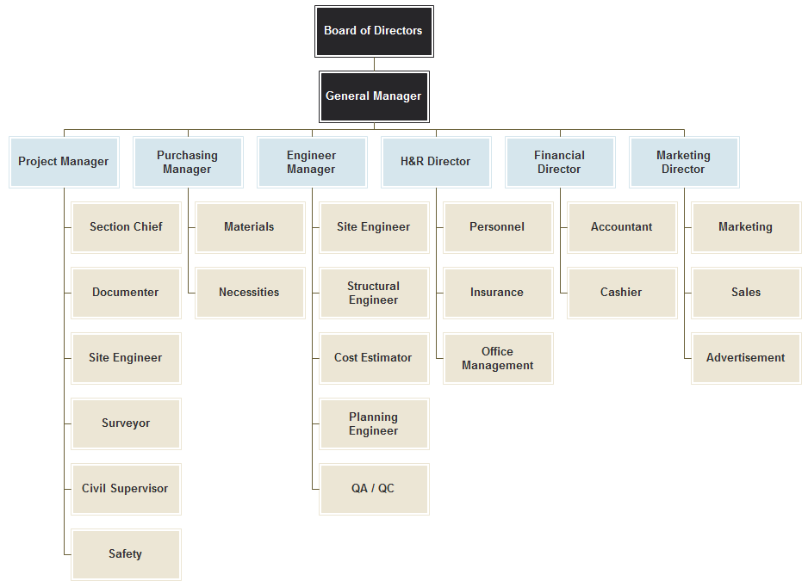

Finance
Construction financing continues to be a challenge for many contractors. The materials utilized in the construction industry: steel, iron, cement, bricks, stone, concrete, glass, and heavy equipment like cranes, concrete mixers, etc., are all costly.
Financial activities involved in construction can be classified into the following categories:
- Investments in fixed assets, such as, tools, equipment, machinery, cantering, and shuttering, etc.
- Short-term finances, such as, earnest money and security deposits to meet the cash flow requirements at construction sites
- Investment in future through education, training, research, and development of human resource and technologies
- Overheads in salaries and establishment other expenses relating to advertisement and public relations, legal expenses and other related expenses required for the project to run smoothly
Funding sources include credit facilities, loans, and securities. Most times, the construction industry experiences cash flow issues due to the blockage of security deposits, earnest money, and delayed payment of bills, among many other impediments. (Introduction to Construction Management, page 5)
Management
Construction management involves a number of different trade contractors. These trade contractors are contracted to the client but managed by a construction manager.
Since most company’s HQs are far from the project site, it becomes difficult for the management to provide direct supervision and control of activities. This makes most projects workforce free in tackling their responsibilities. Therefore, it is necessary to have available well-trained personnel who would executive their mandated activities professionally and on time to achieve satisfactorily high quality products. (Introduction to Construction Management, page 5)
Productivity
The measure of the rate at which work is performed is called “productivity”. It is a ratio of production output to what is required to produce it. The measure of productivity is defined as a total output per one unit of a total input.
In construction, the output is usually expressed in weight, length, or volume, and the input resource is usually in cost of labor or man-hours. There are several standards available in the construction industry for contractors as reference values for purposes of construction cost estimation. https://www.intergraph.com/assets/global/documents/SPC_LaborFactors_WhitePaper.pdf Accessed on : 17/4/17
The construction industry is not as productive as other industries according to several studies. Historically, productivity in the construction industry has not been as high as one would have expected given the large number of people employed in this sector. Two main reasons may account for this low productivity:
- Supply issues
- Demand issues
Supply is hampered by the immobile nature of projects and the harsh conditions prevailing during the construction process. With regards to demand issues, the demand for construction products tends to be seasonal or cyclic, making it a highly unpredictable market. The lack of adequately-trained personnel is the single most important factor for low productivity records. The availability of well-trained personnel to carry out good decisions in executing activities becomes very important to produce high quality products. Areas, such as, effective information management systems and design and equipment management are both in dire need of high quality personnel. Better productivity can be achieved through systematic planning and management of all aspects of construction projects using highly trained human resource at all levels as well as the best available techniques and equipment to produce quality product at lower cost and shorter durations. (Introduction to Construction Management, page 5)
Because of the diversity of the construction industry, a single index for the entire industry is neither meaningful nor reliable. Productivity guides may be developed for major segments of the construction industry nationwide if reliable statistical data can be obtained for separate industrial segments.
Job-site productivity is influenced by many factors which can be characterized either as labor characteristics, project work conditions or as non-productive activities. The labor characteristics include:
- age, skill and experience of workforce
- leadership and motivation of workforce
The project work conditions include among other factors:
- Job size and complexity.
- Job site accessibility.
- Labor availability.
- Equipment utilization.
- Contractual agreements.
- Local climate.
Local cultural characteristics, particularly in foreign operations.
http://pmbook.ce.cmu.edu/04_Labor,_Material,_And_Equipment_Utilization.html#4.2%20Labor%20Productivity (Accessed on 14/4/17)
Labour Quality
Labour for construction work mostly depends upon the location of the project site. This means that the local workforce is normally employed to carry out various aspects of the construction. The quality of the labour employed will determine the quality of the final product. Workers may improve on their skills through on-the-job learning by trial and error or by imitation. (Introduction to Construction Management, page 5)
Quality control and safety are increasingly important concerns for project managers. Failures in constructed facilities can result in huge costs. Even with minor defects, re-construction may be required and facility operations impaired. Increased costs and delays are the result. Accidents during the construction process can result in personal injuries and large costs. Good project managers try to ensure that the job is done right the first time and that no major accidents occur on the project. http://pmbook.ce.cmu.edu/04_Labor,_Material,_And_Equipment_Utilization.html#4.2%20Labor%20Productivity (Accessed on 14/4/17)
The quality of labour force and its structure is also the matter of concern in the context of productivity measurement as it impacts the compositional changes on productivity.
Safety Hazards
Careful and adequate research needs to be conducted to determine the most effective types of safety procedure to implement on the site because losses resulting from construction accidents may be significant to the extent that they may even wipe out profits. (Introduction to Construction Management, page 6)

Accident fatality rates in the construction industry are double that of the sector average, with rates of minor accidents almost incalculably more.
The risks associated with working at height are often enlarged by added access and mobility restrictions. Training, including safety awareness training, is crucial for employees required to work at height.
http://blog.papertrail.io/construction-safety-risks/#.WPTor2VMIyk
Accessed 15 / 4 /17

3. How has the growth in technology affected the construction industry?
Construction companies have been advancing in technology in recent years by taking on new processes and purchasing state-of-the-art machinery. This has aided workers to increase efficiency, shorten the duration of projects and ultimately increase profit. For workers, these construction technology advances are bringing opportunities to acquire new skills, develop their knowledge and progress in their career.
These advancements in modern construction methodologies and techniques, as well as, the emergence of more productive equipment means that industry players must remain on their toes to keep up with the latest construction technology. In order to remain relevant, companies must adopt fresh approaches to managing and building projects. Growth in technology means that there are new and better materials to use, newer techniques of accomplishing tasks at lower costs and better time management skills, and newer equipment for more productive work, etc. (Introduction to Construction Management, page 2)
The increased use of the smart phones and aerial drones are some examples that show the construction industry is exploding into new realms with the technology of today. Drones are becoming very popular in construction sector, changing the way that much of the industry works. This is a change which will continue to have lasting effects as the technology looks to improve efficiency, eliminate human errors and improve health and safety.
We can’t mention technological growth without referencing the the Internet. Without a shadow of doubt, it has It has changed how the industry designs, builds, and monitors innovative construction projects. https://www.whirlwindsteel.com/blog/bid/374309/How-Has-New-Technology-Transformed-the-Construction-Industry
Accessed: 17/4/16
Blueprint Apps are very common now nowadays. This means there are less offices on site overflowing with documents as the industry is becoming more technologically advanced.

https://www.thatcherassociates.com/blog?title=How%20Technology%20is%20Changing%20the%20Construction%20Industry Accessed on : 17/4/17
The Construction and Property Services Industry Skills Council (CPSISC) for their report ‘Future forecasts: Construction and Property Services Skills 2016–26’found that an increase in new technologies, for example 3D and pre-fabrication may require a shift in the skills and training, as well as a change in the attitudes of consumers and builders.
The Construction 2020 Vision Report of 2004 identified that in 5 -15 years’ time (2009-2019) a wide range of products will probably be manufactured off-site and assembled on-site. This change is predicted to result in better quality control, improved site processes including Occupation Health and Safety, be environmentally friendly and may reduce costs. The research also identified that the industry was not developing adequate skills for the future.

