
Assignment Cover Sheet

Student Name: | Paul Mitchell
Student Number: | 32628
Course: | Advanced Diploma in Logistics Management (Level 5)
Assignment NO: | ASSESSMENT # 11

Marking Criteria:
We expect the learners to write minimum one well expressed point in three lines against each allocated mark. This means one needs to write 15 lines with 5 well expressed points to get high grades for a 5 marks question.
For high grades use examples and illustrations where appropriate.
ASSESSMENT # 11
- The use of technology in a supply chain is extremely helpful to ensure that every link
in the chain is constantly monitored and checked to ensure that a smooth flow of
products come in and out of an organisation.
Any problems that occur within the supply chain such as held up deliveries will be immediately be flagged for all concerned parties to see and any necessary action can be sanctioned immediately.
The complete supply chain from product tracking in and out, inventory control including procurement, all goods documentation ( picking notes, delivery notes) will follow a product through the supply chain, inward and outward transport arrangements can be tied in with your technology and be instantly arranged. Invoices and accounts can follow products through the chain and be raised in accordance most payments are now done by technology using bacs.. The technology overlooking all these processes simplifies and ensures everything happens when it should happen and will make the whole chain totally transparent.
Technology in marketing can ensure that sales forcasting is accurate to help keep inventory levels in line with sales. Market research and customer satisfaction are also monitored by technology With a click of a mouse the whole supply chain can be monitored or repaired. Simulations can be run to confirm any changes in the supply chain will be effective and cost effective.
ii. Business intelligence system (BI)
These systems gather, store and examine data. BI software tools assist in the study
Of this data and display the results as real time data. This ensures that an
Organisation are continually up to date with any events as they occur. And give
And give an understanding to what they signify and why.
Some of the functions are DATA MINING ( turning raw data into useful
Information) , PROCESS ANALYSIS ( looking at all processes involved)
PREFORMANCE/BENCHMARKING ,DESCRIPTIVE ANALYTICS( historical
Data). PREDICTIVE and PRESCRIPTIVE ANALYTICS ( former predicts
future outcomes latter draws up recommendations). (Nicole Fallon December
17th 2015).

PAGE 1

The results of BI systems can be available on a simple spread sheet or more
complex charts and graphs. Giving the organisation a detailed insight into its
business processes and the state the organisation is in.
See figure 1 and 1a for BI features figure 1c BI

FIGURE 1
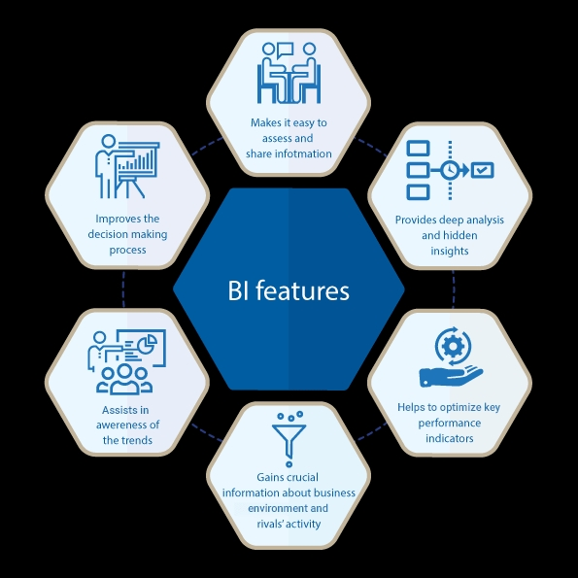

PAGE 2

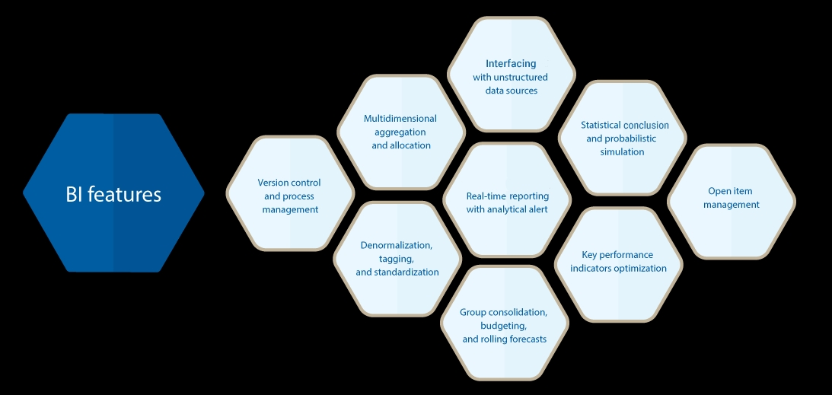
Figure 1a

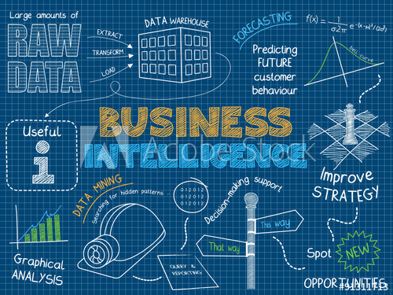
Figure 1c
Image source (Galaktikasoft Feb 2018)

Image source ( Treenabeena August 2020)

PAGE 3
iii. ENTERPRISE RESOURCE PLANNING (ERP).
Is a system Of integrated software applications that collect data across numerous functions within an organisation. It streamlines all integrated business processes from finance, human resources,procurment (inventory) and distribution and links up every department within an organisation. This gives a process orientated sight right across all functional departments within an organisation. See figure 2.
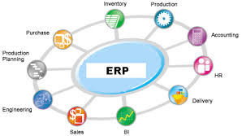
Image source ( AssignmentPoint.com 2020.)
iv. INVENTORY MANAGEMENT SYSTEMS (support)
These technological systems support all the activities in inventory management,
They monitor inventory levels(locations, quality etc.) and calculate economic order
quantities by tracking historical demand patterns of products to ensure inventory
levels are kept in line with the demands of a product.
They also monitor and ensure correct levels of safety inventory are kept,
Ensuring they are replenished as they are used.
PAGE 4

These systems ensure,
the correct balance of inventory are kept for an organisation they look at the costs
These systems ensure the correct balance of inventory are kept for an organisation
they look at the costs of carrying inventory and the costs of running out
of inventory causing lost sales revenue.
Finely balancing this equation to ensure inventory levels and costs are
perfectly balanced. These systems can all be linked so replenishing stock is done
automatically. These systems work in line with suppliers ensuring that the most
economic order quantities are made and meet suppliers minimum order levels.
. They can work with reverse logistics altering inventory levels of
Retuned stock and arranging collection of damaged or faulty products for return
To suppliers. Overall inventory costs can be displayed enabling an organisation
determine whether the costs of holding stock are effecting the cash flow of an
organisation.
v. WAREHOUSE MANAGEMENT SYSTEMS (WMS)
This technology and it systems are designed to sustain all daily operations in a
Warehouse. They facilitate the management for daily planning of staffing,
Inventory (levels and product locations). They control the utilization of all the
Warehouse resources for the daily workload. They maintain all the actions
required to move pick, pack and load customer orders ready for shipment.

PAGE 5
See figures 3 and 3a for Warehouse management systems.

Figure 3
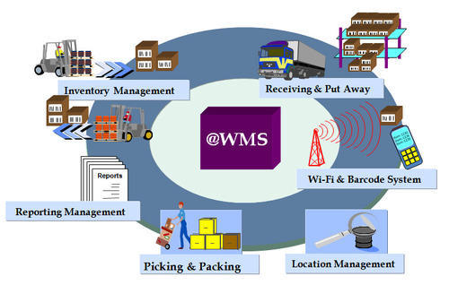

Image source (indiaMART August 2020)

PAGE 6

Figure 3a
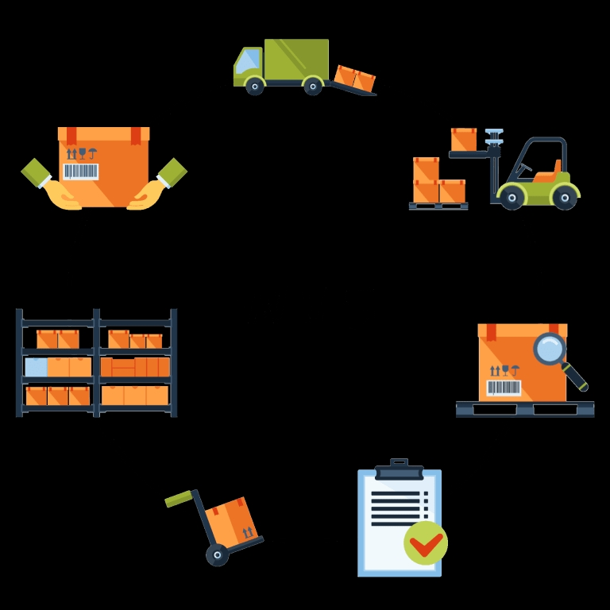
Image source (SCLsistemas August 2020)

vi. BUSINESS PROCESS MANAGEMENT ( BPM)
This is the use of a systematic approach to the steps taken to deliver a product or
service. The use of this technology in an organisation is to give anyone that is
accountable in this process the ability to see every thing that is happening in this
process at the time it is happening so they can react to any problems at the time

PAGE 7
they are happening and recover the organisations profitability. The uses of BPM are
to improve AGILITY (response to problems or obstacles), PRODUCTIVITY,
EFFICENCY, COMPLIANCE and TRANCEPARANCEY ( of the chain), RISK
REDUCTION, BOTH EMPLOYEE AND CUSTOMER SATISFACTION (FOCUS),
CONSITANCEY,MEASURABILITY AND SUSTAINABILITY of an organisation.
See figure 4

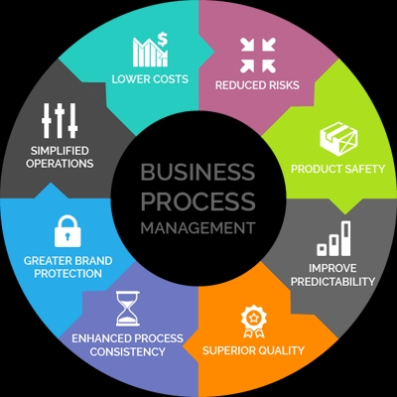
BUSINESS PROCESS MANAGEMENT Figure 4
Image source (SkyTechNG) 2020

PAGE 8

BENEFITS OF E BUSINESS INTERGRATION
E business is emerging as a key asset to supply chain integration, Organisations can use the internet to gain visibility across their entire network of inward and outward goods.
Trading over the internet has enabled organisations to respond quickly to consumer demands and trends. Now organisations can compete and reach a global market at the click of a mouse.
Communication is much simpilar over the internet with no need for lots of paperwork. By using the latest barcode, scanning devices all products can be followed throughout the supply chain. Taxes or import duties can be paid at source enabling imported goods to have a quicker journey time.
E business can save money with the ability to reduce warehouse and storage space, large companies that hold or have production cycles can use cross docking to reduce the space needed to hold stock. Smaller companies can trade over the internet with virtual shops and showrooms elevating the need for shops and storage space. Consumers can order goods and delivery via your website this being linked to your supplier goods are put in a virtual cart ready for delivery and can be tracked and traced throughout there journey. Your office can be anywhere.
Marketing of goods and products is cheaper with E business and organisations have more control over marketing by not having to use marketing agencies.
E business enables consumers to shop or order goods 24/7 365 days a year. They don’t have to wait for stores and organisations to open for business. The use of the internet opens more avenues for organisations to make money by giving them a wider and potentially global market to trade in. With everything linked up electronically everything is visible to organisations and consumers. There is less human involvement reducing the likelihood of human error.
There are four main types of E business
BUSINESS TO BUSINESS (B2B) All types of computer enabled inter organisational trade.
BUSINESS TO CONSUMER (B2C) Selling direct to consumers via websites.
PEER TO PEER (P2P) Mobile commerce interconnected computers for downloading of documents information and files.

PAGE 9
CONSUMER TO CONSUMER (C2C) Helping consumers sell to each other via your websites ( e.g. E-BAY).

The integration of E business and the supply chain according to professors Lee and Wang and also Stanford Global Supply Chain Management forum (SGSCFM-W2-2001) (November 2001) there are 4 dimensions to integration.

IMFORMATION INTERGRATION – Sharing all applicable information between al, companies electronically within the supply chain (sales history and demand forcasting, inventory status, production capacity and scheduling, sales promotions and transport scheduling).

PLANNING SYNCHRONIZATION – The combined contributions of all companies in the supply chain for all ( demand forcasting, inventory replenishment scheduling, design and development of products, and involvement bringing any new products to the market).

WORK FLOW CO ORDERNATION – The subsequent step after planning synchronisation . Streamlining and computerization of all business activities across all companies in the supply chain ( purchasing and product design).

NEW BUSINESS MODELS- A consequence of supply chain integration that has been made promising by the internet. The rolls of all the companies in the supply chain can be redesigned so that every company can focus on its core activities .All non core activities are able to be outsourced. Now new effectiveness and capabilities can become possible.
SEE DIAGRAM FOR INTERGRATION DIMENSIONS

PAGE 10
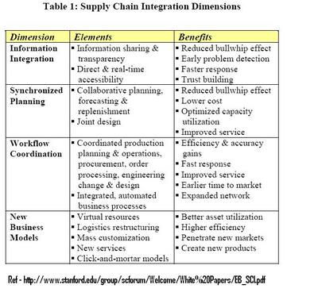
Diagram source (SGSMF-W2-2001 November 2001)
The conclusion E business is a powerful and compelling enabler of supply chain integration enabling electronic connections with all companies within the supply chain. All being able to share and exchange all product information on all levels. This leads to a new level of co-operation and a far superior business efficiency and receptiveness..

PAGE 11

Student Statement:

By submitting this assignment, I confirm that this is my own work.

Student Signature |  | Date

For Tutor / Assessor Use Only
Total Marks
Marks Obtained
Percentage / Grade

