
Assignment Cover Sheet

Student Name: | Joanne Kerr
Student Number: | 8937
Course: | Diploma in Interior Design Level 4
Assignment NO: | 9

Marking Criteria:
We expect the learners to write minimum one well expressed point in three lines against each allocated mark. This means one needs to write 15 lines with 5 well expressed points to get high grades for a 5 marks question.
For high grades use examples and illustrations where appropriate.
Q.1 Short Questions:

i. “Being the boss is fun. It is also risky and a lot of hard work”. Explain.

Owning your own company (Interior Design or otherwise) means taking a step into the unknown. As an employee of a company everything is broadly known – what is expected of you (role, responsibilities) and what you will receive in return (wages, career growth). As the boss of a company there are some ‘knowns’ (tax, legal liabilities etc.) but you have much greater freedom to develop your business in a way that matters to you personally and to your customers/prospects. There isn’t anyone ‘expecting’ you to do anything – success or failure is going to come down to you. The business could grow and expand exponentially or it could wither in its first year. Passion to achieve your own business dreams are crucial.

When you are the boss, the buck stops (or expands) with you. I know many freelance/self-employed individuals and what always strikes me is how hard they work – but with a smile on their faces. To some of them it doesn’t feel like ‘work’ as they are simply pursuing the lifestyle that they have designed for themselves and I personally think this is why ‘being the boss’ is pretty appealing.

ii. Briefly describe three main advantages of owning an Interior design business.

Firstly, I think it’s about being able to set the direction of your business. You have complete ownership (within financial constraints) to determine your strategy and make the decisions necessary to pursue this strategy. You have no boss or board to answer to – it’s up to you.
Secondly, income isn’t constrained by ‘salary’. How much you could earn, comes down to your strategy, how hard you work and how well your clients respond to your creatively and professionalism (and recommend you afterwards).
Thirdly, you have the freedom to pursue exactly which is aspect of design you want to focus on, embracing what you are best at and seeking contracts that play naturally to this area of focus/strength.

Being a business owner feels ‘expansive’, rather than constrained. The ‘world is your oyster’ phrase describes it well. No one is going to hold you back, but that also means no one is going to push you forward, therefore being self-motivated and self-reliant is crucial.

iv. “An interior designer has to be versatile and should be able to change with time.” Why

Design doesn’t stand still! Nor do cultural trends. Twenty years ago most people didn’t know what ‘sustainability’ meant, let alone sustainable design. This is just one example of how Interior Designers have had to adapt and build their knowledge. People’s lives are evolving and therefore so will the design solutions that are expected from a good designer. We also now live in an era of Instagram and Facebook – people have a greater exposure to Interior Designs and therefore an idea of what trends are out there. As an Interior Designer it is essential to stay current and be inspired by new ideas all the time. I personally am seeing a shift and desire culturally for ‘living small / simple’ and am trying to absorb lots of knowledge about design for small spaces to get ahead of what people are looking for – not something big yet in the UK but thanks to the Internet I can gain a lot of knowledge for the US who appear to be ahead in this area.

v. Why it is essential for a designer to possess skills for negotiation?
Negotiation is an essential skill in business generally – I think more so in industries that have ‘subjective’ aspect like design, art, advertising etc. The dictionary definition is ‘discussion aimed at reaching an agreement’ and I completely agree. Real and productive negotiation is about ensuring both parties are happy with the outcome. Whether that be regarding costs on the project, timings or finding solutions to challenging problems and they arrive during delivery. Being professional and calm at all times in negotiation is crucial – clearly stating what you need, and listening to the needs of the other party. I also think the skill of persuasion goes hand in hand with negotiation and I can see this being a key requirement for an Interior Designer. Being able to clearly persuade a supplier to stay that extra hour when need be, or to explain to a client if there has been a mix-up with deliveries are all crucial moments where the Interior Designer can be persuasive, negotiate fairly – and ultimately enhance a relationship or damage it.

Q.2. What is a portfolio? How important it is for an interior designer?

A portfolio is crucial for an Interior Designer as it provides a document of the projects they have undertaken and gives a prospective client an easy way to understand the type of work they have undertaken and the style and scale of projects that they have worked on.

It’s essentially provides a visual resume of the Interior Designer’s capabilities.

I am in the very early stages of building a portfolio for myself. The following examples are a couple of pages from a case study I developed as I re-designed my own flat. This is currently in PDF booklet format and includes before and after pictures, layout re-designs, and detailed information on the work that was carried out, along with costs and timings.
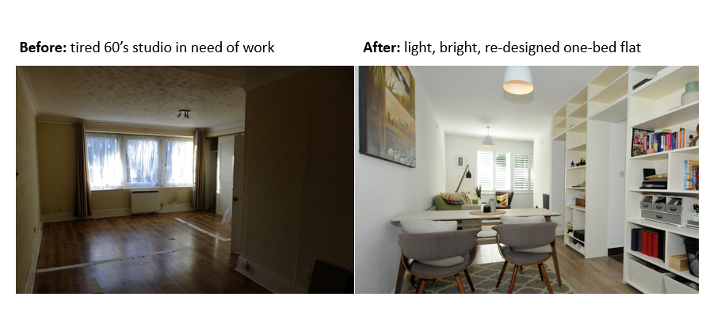
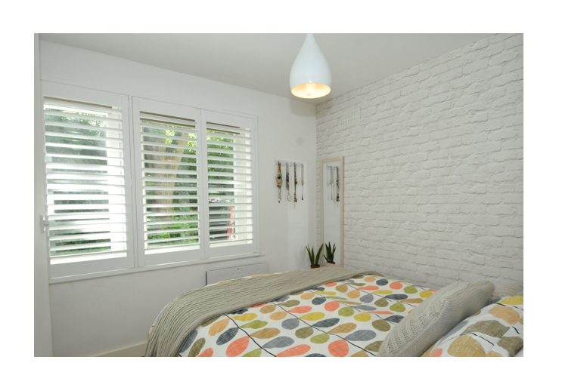

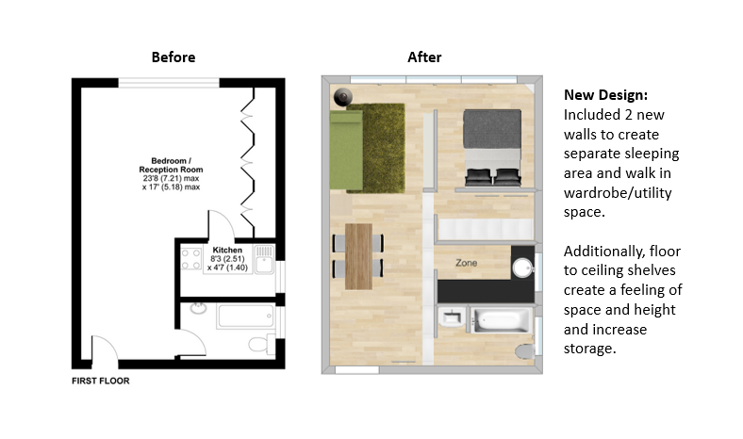
Whilst traditionally, portfolios have been physical documents that clients could look through, technology has created new ways to showcase work. I think it is crucial for Interior Designers to look professional, ideally having a website with examples of work that has been undertaken, supported by client testimonials and reviews.

I also see social media channels such as Instagram and Facebook playing a crucial role in building an Interior Designers profile and a great visual way to demonstrate ideas and capabilities. I have an Instagram account – even though I am not yet pursuing a career in Interior Design. I am using it as a way to be inspired, showcase some of the work I do get involved in (voluntary projects for friends, mainly) and to build a bit of a following in the hope that if/when I follow this dream I may already have some prospect clients!!

Student Statement:

By submitting this assignment, I confirm that this is my own work.

Student Signature | Joanne Kerr | Date | 8 April 2018

For Tutor / Assessor Use Only
Total Marks
Marks Obtained
Percentage / Grade

