

Assignment Cover Sheet

Student Name: | Antonio Javier Vazquez Gavides
Student Number: | 14674
Course: | Diploma in Construction Management
Assignment NO: | 13

Marking Criteria:
We expect the learners to write minimum one well expressed point in three lines against each allocated mark. This means one needs to write 15 lines with 5 well expressed points to get high grades for a 5 marks question.
For high grades use examples and illustrations where appropriate.
1. Answer the following questions: (24)
i. How would you define a contract?

A contract is a legally enforceable agreement between two or more parties. It may be oral or written. A contract is essentially a set of promises. Typically, each party promises to do something for the other in exchange for a benefit that creates a legal duty or responsibility. Is enforceable by law as a binding legal agreement. Contract law recognises and governs the rights and duties arising from agreements

Within jurisdictions of the civil law tradition, contract law is a branch of the law of obligations.

ii. What are the essential elements of a contract?
To constitute a legal contract, an agreement must have all of the following 5 characteristics:

Legal purpose A contract must have a legal purpose to be enforceable. For example, Steve hires Paul to kill Susan. Steve drafts an agreement outlining Paul's responsibilities, namely to acquire a gun and shoot Susan in the head. The agreement also specifies the amount Steve will pay Paul once Susan is dead. A contract of murder for hire is illegal. If Paul fails to fulfill his obligations under the agreement, Steve will have no recourse against Paul. The agreement Steve has drafted is unenforceable.

Mutual Agreement All parties to the contract must have reached a "meeting of the minds." That is, one party must have extended an offer to which the other parties have agreed. For example, Jim signs a contract with Tom's Tree Trimming. The contract outlines the scope of the work Tom will perform on Jim's property. Jim and Tom have a mutual agreement regarding the work that will be done.
Consideration Each party to the contract must agree to give up something of value in exchange for a benefit. For example, you hire an independent contractor to repave your driveway. You and the paving contractor sign an agreement in which you promise to pay a sum of money in exchange for the paving work. Both you and the contractor have agreed to give up something of value. You have agreed to pay money, and the contractor has agreed to perform the paving work.
Competent Parties The parties to a contract must be competent. That is, they must be of sound mind, of legal age, and unencumbered by drugs or alcohol. If you enter into a contract with a minor or an insane person, the contract will not be enforced.
Genuine Assent All parties must engage in the agreement freely. A contract may not be enforced if mistakes have been made by one or more parties. Likewise, a contract may be voided if one party has committed fraud or exerted undue influence over another. For example, you sign a contract in which you agree to sell your house to your next-door neighbor for $1. When you signed the contract, your neighbor was pointing a gun at your head. Clearly, you made the agreement under duress, so the contract is not valid.

Some types of contracts must be in writing. An example is a contract in which you agree to sell your property to someone else. Real estate sales contracts must be written in order to be enforceable.

Bilateral or Unilateral
Most contracts are bilateral. This means that each party has made a promise to the other. When Jim signed the contract with Tom's Tree Trimming, he promised to pay the contractor a specified sum of money once the job was completed. Tom, in turn, made a promise to Jim to complete the work described in the agreement.

In a unilateral contract, one party makes a promise in exchange for an act by the other party. Insurance policies are unilateral contracts. When you buy liability insurance or any other type of policy, you pay a premium (an act) in exchange for the insurer's promise to pay future claims.

iii. What are lump sum contracts?

A contract under which a principal (customer or owner) agrees to pay a contractor a specified amount for completing work without requiring a cost breakdown.
A lump sum contract (or stipulated sum contract) is the traditional means of procuring construction, and still the most common form of construction contract. Under a lump sum contract, a single ‘lump sum’ price for all the works is agreed before the works begin .It is a fixed price contract where contractors undertake to be responsible for executing the complete contract work for a stated total sum of money.
This is generally appropriate where the project is well defined, when tenders are sought, and significant changes to requirements are unlikely. This means that the contractor is able to accurately price the works they are being asked to carry out.

A lump-sum contract is normally used in the construction industry to reduce design and contract administration costs. It is called a lump-sum because the contractor is required to submit a total and global price instead of bidding on individual items. A lump-sum contract is the most recognized agreement form on simple and small projects and projects with a well-defined scope or construction projects where the risk of different site conditions is minimal. Lump-sum contracts are a great tool for smaller jobs and quite simple projects. However, lump-sum contracts could eventually produce large dispute and claims that will arise from contract documents

Lump sum contracts apportion more risk to the contractor than some other forms of contract, as there are fewer mechanisms to allow them to vary their price, and they give the client some certainty about the likely cost of the works. The tender process will tend to be slower than for other forms of contract and preparing a tender may be more expensive for the contractor.

However, a lump sum contract does not give all the project risk to the contractor, and it is not a fixed price, or even a guaranteed maximum price. The price of a lump sum contract can change.

Where is a lump sum unsuitable?

Lump sum contract is unsuitable for the following:
- When dealing with difficult foundation works.
- Works which are difficult to estimate due to the difficult conditions of the soil structure of the site. E.g. excavation involving rocks.
- When alterations or additions have to be included in the work
- When extreme weather conditions exist at the site.

What are the advantages and disadvantages of a lump sum contract?

Lump-Sum Contract Advantages

A lump-sum contract offers the following advantages:
Low risk to the owner.
'Fixed' construction cost.
Minimize change orders.
Owner supervision is reduced when compared to Time and Material Contract.
The contractor will try to complete the project faster.
Accepted widely as a contracting method.
Bidding analysis and selection process is relatively easy.
The contractor will maximize its production and performance.

Lump-Sum Contract Disadvantages

Although lump-sum contracts are the standard and preferred option for all contractors, it might also have some limitations:

It presents the highest risk to the contractor.

Changes are difficult to quantify.
The Owner might reject change order requests.
The project needs to be designed completely before the commencement of activities.
The construction progress could take longer than other contracting alternatives.
The contractor will select its own means and methods.
Higher contract prices that could cover unforeseen conditions.

iv. What is a cost plus percentage of cost contract?

A method of payment to a contractor in which an additional amount of money, expressed as a percentage, is paid by the client that is designated to cover the contractor's overhead costs. When paid as a predetermined profit, the client will usually require a strict accounting of expenses.

Cost plus percentage contracts are used when doing custom work or work that changes and therefore has costs that can't be easily estimated e.g. An outdoor kitchen contractor, offer a range of services. For example a basic barbecue cleaning service for a fixed price of $95 plus the cost of any parts he need to replace.

For custom built outdoor kitchens though, the customer may want a particular shaped counter with particular materials, and other very specific requests. For this, he don't charge a fixed price.

Instead, he use a cost plus percentage contract. This covers his cost of materials and the added percentage covers the overhead like the insurance or any clerical help it takes him to build the kitchen.

He use a cost plus percentage contract because he won't know just how much his final bill will be until all the custom work is done. His customer might very well add in a detail here and there during the building process. This cost is then added to the final bill.

v. How would you select the type of contract for a piece of construction work?

The following are some factors to consider when selecting the type of contract:

- The uncertainty of the scope of work needed
- The party assuming the risk of unexpected cost increases
- The importance of meeting the scheduled milestone dates
- The need for predictable project costs
There are several types of contracting approaches and each supports different project environments and project approaches.

vi. What are insurance contracts?

An insurance contract is a document representing the agreement between an insurance company and the insured as well as the specific conditions of coverage and the policy term and cost.. Central to any insurance contract is the insuring agreement, which specifies the risks that are covered, the limits of the policy, and the term of the policy. Additionally, all insurance contracts specify:

- conditions, which are requirements of the insured, such as paying the premium or reporting a loss;
- limitations, which specify the limits of the policy, such as the maximum amount that the insurance company will pay;
- exclusions, which specify what is not covered by the contract.
- indemnification.
Obviously, the contents of an insurance contract depends on the type of policy, what the insurance applicant wants, and how much he is willing to pay. The details of insurance policies are covered in Standard Insurance Policies. This article covers what is required of valid insurance contracts, since only valid contracts are legally enforceable.

There are 4 requirements for any valid contract, including insurance contracts:

- Offer and acceptance,
- Consideration,
- Competent parties, and
- Legal purpose.

Insurance contracts have an additional requirement that they be in legal form. Insurance contracts are regulated by state law, so insurance contracts must comply with these requirements. The state may stipulate that only certain forms may be used for certain types of insurance or that the contract must have certain provisions. Additionally, contracts must be approved by the state insurance department before they can be used, to ensure that they comply with regulations.

2. "A particular type of contract is normally suitable for a particular situation." Comment and describe with suitable examples

Lump Sum Contract
With this kind of contract the engineer and/or contractor agrees to do the a described and specified project for a fixed price. Also named "Fixed Fee Contract". Often used in engineering contracts.

A Fixed Fee or Lump Sum Contract is suitable if the scope and schedule of the project are sufficiently defined to allow the consulting engineer to estimate project costs.

Unit Price Contract
This kind of contract is based on estimated quantities of items included in the project and their unit prices. The final price of the project is dependent on the quantities needed to carry out the work.

In general this contract is only suitable for construction and supplier projects where the different types of items, but not their numbers, can be accurately identified in the contract documents.

It is not unusual to combine a Unit Price Contract for parts of the project with a Lump Sum Contract or other types of contracts.

Cost Plus Contract
A contract agreement wherein the purchaser agrees to pay the cost of all labor and materials plus an amount for contractor overhead and profit (usually as a percentage of the labor and material cost). The contracts may be specified as

- Cost + Fixed Percentage Contract
- Cost + Fixed Fee Contract
- Cost + Fixed Fee with Guaranteed Maximum Price Contract
- Cost + Fixed Fee with Bonus Contract
- Cost + Fixed Fee with Guaranteed Maximum Price and Bonus Contract
- Cost + Fixed Fee with Agreement for Sharing Any Cost Savings Contract
This types of contracts are favored where the scope of the work is indeterminate or highly uncertain and the kinds of labor, material and equipment needed are also uncertain. Under this arrangement complete records of all time and materials spent by the contractor on the work must be maintained.

Table of Fixed Price Contracts and Characteristics

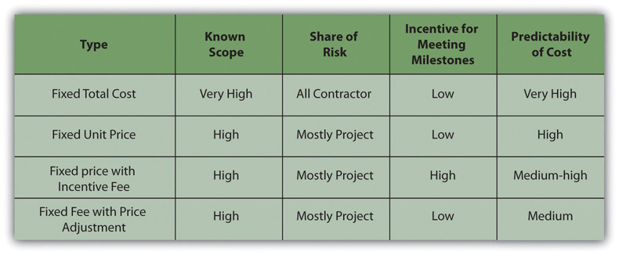

Table of Contract Types and Characteristics
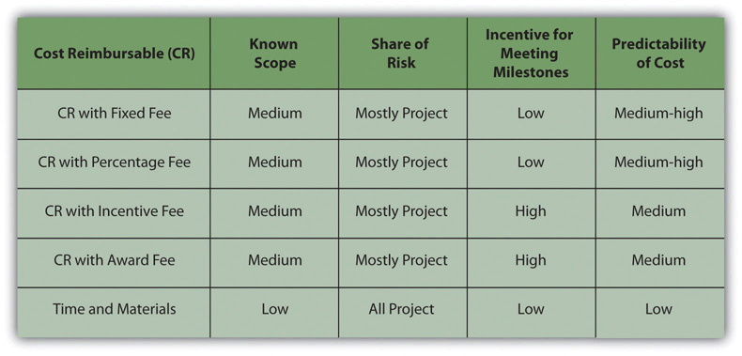

Contracts types and Aplications

Contract Type | Description | Applications
Firm Fixed Price (FFP) Contracts | Provides supplies or services for a specific price not subject to any adjustment on the basis of the contractor’s incurred costs. This contract type imposes minimum administrative burden. | Generally favored because the contractor assumes the risk of increase performance costs. Used for acquiring supplies and services with reasonably definite specifications, and reasonable prices can be established at the outset.
Cost Reimbursement Contracts | Provides for payment of allowable incurred costs, to the extent prescribed in the contract. These contracts establish an estimate of total cost for the purpose of obligating funds and establishing a ceiling that the contractor may not exceed (except at its own risk) without the approval of the contracting officer. This places cost risk on the government. | Used only when circumstances do not allow the agency to define its requirements sufficiently to allow for a fixed-price type contract, OR uncertainties involved in contract performance do not permit costs to be estimated with sufficient accuracy to use any type of fixed-price contract.
Cost Contracts (subtype of Cost Reimbursement Contract) | A Cost contract reimburses allowable costs up to the specified total awarded amount of the contract in which the contractor receives no fee or profit. | Used for research and development work, particularly with nonprofit educational institutions or other nonprofit organizations.
Cost Plus Fixed Fee Contracts  (subtype of Cost Reimbursement Contract) | Provides payment to the contractor for a negotiated fee (profit) that is fixed at the inception of the contract. The fixed fee does not vary with actual cost, but may be adjusted as a result of changes in the work to be performed. This permits contracting for efforts that might otherwise present too great a risk to contractors, but provides the contractor only a minimum incentive to control costs. | Same as stated for Cost Reimbursement contracts AND for example when the contract is for the performance of research or preliminary/ exploration study, and the level of effort required is unknown.
Time and Materials Contracts | Acquires supplies or services on the basis of:  - Direct labor hours at specified fixed hourly rates that include wages, overhead, general expenses, and profit  - Actual cost for materials including:  - Direct Materials  - Subcontracts for supplies and incidental services for which there is not a labor category specified in the contract;  - Other direct costs (travel, computer usage etc.)  - Applicable indirect costs. Material handling costs shall include only costs clearly excluded from the labor-hour rate. | Used only when it is not possible at the time of placing the contract to estimate the extent or duration of the work or to anticipate costs with any reasonable degree of confidence. Used only when the contracting officer determines that no other contract type is suitable. When acquiring commercial services, a time-and-materials or labor hours contract may be used only when the award of the contract or order is made using competitive procedures.
Labor Hour Contracts | A variation of the Time and Materials contract type, differing only in that materials are not supplied by the contractor. | Used only when it is not possible at the time of placing the contract to estimate the extent or duration of the work or to anticipate costs with any reasonable degree of confidence. Used only when the contracting officer determines that no other contract type is suitable. When acquiring commercial services, a time-and-materials or labor hours contract may be used only when the award of the contract or order is made using competitive procedures.
Indefinite-Delivery, Indefinite-Quantity | Acquires supplies or services but does not specify a firm quantity that will be issued and delivered during the period of the contract (as delivery orders or task orders). The basic contract specifies the contract types authorized (e.g. Cost Reimbursement or Firm Fixed Price) and each task order will identify the specific contract type utilized. | Used when the Government cannot predetermine, above a specified minimum, the precise quantities of supplies or services the Government will require during the contract period and it is inadvisable for the Government to commit itself for more than a minimum quantity. Used when a recurring need is anticipated. There are three types of indefinite-delivery contracts: definite quantity, indefinite quantity, andrequirements contracts.

Student Statement:

By submitting this assignment, I confirm that this is my own work.

Student Signature | Antonio Javier Vazquez Gavides | Date | 15/04/2018

For Tutor / Assessor Use Only
Total Marks
Marks Obtained
Percentage / Grade

