
Assignment Cover Sheet

Student Name: | Sara Csiplity
Student Number: | 28900
Course: | Digital Marketing level 5
Assignment NO: | 5

Marking Criteria:
We expect the learners to write minimum one well expressed point in three lines against each allocated mark. This means one needs to write 15 lines with 5 well expressed points to get high grades for a 5 marks question.
For high grades use examples and illustrations where appropriate.
Please insert your completed assignment ( in word format) here:
Assessment 5

1.Question

1. Advantages of pay-per-click advertising
The benefits of running PPC advertising include:
- Cost effective - because you only pay when a user actually reaches your website, it can be good value for money. You can choose to spend as much or as little as you like.
- Targeted - you can choose your audience according to demographics like location, language and device
- Measurable - PPC campaigns can be set up to carefully measure effectiveness. You can determine exactly how much your return on investment is.
- Customisable - as you run your campaigns, you can make many small adjustments to improve based on what works best.
- Training resources - there are many (often free) online courses and training materials to help you develop your skills.
- Fast - you will see the impact of your PPC efforts almost immediately. Organic search engine optimisation (SEO) tactics can take months to make a difference.

2. Reach the right audience -When running a PPC campaign we choose where and when our ads will appear based on a number of factors including keywords, location, website, device, time and date and much more. The flexibility that we have allows you to segment your market and bring your products and services in front of the right audience.

3. Take the advantage of business opportunities-Let’s say that we are selling web hosting packages and one of the main competitors is offline due to a technical problem. This is a great opportunity for us to run a targeted PPC campaign and give those angry customers another option. This is only possible with PPC because it is easy to implement and generates instant results.

4. Brand recognition-We can use PPC to target keywords related to our industry so that people searching for those keywords will constantly see our ads. Although general keywords will not generate more sales, indirectly they help to increase brand awareness and establish the business as an authority and leader in the industry.
5. Open doors to local customers- PPC is highly effective for local search. People searching using their mobiles for products or services in their area can see the ads, click on them and get instructions on how to reach our store. Recent statistics show that 75% of people are more likely to visit a store if they find it in the search results. If they don’t see ad then most probably will click on the competitors ad and in that case we are in position to just lose a customer.

6. Rich Functionality and Reporting-PPC platforms like Google Ad words and Bing Ads provide with all the tools we need to run campaigns, collaborate with teammates and analyse data and results (reporting). This is considered a business advantage because with out the right tools and reporting system is like swimming in the sea with your eyes and ears closed. The right tools with the right marketing strategy can give the right results. PPC and SEO can work together in harmony for the best possible results as they are 2 of the major components of digital marketing.
2. Question
Quality Score is the metric Google uses to determine the quality (duh) and relevance of your ad copy and landing page in relation to a given keyword. It’s then used to calculate your cost per click (CPC) and ad rank for that keyword. The higher your relevance and your Quality Score, the better your ad rank and the less you pay every time someone clicks on your ad.
A good Quality Score depending on what kind of keyword bidding on. Viewing this key AdWords metric in context will help you identify the right keywords to focus your optimization efforts on.
This makes Quality Score really important to your AdWords performance.

Example:

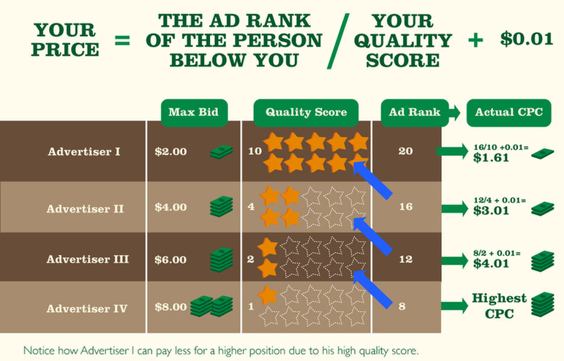

Between the poles of brand and competitor, we can split keywords into two groups: low intent (typically informational or navigational searches) and high intent (commercially relevant keywords, the ones that lead to conversions, the backbone of your AdWords account). Both are important to overall AdWords success (if you use remarketing, cheaper low intent keywords are a great way to create audiences and drive conversions down the road), but treating them as equals is a waste time and money.

3. Question
- Selecting Better keywords
- Creating More Relevant Keyword Groups
- Writing High-Quality Score AdWords Ads
- How to improve your AdWords Quality Score and ROI
Quality Score is a measure of the quality, relevance, and performance of your pay-per-click advertising campaigns. Because it affects both:
the position of ads and
the cost per action
A way to improve your Quality Score is to use a PPC management solution like WordStream, Proper, AdWords campaign management and organization increase Quality Score via multiple avenues:
- Better keyword data: WordStream helps to perform continuous, personalized keyword research, so you can build your campaigns on the right foundation, ultimately increasing the relevancy of your keywords to your ad messaging and website content.
- Effective keyword grouping: Organizing keywords into small, tightly related groups is the key to high AdWords Quality Scores. This practice makes it much easier to create specific ads and landing pages targeted to your intended audie
- More relevant ads: WordStream includes tools to help search marketers efficiently write AdWords ads that are compelling and speak to the searcher's query, increasing (CTR).

Sara Csiplity

Student Statement:

By submitting this assignment, I confirm that this is my own work.

Student Signature | Sara Csiplity | Date | 03.03.2019

For Tutor / Assessor Use Only
Total Marks
Marks Obtained
Percentage / Grade

