
Assignment Cover Sheet

Student Name: | Kasey Holding
Student Number: | 30266
Course: | Fashion Diploma Level 4
Assignment NO: | 11

Marking Criteria:
We expect the learners to write minimum one well expressed point in three lines against each allocated mark. This means one needs to write 15 lines with 5 well expressed points to get high grades for a 5 marks question.
For high grades use examples and illustrations where appropriate.
Assignment 11

1.
i. Discussing the concepts in the module starting with sales promotion, in larger stores around, there will be a sales promotion manager who co-ordinates the advertising together as well as displays, public relations, special events and the fashion office. Advertising is normally the use of a paid space or time in the media able to promote a certain product or event. A formal fashion show will need a lot of planning as well as booking models in, fittings, organizing for a runway, any scenery that they might need, music, lighting, seating. When considering a formal runway show it is crucial to have rehearsals as they will have a theatrical aspect included, so that everyone will know what is going on, as in where to be and what they should be doing at that moment in time. Also this makes there to be a definitive description to the whole show that the audience can enjoy just as much.

ii. The purpose of fashion promotion is to catch the attention of many people to oversee what is in store for them, this is very important to the sellers so that each garment can become popular in their own way at different times. Stores which already have a demanding fashion image try to maintain their leadership status in order to make sure they still represent the latest fashions of that time. The customers of these types of stores will be fashion leaders which helps in becoming successful, as they have a great sense also people who adopt the newest trends and styles at the start of each fashion cycle. Stores that try their best to strive with promotional stores on prices in a number of areas. Promotional stores will be those which are able to charge lower prices down to low overheads. Mass merchants who will just offer fashion merchandise of proven styles as they appeal to fashion followers. These sorts of customers buy nothing else but styles that they are used to seeing on others. A fashion style reaches these stores later than the others because it takes the mass producers some time to copy them at lower prices.

iii. The difference between advertising and publicity are proven to be that there are two types of advertising that is used by stores, number one being the selling of an exact image or selling of a precise item. To appeal attention to the store rather than the product, this is where institutional or prestige advertising is used. The fashion image, fashion leadership, community goodwill, the opening of a new store or a special event is the concentration with this type of advertising. The most operative sort of advertising is that which is accommodated to the customer’s way of seeing things. When it comes to fashion advertising, the main attention is on making sure that the customers can imagine how attractive they look when they are wearing the items being advertised. One element is that advertising needs to be truthful. This is so that the company will build an aspect of customer confidence and create a strong reputation for the store or manufacturer.

Whereas publicity is varying to be the upgrade and exposure of information regarding people, special events and exciting topics which has the possibility of making the news, through many forms of communications media. In the fashion industry publicity helps to promote the sale of fashion products by making the public a lot more aware of a certain manufacturer, retailer, style, trend. Media editors choose material that they feel can be of attention to the public. The how, when, and where of the message is determined by the media.

iv. When supplying apparels to the retailers sometimes financial problems are created this happens when retailers buy from manufacturers on a credit allowance. They buy product but do not need to pay anything for around 30 –to-60 days after the purchase has been made, depending on what the agreement is. This normally creates a problem for the manufacturer who needs to make an initial outlay for fabric, trims and labour costs. To get this done most manufacturers will go straight to finance companies, banks or factoring firms for financing. In the case of bank loans, they could either be unsecured for well-financed companies with good performance histories, or secured in which case they must have some collateral to bargain with for example: property.

v. ‘Textile sales people encourage manufacturers to make a commitment early in the season to buy a specific amount of yardage’ This is to make sure there is a reasonable amount of materials available especially with more popular fabrics so a manufacturer will need to order in advance to secure what they need as this is their job for both duplicate cutting and also stock. Seven to eight weeks lead time for delivery is the amount of time needed for volume orders. Sometimes, the very popular fashion fabrics and yarn dyes need as much as a six-month lead time. Calculating how much fabric may be needed for possible re-orders is something the manufacturer has to do. This is so important as there is not enough time after re-orders have arrived to wait for yet another fabric shipment. Furthermore, there is a risk associated with stocking up for anticipated orders if they don’t materialize. This is why careful prediction is imperative. To successfully eliminate some of the risk, manufacturers can choose to commit to “greige” which is a colour mix between grey and beige goods which can be dyed at a later date. When more precise sales information becomes accessible then the colours can begin to be sorted.

vi. Fabrics are usually inspected when it has been received this refers to Total Quality Control which is the procedure that focuses on making an understanding of quality success through the whole business. This includes inspection routines, but in particular it involves making sure everyone involved understands that their contribution influences the finished quality of a project. Quality Assurance talks about the maintenance of quality. There are, however, two generic uses of ‘quality assurance’ this is firstly, making sure to pay attention to issues which appear from the garment production other than any issues which arise from the original design or the design of the production process. It is the inspectors, not the designers or production staff, who have the ultimate responsibility here. The clothing industry frequently uses this system, regular changes in design occur, in particular in women’s fashion, and faults are given back to machinists or deductions are made from payments. This, of course, reduces motivation. Secondly, the manufacturing quality into garment manufacturing. This can be applied in three ways. Firstly, any defects that are found are traced back to the production process and when the causes are identified they are eliminated. Secondly, the ‘Total Quality Control’ aspect is used whereby sustained quality performance is understood to involve every relevant area of the company and its suppliers. Thirdly, company-wide quality control entails a commitment from all departments, not only in production, and involves methods like quality circles.

2. There are different types of Media in the Fashion industry such as magazine advertising take's lead of national circulation, large retailers often advertise in fashion magazines. These magazines have regional editions that place inserted pages of local store advertising. Also there is radio and television advertising Fashion advertising is being seen more and more on television in commercials. This sort of advertising is to show potential consumers how the clothing fit's in a real life scenario. The only disadvantage to TV advertising is that air time and production is generally quite expensive. The cost change's a little, varying on the length of the ad and when it will be shown. Prime time, which is between 7 and 11 PM is the most expensive as it is when the biggest number of adults watch the television. Local TV stations can often be less expensive, these types of ads are made under the direction of the retailer.

If fashion advertising is not noticed it won't be successful. The sales message has to be put across to the target market in an effective way, and that means it must be noticed. Because of this it is necessary to choose the most effective medium, the one that will best promote an event or reach the target audience. Fashion advertising is mostly visual, so this must be kept in mind when deciding on the best medium for the particular job. Every consumer group has its own individual interests, tastes and ideas, and therefore will respond to different media. To strengthen the advertising campaign, many ads are placed in different media outlets in order to support each other. For example, a spot radio commercial aimed at car users might be placed along with one in the newspaper for train and bus users to also read. Advertising works well with repetition and so this is necessary as it continues to retain public interest. Along with repetition, consistency is just as important. Placing the same ad on the same page in the newspaper every week as well as the same ad read out on radio at the same time every day will ensure people become very aware of the brand name or the store and the fashion message it is aiming to promote.
Projects

1. When I was looking through a fashion magazine I found a couple of examples of co op advertising, this would be in Vogue towards the back of the magazine they have a couple of pages that are featured with advertising of a certain company with a certain product in the center.

2. Looking at the advertising campaigns by a fashion designer in both newspapers and fashion magazines, I have found that they are in most cases given a high fashion image, I do feel like the advertisement's are effective as they make the garment's the model is wearing look appealing and sound appealing to viewers, the way it is presented is enticing. They mainly use photography, you can see that the front cover of this 'Vogue' magazine, this is a photo shoot and generally looks amazing, the background draws you in as well as the different colours in the dress, this looks like it has a forestry feel to it and it works.
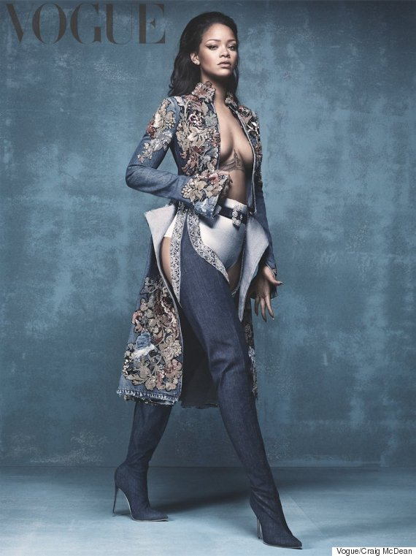
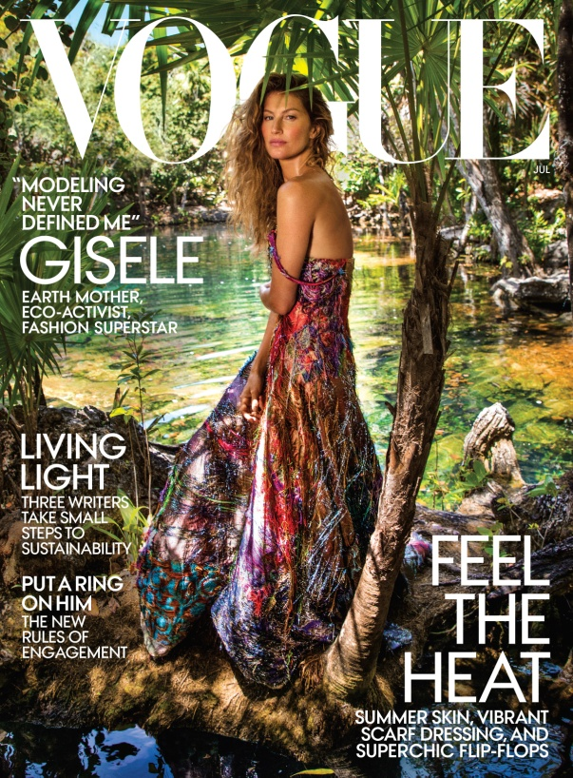
Another image I have picked out from a 'Vogue' magazine is of another photo shoot with Rihanna, the background looks very plain so that it captures the feel of the outfit she is wearing and so that it has your full attention.

3. Going into a local designers, I found that the inside the lights were dimmed for a relaxing feel I gathered that it was used effectively for this certain kind of feel inside, there were mannequins out and on them was garment's for display as well as hanging up on a dark oak rail with some rich coloured hangers so yes I do feel as though the merchandise was arranged attractively, I saw a lot of materials, and threads with a sewing machine on the side. The interior was very lavish, with vibrant rich colored wallpaper on the walls, and dark oak flooring and furniture, with a small three seater chesterfield sofa.

Student Statement:

By submitting this assignment, I confirm that this is my own work.

Student Signature | Kasey Holding | Date | 03/04/2019

For Tutor / Assessor Use Only
Total Marks
Marks Obtained
Percentage / Grade

