
Assignment Cover Sheet

Student Name: | Leonard Amadeus Pienaar
Student Number: | 33647
Course: | Critical Thinking
Assignment NO: | 02

Marking Criteria:
We expect the learners to write minimum one well expressed point in three lines against each allocated mark. This means one needs to write 15 lines with 5 well expressed points to get high grades for a 5 marks question.
For high grades use examples and illustrations where appropriate.
Please insert your completed assignment ( in word format) here:

Answer the following questions:
Q: 1: Short Questions
- Outline some common tips for identifying the issue.

Tips given in the Module to identify the issue are as follows:

- Try writing it as a question that can be answered yes or no.
- Be neutral and objective.
- Review the issue statement with others involved to make sure that you have gotten to the core of the problem.
- If there are one or more issues, separate them out so that you can focus on one thing at a time.

- List various tips for becoming a better listener.
Tips given in the Module to become a better listener are as follows:
- Make a decision to listen. Close your mind to clutter and noise and look at the person speaking with you. Give them your undivided attention.
- Don’t interrupt people. Make it a habit to let them finish what they are saying. Respect that they have thoughts they are processing and speaking about, and wait to ask questions or make comments until they have finished.
- Keep your eyes focused on the speaker and your ears tuned to their voice. Don’t let your eyes wander around the room, just in case your attention does too.
- Carry a notebook or start a conversation file on your computer. Write down all the discussions that you have in a day. Capture the subject, who spoke more, what you learned in the discussion, as well as the who, what, when, where, why, and how aspects of it. Once you have conducted this exercise 8-10 times, you will be able to see what level your listening skills are currently at.
- Ask a few questions throughout the conversation. When you ask, people will know that you are listening to then, and that you are interested in what they have to say. Your ability to summarize and paraphrase will also demonstrate that you heard them.

- What is the difference between an open question and a closed question?

Open Questions
Open questions are broad, general questions that require your conversation partner to provide more than just a “yes” or “no” answer. Open questions allow the person who answers to decide how much information will be given. Open questions start with the five W’s (who, what, where, when, and why) or ask “How?” Open questions can provide more information, encourage conversation, share opinions and ideas and help us determine if people have interpreted what we say accurately.

Closed Questions
Closed questions are usually answered by a single word or two, such as yes or no. They can finish a conversation rather than encourage it. These type of questions can be used to provide confirmation but do not necessarily lead to a comprehensive informative conversation. Closed questions give someone control over the questions and the type of answers that will be received.

Closed questions are easy to interpret and more questions can be answered in less time but if the objective is to get more detailed information, then open questions are better.

- Define probing techniques.
Asking the right questions to gain relevant information is very important and the follow up even more. To clarify information one has to “probe” the answers given to extract the desired information. Mindtools.com explains probing questions as follows:
“Probing Questions

Asking probing questions is another strategy for finding out more detail. Sometimes it's as simple as asking your respondent for an example, to help you understand a statement that they have made. At other times, you need additional information for clarification, "When do you need this report by, and do you want to see a draft before I give you my final version?" Or to investigate whether there is proof for what has been said, "How do you know that the new database can't be used by the sales force?"…
Probing questions are good for:
- Gaining clarification to ensure that you have the whole story and that you understand it thoroughly.
- Drawing information out of people who are trying to avoid telling you something.”¹ (Mindtools.com Staff. © Mind Tools Ltd, 1996-2019)
The probing techniques listed in the Module are:
- Ask an open question
- Pause
- Use reflective or mirroring questions
- Paraphrase
- Use summary questions

- Ask an open question.
Open questions are broad, general questions that require your conversation partner to provide more than just a "yes" or "no" answer. Open questions allow the person who answers to decide how much information will be given. Some good questions include:
- “Can you describe that more clearly?”
- “Would you give me a specific example of what you mean?”
- “What do you think we should do?”
If too many questions are asked, the conversation might start to feel like an interrogation, so use open questions carefully.
- Pause
Many of us feel uncomfortable when silence overtakes a conversation, and we will fill the silence by expanding on what was said previously. Pausing after a reply can prompt the person to continue answering the question or to elaborate on what was already said. This is a silent way of extracting more information without making the person feel they are interrogated.

- Use reflective or mirroring questions.
Reflective or mirroring questions help to focus or clarify and summarize without interrupting the flow of the conversation. They demonstrate the intent to understand the speaker’s thoughts and feelings.
For example, if someone says “Susan quit because she felt underappreciated,” you may respond by just reflecting back to them, “Underappreciated?” Then pause. Usually, the other person will provide you with an expanded answer without you asking more questions or interrogating.
- Paraphrase
Paraphrasing is the restatement of something in a different form or using similar words and expressions to clarify meaning. The Module suggests the following to help when paraphrasing something:
Reflect what has just been said in your own words. “So if I understand you correctly, you…” This technique shows that you want to understand your conversation partner and that you want to be accurate. It also allows the sender to hear back what they have said from someone else’s point of view.
- Use summary questions
Summary questions are a helpful way of probing and winding up the conversation at the same time. For example: “In summary, you have found that 90% of employees have not received a pay increase in the past 18 months and that 95% of employees have not received a performance review in the past 24 months.”
- Pushing My Buttons
“Pushing my buttons” is an attempt to prompt or provoke a response.
For example, the following is a list of statements that can be used to prompt a response:
- I think this city is too hot
- I really dislike cooking
- You’re not very good at your job
- I think the report you wrote is terrible
- Your new hair cut isn’t flattering
- I wish I didn’t have to go to that meeting tomorrow

- What is paraphrasing?

The definition of paraphrasing given on thefreedictionary.com is:

  - A restatement of a text or passage in another form or other words, often to clarify meaning.

  - The restatement of texts in other words as a studying or teaching device.

  - The adaptation or alteration of a text or quotation to serve a different purpose from that of the original.² (TFD Staff. Copyright © 2003-2019 Farlex, Inc.)
The Module provides the following tip to comprehend paraphrasing:
Reflect what has just been said in your own words. “So if I understand you correctly, you…” This technique shows that you want to understand your conversation partner and that you want to be accurate. It also allows the sender to hear back what they have said from someone else’s point of view.

Q: 2: Discuss the four-step cycle which can be used to build an explanation.
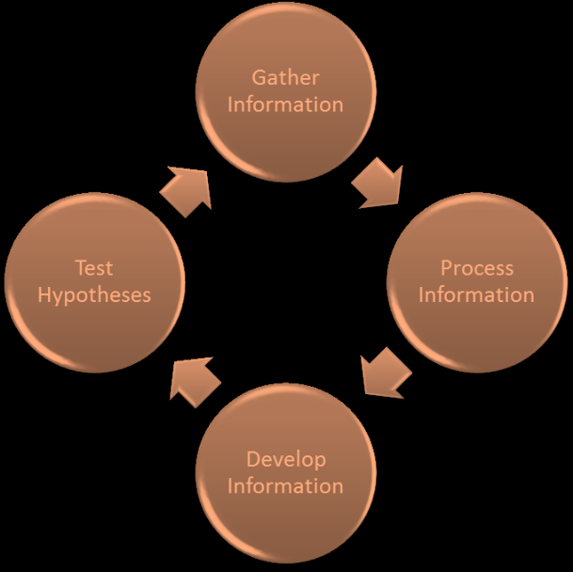

The four-step cycle consists of:
- Gathering Information
- Processing Information
- Developing Hypotheses
- Testing Hypotheses

- Gathering Information
Gather as much information as possible from as many different sources as possible. Be open-minded and make sure not to discard anything right away.
- Processing Information
Once information is gathered, it must be processed. This means categorizing the information, assessing its reliability and credibility, and comparing and contrasting similar pieces of information. Your goal is to make sense of what is in front of you.
- Developing Hypotheses
Synthesize the information that you have gathered and processed it into some possible explanations. Typically, three to five tentative hypotheses is a good number to aim for: not too few to restrict yourself, but not too many to overwhelm you.
The following questions can be asked to develop a hypothesis:
- How might someone else explain this?
- Step back from the data and look at the big picture. What does it tell you?

- Testing Hypotheses
The hypothesis must be tested to determine accuracy and practicality.
The following questions can be asked to test and evaluate hypotheses:
- Does this hypothesis account for all the evidence?
- Does the hypothesis make sense? Is it believable?
- Why is it better than the other alternatives?
Based on the results, you may need to return to a previous phase in the cycle.

Q: 3: Describe the seven standards that should be in the minds of critical thinkers.
The seven standards for critical thinkers are:
- Clarity
- Relevance and Significance
- Logic
- Accuracy
- Depth
- Precision
- Breadth

  - Clarity
“Clarity forces the thinking to be explained well so that it is easy to understand. When thinking is easy to follow, it has Clarity.”³ (Meegan, G. Copyright © 2015-2019)
The Module lists the following points to help with clarity:
- Ask for illustrations and examples
- Get hard facts
- Ask the person to elaborate or express the idea in another way

  - Relevance and Significance
“Relevance means that everything included is important, that each part makes a difference. If something is focused on what needs to be said, there is Relevance.”³ (Meegan, G. Copyright © 2015-2019)
The Module lists the following points to help with Relevance and Significance:
- How does that statement connect to the issue?
- What are the most important parts of the issue, argument, or evidence?

  - Logic
“Logical means that an argument is reasonable, the thinking is consistent and the conclusions follow from the evidence. When something makes sense step-by-step, then it is Logical.”³ (Meegan, G. Copyright © 2015-2019)
The Module lists the following points to help with logic:
- Apply common sense
- Connect the dots between the points
- Ask for clarification when points clash with each other

  - Accuracy
“Accuracy makes sure that all information is correct and free from error. If the thinking is reliable, then it has Accuracy.”³ (Meegan, G. Copyright © 2015-2019)
The Module lists the following points to help with accuracy:
- Look for supporting evidence
- Check and double-check the facts
- Get first-hand information whenever possible

  - Depth
“Depth makes the argument thorough. It forces us to explore the complexities. If an argument includes all the nuances necessary to make the point, it has Depth.”³ (Meegan, G. Copyright © 2015-2019)
The Module lists the following points to help with depth:
- Make sure you are not over-simplifying the problem
- Are you covering all the issues?
- Are you covering the most significant issues?

  - Precision
“Precision goes one step further than Accuracy. It demands that the words and data used are exact. If no more details could be added, then it has Precision.”³ (Meegan, G. Copyright © 2015-2019)
The Module lists the following points to help with precision:
- Ask for precise measurements (63% rather than “Over half the population”)
- Watch out for vague words

  - Breadth
“Breadth demands that additional viewpoints are taken into account. Are all perspectives considered? When all sides of an argument are discussed, then we find Breadth.”³ (Meegan, G. Copyright © 2015-2019)
The Module lists the following points to help with breath:
- Are you looking at all the points of view?
- How could you gain more perspective?
- Look at it through someone else’s eyes (your children, your manager, etc.)

Reference:
- Source: By Mindtools.com Staff. © Mind Tools Ltd, 1996-2019. Questioning Techniques. Available at: https://www.mindtools.com/pages/article/newTMC_88.htm [Accessed: 10 July 2019].
- Source: By TFD Staff. Copyright © 2003-2019 Farlex, Inc. paraphrase. Available at: https://www.thefreedictionary.com/paraphrase [Accessed: 10 July 2019].
- Source: By Meegan, G. Copyright © 2015-2019. The Intellectual Standards. Available at: https://theelementsofthought.org/the-intellectual-standards/ [Accessed: 10 July 2019].

Student Statement:

By submitting this assignment, I confirm that this is my own work.



Student Signature |  | Date: 10/7/2019

For Tutor / Assessor Use Only
Total Marks
Marks Obtained
Percentage / Grade

