
Assignment Cover Sheet

Student Name: | Wenzel Lositaño
Student Number: | 10478
Course: | Diploma in Construction Management
Assignment NO: | 2

Marking Criteria:
We expect the learners to write minimum one well expressed point in three lines against each allocated mark. This means one needs to write 15 lines with 5 well expressed points to get high grades for a 5 marks question.
For high grades use examples and illustrations where appropriate.
  - Every project is unique and has its own defined requirements and budget but in a general point of view, almost every projects might experience project cost and time overruns at any stage of the project. These are the following reasons:
    - Late execution of the contractor due to slow progress in the construction.
    - The client might not be happy with the performance and workmanship on the construction site, thus the client will order to the contractor for repeat of work.
    - Late delivery of materials on site is a common problem due to unorganized procurement process, issues on the availability of materials, mode of delivery (by sea or by air freight).
    - Late submission of technical drawings and specifications for approvals.
    - Conflict between the main contractor and sub-contractor regarding sub-sequent payments. For this reason, the sub-contractor will stop the work.
    - General conflict with the payment from the owner to the contractor and to all specialist contractors of the projects.
    - Change orders, change of specifications or materials as the owner instructs.
    - natural calamities or force majeure can stop the work.
  - The main resources of the project finance varies depending on the scale and complexity of a project. The owner of the project can have its approved budget from the allotted finance from its approving department. Other might use the following to finance the project. Below is a graphical representation on how projects are being finance from various scenarios and position of the owner.
    - Long-term financing means capital requirements for a period of more than 5 years to 10, 15, 20 years or maybe more depending on other factors. Capital expenditures in fixed assets like plant and machinery, land and building etc of a business are funded using long-term sources of finance.
    - Medium term financing means financing for a period of 3 to 5 years and is used generally for two reasons. One, when long-term capital is not available for the time being and second when deferred revenue expenditures like advertisements are made which are to be written off over a period of 3 to 5 years.
    - Short term financing means financing for a period of less than 1 year. The need for short-term finance arises to finance the current assets of a business like an inventory of raw material and finished goods, debtors, minimum cash and bank balance etc. Short-term financing is also named as working capital financin

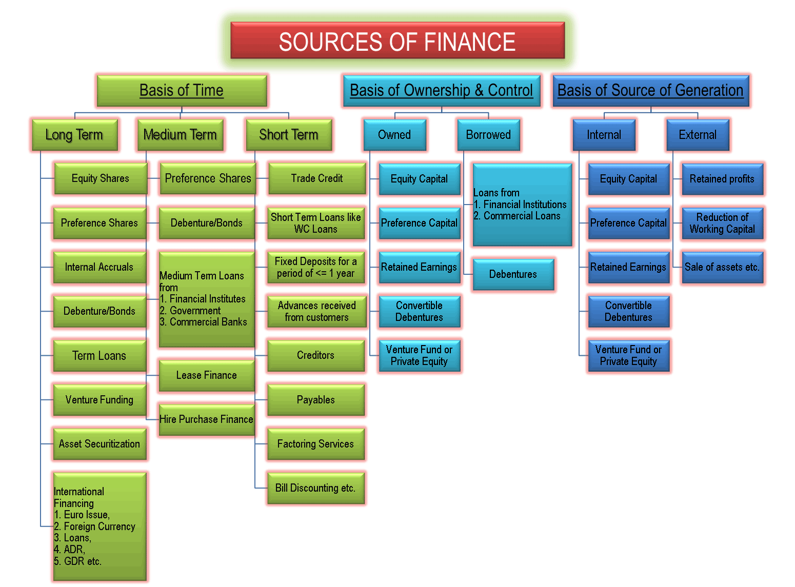
(Figure 1: Resources of Finance)
(Reference: https://efinancemanagement.com/sources-of-finance)

  - In order to achieve the project goals, the project must adhere to time and budget. During the construction period, it is the owner responsibility to check the contractor if he is doing his job right. The contractor of the project can use the industries best practices in order to control the project's phase:
    - Using the Ghant Chart as the base line of the construction stages and periodic checking on the actual finished or pending works on the site. This is a very helpful tool since is indicates the expected start and finish of each task.
    - Every project has a critical path. If any activity on the critical path is delayed, the project completion date is directly impacted. Therefore, monitoring and controlling activities on the critical path is more important than doing so with other activities. The project control techniques you employ must always include the activities on the critical path.
    - Weekly meetings is an important tool for all stakeholders of the project. Meetings also involve identifying dependencies and risks to the assigned tasks. Capturing meeting notes is critical to ensuring next steps and key decision are taken. During meetings, reports are being reviewed and commented. This is also a good opportunity for the client and contractor to see any possible issues that can affect the progress timeline of the project.
    - Project control techniques that pertain to measurement of project performance include earned value analysis. Earned value analysis is a technique that enables you to quantify project progress. Earned value analysis has some key indices, such as Cost Performance Index (CPI) and Schedule Performance Index (SPI).
    - using standard project forms for documentation and records of controlling the project.
    - Implementation of ISO standard procedures for construction and health and safety for construction projects which can be modified with reference to the projects requirements and scale.
  - Task that are undertaken in the project close-up phase are the following:
    - Submission of final as-built drawings for architectural and MEP drawings
    - Submission of operations and manual for both architectural and MEP which is composed of the specifications used in the actual installation, drawings and references, maintenance and care, warranties and guarantees, contact details of the contractor, specialist or suppliers.
    - Copy for the client of the approvals from the statutory agencies.
    - clearing the site, removal of temporary structures and facilities.
    - Contract copy and final payments must be finalized for all involved.
  - A feasibility study is used to determine the viability of an idea, such as ensuring a project is legally and technically feasible as well as economically justifiable. It tells us whether a project is worth the investment—in some cases, a project may not be doable. For a construction project, feasibility study is a great help for the client and project investors to understand the physical and financial aspects of a project. At this point, many unforeseen items are not clear at the beginning of the project. The owner might allow extra budget percentage for possible risk that can cause increase of construction cost. The paper is also important for the investors to understand what kind of project they are dealing with and if it will benefit them in the long run.
  - Project completion report is a formal document of closing of a project. You must prepare the project completion report even if your supporting agency does not put the obligation on you. It is a document of organization’s learning also. Hence it must be prepared and preserved for future reference. Below are the items that can be included for a project completion report:
    - The cover should contain the title page outlining the project title, its starting and ending date and name of the supporting as well as implementation agencies.
    - The executive summary
    - table of contents separating each disciplines
    - overview of the project writing a summary statement that the project is complete as the beginning of the overview
    - description of the project including the background of the problems aimed by the project and specify the goals and objectives of the project as well as its intervention area in the overview
    - Describe the results and outcomes of the project.
    - Provide a section as project highlights describing the most important aspects of the project.
    - Indicate some important issues, challenges and difficulties as risk summary.
    - end write about the lessons learnt, what worked during the implement and what did not; what are the ways to improve the intervention.
    - best practices as the appendix in the project completion report.
    - Evaluation of performance of the contractors and other specialist contractors
    - Appendixes and references, other necessary attachments if required

- PROJECT - It's a temporary endeavour undertaken to create a unique product, service or result. A project is temporary in that it has a defined beginning and end in time, and therefore defined scope and resources. It is also an individual or collaborative enterprise that is carefully planned and designed to achieve a particular aim. Below are the processes undertaken throughout the development of a construction project. It is divided in five basic phases:
  - Project Concept & Initiation - this is the first stage of the project where the requirements are being defined by the client. Ideas are created and collaborated by the stakeholders and agreed a final design idea. A feasibility study can be done and put things into proper documentation and approval. At this stage a financial budget is allocated with referenced to the design complexity and size. A go signal is released from the approving person through a proper signed document.
  - Project Definition & Planning - At this stage, the requirement of the project is broken down into a more detailed needs. The planning stage requires inputs from the architects and engineers to developed the concept designs to working drawings that will be used for the actual construction of the project. All drawings and related project documentations are being reviewed and approved by the approving party for formality. At this stage also, the budget is stretched to meet the actual material prices as per current market trends. This stage requires intensive coordination and internal collaborations so that possible issues during the construction will be addressed.
  - Project Launch & Execution - At this stage, the contract is awarded to the bidder and the site is open to the contractor to enter the site and do site inspections. The site will be secured with fences and will built temporary site offices including temporary facilities for water supply, power, internet connection, store rooms, etc. This stage of the project is the most strenuous because it requires organization within the site office and site construction. Project execution plan and methodologies are being followed on site to meet the time requirement. Site task are organized in proper sequence and it is overseen by the Project manager. Materials and delivery are being handled on site and thus requires proper logistics without causing delays or safety issues with other trades. Safety is the priority too and it is very important that all operatives adhere to site health and safety rules.
  - Project Performance & Control - Cost, schedule, and quality are the main indicators of performance in construction projects. These indicators are highly interrelated and require some balance and trade-off among them to achieve efficient overall control over project performance. It is important that the project is controlled and monitored from beginning to end. At the start of each performance period, reconfirm that the necessary people and resources are available and scheduled in accordance with your current project plan. At the end of each performance period, do the following: Gather activity start and end dates, milestone dates, resource expenditures, and the results of quality assessments. Compare the actual results with the planned results, identify any issues or problems, and take any necessary corrective actions. Report your progress for the period to your project audiences.
  - Project Close Out - The project closing process is generally phased over a period of time, rather than being a single event. Depending on the project type, project close out can begin as deliverables are completed, iterations/phases closed, or at the end of the project. Project Closure involves handing over the deliverables to your customer, passing the documentation to the business, cancelling supplier contracts, releasing staff and equipment, and informing stakeholders of the closure of the project. This phase requires the completion of the seven activities.
    - Perform project closeout
    - Perform client closeout
    - Perform organizational closeout
    - Conduct subcontractor closeout
    - Perform final risk assessment
    - Write project final report or briefing
    - Conduct team closeout

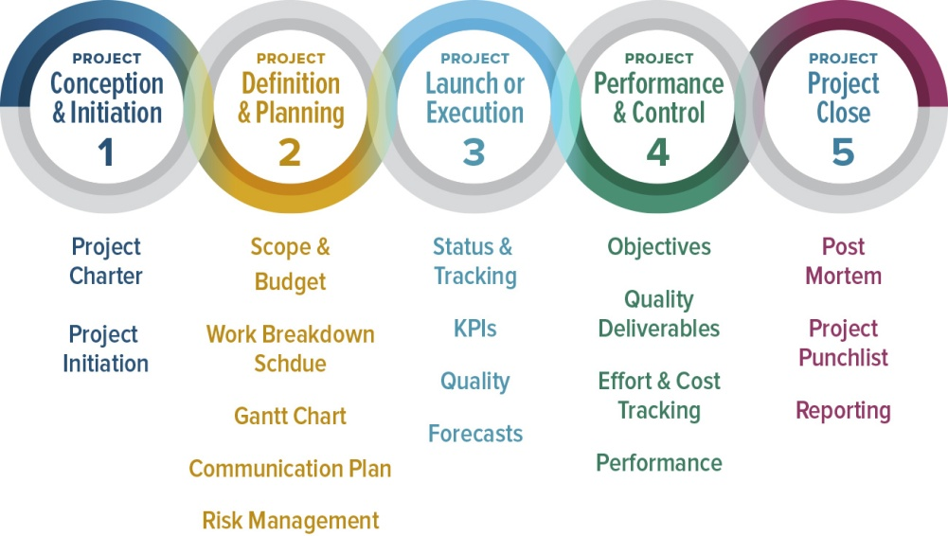

Student Statement:

By submitting this assignment, I confirm that this is my own work.

Student Signature | Wenzel Lositaño | Date | 08August2018

For Tutor / Assessor Use Only
Total Marks
Marks Obtained
Percentage / Grade

