
Assignment Cover Sheet

Student Name: | Luigi di Ronza
Student Number: | 29933
Course: | Diploma in Customer Service 4
Assignment NO: | 9

Marking Criteria:
We expect the learners to write minimum one well expressed point in three lines against each allocated mark. This means one needs to write 15 lines with 5 well expressed points to get high grades for a 5 marks question.
For high grades use examples and illustrations where appropriate.
- Give short answers to the following questions:

- Who are unprofitable customers?

Unprofitable describes a business or project that does not make a profit. It either breaks even or makes a loss. In other words, it is the state of generating a negative net income or zero profit. Not being profitable can eventually lead to bankruptcy.
Customer profitability (CP) is the profit the firm makes from serving a customer or customer group over a specified period of time, specifically the difference between the revenues earned from and the costs associated with the customer relationship in a specified period. According to Philip Kotler, a profitable customer is a person, household or a company that overtime, yields a revenue stream that exceeds by an acceptable amount the company's cost stream of attracting, selling and servicing the customer."
Calculating customer profit is an important step in understanding which customer relationships are better than others. Often, the firm will find that some customer relationships are unprofitable. The firm may be better off (more profitable) without these customers. At the other end, the firm will identify its most profitable customers and be in a position to take steps to ensure the continuation of these most profitable relationships. However, abandoning customers is a sensitive practice, and a business should always consider the public relations consequences of such actions
Customers who are unprofitable consume more of your business’ resources than they pay for. These customers divert attention and resources from a business’ profitable customers. Salespeople dislike having to deal with customers that do not make a profit for the company.

- What is customer data base and how does it help organizations in improving their customer services?

Knowing your customer base is a crucial component of a successful business. A customer database is a collection of information about all the customers that have made a purchase from your business. It is the most powerful tool at your disposal. If you’re not taking advantage of your customer database you’re missing out on potential sales.
Here are the top 5 benefits to using your customer database for your marketing efforts:
- Create Brand Affinity
Today’s customers want to buy from businesses they know and love. When armed with a customer database, you have the ability to build brand affinity by sending out marketing emails to people that have opted to receive them. Reaching out to customers by sharing new products, special offers or company news can help them feel connected to your business and nurture a relationship of trust.
- Develop Customer Loyalty
A customer database allows your business to identify the most loyal and profitable customers. You’ll be able to target and give the red carpet treatment to this segmented audience. An effective way to reach these customers is through email marketing that takes the preferences of the customer into account. This engages customers, building further brand loyalty, and can inspire them to share your brand with friends and family. Not to mention, sending them special discounts and offers is a great way to encourage new purchases.
- Provide Better Customer Service
Happy customers equal good business. Database marketing allows you to develop a stronger relationship with your customers. Having information like buying behavior, post-purchase feedback and reviews allows businesses to take a consumer-centric approach to customer service. Keeping up to date with the wants of your customer base allows the insight necessary to personalize communication so you can serve them better.
- Direct Channel to Customers
One of the key benefits of a customer database is that it is a collection of actual customers that have purchased from you in the past. The foremost benefit of leveraging these names is that because they are verified customers, they are already interested in your product or service. The desire to purchase from your business is higher than it would be if you were prospecting for new customers.
- Launching New Products
Rolling out new products to a small segment of your audience is a great way to test the water before launching it on a wider scale. You can target an audience based on information from your customer database. Selecting a group of your most trusted customers can allow a business to gather constructive feedback that can help improve later versions of the product. Keeping a pulse on what customers think and want is a great way to enhance the products you offer and how you offer them.

- Who are profitable customers?

One of the common strategies for increasing your sales revenue is targeting your most profitable customers. Customers are not all equal. Figuring out how profitable your customers are, can help you grow every facet of your company. These won’t necessarily be the ones who spend the most —some of your customers who spend the most money won’t be profitable, as they may have negotiated heavy discounts or might require more customer support. The key is to identify those customers early and adapt your sales strategy accordingly.
You can use different measurements to identify your most profitable customers. For example, you can analyse your previous sales to find out who they are, take note of what they buy and when they buy it. You can then segment your customers and the products or services they buy into one of four categories:

- High sales and high profit
- High sales and low profit
- Low sales and high profit
- Low sales and low profit

It’s a good idea to focus on customers that provide high sales and high profit. However, customers that provide high profit on low sales can also help boost profits. If customers are providing low profit from high sales, you should think about adjusting your pricing to see if you can generate more revenue from these sales.

Analysing your customers allows you to identify those who best fit your business priorities. This will depend on your strategy; for example, if you are launching a new product, your aim might be to build sales as quickly as possible, whereas if you have cash flow problems you might value customers who pay quickly.

- Explain the term ‘serial complainers’.

The serial complainer is the customer who is always complaining. No matter what the situation, they always seem to have something to gripe about, and it probably seems like you are always busting your butt to come up with a way to please them; they are your customers and you cannot just completely ignore them. Serial complainers are a drain on resources. The effect that they have on call centre staff and service personnel, for example, can often outweigh the validity of their complaint. Always evaluate the financial cost of their ongoing complaining. Take into consideration the cost of the time the CSR spends with a serial complainer, the cost of any reparation (the outcome) and the effect that it has on morale. The serial complainer is a customer that nobody wants. Most organisations are capable of identifying serial complainers, yet data collection and dissemination is woefully weak.

- Why organizations group their customers in different segments?

Segmenting your customers into groups according to their needs has a number of advantages. It can help you to:
- identify your most and least profitable customers
- focus your marketing on the customers who will be most likely to buy your products or services
- avoid the markets which will not be profitable for you
- build loyal relationships with customers by developing and offering them the products and services they want
- improve customer service
- get ahead of the competition in specific parts of the market
- use your resources wisely
- identify new products
- improve products to meet customer needs
- increase profit potential by keeping costs down, and in some areas enabling you to charge a higher price for your products and services
- group your customers by factors such as geographical location, size and type of organisation, type and lifestyle of consumers, attitudes and behaviour

In order to effectively evaluate a segment of your customer base, it is necessary to establish your segmentation methodology. The methodology and objectives should be in-line with your corporate strategy and take into account corporate culture. Having established the ‘rules of engagement’, you are faced with the task of establishing why you have undertaken the segmentation of your customer base. This can be summed up by the rule that it is far easier to deal with a small number of segments than a very large number of individuals. Each individual customer’s profile will differ from the next, but certain characteristics will stand out that enable groups to be established. These groups are referred to as segments. Targeting specific segments of customers highlights a belief in the organisation that a particular segment is valuable to the overall goals and aims of the business. Having targeted them and enlisted them as your customers, the next phase of segmentation is likely to take place. This is where you look at that particular segment and break it down further, splitting those that are profitable to the organisation and those who are less profitable.

- Discuss the main attributes of unprofitable customers.

Companies with lots of unprofitable customers may sometimes spend money on bringing in customers who are reducing the value of the firm. When you have already got your customer purchase information, it is easier to identify your unprofitable customers. These kinds of customers have certain characteristics. One of these, for example, could be that they always buy products that are on sale at reduced prices. In order to increase cross-buying or reduce storage, companies always have certain products on special sale. Products on sale are, unfortunately, always less profitable or even non-profitable.
Managers must often make difficult decisions - letting go of unprofitable customers is one of them. There are several common methods of letting them go. Stop sending promotional advertising to unprofitable customers, for example. If they do receive the information, the frequency of purchase may lessen and the chances of them buying other valuable customers’ recourses will be reduced. You could also increase their waiting time. Managers should maintain a list of unprofitable customers. When they call for help, companies can put them in a long waiting line to deliberately make them impatient and take their business elsewhere. Customers who only buy products on sale therefore are typically unprofitable customers.
For example, Barclays tries not to open personal bank accounts for customers with no income as those customers will be account holders with no money in and out, never will be interested in any paid products and services. They will take advantage from the free bank service.

- Discuss in details the different strategies for converting unprofitable customers into profitable customers.

Not all customers are created equal, wrote Peter Fader in his book, Customer Centricity. This, not customer service, is the key idea behind customer-centricity. Some customers are more valuable to your business, while others are of less value or even cost you money. In a customer-centric model, you differentiate your customers based on their value – and design treatment strategies accordingly. With the right data, you can explore how to level-up your less profitable customers and how to retain your most profitable ones, while identifying if there are any customers who are simply not providing value to your business. Becoming customer-centric is about more than adopting a new strategy and way of thinking. Success is also predicated on the data and your ability to analyse it to understand customer value.
Customer - centric businesses:
•Design product offerings for their best customers – and to attract others like them
•Ensure a superior customer experience for their best customers (this might result in all customers getting better experiences, but they are designed with the best customers in mind)
•Create strategies to enhance the value of the unprofitable ones
•Reward loyal customer
Customer divestment, whereby a company stops providing a product or service to an existing customer, was once considered an anomaly. However, it is fast becoming a viable strategic option for many organizations. Certainly, the skyrocketing costs of acquiring new customers and the complexities of cross-selling to different market segments continue to make customer retention imperative. But some firms are taking advantage of new segmentation approaches and technologies that have made it easier to focus on retaining the right customers—those who will bring in the most revenue over time—and, by extension, to show problem customers the door. Before making any moves to divest, businesses would do well to walk themselves and their B2B or B2C customers through a five-part framework. It will help executives consider the strategic impact of customer divestment beyond just profitability.
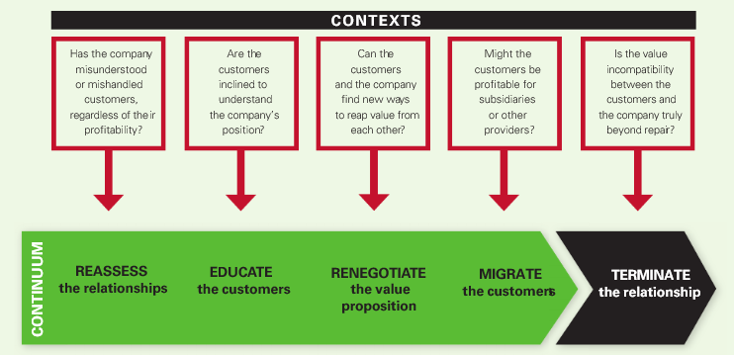

A change in marketing promotion strategy is required to change the unprofitable customer into a profitable customer. Stop using a discount strategy - bundled selling is a better approach. With this method, if you want to buy something at a lower price, you also need to buy something else. “Buy one get one free” is also a better promotion strategy than direct discount. When companies change their promotion method, unprofitable customers will change their purchase behaviour or may adapt themselves to the new policy and become profitable customers. Otherwise, they may leave the company – though the company will become more profitable without them.
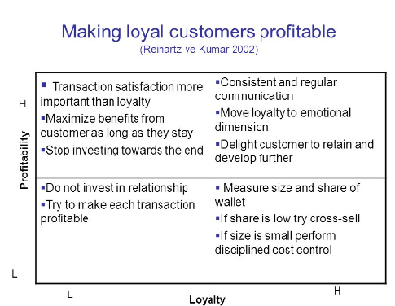
Another strategy is allowing customers to use a self-service system. Self-service can greatly reduce costs. If unprofitable customers switch to lower-cost channels, they become more profitable customers.

References

Adler, Ralph W. (2000), “Strategic Investment Decision Appraisal Techniques: The Old and the New,” Business Horizons, 43 (6), 15–22.
Bougie, R., Pieters, R., & Zeelenberg, M. (2003). Angry customers do not come back, they get back: The experience and behavioral implications of anger and dissatisfaction in services.
Journal of the Academy of Marketing Science, 31(4), 377—393.

Bowman, D., & Narayandas, D. (2004). Linking customer management effort to customer proﬁtability in business markets.
Journal of Marketing Research, 41(4), 433—447.
Mittal, Vikas and Sarkees, Matthew and Murshed, Feisal (2008) The Right Way to Manage Unprofitable Customers. Harvard Business Review, Vol. 86, No. 4
Helm, S., Rolfes, L. and Günter, B. (2006), "Suppliers' willingness to end unprofitable customer relationships: An exploratory investigation in the German mechanical engineering sector", European Journal of Marketing, Vol. 40 No. 3/4, pp. 366-383.
Dave Anderson (2007). How to Deal with Difficult Customers: 10 Simple Strategies for Selling to
Roy Lilley (2010). Dealing with Difficult People, (Revised 1st Edition 2010)
Susan Benjamin (2008). Perfect Phrases for Dealing with Difficult People: Hundreds of Ready-to-Use.
Tax SS, Brown SW & Chandrashekaran M, 1998, Customer Evaluations of Service Complaint Experiences: Implications for Relationship Marketing, Journal of Marketing, Vol. 62, April, 60-76
Taylor SA & Baker TL, 1994, An Assessment of the Relationship Between Service Quality and Customer Satisfaction in the Formation of Consumers’ Purchase Intentions, Journal of Retailing, Vol. 70, No. 2, 163-178

Student Statement:

By submitting this assignment, I confirm that this is my own work.

Student Signature | Luigi di Ronza | Date | 05.07.2020

For Tutor / Assessor Use Only
Total Marks
Marks Obtained
Percentage / Grade

