
Assignment Cover Sheet

Student Name: | Shoaib Qazi
Student Number: | 9090
Course: | Diploma in Business Administration
Assignment NO: | 13-Starting a Business

Marking Criteria:
We expect the learners to write minimum one well expressed point in three lines against each allocated mark. This means one needs to write 15 lines with 5 well expressed points to get high grades for a 5 marks question.
For high grades use examples and illustrations where appropriate.
Q.1. Prepare a business plan for any business of your choice.

Ans.

Executive Summary

HR Technicist (HRT) is a human resource consulting company located in Karachi (Pakistan). HRT has expertise in a wide range of HR areas and is targeting the emerging company market. HRT will offer this market the ability to compensate client's employees with stock options from their company. This will be especially appealing to many start-up companies that find capital scarce.

The founder and owner will be leveraging his past and current personal/professional relationships to generate business for HRT. Owner will be the sole employee until month six when he will be hiring a human resource specialist/manager to help out with the consulting. HR Technicist will show increasing profitability over the next three years.

Highlights (Graphical)

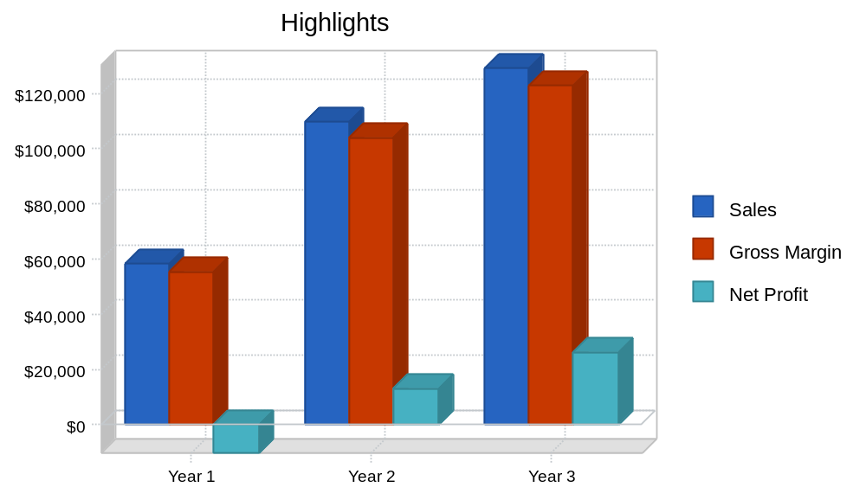

Keys to Success

The keys to success are to provide a needed service while providing a flexible means of compensation.

Mission

HRT mission is to provide human resource consulting for emerging companies. We exist to attract and maintain customers. When we adhere to this maxim, everything else will fall into place. Our services will exceed the expectations of our customers.

Objectives

The objectives for the first three years of operation include:

- To create a service-based company whose primary goal is to exceed customer's expectations.
- To increase our number of clients served by 20% per year through superior performance and word-of-mouth referrals.
- To develop a sustainable start-up consultancy firm that can survive off its own cash flow and has significant equity holdings in emerging companies.

Company Summary

HR Technicist is a HR consultancy firm serving the Karachi (Pakistan) & UAE area market. HRT will be set up as a Pakistan Corporation owned by Qazi Abdul Saboor and will focus on emerging companies.

Company Ownership

HR Technicist is a privately held Pakistan corporation founded and owned by Mr. Qazi Abdul Saboor.

Start-up Summary

HR Technicist will incur the following start-up expenses:

- Two desks, two chairs, and two lockable file cabinets.
- Two computer systems including a CD-RW, printer and a third computer to serve as a server.
- DSL router and DSL connections.
- Two telephones, fax machine, and copier.
Please note that the following items which are considered assets to be used for more than a year will labeled long-term assets and will be depreciated using G.A.A.P. approved straight-line depreciation method.

Start-up
Start-up
Requirements | Cost
Start-up Expenses
Legal | $1,000
Stationery etc. | $150
Website development | $0
Other | $0
Total Start-up Expenses | $1,150
Start-up Assets
Cash Required | $10,050
Other Current Assets | $0
Long-term Assets | $4,800
Total Assets | $14,850
Total Requirements | $16,000

Start-up (Graphical)

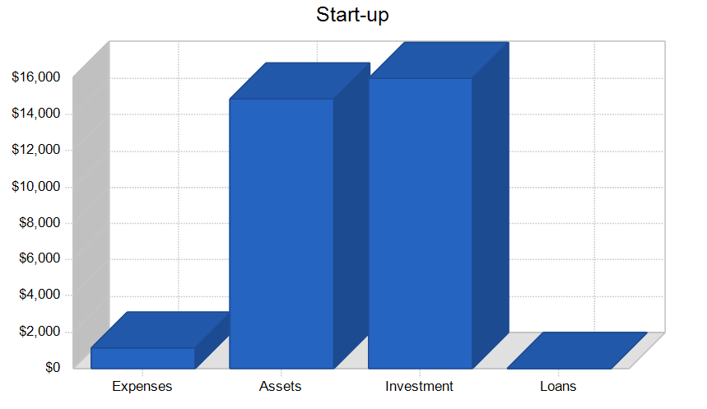
Services

HR Technicist provides human resource consulting to emerging companies in the Karachi (Pakistan)& UAE market. HR Technicist will charge a below market rate and take stock options in the company. HR Technicist will provide consulting for the following service areas:
- Human resource management.
- Organizational management.
- Professional development.
- Employee relations.
- Labor relations.
- Benefits and compensation.
- HR policy and procedure.
- Executive search.
- Sexual harassment.
- Position classification.
- Personnel management systems.
- Performance evaluations.
- Diversity.

The pricing structure will either be an hourly rate or a per project fee. These options will be settled on in negotiation with the client. In general, HR Technicist is willing to be as flexible as possible.

Market Analysis Summary
- Emerging companies will be the target market for several reasons:
- They are in need of HR services as they are growing rapidly.
- They often do not have a large enough in-house solution as they are increasing in size.
- Capital is a scarce resource for emerging companies so the ability to accept stock options in replace of cash is appealing.

The emerging company market can be further broken down into two categories, technology and non-technology. The significance of the breakdown is not that significant because many of the networking activities are occurring in settings that do not differentiate between technology and non-technology.
Market Segmentation

HR Technicist market can be segmented into two different groups, emerging high-tech companies and emerging non-high tech companies with a core focus on Oil & Gas Sector. The emerging high-tech companies are going to be the larger of the two segments. Even with the Internet bubble bursting within the last year, there are still many different emerging high-tech companies proliferating. This is evidenced by the Business Journal of Karachi (Pakistan) which in their annual list of fastest growing companies for this year, 18 of the top 25 were technology companies.

There are also non-technology companies that are emerging in the Karachi (Pakistan) area and HR Technicist will be able to serve them as well.

Market Analysis
Market Analysis
 |  | Year 1 | Year 2 | Year 3 | Year 4 | Year 5
Potential Customers | Growth |  |  |  |  |  | CAGR
Emerging technology companies | 10% | 345 | 380 | 418 | 460 | 506 | 10.05%
Emerging non-technology companies | 9% | 225 | 245 | 267 | 291 | 317 | 8.95%
Other | 0% | 0 | 0 | 0 | 0 | 0 | 0.00%
Total | 9.62% | 570 | 625 | 685 | 751 | 823 | 9.62%

CAGR=Compound Annual Growth Rate

Market Analysis (Pie)

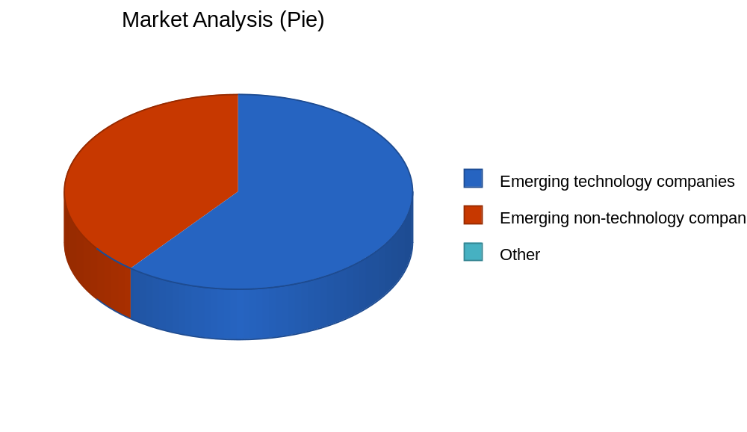

Start-up Funding
Start-up Funding | Cost
Start-up Expenses to Fund | $1,150
Start-up Assets to Fund | $14,850
Total Funding Required | $16,000
Assets
Non-cash Assets from Start-up | $4,800
Cash Requirements from Start-up | $10,050
Additional Cash Raised | $0
Cash Balance on Starting Date | $10,050
Total Assets | $14,850
Liabilities and Capital
Liabilities
Current Borrowing | $0
Long-term Liabilities | $0
Accounts Payable (Outstanding Bills) | $0
Other Current Liabilities (interest-free) | $0
Total Liabilities | $0
Capital
Planned Investment
Major | $16,000
Investor 2 | $0
Other | $0
Additional Investment Requirement | $0
Total Planned Investment | $16,000
Loss at Start-up (Start-up Expenses) | ($1,150)
Total Capital | $14,850
Total Capital and Liabilities | $14,850
Total Funding | $16,000

Target Market Segment Strategy

Human Capital Maximizers' two markets will be primarily targeted through networking activities. Some networking will be conducted through the Pakistan Entrepreneur Association, an association that supports entrepreneurial ventures in the local area. This organization has monthly meetings that are in round-table format, allowing members to socialize.
HR Technicist will also be networking from personal/professional contacts that Major has developed professionally in the last five years in the HR/start-up industry. HRT will also be relying on word of mouth to grow its customer base.

Strategy and Implementation Summary
HR Technicist will use their competitive edge of compensation flexibility to attract emerging companies. This competitive advantage is especially valuable to emerging companies who are typically struggling to find enough capital to grow their business. Accepting stock options as compensation is useful because equity is one thing these companies have lots of (that is of course if they haven't given it all away to the Venture Capitalists).
Milestones

HR Technicist will have several milestones early on:
- Business plan completion. This will be done as a roadmap for the organization. This will be an indispensable tool for the ongoing performance and improvement of the company.
- Set up office.
- HRT's first five customers.
- Profitability

Milestones (Tabulated)

Milestones
Milestone | Start Date | End Date | Budget | Manager | Department
Business plan completion | 1/1/2001 | 2/1/2001 | $0 | ABC | Marketing
Set up office | 1/1/2001 | 2/1/2001 | $0 | ABC | Department
HRT's first five customers | 1/1/2001 | 3/31/2001 | $0 | ABC | Department
Profitability | 1/1/2001 | ****** | $0 | ABC | Department
Totals |  |  | $0

Sales Strategy

As stated earlier, the marketing and sales will be done primarily through networking. This means the bulk of the leads will have been developed through a personal/professional relationship that Major has developed either in his previous professional work or through his activities with the Pakistan Entrepreneurs Association and other similar associations. The sales spiel will be based on HR Technicist experience in the field as well as their flexibility for compensation. Major will be able to explain to the prospective client the areas that he has experience in and the solutions that he can offer.
Major will also be able to speak about HR Technicist ability to accept options in lieu of cash. This will be appealing to companies, particularly in the current capital market which is quite scarce. Since capital is more difficult to come by now than in the last few years, emerging companies will be excited about this option.
Sales Forecast

The first month will be used to set up the office. Additionally, during the first month Major will be working hard on developing contracts. The second month will see some activity, but it will not be until month six when business will be picking up at a higher rate. Sales will continue to grow through year three.

Sales Forecast (Tabulated)

Sales Forecast
 | Year 1 | Year 2 | Year 3
Sales
Emerging technology companies | $41,500 | $78,455 | $92,541
Emerging non-technology companies | $16,600 | $31,382 | $37,016
Total Sales | $58,100 | $109,837 | $129,557
Direct Cost of Sales | Year 1 | Year 2 | Year 3
Emerging technology companies | $2,075 | $3,923 | $4,627
Emerging non-technology companies | $830 | $1,569 | $1,851
Subtotal Direct Cost of Sales | $2,905 | $5,492 | $6,478

Sales Monthly (Graphical)

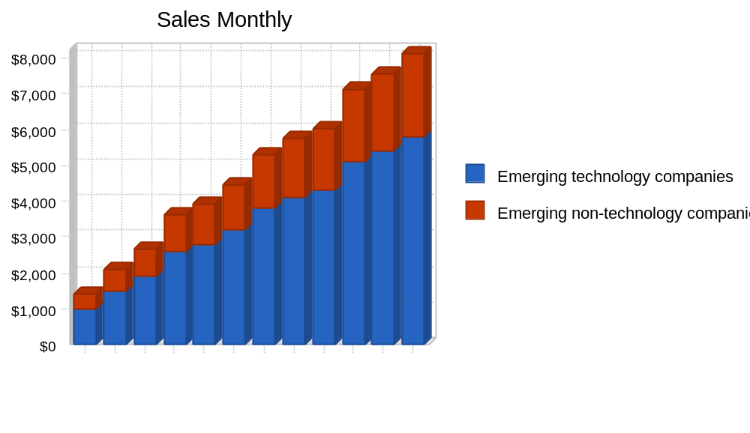

Sales by Year (Graphical)

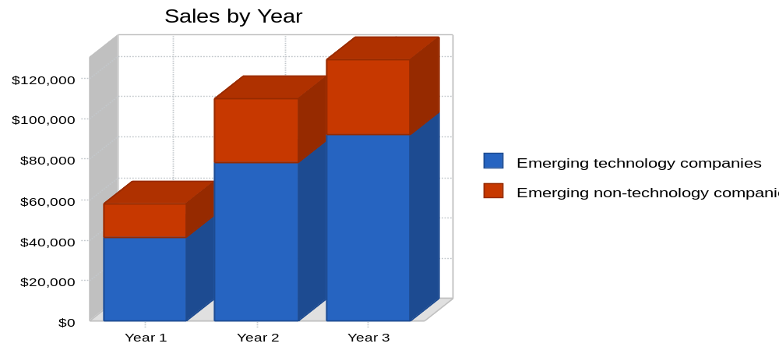

Competitive Edge

HR Technicist competitive edge is their flexibility for compensation. Most or all other companies require compensation to be in the form of cash, for them cash is king. HR Technicist is able to take stock options in lieu of some cash. While HR Technicist needs some cash to float the business, it can take up to 75% of its fees in equity. HR Technicist is able to do this because they have secured an office space that is low in cost, helping them reduce their overhead. In addition, Major's wife contributes a significant portion of money to the household so Major is not in need of a lot of monthly compensation. This allows him to accept options as payment in hopes of an upside to come several years for now. (Please note the HR industry, unlike law firms and accounting firms do not run into conflict of interest situations regarding receiving equity as compensation.)
Web Plan Summary

The website will be used as a resource that prospective companies can view to gain more information about the company. In essence it is Human Capital Maximizers' brochure. On the site there will be information about the management of the company and corresponding bios indicating all of their experience. Also on the website will be a list of present and past clients and information regarding Human Capital Maximizers' fee structure and willingness to accept stakes of option.
Website Marketing Strategy
The marketing of the website will consist of submitting it to the popular search engines. The website will be used more as an information tool that prospective companies can be sent to for more information about HR Technicist as opposed to marketing the website in order for the website to develop new leads.
Development Requirements
The development requirements will entail hiring an individual (preferably a student for cost saving purposes) to develop and produce the site.
Management Summary
Qazi Abdul Saboor, the founder and owner received his undergraduate degree in marketing from Reputed Business College. After completing college Major recognized that he would eventually need to go to graduate school but was not ready to yet.
Major worked in a large bicycle store for four years after college. Major started out as a mechanic but quickly moved up to manager where he was responsible for much of the operation. Some of the new responsibilities that Major enjoyed was the interviewing, selection & hiring, compensation, and employee relations. After four years in the bike shop Major was looking for a new challenge so he entered the University of Karachi (Pakistan) to pursue his MBA.
He received his MBA within two years and went to work for Nike out of school in their HR department. After a year and half, He left Nike to work for a HR consultancy boutique that worked primarily with technology companies, many of them startups. He enjoyed this thoroughly because of the dynamic environment that his clients worked in. Major stayed with this firm for a total of four years.
Toward the end of his four years he got married and his wife, as a professional, was contributing large amounts of salary to the household. This led him to consider opening his own HR consultancy because he would be able to undertake some risk since the household was supported to a large degree by his wife. Additionally, Qazi was could consider taking equity as compensation because a monthly salary was not a necessity.
Personnel (Tabulated)
Personnel Plan
 | Year 1 | Year 2 | Year 3
Major | $24,000 | $24,000 | $24,000
Full time employee | $24,500 | $42,000 | $42,000
Total People | 2 | 2 | 2
Total Payroll | $48,500 | $66,000 | $66,000

Financial Plan
The following sections will outline important financial information. Please note that the stock options granted in lieu of compensation are not entered into the financial plan as they are not yet of value. Upon exercising the options there will be tax consequences (because one of the realizing events has occurred) as well as assets to be accounted for.
Important Assumptions
The following table details important financial assumptions.

General Assumptions
 | Year 1 | Year 2 | Year 3
Plan Month | 1 | 2 | 3
Current Interest Rate | 10.00% | 10.00% | 10.00%
Long-term Interest Rate | 10.00% | 10.00% | 10.00%
Tax Rate | 30.00% | 30.00% | 30.00%
Other | 0 | 0 | 0

Break-even Analysis
The Break-even Analysis is shown below.

Break-even Analysis (Tabulated)
Break-even Analysis
Monthly Revenue Break-even | $5,766
Assumptions:
Average Percent Variable Cost | 5%
Estimated Monthly Fixed Cost | $5,478

Break-even Analysis (Graphical)
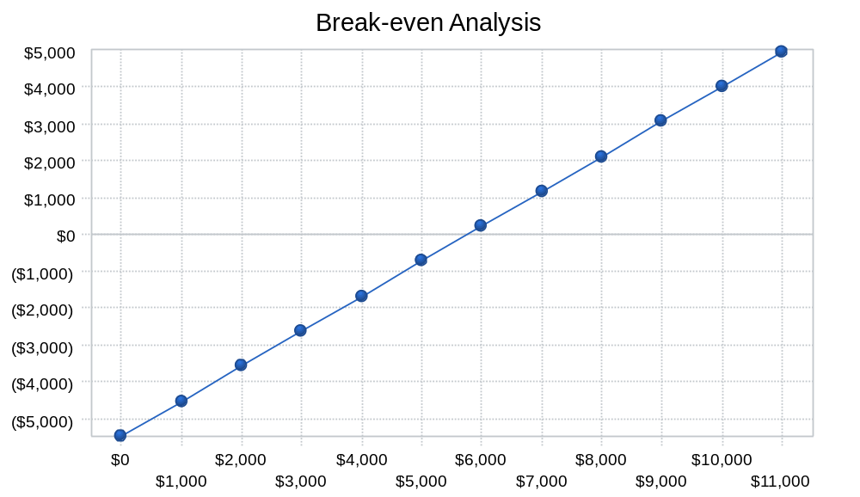

Projected Profit and Loss
The following table will indicate projected profit and loss.
Profit Monthly (Graphical)
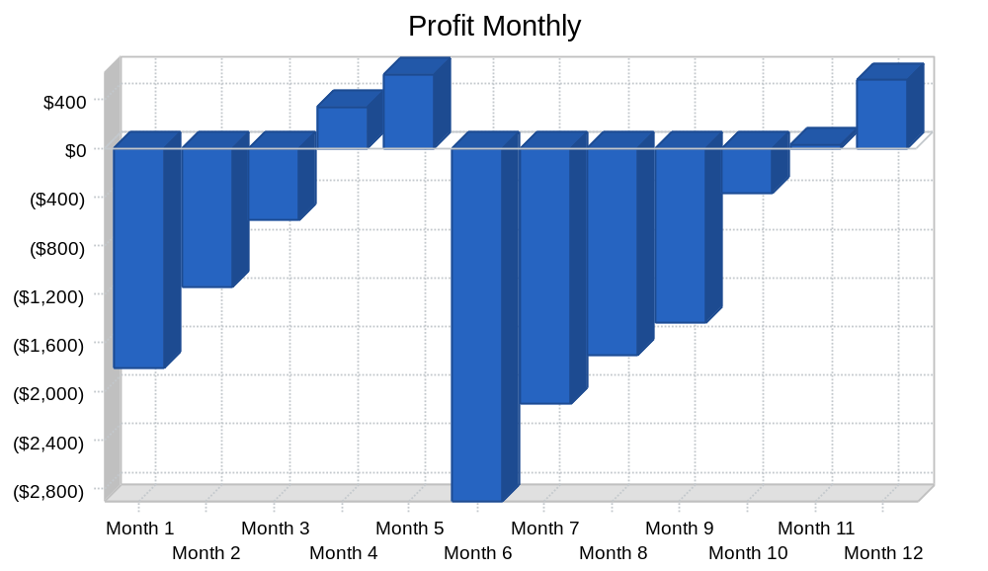

Profit Yearly (Graphical)

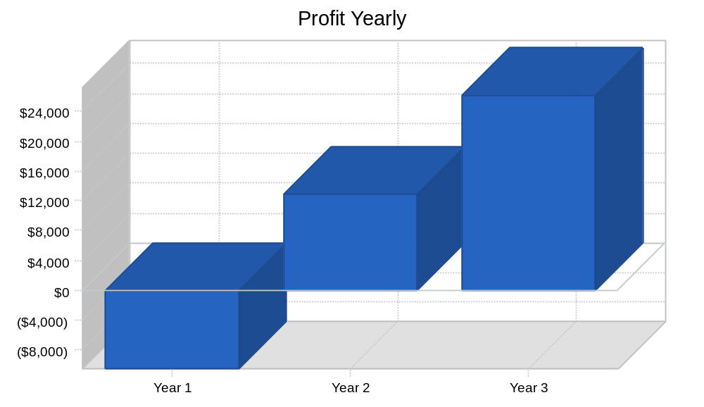

Gross Margin Yearly (Graphical)

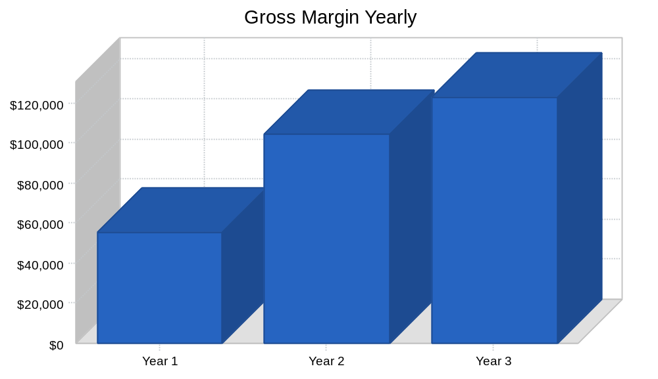
Profit and Loss (Tabulated)

Pro Forma Profit and Loss
 | Year 1 | Year 2 | Year 3
Sales | $58,100 | $109,837 | $129,557
Direct Cost of Sales | $2,905 | $5,492 | $6,478
Other Production Expenses | $0 | $0 | $0
Total Cost of Sales | $2,905 | $5,492 | $6,478
Gross Margin | $55,195 | $104,345 | $123,080
Gross Margin % | 95.00% | 95.00% | 95.00%
Expenses
Payroll | $48,500 | $66,000 | $66,000
Sales and Marketing and Other Expenses | $0 | $0 | $0
Depreciation | $960 | $960 | $960
Leased Equipment | $0 | $0 | $0
Utilities | $1,200 | $1,200 | $1,200
Insurance | $1,800 | $1,800 | $1,800
Rent | $6,000 | $6,000 | $6,000
Payroll Taxes | $7,275 | $9,900 | $9,900
Other | $0 | $0 | $0
Total Operating Expenses | $65,735 | $85,860 | $85,860
Profit Before Interest and Taxes | ($10,540) | $18,485 | $37,220
EBITDA | ($9,580) | $19,445 | $38,180
Interest Expense | $0 | $0 | $0
Taxes Incurred | $0 | $5,546 | $11,166
Net Profit | ($10,540) | $12,940 | $26,054
Net Profit/Sales | -18.14% | 11.78% | 20.11%

Projected Cash Flow

The following chart and table will indicate projected cash flow.
Cash Flow

Pro Forma Cash Flow
 | Year 1 | Year 2 | Year 3
Cash Received
Cash from Operations
Cash Sales | $58,100 | $109,837 | $129,557
Subtotal Cash from Operations | $58,100 | $109,837 | $129,557
Additional Cash Received
Sales Tax, VAT, HST/GST Received | $0 | $0 | $0
New Current Borrowing | $0 | $0 | $0
New Other Liabilities (interest-free) | $0 | $0 | $0
New Long-term Liabilities | $0 | $0 | $0
Sales of Other Current Assets | $0 | $0 | $0
Sales of Long-term Assets | $0 | $0 | $0
New Investment Received | $0 | $0 | $0
Subtotal Cash Received | $58,100 | $109,837 | $129,557
Expenditures | Year 1 | Year 2 | Year 3
Expenditures from Operations
Cash Spending | $48,500 | $66,000 | $66,000
Bill Payments | $17,265 | $29,392 | $36,001
Subtotal Spent on Operations | $65,765 | $95,392 | $102,001
Additional Cash Spent
Sales Tax, VAT, HST/GST Paid Out | $0 | $0 | $0
Principal Repayment of Current Borrowing | $0 | $0 | $0
Other Liabilities Principal Repayment | $0 | $0 | $0
Long-term Liabilities Principal Repayment | $0 | $0 | $0
Purchase Other Current Assets | $0 | $0 | $0
Purchase Long-term Assets | $0 | $0 | $0
Dividends | $0 | $0 | $0
Subtotal Cash Spent | $65,765 | $95,392 | $102,001
Net Cash Flow | ($7,665) | $14,445 | $27,557
Cash Balance | $2,385 | $16,830 | $44,387

Cash (Graphical)

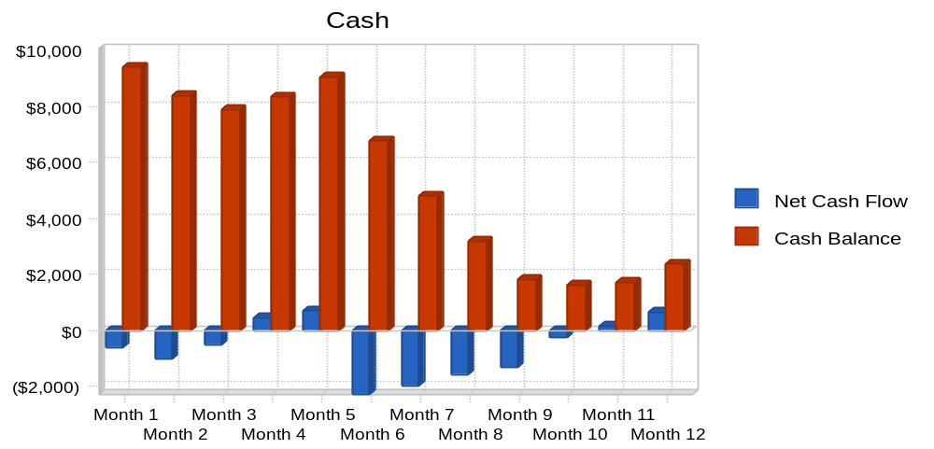
Projected Balance Sheet

The following table will indicate the projected balance sheet.

Balance Sheet
Pro Forma Balance Sheet
 | Year 1 | Year 2 | Year 3
Assets
Current Assets
Cash | $2,385 | $16,830 | $44,387
Other Current Assets | $0 | $0 | $0
Total Current Assets | $2,385 | $16,830 | $44,387
Long-term Assets
Long-term Assets | $4,800 | $4,800 | $4,800
Accumulated Depreciation | $960 | $1,920 | $2,880
Total Long-term Assets | $3,840 | $2,880 | $1,920
Total Assets | $6,225 | $19,710 | $46,307
Liabilities and Capital | Year 1 | Year 2 | Year 3
Current Liabilities
Accounts Payable | $1,915 | $2,461 | $3,004
Current Borrowing | $0 | $0 | $0
Other Current Liabilities | $0 | $0 | $0
Subtotal Current Liabilities | $1,915 | $2,461 | $3,004
Long-term Liabilities | $0 | $0 | $0
Total Liabilities | $1,915 | $2,461 | $3,004
Paid-in Capital | $16,000 | $16,000 | $16,000
Retained Earnings | ($1,150) | ($11,690) | $1,250
Earnings | ($10,540) | $12,940 | $26,054
Total Capital | $4,310 | $17,250 | $43,303
Total Liabilities and Capital | $6,225 | $19,710 | $46,307
Net Worth | $4,310 | $17,250 | $43,303
Business Ratios

The following table outlines some of the more important ratios from the Management Consulting Resources industry. The final column, Industry Profile, details specific ratios based on the industry as it is classified by the Standard Industry Classification (SIC) code, 8742.

Ratios

Ratio Analysis
 | Year 1 | Year 2 | Year 3 | Industry Profile
Sales Growth | N/A | 89.05% | 17.95% | 8.60%
Percent of Total Assets
Other Current Assets | 0.00% | 0.00% | 0.00% | 46.70%
Total Current Assets | 38.31% | 85.39% | 95.85% | 74.90%
Long-term Assets | 61.69% | 14.61% | 4.15% | 25.10%
Total Assets | 100.00% | 100.00% | 100.00% | 100.00%
Current Liabilities | 30.76% | 12.48% | 6.49% | 42.80%
Long-term Liabilities | 0.00% | 0.00% | 0.00% | 17.20%
Total Liabilities | 30.76% | 12.48% | 6.49% | 60.00%
Net Worth | 69.24% | 87.52% | 93.51% | 40.00%
Percent of Sales
Sales | 100.00% | 100.00% | 100.00% | 100.00%
Gross Margin | 95.00% | 95.00% | 95.00% | 0.00%
Selling, General & Administrative Expenses | 113.14% | 83.22% | 74.89% | 83.50%
Advertising Expenses | 0.00% | 0.00% | 0.00% | 1.20%
Profit Before Interest and Taxes | -18.14% | 16.83% | 28.73% | 2.60%
Main Ratios
Current | 1.25 | 6.84 | 14.78 | 1.59
Quick | 1.25 | 6.84 | 14.78 | 1.26
Total Debt to Total Assets | 30.76% | 12.48% | 6.49% | 60.00%
Pre-tax Return on Net Worth | -244.55% | 107.16% | 85.95% | 4.40%
Pre-tax Return on Assets | -169.32% | 93.78% | 80.38% | 10.90%
Additional Ratios | Year 1 | Year 2 | Year 3
Net Profit Margin | -18.14% | 11.78% | 20.11% | N/A
Return on Equity | -244.55% | 75.01% | 60.17% | N/A
Activity Ratios
Accounts Payable Turnover | 10.02 | 12.17 | 12.17 | N/A
Payment Days | 27 | 27 | 27 | N/A
Total Asset Turnover | 9.33 | 5.57 | 2.80 | N/A
Debt Ratios
Debt to Net Worth | 0.44 | 0.14 | 0.07 | N/A
Current Liab. to Liab. | 1.00 | 1.00 | 1.00 | N/A
Liquidity Ratios
Net Working Capital | $470 | $14,370 | $41,383 | N/A
Interest Coverage | 0.00 | 0.00 | 0.00 | N/A
Additional Ratios
Assets to Sales | 0.11 | 0.18 | 0.36 | N/A
Current Debt/Total Assets | 31% | 12% | 6% | N/A
Acid Test | 1.25 | 6.84 | 14.78 | N/A
Sales/Net Worth | 13.48 | 6.37 | 2.99 | N/A
Dividend Payout | 0.00 | 0.00 | 0.00 | N/A

Appendix


Q: 2: A group of 18 year old ask you, a bank manager, for a £7000 loan to start a car wash business.
They have found a space for reasonable rent of £500/ month. They hope to be in profit after a year.

- What information would you expect to see in their business plan?
- Why are good business plans important?

Ans to Question # 2 Part 1. To answer the question # 2 part # 1 , first we will discuss in tabulated form and in the later part of the answer- we will discuss about each and every part content of business along with details and comparison of business plan with business case.

Element of Business Plan | What is expected | What should be in Car Wash Business
Executive Summary | It distills all the important information about your business plan into a relatively short space. It’s a high-level look at everything and should include information that summarizes the other sections of your plan. | In this section, it must be mentioned that;  - How much cars can be washed per day.  - What is market slot empty for this business?  - What is the competition.  - What will be the payback period?
Business Description | - What is the business model? (What are your customer base, revenue sources and products?)  - Do you have special business relationships that offer you an advantage?  - Where are you located?  - Who are the principals?  - What is the legal structure?  - What are some of the market opportunities?  - What is your projected growth? | In this section it is very necessary to mention that;  - What type of car or customer will be focused.  - Networking or previous relationships with potential customers.  - Location of business – easily accessible from very parts of city in order to cover both long route and city bound customers.  - The material used for washing i.e. like was detergents, foam etc and their recognition and acceptability in the market.  - Is there any legal , environmental issues with the business of local municipality restriction in setting up business in residential areas and/or specific industrial area?  - Any possibility of contract with TAXI companies or RENT A CAR or organizational fleets like Airline vehicle fleet.  - Possibility of growth in business.
Market Analysis | Your market analysis is an exercise in seeing where you fit in the market - and how you are superior to the competition.  As you create your market analysis, you need to make sure to include information on your core target market, profiles of your ideal customers and other market research. You can also include testimonials if you have them. | Following should be addressed in this section;  - Demographics and Segmentation  - Target Market  - Market Need  - Competition  - Barriers to Entry  - Regulation.  All the relevant data and data source should be attached.
Organization &  Management | Use this section of your business plan to show off your team superstars.  Venture capitalists want to know you have a competent team that has the grit to stick it out. | The whole team short description along with the details or management team with credentials (academic and/or experience)
Sales Strategies | How will you raise money with your business and make profits a reality? You answer this question with your sales strategy. This section is all about explaining your price strategy and describing the relationship between your price point and everything else at the company.  You should also detail the promotional strategies you’re using now, along with strategies you hope to implement later. This includes your social media efforts and how you use press releases and other appearances to help raise your brand awareness and encourage people to buy or sign up for your products or services. | - Starting with small niche markets  - Flexibility  - Connection with the decision maker  - Perfection of sales pitch (make it exciting)  - Highlight risks and opportunities  - Helpfulness  - Use of specific referrals  - Short product demos  - Addressing uncertainty  - Sell more to your existing customers  - Intelligently use free trials
Funding Requirements | Here’s where you ask for the amount of money you need. Make sure you are being as realistic as possible. You can create a range of numbers if you don’t want to try to pinpoint an exact number. Include information for a best-case scenario and a worst-case scenario. You should also put together a time line, so your potential funders have an idea of what to expect. | For cars washing business, the major expenses will be the utility bills ( Water, electricity etc) Employee Salaries (wages), Consumables ( Detergent, wax, soap) etc. In addition to the rent and regular ( govt fee and taxes).  Normally the minimum finance required for a business is three months reserves of operating expenses and one month running expenses.  So, the funding requirements will be  (Monthly expenses x 4) – Available Funds = Funding Required.
Financial Projections | Your forward-looking projections should be based on information about your revenue growth and market trends. You want to be able to use information about what’s happening, combined with your sales strategies, to create realistic projections that let others know when they can expect to see returns. | In this section, the calculation regarding expected sales possible upcoming contracts (short/long term), possible increase in sales because of some sand storm or thunder storm or some festivals because of these factors the car washing requirement increase.

A business plan is "merely" a "plan for the business," where the business may be a profit-making company, a government organization, or a non-profit organization. A business plan can also represent a product line, an individual product, a line of service products, or some other part of a larger business entity.

For companies in private industry, the heart of the business plan is a business model and business strategy which describe how and where the company expects to make and spend money. All other parts of the business plan stem from the model.

The Business Plan Looks Forward in Time

Business plans usually look forward in time for a period of one to three years to a "planning horizon," which moves forward periodically with reviews and updates. Business plans for different organizations will differ somewhat in content and structure, but most are designed to address two fundamental kinds of questions:

What will the business look like in one year? Two, or three years? (I.e., what will business performance look like and what will the financial position look like then?)
How does the organization bring about the desired performance and build a stable financial situation?
Founders and owners typically develop an initial business plan before startup. They build the plan anticipating using it as a tool for supporting their requests for investment capital or loans to start the business. And, once the company is operating, the business plan becomes a living document, which management reviews and revises at least quarterly.

Explaining the Business Plan in Context

Following sections further describe and illustrate the business plan. Note especially that examples and illustrations appear in context with concepts from business strategy and business case analysis.

The business plan typically serves quite a few different purposes including the following. An in-depth business plan:

Projects the Financial Future

The main item of interest in the business plan, for many people, is a picture of the financial future. The plan projects the future economic situation and financial performance of the company, for owners, investors, and potential investors.

Identifies and Measures Risks

An in-depth business plan Identifies and measures significant risks for the business. These are events that would lead to different financial situations and financial performance results. The document must therefore also present strategies for dealing with threats and managing risks.

Describes the Business Model

The business plan defines and outlines the company's business model. The model shows where and how the company expects to spend money, bring in revenues and earn margins. And, the model includes a quantitative Pro-forma Income statement estimating gross margin, operating margin, and profit margin.

Identifies Key Assumptions

A complete business plan Identifies critical assumptions and trends underlying future financial results for the company. These may include trends in business volume, market demand, competitors’ actions, or prices of goods and services crucial to the business. As a result, senior managers watch these trends closely and update the plan when they change.

Helps Prioritize Business Objectives

A complete business plan guides management in setting and prioritizing business objectives. The business plan thereby provides a basis for:

- Setting financial targets for financial goals.
- Setting targets for key performance indicators for non-financial objectives.
- Setting targets for key performance indicators for non-financial objectives.
- Identifying contingencies and critical success factors critical for meeting objectives.

Source for Budgeting

The business plan serves as the primary starting resource for developing budgets. The business plan serves as the primary starting resource for developing budgets. In this role, it is indispensable for budgetary work because it captures the company's forecasts for spending and incoming revenues.

Serves as a Resource for Business Case Analysis

The business plan is a critical resource for those building or evaluating business case analyses. Business Case Analysis is central for instance, for supporting capital acquisitions, investments, product or marketing decisions, and project proposals.

The contents, structure, and emphasis in the business plan are designed to address purposes that are most important to management, owners, and investors.

Business Plan for a Startup Company

Founders of a business startup construct a business plan, intending to show potential investors or loan sources all of the following:

- The company's business prospects are good.
- Management and Directors are competent.
- Management understands the company's products, markets, and competition. And, the company's strategy is sound.
- Planning is robust and realistic.
- Investors can expect a good return on their investment.

Business Plan for an Established Company

A business plan for an established company that is performing well will emphasize the same points as the plan for a startup company, above. By contrast, the business plan for a poorly performing company poorly will try to make these points:

- Management understands the reasons for poor business performance.
- Management has promising strategies for improving performance. One such approach, for instance, could be changing the business model.
- Management has the means and ability to implement an improvement plan.
Business Plan for Government and non-profit organizations
Business plans for government and non-profit organizations can be very similar to those for companies in private industry sell goods and services. The similarity is necessary because governments and non-profit organizations still must:

- Deliver services.
- Recognize they have a "market" and "customers, " These organizations, in other words, have a population to serve.
- Create and operate within spending budgets.
- Find ways to receive funds to cover expenses.

The emphasis and order of business plan components can, of course, differ from business to business. Nevertheless, a business plan template or business plan model for most companies would almost certainly include at least some treatment of all of the following sections.

High-Level Description of the Business

Describe the business of the company or organization and provides a brief history and status summary of the firm.

Products and Services

Describe what the organization sells or delivers. Include the company's value proposition. Also, include a strategy for continuing or evolving products/services to remain competitive and grow the business. This section may also include product, manufacturing, distribution, and service plans.

The Market

Describe the market the business addresses (or the population served). The description should include the following:

- Total Market Size
- Accessible Market Size
- Market Demographics
- Market Growth
- Market Maturity
- Changing Market Demand
- Current and Target Share
- Competitors
- Competitive Analysis

Also, include marketing strategy and marketing plan.

Business Location and Manner of Doing Business

Describe the role physical location does or does not play in the business and the manner of selling. Also, describe how the firm delivers products and services. Such descriptions could refer to "brick and mortar" stores, internet sales, or mail order sales and delivery, for instance. And, finally, describe the role (if any) of a direct sales force.

Management and Governance

Describe management organization and management levels, lines of reporting and accountability. Also, describe capabilities and professional experience and skills necessary for management.

Financial Information

Include the following:

- Pro-forma (projected future) financial accounting statements for several years or more into the future (Income statement, Balance sheet, statement of changes in financial position, and retained earnings statement).
- Expected sources of funds, e.g., invested capital, sales revenues, loans, and other funding sources,
- Cost structure and expected uses of funds.
- Working capital requirements and expected cash inflows/outflows.
- Business performance projections and financial position financial metrics (including investment metrics, such as return on assets, leverage metrics such as the debt/equities ratio, and profitability metrics such as operating margin and profit margin.

Business Strategy

Explain how the company defines and distinguishes itself from the competition and identify critical strategic objectives. For instance, explain how the firm expects to achieve industry-leading customer satisfaction. Or, show how the firm will successfully "brand" company products and services for design and quality leadership. (For more on business strategy see Business Strategy).

The Business Model

It is fair to say that the business model is the "heart" of the business plan. Or, more accurately, the business model is the framework for describing the business and projected results. Sections 1-7 above show how the company will build on that framework to achieve good results and what they will look in Pro-forma statements. (For more on the business model, see Business Strategy).

Business Plan vs. Business Case

The business case is organized around an action or decision, to address business case questions like those given above. Those questions contrast with the focus of the business plan, which addresses similar issues about the organization (or about the business). The business plan address questions like these:

- What will the "business" look like in one year? In Three Years? That is, what will its financial position and business performance look like then?
- How does the business get to those results?
- What sales, margins, and revenues can we expect next year?
- How many years will it take this startup firm to become profitable?
Confusion sometimes arises about the differences between the business case and the business plan and the ways they complement each other.

In brief, a business plan (as it appears above) is "all about" the "business" (or the organization, or a part of the firm). The business case is designed to address questions about a single action or decision.

Whereas the business plan asks what the business will look like, the business case asks: What will be the consequences (in business terms) if we take this or that action? In contrast to the business plan questions above, the business case addresses issues like these:

Business cases are designed to answer questions like these about the consequences of an action or decision:

- What will be the financial consequences if we choose X or do Y?
- Are there critical non-financial outcomes can we expect in either case?
- What will we need as a capital budget next year if we decide to buy the service vehicles instead of leasing them?
- Is the investment in new phone technology justified? Is there a positive ROI?

Business Case and Business Plan Compared

The table below summarizes and contrasts the essential differences between a business case and a business plan.

 | A Business Plan... | A Business Case.
Is organized around: | An organization or the entire enterprise. The plan may cover a single product or product line or the whole organization | A single action or single decision and its alternatives.
Predicts: | Business performance of the organization, especially in the main categories of the Income statement. May include projected Pro-forma Income statements or Balance sheets for future years. | Cash flow results and critical non-financial impacts that follow from the action.
Focuses on: | Business objectives for the organization. | Business objectives for the action (what the act intends to accomplish).
Is based on: | The business model for the organization (showing where and how the company makes money, similar to Income statement), as well as expected trends, competitor actions, etc. | A cost model and a benefits rationale, designed for the case, and applied to one or more action scenarios.
Measures: | Business performance in terms such as sales, margins, profits, and business "health" by contributions to important Balance sheet categories | Financial metrics such as NPV, IRR, ROI, payback period, and TCO, based on projected cash flow. Also includes critical non-financial impacts.
In a non-profit or government organization: | May focus on funding needs, budgetary requirements, and ability to operate within a budget. | The scope of the case may include benefits and costs to the population served as well as the organization itself.

A business case can support a business plan by helping answer questions like this: "How will the action impact the organization's business performance?

A business plan can support a business case by helping case developers estimate costs and expenses, revenues, and expected changes in these areas.

- Why are good business plans important?

Ans to Question # 2 Part 2.No matter how long you’ve been in operation, your business needs a plan. A good business plan can help you secure funding for your startup or expand your operation.

Even if you aren’t looking for a capital infusion right this moment, a business plan can still be a great deal of help. The process of creating a business plan forces you to look at your business and evaluate what’s working -and what isn’t. It can help you focus on the right things and give you a roadmap to future success.

The Importance of a Business Plan

A few years ago, a software company surveyed its users to determine how helpful a business plan was to success. The results were reviewed by the University of Oregon for validation, and seem to point to the improved outcomes for those with business plans:

Of those who created plans, 64 percent grew their businesses, compared to 43 percent of companies that hadn’t yet finished a plan.
Those who created plans were more likely to secure a loan or investment capital.
A Babson College study discovered a written business plan wasn’t all that important -unless you were trying to raise money. In cases involving raising capital or getting a loan, businesses with plans were more likely to get the funding they needed.

Consider the company Coffee House, Inc. The founders are excited about providing a coffee shop for customers using their own brand of coffee. They plan to grind the beans at the coffee house to provide fresh coffee, as well as sell some of their product in bulk to customers who want to brew at home. They can also sell accessories to help customers make the most of their coffee experience, at the shop and at home.

Coffee House isn’t sure about how to proceed or measure success. A business plan can take ideas from the founders, put them to paper and provide a roadmap to take action.

Times You’ll Be Glad You Have a Business Plan

Any business hoping to raise funds, either with the help of loans or through venture capital, needs a plan. If you show up at the bank to ask for a loan, all the decision-makers will want to see a business plan. Venture capitalists also like to know that you are organized and informed and that you have a strategy to help them realize a return on their investment.

However, you can benefit from a business plan beyond raising money. Even if you aren’t currently looking for funding, you’ll be glad to have a direction when you are trying to figure out what your next step should be. The market analysis section can help you clarify your efforts, so you focus on just the right thing to find your niche and exploit it.

A good business description can help you stay on track, while sales strategies can remind you of how you plan to increase your revenue. Your business plan is about organizing and planning ahead so you have the lay of the land and are ready to build your business in a way that makes sense. When you face uncertainty and you aren’t sure where to go next, your business plan can provide you with the guidance you need.

A business plan is an important tool for managing and growing your business. A well-designed plan lays out a vision of growth and the steps needed to get there. A plan is also an essential communications tool for attracting financing for your business as well as managers and staff as your business grows.

Clarify Direction

The primary purpose of a business plan is to define what the business is or what it intends to be over time. Clarifying the purpose and direction of your business allows you to understand what needs to be done for forward movement. Clarifying can consist of a simple description of your business and its products or services, or it can specify the exact product lines and services you'll offer, as well as a detailed description of your ideal customer.

Future Vision

Businesses evolve and adapt over time, and factoring future growth and direction into the business plan can be an effective way to plan for changes in the market, growing or slowing trends, and new innovations or directions to take as the company grows. Although clarifying direction in the business plan lets you know where you're starting, future vision allows you to have goals to reach for.

Attract Financing

The Small Business Administration states, "The development of a comprehensive business plan shows whether or not a business has the potential to make a profit." By putting statistics, facts, figures and detailed plans in writing, a new business has a better chance of attracting investors to provide the capital needed for getting started.

Attract Team Members

Business plans can be designed as a sale tool to attract partners, secure supplier accounts and attract executive level employees into the new venture. Business plans can be shared with the executive candidates or desired partners to help convince them of the potential for the business and persuade them to join the team.

A business plan is a very important strategic tool for entrepreneurs. A good business plan not only helps entrepreneurs to focus on the specific steps necessary for them to make business ideas succeed, but it also helps them to achieve both their short-term and long-term objectives.

If you fail to plan, you are planning to fail.
Benjamin Franklin

Venture capitalist and Silicon Valley pioneer Eugene Kleiner once stated that writing a business plan forces you into disciplined thinking. An idea may sound great, but when you put down all the details and numbers, it may fall apart.

While a business plan is absolutely essential in entrepreneurship, not every entrepreneur sees the need for it. Many are reluctant to have their plan written down. In fact, there are numerous articles online claiming that the business plan is dead or irrelevant. Of course not everyone agrees with that.

A large number of business funding experts, agree that having a good business idea is not enough. Even excellent business ideas can be totally useless if you cannot formulate, execute and implement a strategic plan to make your business idea work.

If you're looking to raise funds from institutional investors and lenders, keep in mind that having a good business plan is extremely valuable. You should aim to have a well-documented business plan that speaks for itself. It needs to be clear and easy to read and understand.

Unless commitment is made, there are only promises and hopes; but no plans
Peter F. Drucker

Before writing a business plan, it is important to consider two important factors-

Who will the reader be?
For example, if you are interested in raising capital, it is very likely that investors will be your target audience. If you are interested in partnerships or joint ventures, your potential business partners will be your audience.
What do you want their response to be?
Depending on your target audience, focus on the key message you want them to receive in order to get the response you want.
Few reasons why you need a business plan are;

To raise money for your business

Potential investors or lenders want a written business plan before they give you money. A mere description of your business concept is not enough. Instead, ensure you have a thorough business and financial plan that demonstrates the likelihood of success and how much you will need for your business to take off.

To make sound decisions

As an entrepreneur, having a business plan helps you to define and focus on your business ideas and business strategies. You not only concentrate on financial matters, but also on management issues, human resource planning, technology and creating value for your customer.

To help you identify potential weaknesses

Having a business plan helps you to identify potential pitfalls in your idea. You can also share the plan with others who can give you their opinions and advice. Identify experts and professionals who are at a position to give you invaluable advice and share your plan with them.

To communicate your ideas with stakeholders

A business plan is a communication tool that you can use to secure investment capital from financial institutions or lenders. It can also be used to convince people to work for your enterprise, to secure credit from suppliers, and to attract potential customers.

Creating a business plan involves a lot of thought. You need to consider what you want to do and use that as a starting point. It doesn't need to be complicated. At its core, your plan should identify where you are now, where you want your business to go, and how you will get there.

Writing a good business plan, the Ernst and Young Business Plan Guide adds, can’t guarantee success, but it can go a long way toward reducing the odds of failure.

Why do you want a business plan? You already know the obvious reasons, but there are so many other good reasons to create a business plan that many business owners don't know about. So, just for a change, let's take a look at the less obvious reasons first and finish with the ones you probably already know about. Think of this as a late-show top 10, with us building up to the most important reasons you need a business plan

Set specific objectives for managers

Good management requires setting specific objectives and then tracking and following up. I'm surprised how many existing businesses manage without a plan. How do they establish what's supposed to happen? In truth, you're really just taking a short cut and planning in your head--and good for you if you can do it--but as your business grows you want to organize and plan better and communicate the priorities better. Be strategic. Develop a plan; don't just wing it.

Share your strategy, priorities and specific action points with your spouse, partner or significant other

Your business life goes by so quickly: a rush of answering phone calls, putting out fires, etc. Don't the other people in your business life need to know what's supposed to be happening? Don't you want them to know?

Deal with displacement

Displacement is probably by far the most important practical business concept you've never heard of. It goes like this: "Whatever you do is something else you don't do." Displacement lives at the heart of all small-business strategy. At least most people have never heard of it.

Decide whether or not to rent new space

Rent is a new obligation, usually a fixed cost. Do your growth prospects and plans justify taking on this increased fixed cost? Shouldn't that be in your business plan?

Hire new people

This is another new obligation (a fixed cost) that increases your risk. How will new people help your business grow and prosper? What exactly are they supposed to be doing? The rationale for hiring should be in your business plan.

Decide whether you need new assets, how many, and whether to buy or lease them

Use your business plan to help decide what's going to happen in the long term, which should be an important input to the classic make vs. buy. How long will this important purchase last in your plan?

Share and explain business objectives with your management team, employees and new hires

Make selected portions of your business plan part of your new employee training.

Develop new business alliances

Use your plan to set targets for new alliances, and selected portions of your plan to communicate with those alliances.

Deal with professionals

Share selected highlights or your plans with your attorneys and accountants, and, if this is relevant to you, consultants.

Sell your business

Usually the business plan is a very important part of selling the business. Help buyers understand what you have, what it's worth and why they want it.

Valuation of the business for formal transactions related to divorce, inheritance, estate planning and tax issues

Valuation is the term for establishing how much your business is worth. Usually that takes a business plan, as well as a professional with experience. The plan tells the valuation expert what your business is doing, when, why and how much that will cost and how much it will produce.

Create a new business

Use a plan to establish the right steps to starting a new business, including what you need to do, what resources will be required, and what you expect to happen.

Seek investment for a business, whether it's a startup or not

Investors need to see a business plan before they decide whether or not to invest. They'll expect the plan to cover all the main points.

Back up a business loan application

Like investors, lenders want to see the plan and will expect the plan to cover the main points.

Grow your existing business

Establish strategy and allocate resources according to strategic priority. You can find more information about growing your business with a business plan by reading " Existing Companies Need Planning, Too ."

Reference & Observations
1-The course material provided by the BOLC.

Student Statement:

By submitting this assignment, I confirm that this is my own work.

Student Signature | Shoaib Qazi | Date | 24-Oct-18

For Tutor / Assessor Use Only
Total Marks
Marks Obtained
Percentage / Grade

