
Assignment Cover Sheet

Student Name: | Agata Grabowy
Student Number: | 25644
Course: | Advanced Diploma in Fashion Design – Level 5
Assignment NO: | 6

- Discuss, in detail, how the designers work?

It is an artistic profession. The fashion designer creates functional or artistic collections. In addition, he deals with the design of clothing accessories. A fashion designer is not only a person who designs outfits, but also a tailoring specialist and manager who can organize a show. He is also responsible for the selection of fabrics from which his project is to be made. A fashion designer is very narrowly specialized: one specializes in the design of coats, another in the design of underwear.
The recipient of the designed clothing is people. The point of reference here is their needs, so it is in a sense this profession is focused on services.
To carry out your project, the designer must have an idea, an idea, a vision. Only then does it change into a design (usually a freehand drawing), which is then implemented. Working in a clothing company, the designer cooperates with many people who help select projects that are part of the collection and then implement them.
The designer also cooperates with modeling agencies, participates in the preparation of shows, collection catalogs, and takes care of promoting the collection. In addition, he ensures that his ideas are in line with the trends in the world. For this purpose, she follows what is happening in the fashion world, especially in such cities as Milan, New York, Paris or London, which are considered the most important fashion centers.
The design process itself usually takes place in the office, at the studio, but often also at home. This does not mean, however, that the designer's work is closely related to one room only. On the contrary. Cooperation in the production of a collection or preparation of a show is associated with frequent relocation. The designer often visits many fabrics manufactures to find the right fabric. In addition, he visits fashion fairs, stores, and fashion shows.
A designer's work can be of an individual as well as a team nature. It all depends on the stage of creating the collection. Designing usually takes place individually, because the designer has his vision, which he wants to realize as accurately as possible. If the collection consists of designs of several designers, then cooperation between them is needed to achieve the best end result. This work is associated with intense contacts with people both at the stage of creating collections, as well as preparing fashion shows or promoting the collection. It requires the ability to communicate your thoughts both verbally and with the aid of a drawing.
It is difficult to determine the designer's working hours. Usually, they are variable and depend on the stage of creating a collection.
Due to the creative nature of this work, the designer's basic features are creativity and imagination. Artistic abilities that enable design are also necessary. In addition, it should be characterized by perceptiveness and increased sensitivity, which will allow, for example, choose the right fabric. Also important are the ability to concentrate, divide attention, accuracy, patience, ability to work under pressure.
The designer is independent in his activities; hence he must be able to organize his time and work and have self-discipline. Cooperation with people means that he must be able to cooperate in a team.
In addition, they must be real citizens of the world, must know languages, communicate very easily, and finally have a lot of knowledge in marketing, because it is the market that decides what to adopt, not the designer. The designer must take into account the specificity of youth subcultures and often draws inspiration from them and the natural desire to buy unique garments. Therefore, it should be comprehensively educated. He will need a knowledge of sociology, psychology, and history of culture.
The most important factor allowing to undertake this work is talent. It's good when it is supported by the directional education that gives a broad knowledge of design and the textile industry.

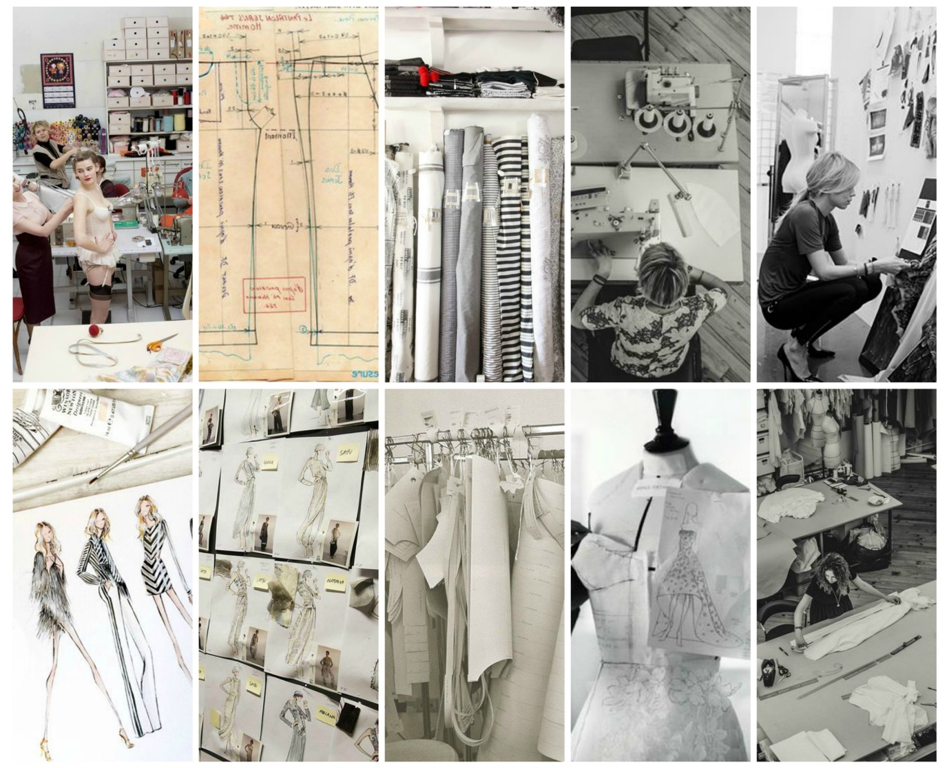

- "A fashion storyboard is a summary of your collection's inspiration and theme. It is a design tool that will help you remain focused and consistent as your line develops.” Discuss this.

Storyboard is really a set of images, texts, materials, objects, photos, color samples, everything that can reflect a certain climate concerning the collection over which the designer works. It sounds a bit intricate, but it's just a collection of inspiration that can be useful for work. Not only fashion designers use the storyboard, but also graphic designers, interior designers, architects, editors, all who simply have to convey some emotions in their works. Sometimes it's just hard to explain something in words. Speaking of green, everyone will have a different shade of color in front of their eyes, saying illustrations, you can mean beautiful old engravings or pictures from stock with funny peoples. Showing the story board (mood board), we show a little what is in our mind. At the same time, it is worth noting that the mood board does not have to be created simply for a specific realization. The "private" mood boards that are good for us every day, which we can look at and just stimulate to act, are equally good. Mood boards sometimes become an art in itself. Maybe because they are associated with scrapbook albums, small collections of memories and dreams?

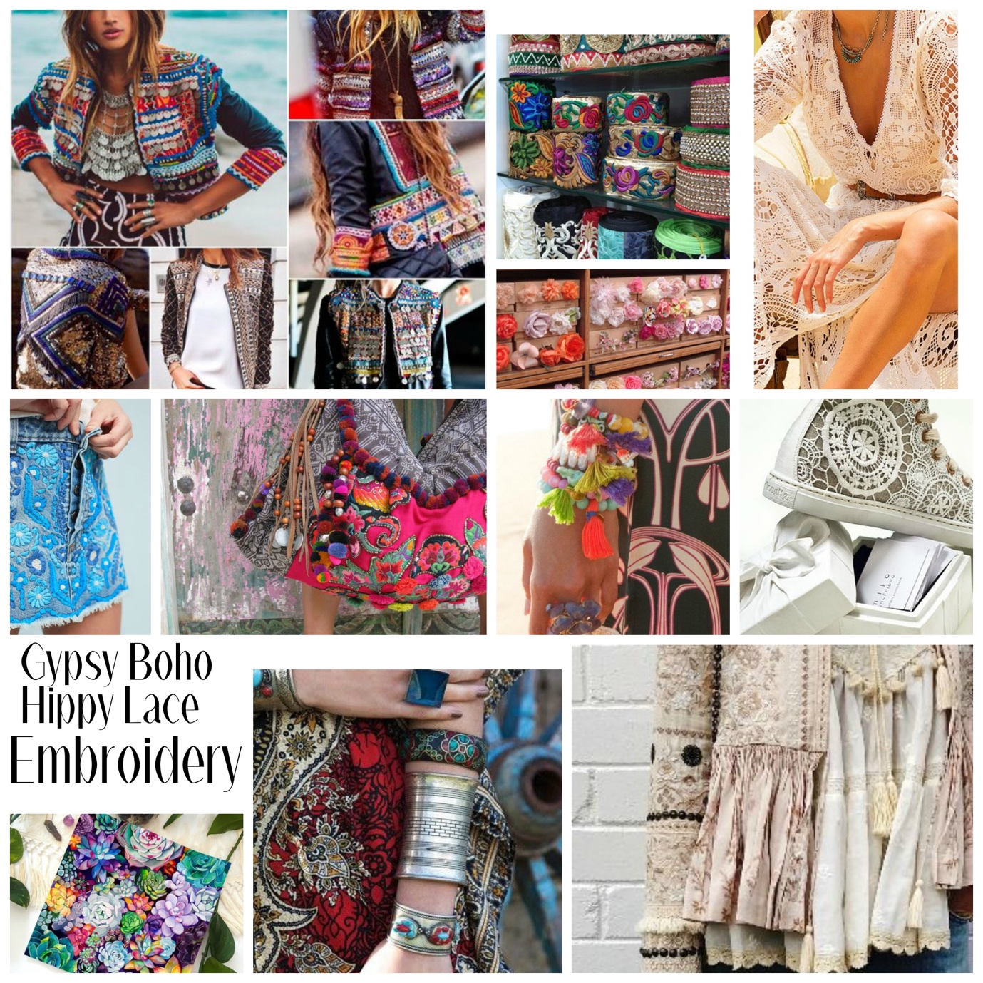

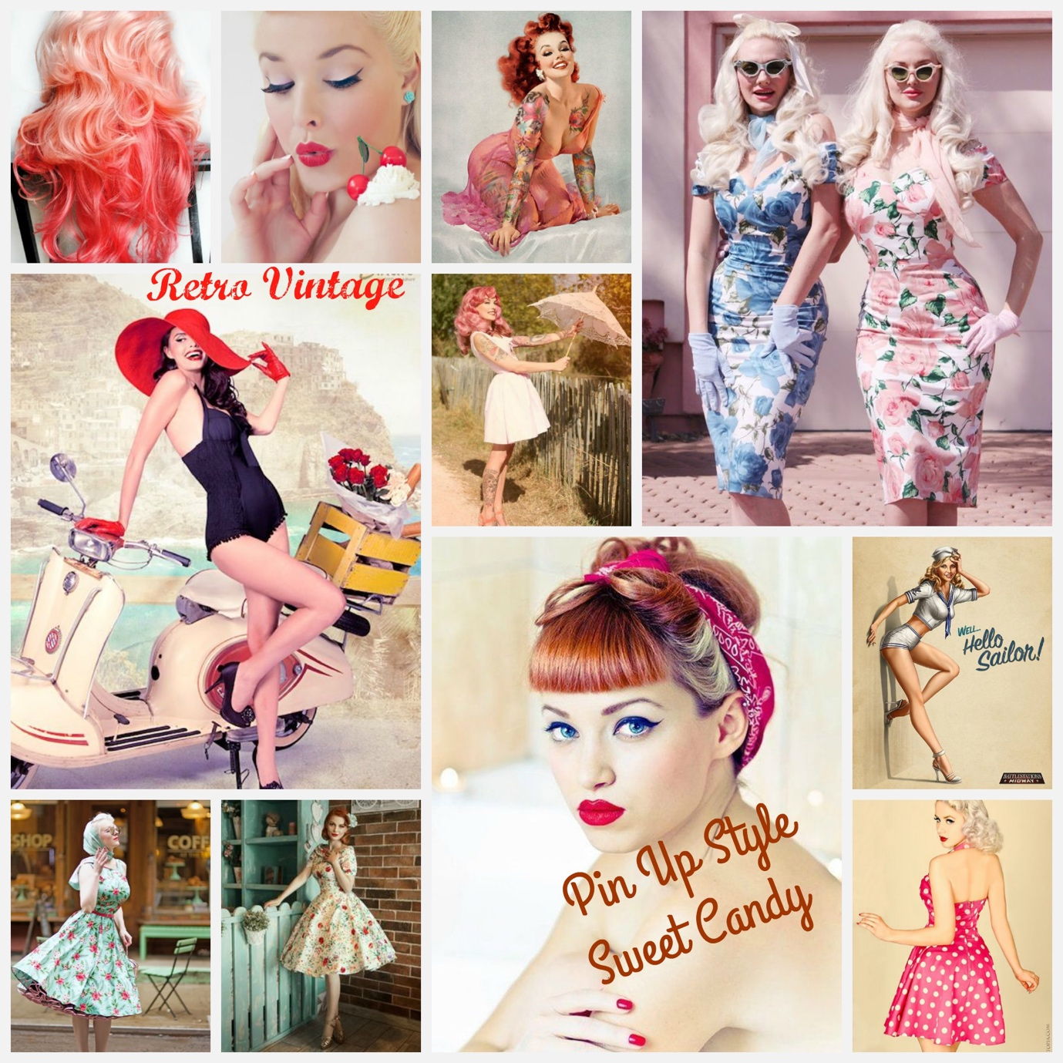

- What is the difference between a story board and a color board?

The color board is all about the colors of your collection. Images in the storyboard must be associated with the color palette. That's why it's good to build a color palette after creating a mood board. However, it is perfectly acceptable to first create a color palette and then find mood board pictures that are related to each other. The designer has to think about clothes that he plans to design and consider if the colors will work in this category. These are the key colors. Sometimes designers use key colors for most of their collections, but they can use other colors as accents. An array of colors will come to life thanks to color samples, photos of everything that reflects the inspiration of colors, including landscapes and products. If the color is vintage, the photo from the vintage decorative magazine can lead to the perfect color scheme. If the vision is a Tuscan-style color scheme, a landscape photo can give a perfect color inspiration and can help build a palette around it.
So, a story board is all the inspirations, items, solutions that can be useful in creating a collection. And a color board is all shades, textures, patterns, color combinations, from which the collection will be made.

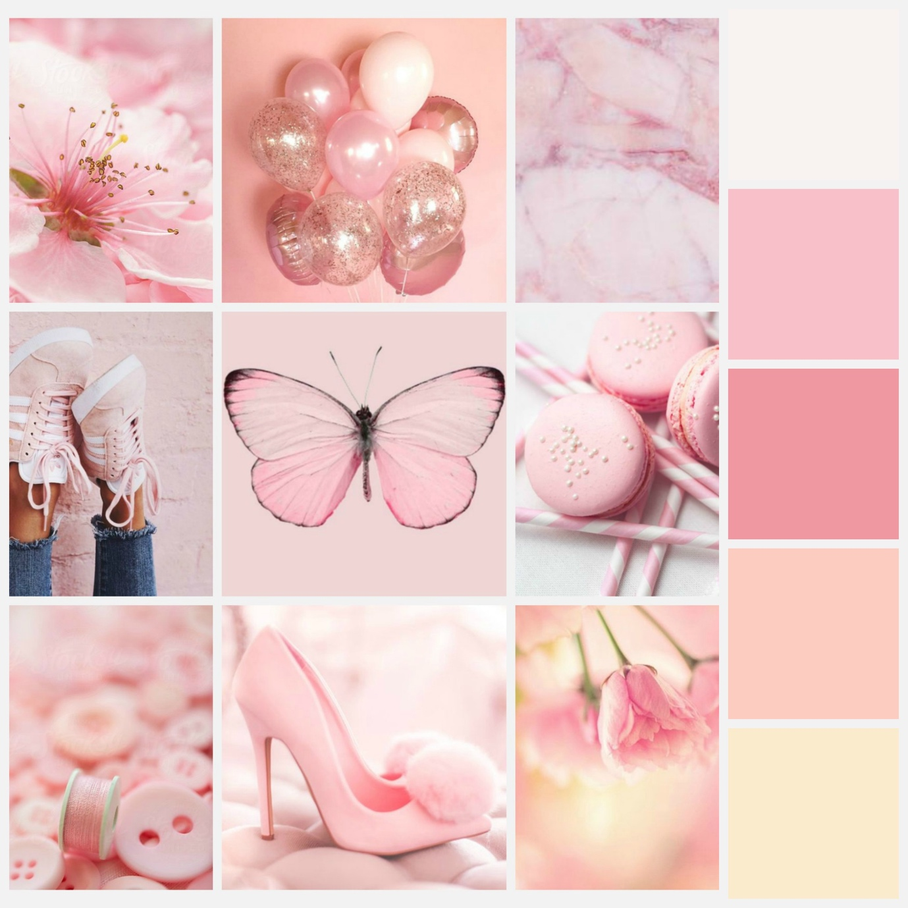

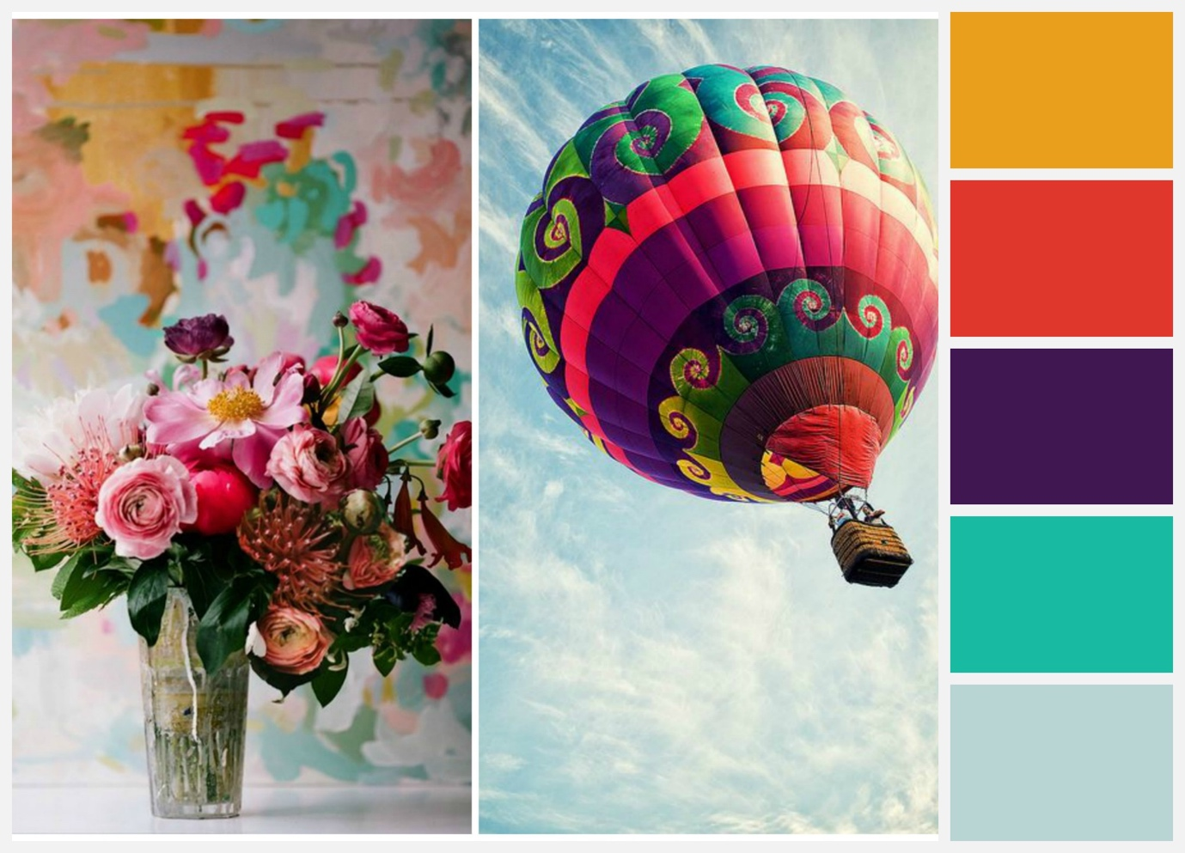

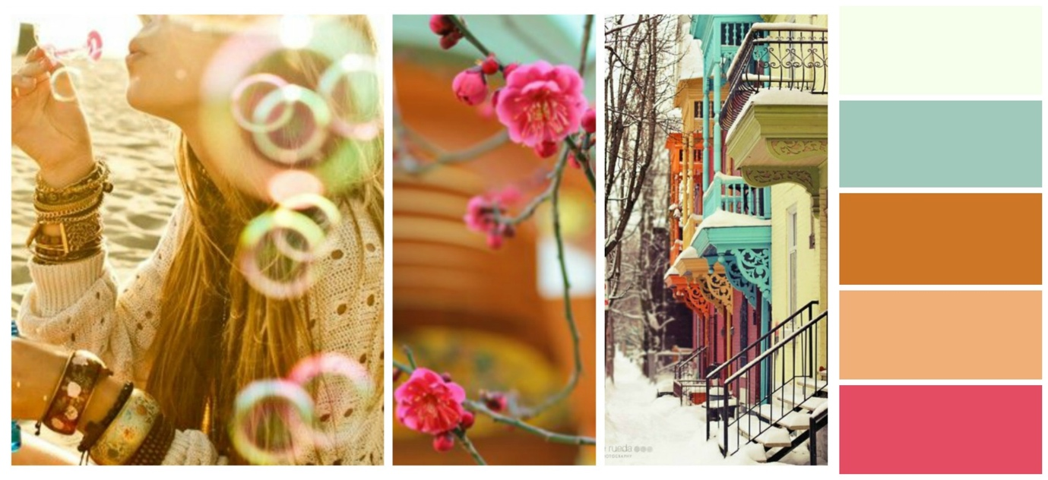

Student Statement:

By submitting this assignment, I confirm that this is my own work.

Student Signature | 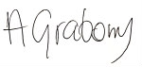 | Date | 8.04.2019

For Tutor / Assessor Use Only
Total Marks
Marks Obtained
Percentage / Grade

