
Assignment Cover Sheet

Student Name: | Hapuarachchige Srinath Jayathilake
Student Number: | 9592
Course: | Diploma in Forensic Accounting
Assignment NO: | Assessment No 09.

Marking Criteria:
We expect the learners to write minimum one well expressed point in three lines against each allocated mark. This means one needs to write 15 lines with 5 well expressed points to get high grades for a 5 marks question.
For high grades use examples and illustrations where appropriate.
Please insert your completed assignment ( in word format) here

- Give short answers for the following question

- Outline the factors on which fraud risk assessment depends?

A fraud risk assessment should be performed periodically to identify potential schemes and events that need to be mitigated.

An effective fraud risk management assessment should identify where fraud may occur and who the perpetrators might be. Therefore, control activities should always consider both the fraud scheme and the individuals within and outside the organization who could be the perpetrators of each scheme. If the scheme is collusive, preventive controls should be augmented by detective controls, as collusion negates the control effectiveness of segregation of duties.

Fraud, by definition, entails intentional misconduct, designed to evade detection. As such, the fraud risk assessment should anticipate the behavior of a potential fraud perpetrator. It is important to design fraud detection procedures that a perpetrator may not expect, requires a skeptical mindset and involves asking questions such as:

- How might a fraud perpetrator exploit weaknesses in the system of controls?
- How could a perpetrator override or circumvent controls?
- What could a perpetrator do to conceal the fraud?

Student Name: | Hapuarachchige Srinath Jayathilake
Student Number: | 9592
Course: | Diploma in Forensic Accounting
Assignment NO: | Assessment No 09.
With this in mind, a fraud risk assessment generally includes three key elements:

- Identify inherent fraud risk -Gather information to obtain the population of fraud risks that could apply to the organization. Included in this process is the explicit consideration of all types of fraud schemes and scenarios; incentives, pressures, and opportunities to commit fraud; and IT fraud risks specific to the organization.

- Assess likelihood and significance of inherent fraud risk - Assess the relative likelihood and potential significance of identified fraud risks based on historical information, known fraud schemes, and interviews with staff, including business process owners.

- Respond to reasonably likely and significant inherent and residual fraud risks - Decide what the response should be to address the identified risks and perform a cost-benefit analysis of fraud risks over which the organization wants to implement controls or specific fraud detection procedures.

Companies should apply a framework to document their fraud risk assessment. This document should consist the following’s
- List of identified fraud risks and schemes,
- Relative likelihood and significance of occurrence.
- Next, the risks and schemes are mapped to the people and/or departments that may be impacted and to relevant controls, which are evaluated for design effectiveness and tested to validate operating effectiveness.
- Lastly, residual risks are identified, and a fraud risk response is developed.

- What are the main concepts about risk assessment?
Once risks have been identified, an assessment of possible impact and corresponding likelihood of occurrence should be made using consistent parameters that will enable the development of a prioritized risk analysis. In the planning stage, management should agree on the most appropriate definition and number of categories to be used when assessing both likelihood and impact. The assessment of the impact of the risk should not simply take account of the financial impact but should also consider the organization’s viability and reputation, and recognize the political and commercial sensitivities involved. The analysis should either be qualitative or quantitative, and should be consistent to allow comparisons. The qualitative approach usually involves grading risks in high, medium and low categories.

Student Name: | Hapuarachchige Srinath Jayathilake
Student Number: | 9592
Course: | Diploma in Forensic Accounting
Assignment NO: | Assessment No 09.

Impact
The assessment of the potential impact of a particular risk may be complicated by the fact that a range of possible outcomes may exist or that the risk may occur a number of times in a given period of time. Such complications should be anticipated and a consistent approach adopted which, for example, may seek to estimate a worst case scenario over, say, a 12 month time period.

Likelihood of occurrence
The likelihood of a risk occurring should be assessed on a gross, a net and a target basis.

The gross basis assesses the inherent likelihood of the event occurring in the absence of any processes which the organization may have in place to reduce that likelihood.

The net basis assesses the likelihood, taking into account current conditions and processes to mitigate the chance of the event occurring.

The target likelihood of a risk occurring reflects the risk appetite of the organization.
Where the net likelihood and the target likelihood for a particular risk differ, this would indicate the need to alter the risk profile accordingly.

It is common practice to assess likelihood in terms of:
•high – probable
•moderate – possible
•low – remote.

The overall risk registers at organizational and operational levels should include the risk of fraud being perpetrated. Some organizations also prepare detailed fraud risk registers that consider possible fraudulent activity. The fraud risk register often directs the majority of proactive fraud risk management work undertaken by an organization.

- What are the internal factors that should be considered for fraud risk assessment?

There are several keys to effective fraud prevention, but some of the most important tools in the corporate toolbox are strong internal controls. Equally important, though, are the company's attitude towards fraud, internal controls and an ethical organizational culture. While ethical culture is driven by senior management's control environment ("tone at the top"), buy in from the company's Board of Directors and Audit Committee are also essential in promoting an ethical and transparent environment.
Student Name: | Hapuarachchige Srinath Jayathilake
Student Number: | 9592
Course: | Diploma in Forensic Accounting
Assignment NO: | Assessment No 09.
Internal control is broadly defined as a process, affected by an entity's board of directors, management and other personnel, designed to provide reasonable assurance regarding the achievement of objectives in the following categories: effectiveness and efficiency of operations, reliability of financial reporting and compliance with applicable laws and regulations.
Internal controls should not be thought of as "static." They are a dynamic and fluid set of tools which evolve over time as the business, technology and fraud environment changes in response to competition, industry practices, legislation, regulation and current economic conditions.
While no company, even with the strongest internal controls, is immune from fraud, strengthening internal control policies, processes and procedures definitely makes companies a less attractive target to both internal and external criminals seeking to exploit internal control weaknesses.
Strengthening internal controls is seldom accomplished by enhancing one process; rather it involves a comprehensive review of the risks faced, the existing internal controls already in place and their adequacy in preventing fraud from occurring. An internal control review may be conducted corporate-wide or on a location by location basis, or broken down to the individual business unit level. Generally, a review of this nature involves an in depth examination of people, processes and technology. However, there are other intangibles your organization can not afford to overlook.

Audit interaction
The first part of strengthening internal controls involves changing the attitude some employees have towards auditors. While it is easy to view auditors as the police department's "Internal Affairs" group—whose sole responsibility it is to ferret out wrongdoing—identifying employees who are breaking the rules, personal and professional success is to be had by viewing auditors as key partners and allies in the battle against fraud. This is further reinforced as the auditor's role ensures that he or she is always at the forefront of corporate policies, practices, procedures, technology, new products and services, making auditors a valuable source of corporate information.
Secondly, part of strengthening internal controls is simply a matter of defining, or clarifying, ownership roles and responsibilities.
A common misperception among corporate employees is that internal controls are solely the responsibility of the company's Audit Department. While internal auditors measure the effectiveness of internal control through their efforts, they don't generally assume ownership. They assess whether the controls are properly designed, implemented and working effectively and make recommendations on how to improve internal control.
According to the Institute of Internal Auditors, "responsibility for the system of internal control within a typical organization is a shared responsibility among all the executives, with leadership normally provided by the CFO."
Student Name: | Hapuarachchige Srinath Jayathilake
Student Number: | 9592
Course: | Diploma in Forensic Accounting
Assignment NO: | Assessment No 09.

Companies with strong internal controls (policies, processes and procedures) view the process holistically and find a team approach valuable. An effective team environment encompasses members from a variety of different business units and disciplines and may include representatives from: Human Resources, Compliance, Investigations, Audit, General Counsel's Office, Senior Management, and Security (Information and Physical).
To manage the process effectively, individual departments work together in an interactive manner. Working together increases issue awareness, strengthens communication, reduces opportunity for fraud and ensures a more comprehensive and robust internal control process.

Communication
One way to strengthen internal controls is by improving the communication process. I've seen countless situations where key stakeholders are unaware of major events occurring within a corporation or business unit. This is problematic as there is no opportunity for management to fix something that they're unaware is broken. Regular interaction and communication between departments is paramount in this process.
Communication protocols must be established and agreed upon enterprise wide. Critical incident event distribution notification processes and procedures must be in place to ensure everyone is aware of an incident and understands what their defined roles are when the incident occurs.
Part of incident awareness lies with the ethics, hotline and event notification systems being used by the corporation pursuant to Sarbanes Oxley requirements. Many industry professionals have experience with the operation of ethics and compliance hotline systems but not all incidents are reported through these compliance mechanisms. One of the key questions surrounds how companies notify key stake holders when an event occurs outside the ethics or compliance system? While this communication often falls under a first responder type program, it is imperative that companies have defined processes and communication protocols in place to notify the key management employees who "need to know."
An effective notification system operates over a central server, delivers event messaging to predefined employees in "real time," as the event occurs, and is sent directly to the employees and their smart devices. This level of event notification ensures that the people who need to know about an incident are made aware in a timely manner and fosters immediate and unified response as required.
While many companies either utilize in-house resources or contract with a vendor to provide these ethics, code of conduct and incident reporting services, an increased number of system reports generally assist in strengthening internal controls as it provides more opportunities to evaluate reported events and corresponding internal control deficiencies.
Student Name: | Hapuarachchige Srinath Jayathilake
Student Number: | 9592
Course: | Diploma in Forensic Accounting
Assignment NO: | Assessment No 09.

Segregation of duties
One area where many companies can significantly strengthen their internal controls involves segregation of duty policies and this is often considered the "primary internal control." It is imperative that there are adequate segregation of duties involving custody, authorization and control of source documents and records. E.g. one person should not have the sole authority to initiate a transaction, authorize or approve a transaction and complete the transaction without appropriate sign off processes and differing levels of management approval. The lack of proper segregation of duty policies is most often the root cause of many fraud and theft events in companies without strong internal controls in this area.
There have been so many examples of fraud committed directly as a result of a company's failure to segregate duties that it's not necessary to focus solely on one. Rather, it's important to examine the common themes which contribute to these frauds. Generally, the fraud usually occurs in a finance area; involves someone with unsupervised control over company funds and documents (cheques) and access to banking accounts for deposits and withdraws; there is no segregation of duties and the fraud occurs in companies with lax internal controls. So, for example a bookkeeper is able to write a cheque to himself without worrying about being detected.
Using established fraud prevention best practices, financial duties (cash disbursements) should always be segregated amongst multiple employees. This usually means that there are multiple employees involved in the financial process with oversight at several places in the process. This ensures that one employee cannot manipulate the entire process and increases awareness amongst employees that someone is not only looking, but conducting random audits to reconcile financial transactions. Cheque stock should be controlled and secured, secondary levels of management approval and dual signatures on checks and payment authorization on amounts over pre-established financial levels should be required. Further, all employee should have individual financial transactional levels established which vary according to their management levels, or position of authority, business unit needs and ability to obligate the business to a financial commitment.
Cheques are not the only area of concern. The same type of internal controls should be in place for company credit cards and electronic payment tools. It would be just as easy for one employee with complete responsibility for accounts payable to fraudulently wire money outside the company or establish fraudulent electronic payments without the proper level of oversight and control. Segregation of duties in this area would also prevent an employee from creating "phantom" vendor accounts, false invoices and making payments against those invoices without additional verifications in place.

Student Name: | Hapuarachchige Srinath Jayathilake
Student Number: | 9592
Course: | Diploma in Forensic Accounting
Assignment NO: | Assessment No 09.

Lessons learned
While no company wants to experience internal or external fraud events, victimization may have long term corporate anti-fraud benefits if all departments have comprehensive incident handling protocols and the incident is handled appropriately after the fact.
Appropriate handling always includes post event analysis which provides the company with an excellent "lessons learned" opportunity. During this process stakeholders need to be asking the tough questions and gathering information to identify the factors that allowed the event to occur.
The process should not be viewed as a fault finding mission but a determination of whether there was a company, policy, procedure or guideline in place to address this situation, whether the guidelines were followed as designed or adequate to address (or prevent) the specific situation that occurred.
If the fraud event occurred because an employee(s) simply failed to follow the internal control policies, then there are corrective measures that business units may take to ensure policies are followed in the future. These include communication to employees regarding increased awareness, correct handling processes and policy adherence. It may simply be that employees performed as expected under the circumstances but there were insufficient internal control policies in place to guide their behavior. Lessons learned here will strengthen internal controls through the creation of new ones.
A fraud event without in-depth incident evaluation, lessons learned and corrective action generally means that there is an excellent chance the criminals will reload the activity and the company will continue to experience high levels of fraud.

Technology
While technology enables us to perform essential business functions, there are direct correlations between technology, fraud events and the internal control process. Technological applications are probably the single greatest sources of risk and exposure that businesses face. Robust internal controls, including platform and network access controls, remote usage and password protection policies, are needed to regulate the entire computing platform.
Additionally, there must be internal controls in place for all mobile computing applications and company telecommunication devices like personal computers and smart phones. Given how quickly technology is changing, strengthening internal controls in this area revolves around fluid processes as the technology is not static.

Student Name: | Hapuarachchige Srinath Jayathilake
Student Number: | 9592
Course: | Diploma in Forensic Accounting
Assignment NO: | Assessment No 09.

- What is the “inherent risk”?

Inherent risk is the risk posed by an error or omission in a financial statement due to a factor other than a failure of control. In a financial audit, inherent risk is most likely to occur when transactions are complex, or in situations that require a high degree of judgment in regards to financial estimates.

Common Examples of Inherent Risk
Inherent risk is common in the financial services sector. Reasons include complexity and dynamism in regulating financial institutions, large networks of related companies and the development of derivative products and other intricate instruments.

Financial institutions often have longstanding and complicated relationships with multiple parties. A holding company might be involved with several different entities at once, each controlling special-purpose vehicles and other off-balance sheet entities. Each organizational structure level might have large numbers of investor and client relationships. Related parties are notoriously less transparent than separate entities.

Business relationships include those with auditors; both initial and repeat engagements with auditors create some inherent risk. Initial auditors might be overwhelmed by complexity or new topics. Repeat engagement may cause overconfidence or laxity due to personal relationships.

Non-routine accounts or transactions can present some inherent risk. For example, accounting for fire damage or acquiring another company are uncommon enough that auditors run the risk of focusing too much or too little on the unique event.
Inherent risk is particularly prevalent for accounts that require a lot of estimates from management. Fair value accounting estimates are difficult to make, and the nature of the fair value process should be disclosed in accounting statements. Auditors may have to investigate and interview the firm's decision-makers about estimation techniques to reduce error. This type of risk is magnified when it occurs for the first time or with rarity.

- Define the “residual risk”?
This is that portion of risks which was not eliminated by management actions at first. The process to minimize the impact on the business may still leave the company vulnerable with an exposed risk. This is called inherent risk. This concept not only applies to threats to a business, but also to opportunities.

Companies assess their risk appetite to see what level of risk they are comfortable with taking. Banks, for example, normally follow a conservative path and do not accept risk easy. Start-up companies, on the other hand, are more aggressive in nature and tend to go after riskier opportunities.
Student Name: | Hapuarachchige Srinath Jayathilake
Student Number: | 9592
Course: | Diploma in Forensic Accounting
Assignment NO: | Assessment No 09.

After the management identifies how much risk they are willing to take, the team analyzes the opportunity for everything they think could go wrong and causes the company to lose money. It’s impossible for management to identify every single threat for a course of action. There are always unforeseen consequences of taking any action, so there is always an element of risk associated with the unknown. The unknown risk that resides afterward is what we are taking about in this article.

Let’s look at some examples.

Transfer the risk (threat) The Company transports high value goods across country. It is not willing to accept the risk in case of damage. The risk response is to take out insurance and reduce the financial impact in case the product is damaged. The company may decide to accept some inherent risk by not insuring the goods in full.

Enhance the risk (opportunity) The Company manufactures an item, which is in a race for time to reach the market first. Two test cycles is required to get the green light for delivery. The risk response is to do an in-house test rehearsal; thereby ensuring the option is open to user acceptance on the first test. This way the product can have an early launch. Inherent risk is the gain from the opportunity that is created to reach the market first.

Share the risk (threat or opportunity) The Company trades in the commodity markets. Fuel costs can have a huge impact on a specific contract. The risk response is an agreement with the buyer: From the price at time of closing the deal any increase will be shared but also the gains in case the fuel price drops. Residual risk is zero.

- Prepare a fraud - risk assessment check list for any business of your choice.

The following is a brief example of a fraud risk assessment on purchasing segment . This example does not list all possible fraud risks that sector might have. Each company has to brainstorm to come up with their own risks. This example is just to help companies get started with their assessments.

This assessment needs to be done for all Operational and Financial areas: Accounting, Payroll, Purchasing, and Contracting and for Information Technology. For agencies with more than one division that has financial functions, the assessment needs to be completed per division

Student Name: | Hapuarachchige Srinath Jayathilake
Student Number: | 9592
Course: | Diploma in Forensic Accounting
Assignment NO: | Assessment No 09.

Sample format of the fraud -risk assessment is given below.
Factor / Risk Area and description and contracts | Date of assessment | Probability / likelihood | Impact | Control Impacts | Net Likely | Action

Check list of the fraud -risk assessment is given below.
Take for example, the risks relating to an unchanging list of suppliers. The risk management group believes fraud has a high likelihood of occurring and if so, it could cause significant financial loss to the business. The controls are thought to be weak and unlikely to reduce the risk. They have assessed the net likely impact to be high and recommend that this is an immediate priority in the contracts area.

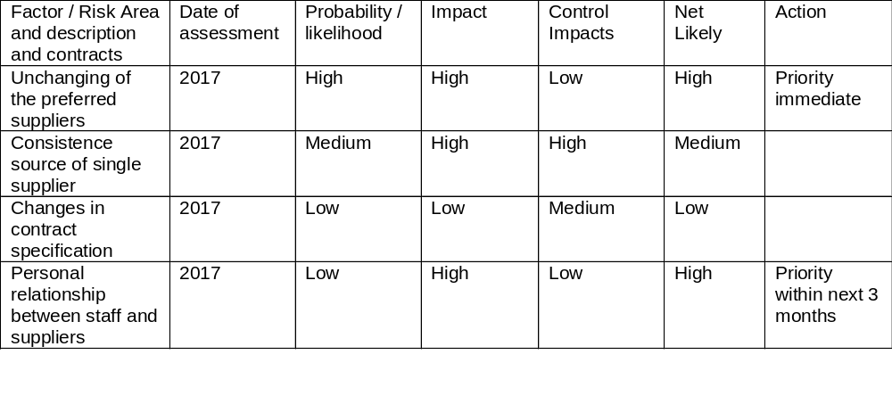
The following is an example of a fraud risk assessment at Palm Oil Plantation segment. Based on the feedback received from management, staff and stake holders, I have listed all possible fraud risks at the plantation sector. Sample format which I used to update the Risk Register is given below.
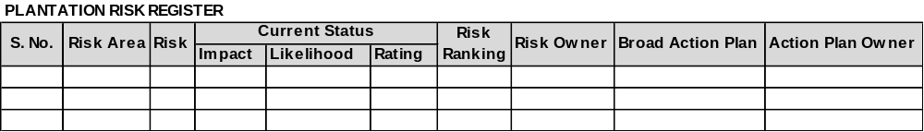
Detail check list is given below.
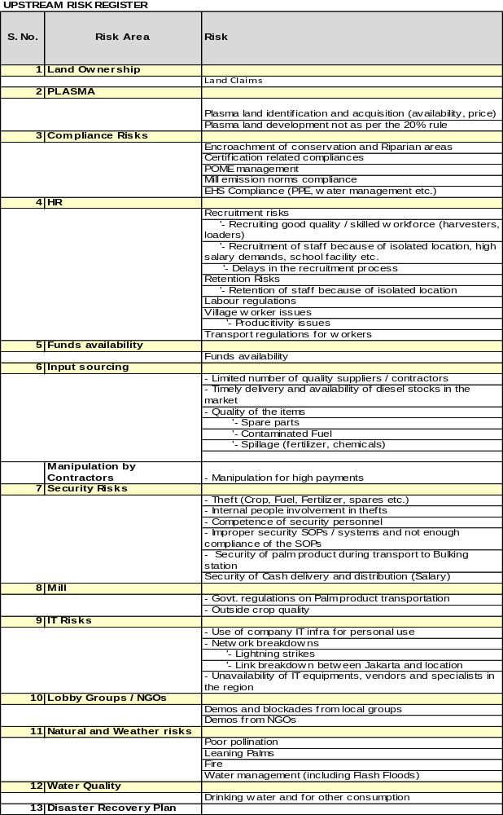

Student Statement:
By submitting this assignment, I confirm that this is my own work.
Student Signature | Hapuarachchige Srinath Jayathilake | Date | 20th Mar 2018
For Tutor / Assessor Use Only
Total Marks
Marks Obtained
Percentage / Grade

