
Assignment Cover Sheet

Student Name: | Gerard Pollock
Student Number: | 3909
Course: | Diploma in Accounting and Finance Level 4
Assignment NO: | 6

Marking Criteria:
We expect the learners to write minimum one well expressed point in three lines against each allocated mark. This means one needs to write 15 lines with 5 well expressed points to get high grades for a 5 marks question.
For high grades use examples and illustrations where appropriate.
Please see attached

Student Statement:

By submitting this assignment, I confirm that this is my own work.

Student Signature | Gerard Pollock | Date | 21.03.18

For Tutor / Assessor Use Only
Total Marks
Marks Obtained
Percentage / Grade

- What is Balance Sheet? Identify and explain any two purposes of a ‘Balance Sheet’.
The balance sheet in accounting, also known as the statement of financial position, is one of three fundamental financial statements, along with the income statement and cash flow statement. The balance sheets, are usually prepared at the end of an accounting period and states the assets, liabilities and owners equity, in other words it shows the net worth of a business.
The balance sheet presents a company’s financial position to interested parties at a specific point in time. This is valuable information for interested paties such as stakeholders, creditors and management and can be used as decision making tools.
The balance sheet is based on the fundamental equation:
Assets = Liabilities + Equity
The balance sheet gets its name from the fact that the two sides of the equation, assets on the left hand side and liabilities + shreholders equity on the right, must balance.
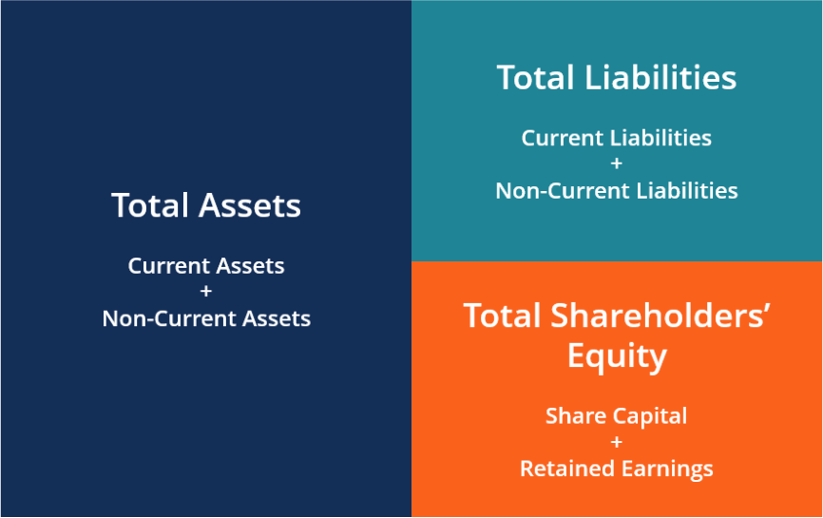

Assets
Within the assets section on the left hand side, these are broken down into 3 categories, and are listed in order of their liquidity or the ease they can be converted into cash.
Current assets – These are anyhting that can be converted into cash within a period of 1 year is classified as a current asset. An example of current assets are:
- Cash - cash in hand, cash in bank & petty cash
- Prepaid expenses – are goods and services the business has paid for in advance but has not yet used.
- Stocks and bonds – equity and debt securities for which there is a liquid.
- Inventory – good available for sale, half finished goods for sale once manufactured and raw materials used for manufacturing goods.
- Accounts receievable – The money that customers owe a business. This information must be readily availabel to the business so it can take action against unpaid accounts. There is an allowance for bad debts for customers who may not be able to pay their debt.
Long term or fixed assets – are different from current assets as they are not for resale and their life exceeds the short term (1 year or business cycle). An example of long term / fixed assets are:
- Long term investments that cannot be liquidated within the year or business cycle
- Fixed assets - Land, machinery, buildings, equipment furntiure and fixtures
- Any other items that are expected to last a long time
- Motor Vehicles
With the expection of land, fixed assets are recorded on the bakance sheet at their original cost and deprecaition is subtracted from the cost, this helps to avoid overvaluation. Sometimes, the original cost of an asset is more than the invoice proce, due to other costs being taken into account, such as shiping installation and associated expenses.
Intangible assets may include secret recipies, patents and royalties.
Liabilities
Within the liabilities section on the right hand side, these are broken down into 2 categories and are the money that is owed to outside parties, such a creditors, interest on loans, bills to suppliers. On a balance sheet the more inmportant the liabilitiy the sooner it needs to be paid. An example of this is an ‘account payable’ will appear before an ‘nopte payable’ as accounts payable have to be paid within 30 days and note payables have to be paid within 90 days.
Current liabilities – this category of liabilities incluce:
- Accounts payable – the amount owed for goods and services received.
- Notes payable – includes the amount that would need to be paid on a loan within one year
- Accrued payroll taxes – the amount that needs to be given to employees who are due to be paid for working.
Long Term Liablities – These are loans that the company has to repay after more than a year from the date of the balance sheet. This would usually incoude start up loans that were taken out to finance the business.
Equity / Net Worth
Net worth, also known as shareholders equity, is the money attributed to the business owner. It is the amount left after liabilities are deducted from the total amount of assets.

- Distinguish between fixed and current assets and describe current ratio.
Assets are items a business owns or controls in order to benefit from their use in some way. Assets are items that either supportt he primary operations of a company, such as buildings, or that generate revenue for the company, such as inventory.
The main differnece between fixed and current assets is how liquid the assets are, how easily they can be converted into cash. If an asset can be easily converted to cash within one year then they are considered as a current asset, however if the asset is kept by the business for more than 1 year then it is considered to be a fixed (long term) or non current asset.
Fixed assets can include buildings, land furniture and fixings,a nd are described as being tangible because they usually have some form os physical substance, unlike tangible assets such as goodwill, patents and royalties. In a financial statement, Fixed assets, are those with benefits that are expected to last more than 1 year from the reporting date.
Current assets such as cash, inventory, accounts receiveable and short term investments are assets that business plans to use up or convert into cash within one year from the reporting date. Inventory is classed as a current asset, as it will generate revenue when the company sells the goods. Likewise accounts receievable is classed as a current asset as it money’s owed to the business from goods that have already been sold and the customer si still due to pay. A certain allowance can be made for debts for customers who may not be able to pay.

An example of a fixed asset is a PC as it is expected to be used for more than one year to help produce goods the company will sell. A business vehicle would also be classed as a fixed asset as it is expected to last more than year to help commuting and transporting goods of the business. Fixed assets are reported on the balance sheet at their orginal cost and then depreciation is deducted so not to overvalue assets and give a reasonable wear and tear value.
Ratio is a relationship between values. It is the size of 2 values in relation to eachother and expressed as the result of one divded by the other. Analysing financial ratios is an important aspect of making financial comparisons between two companies and of determining the financial trends of a business.
Current ratio
The current ratio is a liquidity ratio that measures a company's ability to pay short-term and long-term obligations ie. Liabilities, with its assets such as cash, marketable securities, inventory and accounts receivable. As such, current ratio can be used to make a rough estimate of a company’s financial health. The current ratio can give a sense of the efficiency of a company's operating cycle or its ability to turn its product into cash. Companies that have trouble getting paid on their receivables or that have high inventory turnover can run into liquidity problems if they are unable to alleviate their obligations. The current ratio is called “current” because, unlike some other liquidity ratios, it incorporates all current assets and liabilities. The formula for calculating the a company’s current ratio is:
Current Ratio = Current Assets / Current Liabilities
A ratio under 1 indicates that a company’s liabilities are greater than its assets and suggests that the company in question would be able to pay off its obligations if they were due at that point. While a current ration below 1 shows that a company is not in good financial health, it does not necessarily mean that the company will go bankrupt. There are many ways for a company to access financing, and this is particulary so if a company has realistic expectations of future earnings against which it mght borrow. For expample, if a company has a reasonable amount of short term debt but is expecting substantial returns from a project or other investment close to when debts are due, it will likely be able to pay it’s debts.
Companies in industry such as retail, typically have current ratios below 1. This is acceptable to investors givent hat these conmpanies are able to negotiate long credir periods with suppliers while offering shorter credit periods to customer. This means that they would higher accounts payables, which falls under current assets, compared to lower accounts receivables under current assets. These companies if operating efficiently, are also able to mainten minimum levels of inventory on their balance sheet.
The higher the current ratio, the more capable the company is of paying ints obligations, as it has a larger proportion of asset value relative to the value of its liabilities. However, a high ratio (over 3) does not necessarily indicate that a copany is in a state of financial well being either. Depending on how the company’s asset are allocated, a high current ratio may suggest that a conpany is not using its current assets efficiently, is not securing financing well, or is not managing its working capital well.
An example of Current Ratio in practice is below:
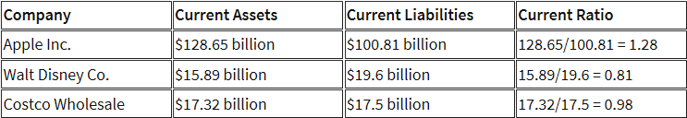

Limitiations of current Ratio
No one ratio is a perfect guage of a cmpany’s financial health or wether or not investing in a company is a good choice. Therefore when using them, it is important to undertsand their limitations.
One limitation of using the current ratio is when using it to compare different compaines with eachother, as operations can differ between industries. Comparing the current ratio of companies in different industries with one another will not necessarily lead to any productive insight. Eg. While one company mare strive to keep debts to a minimum and pay them off at the earilest opportuntiy, another industry may practive taking on large amounts od debt through leverage. This would potentially give these 2 companies different current ratios, though would not mean that one is financially healthier than the other because of their differnet business practices. In light of this, it is always good practice to compare companies within the same industry.
Another limitation of uding current ratios, is its lack of specificity. Of all the different liquidity ratios that exist, the current ratio is one of the least stringent. Unlike other liquidity ratios, it incorporates all of a company’s current assets, even those that cannot be easily liquidated. As such, a high current ratio cannot be used to effectively determine if a company is inefficiently deploying its assets, while other liquidity ratios can.
Generally, liquidity ratios can be used to gauge a company’s ability to pay off its debts. However, there are a variety of different liquidity ratios that exist and that measure this in different ways. When considering the current ratio, it is important to understand its relationship to other popular liquidity ratios.
Another class of liquidity ratios works in a similar way to the current ratio, but is more specific as to the kinds of assets it incorporates. The cash asset ratio (or cash ratio), for example, compares only a company’s marketable securities and cash to its current liabilities. The acid-test ratio (or quick ratio) compares a company’s easily liquidated assets (including cash, accounts receivable and short-term investments, excluding inventory and prepaids) to its current liabilities. The operating cash flow ratio compares a companies active cash flow from operations to its current liabilities.
Another similar liquidity ratio is the debt ratio, which is the opposite of the current ratio. Debt ratio calculations take current liabilities as the numerator and current assets as the denominator in an attempt to measure a company’s leverage.
- What do you understand from the following equation: Assets = Liabilities + Net Worth
The accounting equation is the basis on which the double entry system is constructed. The assets refer to resources owned and controlled by the organisation as a result of past transactions, such as Inventory, cash, and accounts receivable and fixed assets. The liabilities are economic obligations of the organisation. Liabilities represent claims by other parties against the assets of the organisation. Capital is what is left after all liabilities are settled.
The accounting equation offers a simple way to understand how these all relate together. If a business keeps accurate records, the accounting equation will always be in balance, meaning the left side should always equal the right side. The balance is maintained because every business transaction affects at least two of a company's accounts. When a company borrows money from a bank, the company's assets will increase and its liabilities will increase by the same amount. When a company purchases inventory for cash, one asset will increase and one asset will decrease. Because there are two or more accounts affected by every transaction, the accounting system is referred to as double-entry accounting.
When a company records a business transaction, it is not entered into an accounting equation. Rather, the company keeps track of all of its transactions by recording them in accounts in the company's general ledger. Each account in the general ledger is designated as to its type: asset, liability, owner's equity, revenue, expense, gain, or loss account. The general ledger accounts are then used to prepare the balance sheets and income statements throughout the accounting periods.
If the proprietor of a business invests $10,000 to start their business, the effect of this transaction on the accounting equation is:
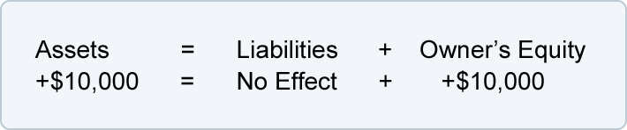
This shows that the business has assets of $10,000 and so does the owners’ equity balancing the equation. This can be interpreted as, the business has $10,000 worth of assets and the source of these assets was the proprietor, and claims against the assets. The transaction is recorded in the asset account cash and the owners’ equity (capital) account as below:
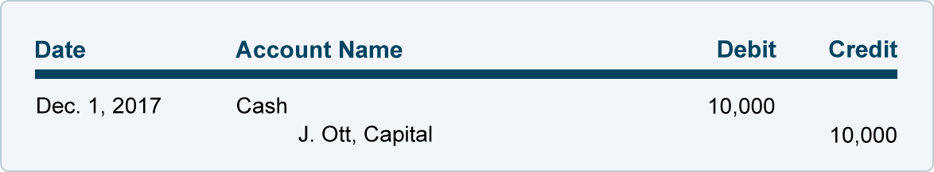
Now that the transaction has been recorded in the accounts, the balance sheet can be prepared to show the business financial position at the end of the reporting period:
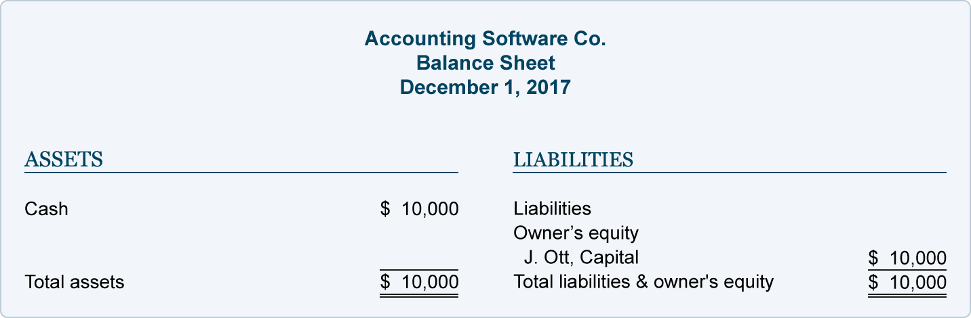
The purpose of an income statement is to report revenues and expenses. Since the business has not yet earned any revenues or incurred any expenses, there are no transactions to be reported on an income statement.
The accounting equation can be extended to:
Assets = Liabilities + Capital + Revenue – Expenses Or A = L + C + R – E
In this equation the effects of dividends and withdrawals has been ignored. If withdrawals or dividends were to taken into account, then the amount of assets will be reduced by the amount of withdrawal or dividend (as below)
Assets = Liabilities + Capital + Revenue – (Expenses + Dividends) Or A = L + C + R – (E+D)
And this equation can now be rewritten as
Assets + Expenses + Dividends = Liabilities + Capital + Revenue
The accounting equation is very important to business as it is always true and forms the basis of all accounting transactions. The accounting equation concept is built into all accounting software packages, so that all transactions that do not meet the requirements of the equation will automatically be rejected.

