
Assignment Cover Sheet

Student Name: | Sally Tomlin
Student Number: | 18902
Course: | Diploma in Construction Management
Assignment NO: | Unit 6

Marking Criteria:
We expect the learners to write minimum one well expressed point in three lines against each allocated mark. This means one needs to write 15 lines with 5 well expressed points to get high grades for a 5 marks question.
For high grades use examples and illustrations where appropriate.
1i. A famous military adage from the British Army goes: Proper Planning and Preparation Prevents Poor Performance. This applies to construction planning too. The equipment planning process as I understand it is the scheduling of all equipment on site to be available when needed, this should include times needed, the cost (should the equipment be bought, rented or leased) including operators costs if applicable, where the equipment is to be located on site, especially storage and security when the site is unmanned and what is to be done with the equipment once the project is finished.
The planning of all equipment should be recorded and all equipment should be utilized to the maximum to prevent any equipment sitting idle (the planning of equipment may use more than one project to prevent this). A maintenance plan should also be included and the possibility of any equipment malfunction (have you got a back up plan.
In short equipment planning is the plan of all equipment to be in the right place at the right time to maximize its potential to avoid delays.

ii. The primary requirement of scheduling any project is a Work Breakdown Structure (WBS) which the Project Management Body of Knowledge defines the WBS as a “deliverable oriented hierarchical decomposition of the work to be executed by the project team” in other words prepare a map or flow diagram outlining the breakdown of the project in terms of work needed to be done, time needed, equipment needed and budget. An example of a WBS is shown below from confluence xcede.
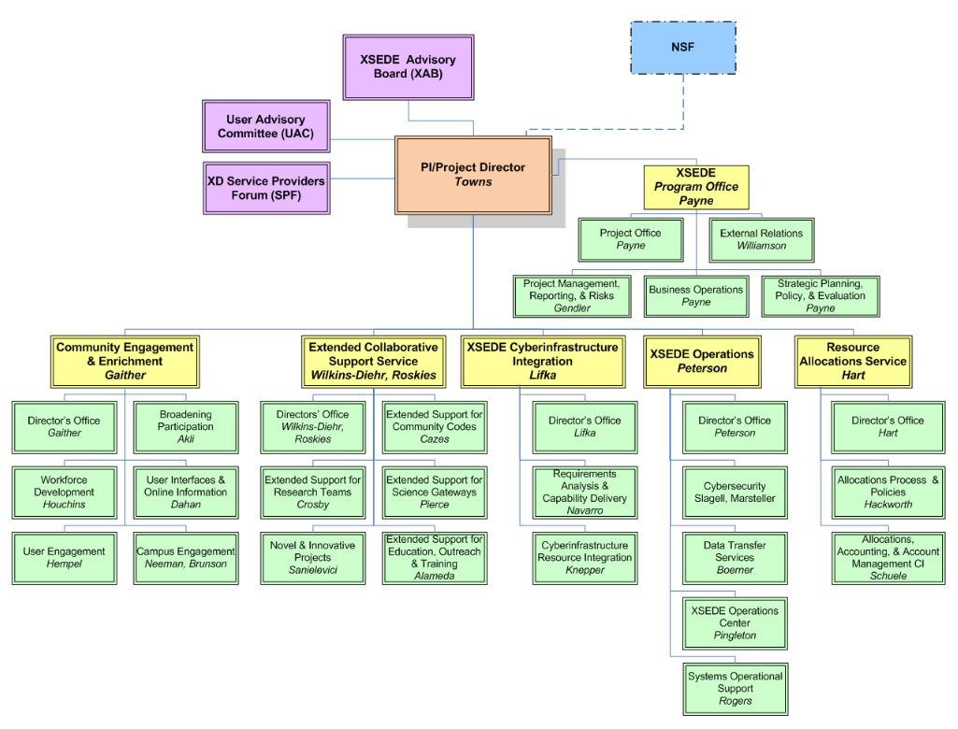
This can also be done in conjunction with the Critical Path Method (CPM) which is a list of all activities required on the project, which sequence the activities need to be done, the estimated time needed for each activity, the earliest start time and end time, the latest start and end time to give you the date range (float time) in which you can start and get finished each activity before the next one must begin.
The CPM should be updated as the project progresses. This is critical because it will keep the project on track according to your finish date and budget that was agreed with the client.
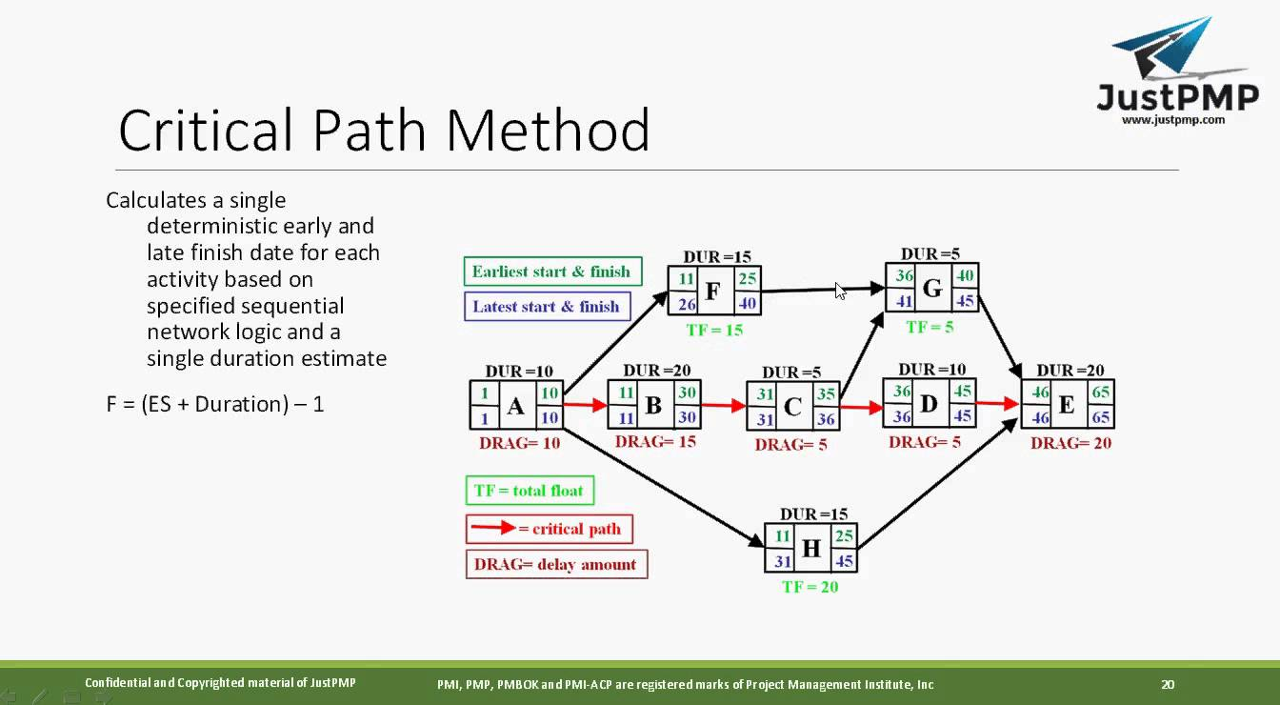
Some project managers may also use a Gantt chart which is a bar chart that illustrates a project schedule. Below is an example of a simple Gantt chart from eforza.
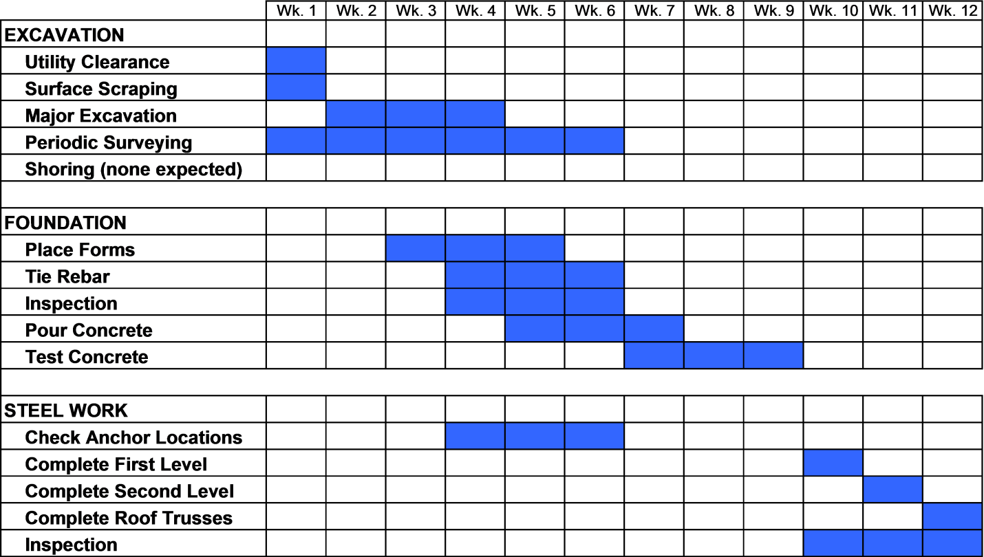

iii. A contractor has a number of options when it comes to Hire Purchase. The most popular is the Fixed Rate HP, because it allows for accurate budgeting, as the repayments are fixed, the interest rate is agreed at the start and stay at that rate for the full term (the interest rates are tax allowable), VAT is fully reclaimable and the machine is yours after the final payment. The payments may be paid monthly, quarterly, half yearly or annually depending on your cash flow. This kind of agreement can be linked to dealer service, repair and maintenance agreements.
A Variable HP is the same as a fixed except the interest is calculated daily and is paid monthly or quarterly, it is possible to pay lump sums to reduce the interest charges or even pay off the whole thing early. If you expect interest rates to fall this is a good option.
HP Plus is the same as a variable, but it is paid monthly and you have the option to take payment holidays. The holiday will just extend the length of the agreement. The interest rates are based upon a negotiated percentage rate at the start of the agreement.
Another form of variable is HP equalized payments, which is fixed monthly payments and unlike a normal variable the equalized payment plan shortens or lengthens the payment plan depending on the interest rate rising or falling.
A letter of agency is another option which allows “cash buyer” negotiating power or where you do not want to reveal to your supplier that you use an external source of finance. The amount borrowed is then usually paid back over a pre-agreed period.
The final option is Contract Purchase, this is a fixed rate HP with lower repayments because of a final balloon payment, which means low payments until the end of the agreement, at which point you decide whether to pay off the remaining balance and keep the machine, trade it in for a replacement or return it.
Not all companies will offer all these options.

iv. According to Minakshi Jain a Plant Layout “is the most effective physical arrangement, either existing or in plans of industrial facilities i.e. arrangement of machines, processing equipment and service departments to achieve greatest co-ordination and efficiency of 4M’s (men, materials, machines and methods).”
It is highly important to prepare a proper plant layout to minimize handling, for the best flow of materials to save time, money, double handling, safety and security (for the plant and workforce).
The plant layout if designed well should take into account where bottlenecks may occur, are there any low cables or underground cables which may need to be addressed and if the project was to increase in size is there room to expand and minimize workforce movement.
Ankit Walia on Slide Share suggests there are 8 principles of Plant Layout:
- Minimum movement
- Flow
- Space
- Safety
- Flexibility
- Interdependence
- Overall Integration
- Minimum Investment
As you can see a plant layout is important for many reasons and each site will be different.
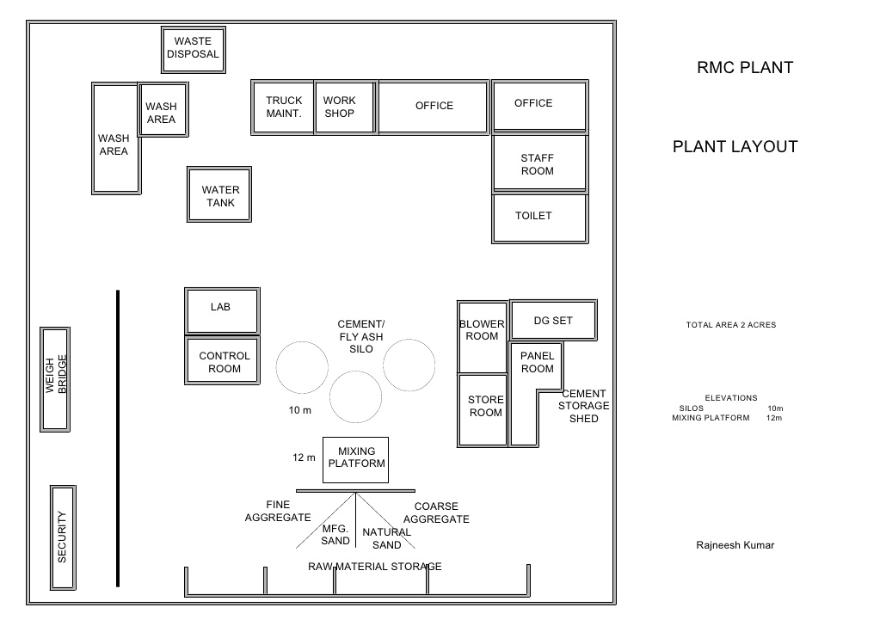

v. The disadvantages of purchasing as opposed to renting are mainly financial and technological. The financial disadvantages are that if equipment is bought outright the purchase price will not be available for any other purpose. All the maintenance, up keep and operation costs will be the purchasers responsibility including the time the equipment is sitting idle and finally the equipment may be utilized beyond its economical life therefore reducing the profit.
The technological disadvantages are that if the equipment becomes overtaken by newer, better upgrades, in short superior equipment, the outright buyer will not be able to take advantage of this, also the owned machine may become a problem to get spares for due to the machine becoming obsolete.
The final disadvantage is the disposal of the equipment after the project is over, as over time the newer and more modern equipment will become the more desirable options.

2. The factors affecting the cost of owning and operating construction equipment start with the initial investment, the cost of the equipment, delivery, the interest on any loans taken out to buy the machine, taxes, insurance, storage and the cost of an operator and mechanic, secondly the costs of maintaining and operating the equipment, this obviously depends on a number of issues. If the equipment is looked after and the maintenance is ongoing (prevention is better than waiting for something major to happen) the equipment is going to last longer, however the conditions the equipment is used in will affect the machine for example the severity of the conditions, the number of hours used, whether spares are easily available and the amount of downtime for the machine. An additional cost is fuel consumption and lubricating oil used.
The equipment is going to be depreciating all the time, also the longer you keep the machines the more likelihood there is of them being overtaken by better and more sophisticated equipment, which may mean your machine will become obsolete making it difficult to obtain spares and to sell the machine when the time comes.

3. Lease agreements are usually less expensive than rentals, because a lease is normally for a longer period (12 months +), although this means that the maintenance of the equipment falls on the end user, but in general leased equipment tends to be new or certainly in better condition than a rental.
Robert Andrade, CEM and heavy equipment consultant says another plus in leasing is that “you are building equity in the machine and you can capture that cash back….You have a lot of flexibility because you are in control of that asset”.
Andy Agos former fleet executive with Neff Products and Hubbard Construction says that “Typically on general construction equipment, if your expected utilization rate is below 40% you don’t own those machines. You rent them. If your utilization rate gets as high as 40-60% you could rent or lease. If this gets over 60% you typically will own or lease the machine”.
Whether leasing or renting it is vital that all the terms and conditions are read and understood, especially who will be liable in cases of malfunction or injuries caused by the machine. CPA models terms and conditions is worth a read.

Student Statement:

By submitting this assignment, I confirm that this is my own work.

Student Signature | S J Tomlin | Date | 18/5/18

For Tutor / Assessor Use Only
Total Marks
Marks Obtained
Percentage / Grade

