
Assignment Cover Sheet

Student Name: | EYIYEMI BAMIDELE
Student Number: | 37630
Course: | LEVEL ADVANCED DIPLOMA LEADERSHIP & MANAGEMENT
Assignment NO: | UNIT 9

Marking Criteria:
We expect the learners to write minimum one well expressed point in three lines against each allocated mark. This means one needs to write 15 lines with 5 well expressed points to get high grades for a 5 marks question.
For high grades use examples and illustrations where appropriate.
Answer the following questions:

1. What is a conflict? How can you avoid it?

Conflict is a situation where two or more people or groups disagree on a subject or issue and feel being threatened. Conflict is a bigger problem that combine disagreement and threat to the party. But it becomes untreated, it fires up the threatened participant’s emotions. It is very possible to always encounter disagreement and conflict while trying to build string relationships. A saying says “we need to disagree to agree” but not to feel being threatened. Sometimes positive conflict is the rule of progress and unity. We could disagree of a subject to hear other people’s opinion and belief.
This is due to the fact the we as an individual comes from different background that possesses different mindset about issues and subjects. For a healthy relationship to survive in place and time of conflict, there is need to realize that conversations are needed to iron out misunderstanding. one way to resolve conflict is settling down for conversations. A lot can be resolve when right conversation is schedule. We need to conscious find a common ground during conversation.

Conversation should not be to argue but to be centered around resolving and knowing the group better. As leader we should first know what the purpose of the meeting for conversation which is is to settle conflict. The conversation should be effective in resolving grudges. The opportunity for the participants to lay down their views genuinely towards the progress of the group.

It is very important that there are conflicts in the group because that is how we can actually know each other if well managed. You can actually know how resourceful a member is and know how strong the impact they could make in the group. There are times that we might be wrong that we don’t really get along with. To resolve conflicts with these people, I think we need to look beyond the grudges, find some positive traits of the person and use to frame positive conversation towards resolving the tension.
Another way conflict could be avoided is setting the rules and policy of the group. There is a saying that goes” where there is no law, there is no sin”. This simply means that when there is no law structure in place, people or members could step on each other’s toes without being aware of the consequences. There is bound to be conflict due to lack of regulation and procedures in place. In the case where everyone is aware of the law governing the rule, the level of conflict is hugely minimized. If any one is faulty, they will be directed to the policies governing the group, so the individual know that he or she is causing conflict. This is because the law is the agreed principle that ultimately controlling their behavior and suggestions.

2. What are the three F’s of getting to the heart of the problem?
a. Facts-
b. Frequency
c. Frustrated relationships

3. Draw and explain the Conflict Resolution Model

STAGE 1
RESEARCH MODEL

*How valued is the conflict
* How clear is the conflict
*How factual, frequent &frustrated is it on relationship

STAGE 2
PRESENTATION MODEL

- Dialogue with hard member
- Safety of the vicinity
- Discuss gap in habit
- Simplify the behaviour
STAGE 3
ACTION PLAN

- Collective agreement
- Agreed actions
- Evaluate the actions

Discussion

Resolving conflict among members is one of the greatest challenges withing a group. A group can not but at one time or the other engage in disagreed conversation, and it is vital that the above diagram will help if used.
stage1- this is the research stage. The research model is the first action to take on board when you encounter conflict. We must establish that the conflict is important to the group. If it’s a conflict that has no value or does not necessary concern the group, it worth to just let it go and not investigated. We got decide if the conflict worth time to be consumed on. Rather than consuming time on irrelevant conflict, the time could consume on planning the projects.
in the scenario where the conflict is relevant, we need to get clear vision of the issues. This could be done by calling on the parties involve hearing the sides of the story. Or if it required that the issue is withing the group where it requires that all members are present. We need to get the clarity, the true picture of the issue.

The 3dr arm of the research is Fact, Frequency and frustrated relationship.
Facts: These are the core reason of the issues. It is very vital to understand the main fact of the problem to know what solution is required to resolve the issues. There are tendencies that you might be sidelined and lose the focus of the issues if care not taking. Because of this, it is important that I write down the list of facts to face in the resolvement. Example: if a member complains of another member insulting her because of her idea and throw a conflict. Understanding the concern of the member is that he was insulted passing his idea and demand an apology. Making enquiries with the other party is vital. If the other party that insult doesn’t mean to, he could agree to apologize so that the concern of the feeled-insulted party is resolve. Getting to the root of the incident with you centered on the fact of the issue is paramount to problem solve.

b. Frequency: This is the pattern of the problem. How frequent is the party insulted the member? Has it been the perpetual habit of the member to pass on insulting comment on other people’s views and opinion? In the case of other members complaining of the same issues with same party. Then the member should be caution and call to order regarding his behavior. It might be that it is unintentional, then he should learn to deliberately think through his statement before voicing out. In other case, it could be that feeled-insulted party have the pattern of unnecessary pick offences in other people comment. As the leader I need to check and look for frequency patterns in the issue occurrences.

c. Frustrated relationship: Focusing on the frequency of the pattern is not enough. But the relationship with the group is more vital than any other thing. I have to make the members be aware of any frustrated behavior from them towards the group. Rather than getting angry, I could just be nicely choosing my word. It could “I feel like if we can work in unity, we would achieve the aim. In the case of the example above. I could just express my intent with each party that I am very interested in having positive relationship with them and with each other. For a party who might be intentionally be insulative, I could say “ I feel if you could try and be civil with members, it would improve your relationship with them and it could cause conflict that could be weighing us down as a group”

stage 2- The presentation model-This is the stage where presentation takes place. The first arm in this stage is hosting a meeting with the person with challenging behavior. I think it will be a great idea to organize a separate meeting where you can meet to discuss and dialogue with him. This process is very useful and could be an opportunity whereby he opens up as to why he behaves the way he does. It would very profiting if you can start with the positive trait of the person. Example: I must say you are one of the most talented and resourceful in the group. But I feel I need to discuss sensitive stuff with. I don’t want to lose, and I would appreciate if you can try to get think through your action before letting go. Am sure it will benefit your relationship with others group forum. With these words, the party is called to caution and better behaviour around others.

It is also very sensible for health and safety purpose to choose a location that safe for meeting. Especially if the party is an erratic person. Environment where people can see you such as coffee shop, open sitting space etc., you don’t want to put yourself in danger of attack in the name of resolving conflict.
you need to dialogue over the frequency pattern of the behaviour in a more appropriate manner and not hash. You could say” I know you are a passionate person and get work done but I feel you will be more productive if you can come to meeting on time. You know when you are late, you tend to miss the importance talk of the meeting and I feel that always make us slow. I feel its not really fair on early comers to always wait for you as we need you and your input very much in our progress. Words as these make the person feel wanted and loved, he also sees how much his lateness has contributed negatively to the group and himself.

Making the conversation very simple and easy for them or him. If you come from the perspective that they are valued members and if they don’t show up early at meeting, we wouldn’t hear form viewpoint as input. Or make them realize that we work collectively. Find out the barriers to the lack of early arrival. Give them an option to leave home an hour earlier depending on home location. Possibly find out if any other member lives closer to give a lift etc.

stage 3- The action plan- This is model that concentrate on changing the unaccepted behaviors that has generated conflict. It is not enough to develop actions without the agreement of the difficult person(s). they must be willing to comply, change and follow through. One of the actions for the difficult could to consciously think before talking.

The person must agree ok I will take time out for breathing over my comment. The late comers as mentioned above could be to leave home in ample time considering traffic. If you leave home 30mins to be meeting for 1mile journey, he needs to leave an hour because of traffic. He must agree to amend his behavior. And this action is brough to the entire house to agree. Another example is when people talk over each other in the meeting is conflicting. The action plan is that you wait for one to finish before next. The agreement that you signify by hands raising should be collective effort.

The evaluation process is another arm under this model. It is essential to check on regular or often occasion with difficult person on how he feels about the action. This is good to evaluate if the procedure is working or need to be amended.
The idea of raising hands to be feedbacked, if it’s creating orderliness and maintain respect for the prior speaker or not. Are members following through our policies? Do we need to update pattern of our relationship with ourselves? Follow-up is vital to the resolution of conflict in the group. It helps to check and ensure that we are handling the problem rightly or wrongly. In the event where the action planned isn’t working or solving conflicts, then a different approach could be adopted; this will be a continuous circle of resolving problems until we get the solution that works out towards solving our conflicts.

Self-Assessment
This assessment will help you to determine your preferences for involvement in dealing with difficult people and taking on those challenging conversations. Answer each question with yes or no. Scoring directions follow the assessment
- Instead of getting into an argument, I put off certain discussions.
Yes

2. When someone doesn’t deliver on a promise, I judge them more quickly than I should.
NO
3. Sometimes I bring up difficult subjects in a way that makes people defensive.
NO
4. Let’s be honest: there are people I deal with who simply cannot be motivated.
YES
5. When someone is struggling, I tend to offer advice, even though they may just want to have someone listen to their ideas.
YES

6. When discussing problems, I sometimes get side-tracked and miss the actual problem
YES

7. There are some people I simply cannot work with.
YES

8. Sometimes it’s not them being difficult, it’s me.
NO

9. I prefer to just jump in and have the conversation, rather than spending a lot of time planning for it.
NO

10. I know that I have to have these conversations, but I do not have to like them.
YES

References
conflict resolution. (n.d.). https://www.skillsyouneed.com/ips/conflict-resolution.html.
conflict Resolution Skills. (n.d.). HelpGuide, https://www.helpguide.org/articles/relationships-communication/conflict-resolution-skills.htm.
importance of setting rules for the group. (n.d.). https://pages.jh.edu/~virtlab/misc/Group_Rules.htm.
Preventing Conflict - How to avoid Conflict? (n.d.). MSG- MANAGEMENT GUIDE, https://www.managementstudyguide.com/preventing-conflict.htm.

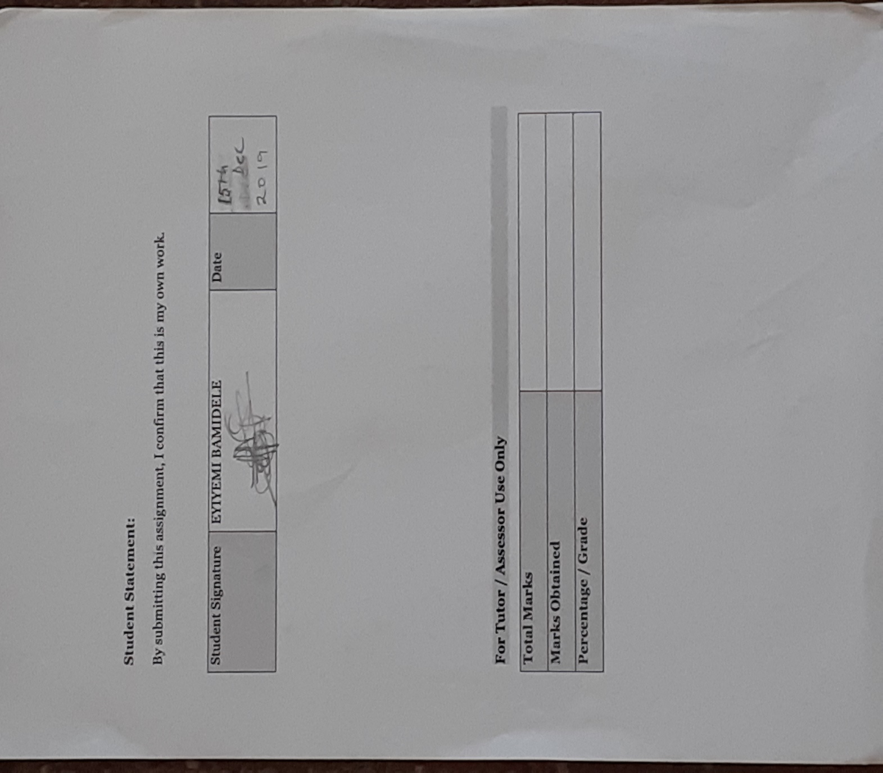

For Tutor / Assessor Use Only
Total Marks
Marks Obtained
Percentage / Grade

